Case Title | Ventricular Fibrillation: Adrenal Crisis
Scenario Name | Ventricular Fibrillation: Adrenal Crisis

Learning Objectives - Use action words
Knowledge:
- Recognize unstable ventricular tachycardia
- Differentiate between unstable ventricular tachycardia and ventricular tachycardia without a pulse
- Recognize ventricular fibrillation
- Recognize the importance of airway management when dealing with cardiac arrythmias
Skills:
- Learn proper management of pulseless ventricular tachycardia and ventricular fibrillation
- Learn how to properly use the defibrillator
Attitude/Behaviours:
- Demonstrate Team skills
- Demonstrate Situational awareness
- Demonstrate Graded Assertiveness
Scenario Environment
Location | ED
Monitors
Props/Equipment | CXR  EKG x2  Crash Cart
Make-up/Moulage | Rash on legs (around ankles)
Potential Distractors

Case Introduction:
8 year old boy with high fever x 3 days. Vomiting x 3 today. Rash on legs noted this morning around ankles. Feeling unwell. Brought to ER.

Patient Parameters | Effective Management | Notes
Phase 1: Toxic  Condition: Looks very unwell, toxic  Initial Assessment  - Heart Rhythm: Sinus Tachycardia  - HR: 160  - BP: 70/P  - RR: 35  - SP02: 90% RA  - T: 40.2  - Chest: Bilateral crackles  - CNS: GCS 10. Drowsy and difficult to arouse  - CVS: gallop rhythm, soft murmur, cap refill 4 secs, pulses weak  - Weight: 25 kg | - Take a focused history (see Notes column)  - Medical Management  - Orders bloodwork : CBC, lytes, gas, lactate, renal function, coags, blood culture  - CXR  - Ceftriaxone / Vancomycin  A  - Head tilt, chin lift, jaw thrust  - Prepare for intubation  B  - Apply monitors  - Apply oxygen by mask  - May decide to bag/mask ventilate patient  C  - Monitors  - Insert IV x 2  - Gives NS bolus 20 cc/kg x 1, then repeats | - Focused History  - Oncology patient  - Unwell today, slept most of the day  - Mom noted new rash this morning around ankles bilaterally  - Difficult to awaken this afternoon, brought to ER  Airway  - Talk to the patient  - Open airway  Breathing  - Check oxygen saturation  - Auscultate chest  Circulation  - Check pulse, cap refill, BP  - Identify hypotension
Phase 2: VTach  Condition: Looks very unwell. Toxic. Rhythm changes to unstable VTach  Physical Examination  - Heart Rhythm: VTach w/pulse  - HR: 160  - BP: 70/P  - RR: 35  - SP02: 87%  - T: 40.2  - Chest: Bilateral crackles  - CNS: GCS 10. Drowsy and difficult to arouse.  - CVS: gallop rhythm, soft murmur, cap refill 4 secs, pulses weak | - Reassessment of patient (see Notes column)  - Medical Management  - Labs come back: review handout  - Order repeat electrolytes  - Orders stress dose of steroid (hydrocortisone or methylprednisolone)  - Identifies high K and institutes immediate therapy :  - Ca gluconate / Ca chloride  - Na HCO3  - Ventolin nebs  - Glucose bolus followed by insulin infusion  A  - Has suction nearby  - prepares equipment for intubation  - Assigns someone to attend to the airway  B  - Prepares bag/mask equipment  C  - Administers sedation (midaz/fent) if not intubated  - Synchronized cardioversion at 0.5-1 J/kg  - Repeat Sync cardioversion at 2 J/kg  - Gives appropriate medication  - Amiodarone 5 mg/kg IV x 1  - Or Lidocaine 1 mg/kg IV x 1  - Calls for help (ICU / Cardiology) | - Reassessment of patient  Airway  - Maintains the airway : jaw thrust, chin lift, head tilt  Breathing  - Applies oxygen  Circulation  - Identifies Unstable Vtach
Phase 3: Pulseless VTach  Condition: unresponsive  Physical Examination  - Heart Rhythm: VTach - pulseless  - HR: 160  - BP: 40/P  - RR: apneic  - SP02: 80% RA  - T: 40.2  - Chest: bilateral crackles  - CNS: GCS 3  - CVS: gallop rhythm, soft murmur, cap refill 7 secs, pulses absent | - Reassessment of patient (see Notes column)  - Medical Management  A  Intubation  - Preoxygenation  - Premedication : n/a  - Cricoid pressure  - Sedation : Midazolam 0.1 mg/kg and Fentanyl 1mcg/kg IV  - Paralysis : Succs 2 mg/kg IV  - ETT : 6.0  - Check tube placement  B  - Continues to bag ventilate the patient  C  - Defibrillation at 2 J/kg then CPR  - Repeat CPR and then defibrillates again at 2J/kg  - Gives epinephrine 1:10000, 0.1 cc/kg then CPR  - Reassesses pulse and rhythm | - Reassessment of patient  Airway  - Rechecks airway / tube  - Intubates now if not intubated previously  Breathing  - Reassesses breathing  Circulation  - Identifies pulseless Vtach  - Starts CPR immediately
Phase 4: Vfib  Condition: Unresponsive  Physical Examination  - Heart Rhythm: Vfib  - HR: -  - BP: 40/P  - RR: Bagged. No resp effort  - SP02: 80%  - T:40.2  - Chest: Bilateral crackles  - CNS: GCS 3. Sedated  - CVS: cap refill 7 secs, pulses absent | - Reassessment of patient (see Notes column)  - Medical Management  - Continues to manage electrolyte abnormalities  - Order repeat lytes and glucose, gas  A  B  - Continues to bag ventilate the patient  C  - Defibrillation at 2 J/kg then CPR  - Gives amiodarone 5mg/kg then CPR  - Orders lidocaine 1mg/kg as next drug  - Reassesses pulse and rhythm | - Reassessment of patient  Airway  - Rechecks airway / tube  - Intubates now if not intubated previously  Breathing  - Reassesses breathing  Circulation  - Identifies Vfib  - Continues CPR
Phase 5: Converts to SR  Condition: Looks very unwell, toxic, rhythm changes to NSR  Physical Examination  - Heart Rhythm: SR  - HR: 70-80  - BP: 70/P  - RR: Bagged  - SP02: 93%  - T: 40.2  - Chest: Bilateral crackles  - CNS: GCS 3. Unresponsive/ sedated when intubated  - CVS: soft murmur, cap refill 5 secs, pulses weak but present | - Reassessment of patient (see Notes column)  - Medical Management  - Continues to manage electrolyte abnormalities  - Repeats bloodwork  - Thinks about appropriateness of transport  A  B  - Continues to bag ventilate the patient  C  - Stops CPR  - Administers NS bolus  - Starts inotrope infusion : dopamine or epinephrine | - Reassessment of patient  Airway  - Rechecks airway / tube  Breathing  - Reassesses breathing  Circulation  - Identifies change to NSR, checks for pulse

Insert more lines if more phases required.

Expected Patient Management | Debriefing Points
- Student

- R1

- Senior IM resident

References:

X-RAYS – Click here

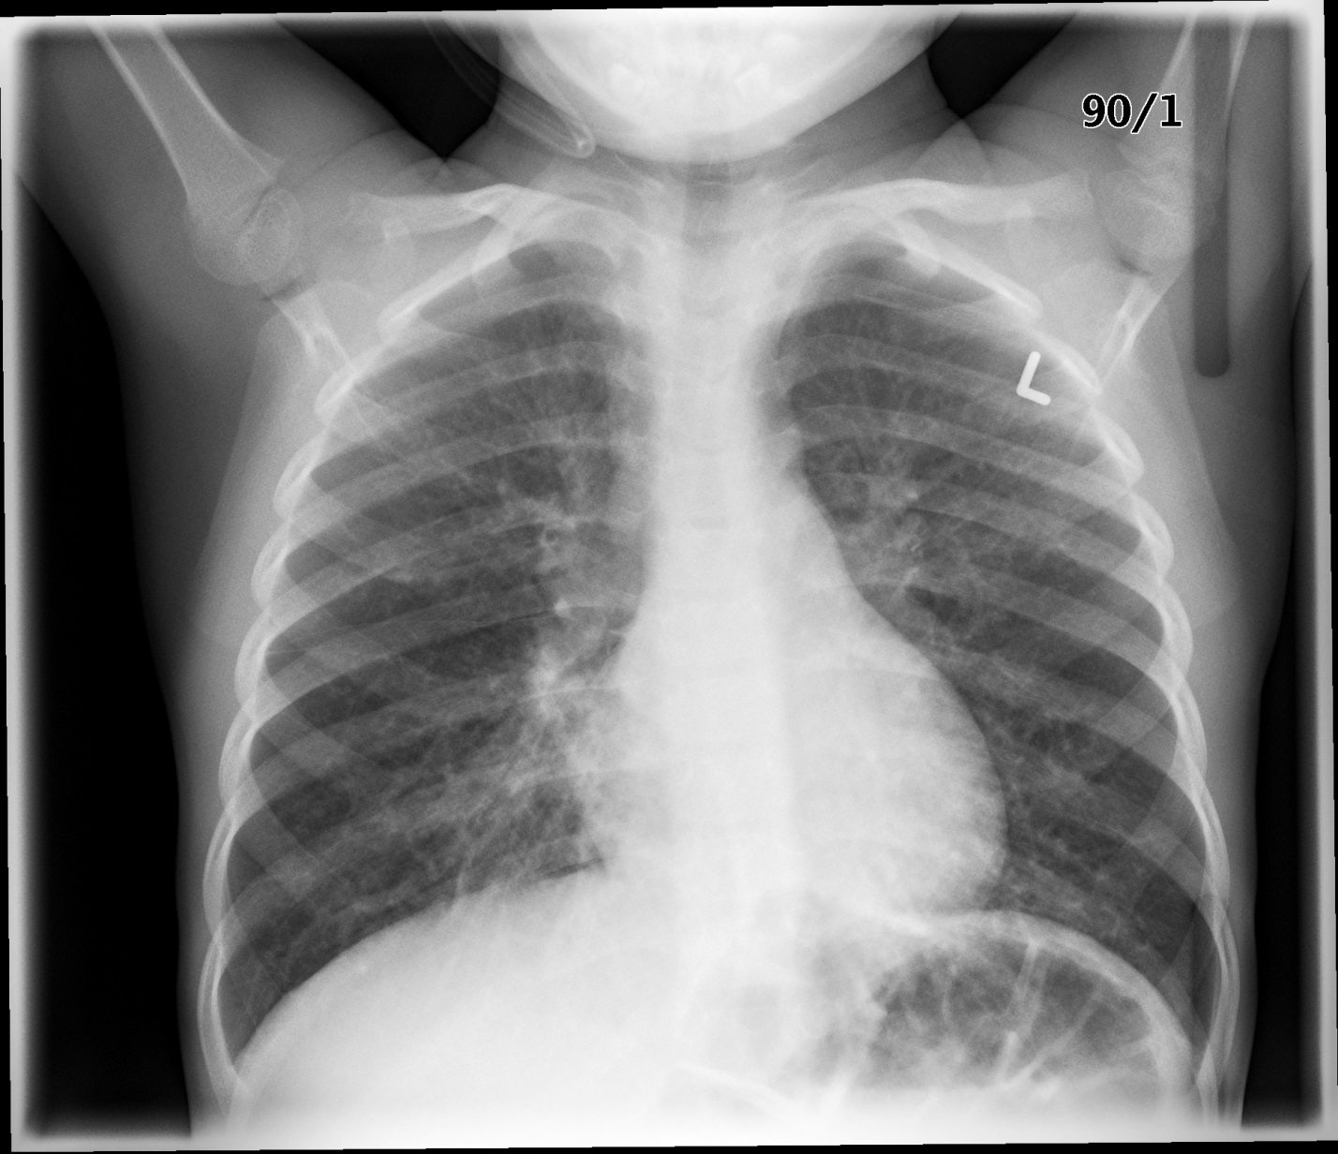

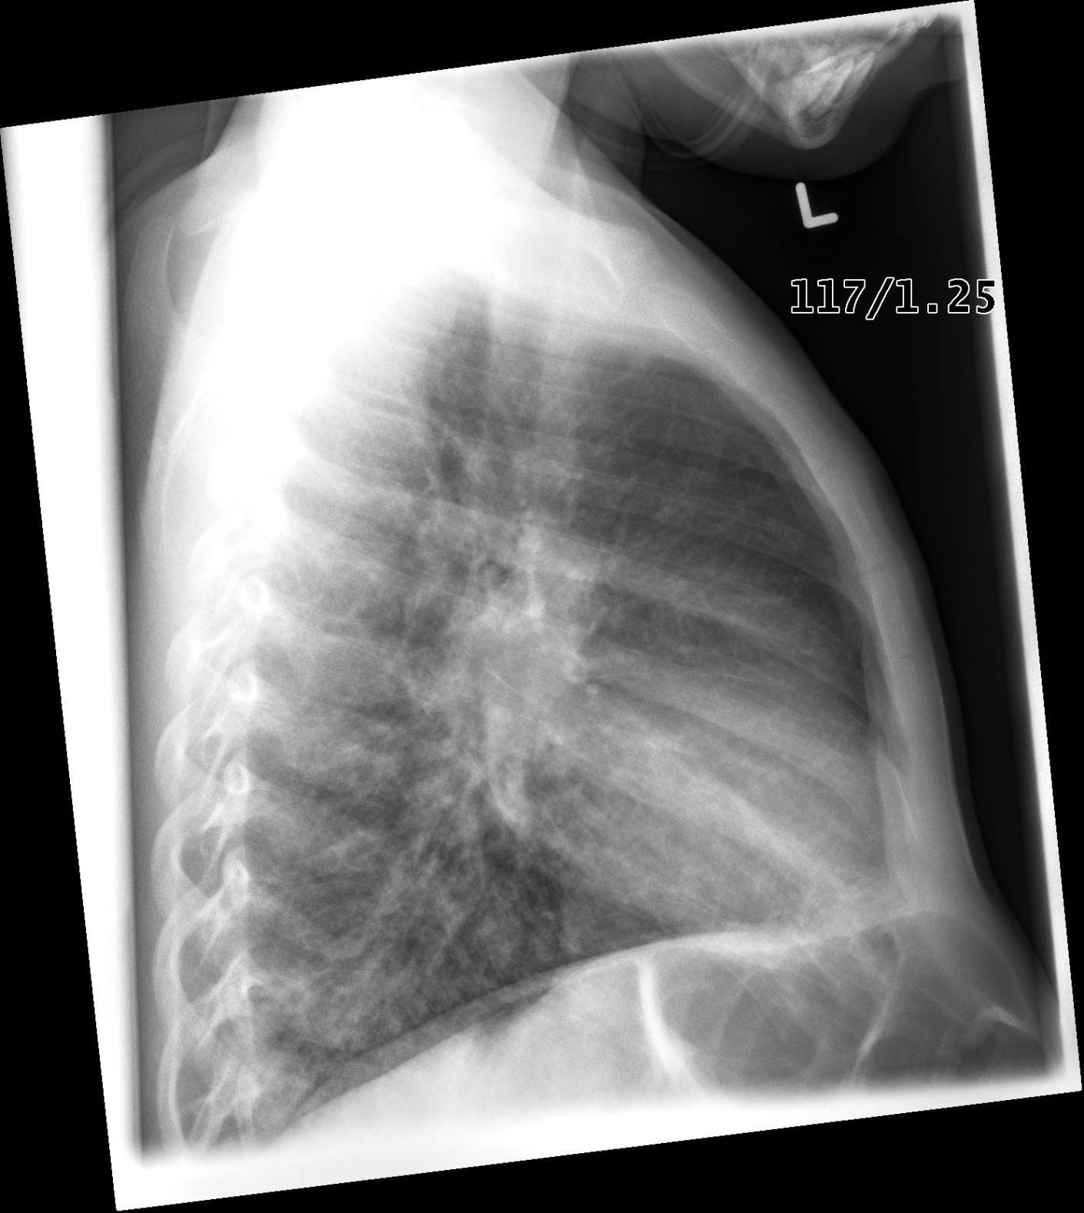
LABS – click here OR fill out below
LABORATORY *LIVE* Lab Summary Report
Test | DATE/TIME here | Flag (H or L) | Reference
CBC
WBC | 16.7 | H | 3.5 – 10.8 10^9/L
Hgb | 120 | L | 130 – 170 g/L
Platelets | 250 |  | 150 – 400 10^9/L
Chemistry
Na | 118 | L | 137 – 145 mmol/L
K | 9.5 | H | 3.5 – 5.0 mmol/L
Urea | 6.0 |  | 2.5 – 6.1 mmol/L
Creat | 80 |  | 62 – 106 umol/L
Glucose - Random | 1.0 | L | 3.0 – 11.0 mmol/L
Lactate | 7.8 | H | 0.9 – 1.8 mmol/L
ABGs
Arterial
pH | 6.99 | L | 7.35- 7.45
pCO2 | 15 | L | 35 – 45 mmHg
PO2 | 60 | L | 80-100 mmHg
BE | -20 | L | -2.0 to +2.0 mmol/L
HCO3 | 5 | L | 22 – 26 mmol/L
O2 Sat |  |  | 95 – 100%

EKGs – click here or paste
