Case Title | Shock in a Pediatric Patient : An Electrical Diagnosis
Scenario Name | Purulent Pericardial Effusion with Cardiac Tamponade

Learning Objectives - Use action words
Knowledge:
- Discuss the differential diagnosis of shock
- Describe the initial management of shock in a pediatric patient
- Identify the clinical and radiographic features of cardiac tamponade
- Describe the management of cardiac tamponade
- Discuss the potential complications associated with intubating a patient with cardiac tamponade
- Recognize the importance of early identification and proper management of this potentially fatal condition
Skills:
- Describe how to perform needle pericardiocentesis in a pediatric patient
- Demonstrate proper teamwork and communications skills during a resuscitation
Attitude/Behaviours:
- Demonstrate Team skills
- Demonstrate Situational awareness
- Demonstrate Graded Assertiveness
Scenario Environment
Location | Emergency Department
Monitors | - Non invasive blood pressure cuff  - Three-lead cardiac monitor  - Pulse oximeter  - Capnograph  - Temperature probe
Props/Equipment | - Simple oxygen mask  - Bag and mask for ventilation  - Endotracheal tube and stylet  - Laryngoscope  - IV needles  - IV line and bag  - Labeled syringes  - Appropriate medications  - Pericardiocentesis Kit / Tray  Supporting Files :  - Chest radiograph with enlarged heart (Figure 1)  - 12 – lead EKG demonstrating ST-segment elevation (Figure 2)  - Rhythm strip demonstrating electrical alterations (Figure 3)  - Echocardiography still photo demonstrating massive pericardial effusion (Figure 4)
Make-up/Moulage
Potential Distractors

Case Introduction:
A 7 year old boy is brought into the resuscitation room by the triage nurse who is concerned about his appearance.
The child is accompanied to hospital by his mother.
He has been brought in to hospital by ambulance, and appears quiet and motionless on the stretcher.
You notice that the paramedics have applied cardiac monitors and oxygen by simple face mask.
The patient has no IV access.

Patient Parameters | Effective Management | Notes
Phase 1: Initial Assessment  Condition: Sleepy but opens his eyes occasionally, responds to commands, no bruising or rash noted, mottled  Initial Assessment  - Heart Rhythm: NSR  - HR: 150  - BP: 80/60  - RR: 40, no SOB  - SP02: 92%  - T: 38.6  - Chest: lungs clear, no resp distress  - CNS: sleepy  - CVS: HS normal, cap refill 3, femoral pulses weak, denies chest pain or palpitations, JVP 4-5cm above sternal angle  - GI: soft, nontender, liver palpable 5cm below right coastal margin, no jaundice, hematuria or dysuria.  - Integ: No bruising/rash  - Weight: 25kg | - Take a focused history (see Notes)  - Medical Management  - cardiac monitor  - ECG  - IV access  - Labs  - Bedside glucose  - Identifies shock, diff dx?, management | - Focused History  - No history of septic risk factors during pregnancy, born SVD 39 wks, no prior hospitalizations.  - The child has had a one day history of fever, decreased appetite and a fluctuating level of consciousness.  - He has been dozing off to sleep today after being awake for only several minutes at a time.  - He has not had anything to eat in the past 2 days.  - He has urinated only once in the last 24 hours.  - There is no history of vomiting, diarrhea,cough.  - Lives with parents, high achiever at school, plays soccer 2 nights a week  PMHx  - Unremarkable  Meds  - Not taking any medications  - Immunizations are up to date  Allergies  - none
Phase 2: Worsening condition  Condition: moaning & groaning, responds to pain only, obv SOB, pale, cool skin  Physical Examination  - Heart Rhythm: NSR with ST changes, low voltage QRS  - HR: 162  - BP: 75/50  - RR: 40, shallow  - SP02: 94% on 15L, only will pick up on earlobe probe  - T: 38.6 C  - Chest: decreased a/e bilat bases  - CNS: GCS 10  - CVS: cap refill 4 sec, femoral pulses weak & diminished with inspiration | - Reassesment of patient (see Notes)  - Medical Management  - I/O if no IV access yet  - Cardiac ECHO/bedside U/S  - CXR  - Cardiac tamponade diagnosis, radiographic features, mgmt, early id and mgmt  - Consider intubation, considerations in pt with cardiac tamponade?  - pericardiocentesis | - Reassesment of patient  Airway  - Maintaining own  Breathing  - Shallow, increased rate, appears distressed and SOB  Circulation  - Pulses weak, JVD present  - “Becks Triad” hypotension, JVD, muffled heart sounds
Phase 3: Unresponsive  Condition: unresponsive  Physical Examination  - Heart Rhythm:  - HR: 170  - BP: 75/50  - RR: 40  - Chest: clear  - CNS: GCS 8 | - Medical Management  - Intubation, RSI and decompensated shock

Insert more lines if more phases required.

Expected Patient Management | Debriefing Points
- Student

- R1

- Senior IM resident

References:

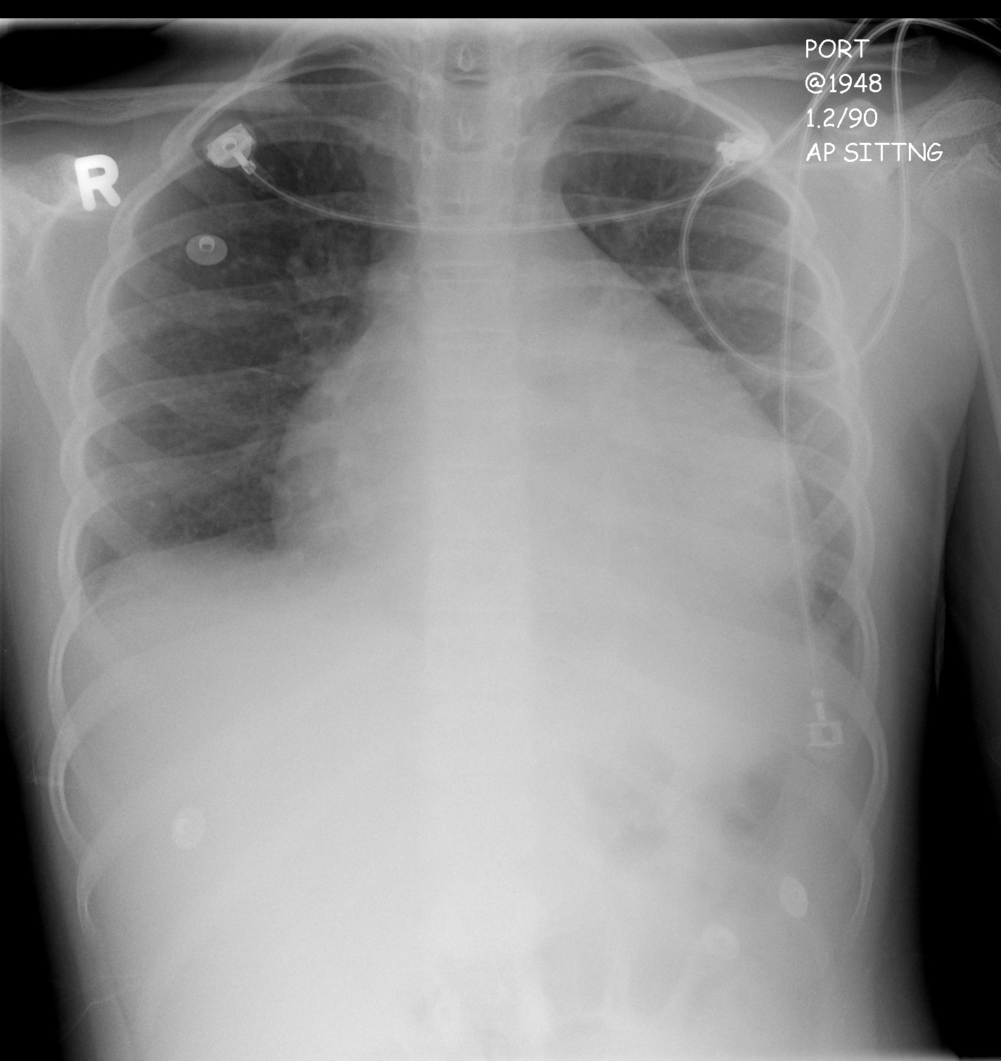
LABS – click here OR fill out below

RUN DATE: Today LABORATORY *LIVE* Lab Summary Report
LOCATION

Name: |  |  |  |  |  | Age/Sex:
Acct#: |  |  | Unit#: |  |  |  |  |  | Status: Admitted |  |  |  | Location: SIM
Reg: |  |  |  |  | Disch: |  |  |  |  |  |  | Code status -
COMPLETE BLOOD COUNT
Date
Time |  |  |  |  |  |  |  |  |  |  | Reference |  | Units
WBC |  |  |  |  |  |  | H |  |  |  | (3.5-10.8) |  | 10^9/L
Toxic changes seen |  |  |  |  |  |  |  |  |  |  | (4.3-5.7) |  | 10^12/l
Hgb |  |  |  |  |  |  | L |  |  |  | (130-170) |  | g/L
MCV |  |  |  |  |  |  | L |  |  |  | (0.37-0.47) |  | L/L
Platelets |  |  |  |  |  |  | H |  |  |  | (150-400) |  | 10^9/L
INR |  |  |  |  |  |  | H |  |  |  | 0.9-1.2
D-Dimer
PTT
CHEMISTRY
ADMISSION
Glucose-Random |  |  |  |  |  |  | H |  |  |  | (3.0-11.0) |  | mmol/L
Na |  |  |  |  |  |  | L |  |  |  | (137-145) |  | mmol/L
K |  |  |  |  |  |  | H |  |  |  | (3.5-5.0) |  | mmol/L
Cl |  |  |  |  |  |  |  |  |  |  | (98-107) |  | mmol/L
HCO3 |  |  |  |  |  |  | L |  |  |  | (22-26) |  | mmol/L
Urea |  | H |  |  |  |  | H |  |  |  | (2.5-6.1) |  | mmol/L
Creat |  |  |  |  |  |  | H |  |  |  | (62-106) |  | mmol/L
GFR Est |  |  |  |  |  |  | L |  |  |  | (> 60) |  | ml/min
C Reactive Protein |  |  |  |  |  |  | H |  |  |  | <10
Lactic Acid |  |  |  |  |  |  | H |  |  |  | <2.0 |  | mmol/L
ARTERIAL BLOOD GAS

pH - , PC02 – , p02 – , HC03 – , O2 Sat - %

EKGs – click here or paste

