Case Title | Congestive Heart Failure (ASVD)
Scenario Name | Congestive Heart Failure (ASVD)

Learning Objectives - Use action words
Knowledge:
- Recognize heart failure in an infant
- Review the differential diagnosis of respiratory distress in an infant
- Review management of heart failure in an infant
Skills:

Attitude/Behaviours:
- Demonstrate Team skills
- Demonstrate Situational awareness
- Demonstrate Graded Assertiveness
Scenario Environment
Location | ED
Monitors
Props/Equipment
Make-up/Moulage
Potential Distractors

Case Introduction:
2 month old; awake, alert, crying; cough and vomiting x 5-6 days; short of breath for 3-4 days; fussy after feeds

Patient Parameters | Effective Management | Notes
Phase 1: Initial Presentation  Condition: awake, crying, looks unwell  Initial Assessment  - Heart Rhythm:  - HR: 170  - BP: 90/50  - RR: 60  - SP02: 100% on room air  - T: 37.3 C  - Glucose:  - Chest: bilateral crackles  - CNS: awake and alert, crying  - CVS: pulses strong, CR 2 sec, loud murmur III/VI  - GI: liver enlarged and palpable below the costal margin  - Weight: 5kg | - Take a focused history (see notes)  - Medical Management  A.  - Suction  - Visualize airway  - Call for help – RT  B.  - Monitors  - Ausculatate chest and observe RR  - Oxygen sat  - Apply oxygen (100%)  - Get anesthesia bag ready (or non rebreathing bag)  C.  - Assess pulse, HR, cap refill, BP | - Take a focused history  PMHx  - Normal pregnancy / delivery  - born at 41 weeks, SVD  - Well at birth, no complications  Meds  - No meds  Allergies  - None known  Airway  - Patent  Breathing  - Bilat crackles  - Increased effort and rate  Circulation  - Strong pulses x 4 limbs  - Cap refill 2 secs  - Murmur III/VI
Phase 2: Worsening Condition  Condition: continues to be fussy, quiet, no crying  Physical Examination  - Heart Rhythm:  - HR: 170  - BP: 65/30  - RR: 70  - SP02: 100% on oxygen  - T: 37.3  - Chest: Bilateral crackles  - CNS: eyes open, but not crying  - CVS: pulses strong, CR 2 secs, loud murmur as before | - Reassessment of patient (see Notes)  - Medical Managament  A.  - Suction the airway  - Reposition the head with head tilt, chin lift, jaw thrust  - Reapply oxygen mask  B.  - Reassess breathing and RR  - Call for help from RT  C.  - Reassess HR, pulse, CR, BP  - IV access  - Order IV fluids – bolus 20 cc/kg NS  - Do bloodwork with IV start : CBC, diff, culture, lytes  - ABG / VBG  - Get STAT CXR  - Consider lasix after CXR shows enlarged heart  - Cardiology referral  - Consider dopamine or milrinone for persistent hypotension | - Reassessment of Patient  Airway  - patent  Breathing  - crackles  - continues with increased effort and rate  Circulation  - pale

Insert more lines if more phases required.

Expected Patient Management | Debriefing Points
- Student

- R1

- Senior IM resident

References:

X-RAYS – Click here

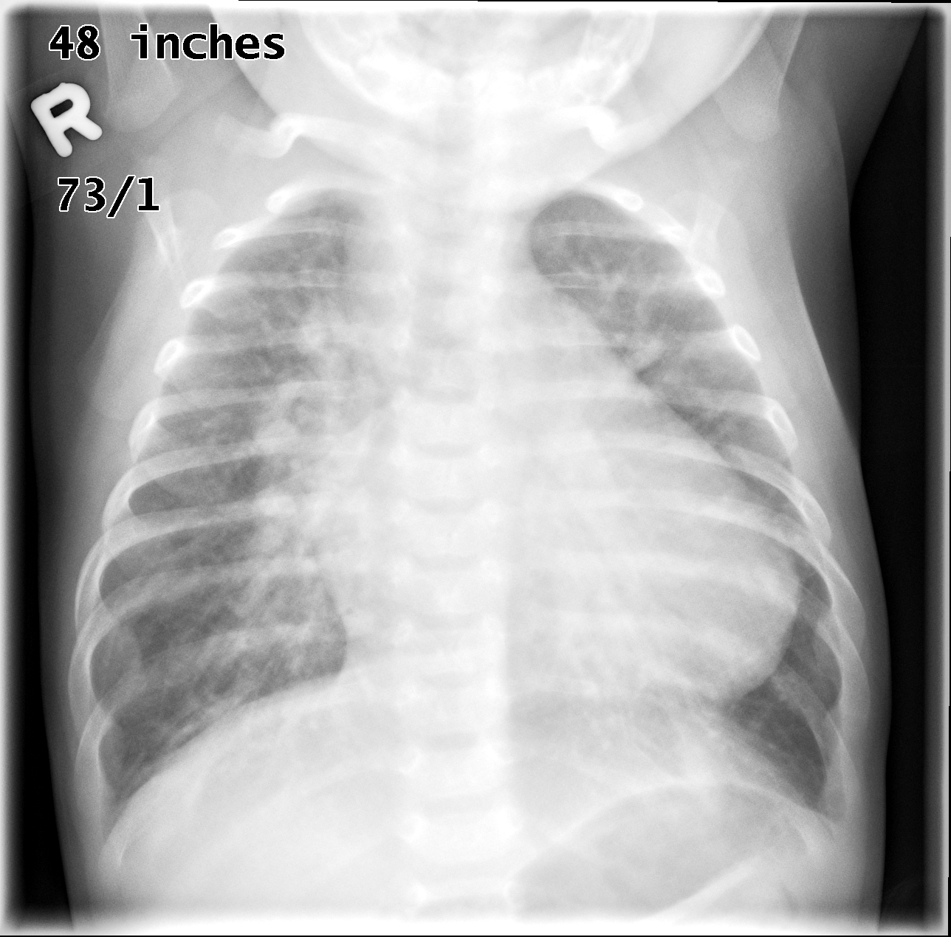
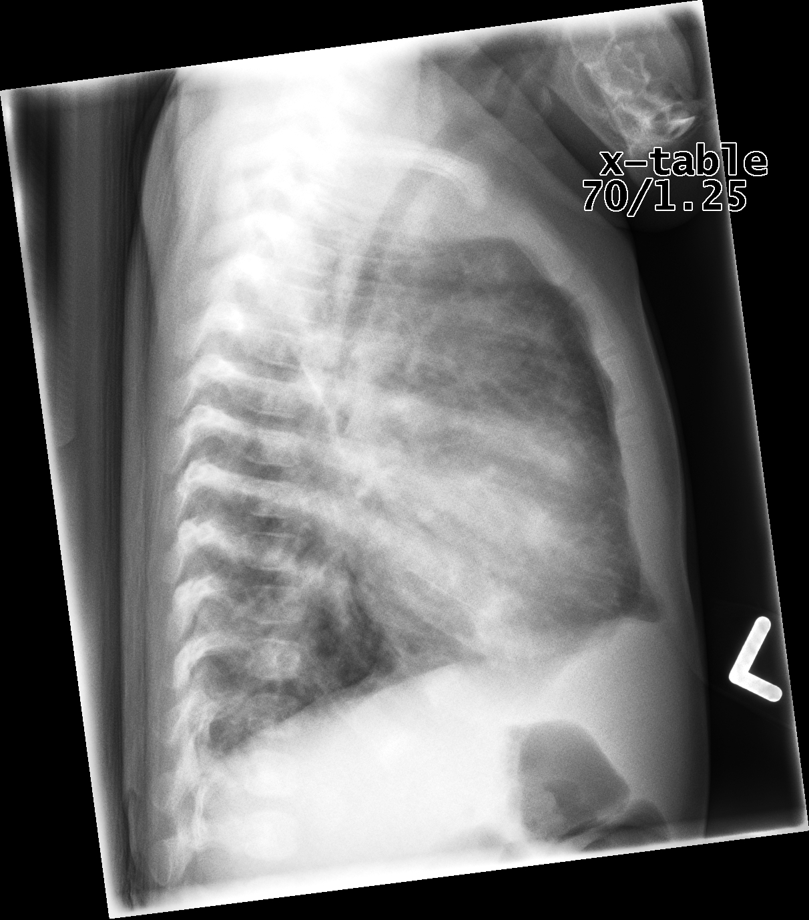

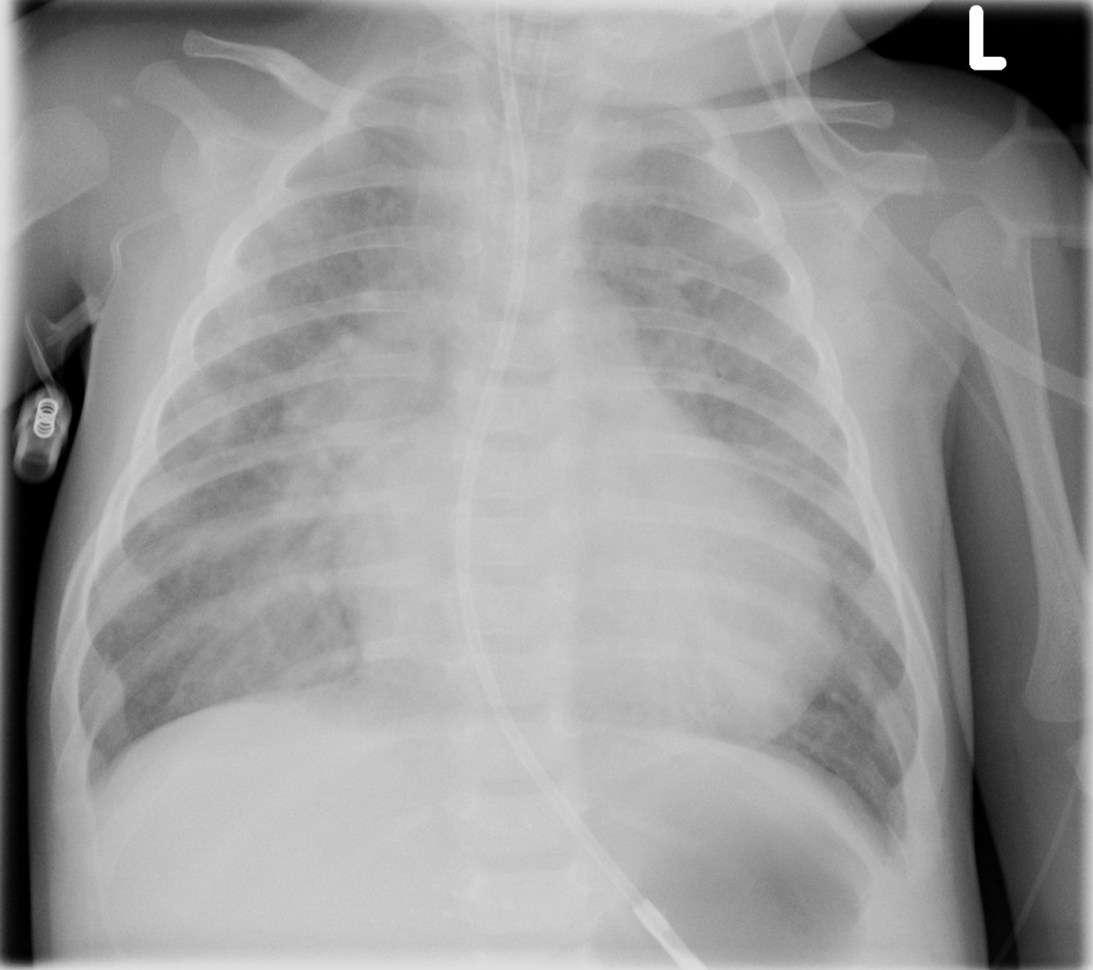

LABS – click here OR fill out below

RUN DATE: Today LABORATORY *LIVE* Lab Summary Report
LOCATION

Name: |  |  |  |  |  | Age/Sex:
Acct#: |  |  | Unit#: |  |  |  |  |  | Status: Admitted |  |  |  | Location: SIM
Reg: |  |  |  |  | Disch: |  |  |  |  |  |  | Code status -
COMPLETE BLOOD COUNT
Date
Time |  |  |  |  |  |  |  |  |  |  | Reference |  | Units
WBC |  |  |  |  |  |  | H |  |  |  | (3.5-10.8) |  | 10^9/L
Toxic changes seen |  |  |  |  |  |  |  |  |  |  | (4.3-5.7) |  | 10^12/l
Hgb |  |  |  |  |  |  | L |  |  |  | (130-170) |  | g/L
MCV |  |  |  |  |  |  | L |  |  |  | (0.37-0.47) |  | L/L
Platelets |  |  |  |  |  |  | H |  |  |  | (150-400) |  | 10^9/L
INR |  |  |  |  |  |  | H |  |  |  | 0.9-1.2
D-Dimer
PTT
CHEMISTRY
ADMISSION
Glucose-Random |  |  |  |  |  |  | H |  |  |  | (3.0-11.0) |  | mmol/L
Na |  |  |  |  |  |  | L |  |  |  | (137-145) |  | mmol/L
K |  |  |  |  |  |  | H |  |  |  | (3.5-5.0) |  | mmol/L
Cl |  |  |  |  |  |  |  |  |  |  | (98-107) |  | mmol/L
HCO3 |  |  |  |  |  |  | L |  |  |  | (22-26) |  | mmol/L
Urea |  | H |  |  |  |  | H |  |  |  | (2.5-6.1) |  | mmol/L
Creat |  |  |  |  |  |  | H |  |  |  | (62-106) |  | mmol/L
GFR Est |  |  |  |  |  |  | L |  |  |  | (> 60) |  | ml/min
C Reactive Protein |  |  |  |  |  |  | H |  |  |  | <10
Lactic Acid |  |  |  |  |  |  | H |  |  |  | <2.0 |  | mmol/L
ARTERIAL BLOOD GAS

pH - , PC02 – , p02 – , HC03 – , O2 Sat - %

EKGs – click here or paste

