Case Title | Myocarditis
Scenario Name | Ventricular Tachycardia

Learning Objectives - Use action words
Knowledge:
- Recognize ventricular tachycardia
- Differentiate between stable and unstable ventricular tachycardia
- Recognize the importance of airway management when dealing with cardiac arrythmias
Skills:
- Demonstrate how to properly use the defibrillator
- Demonstrate proper management of stable and unstable ventricular tachycardia
- Stabilization of a patient who has just converted from ventricular tachycardia to sinus rhythm
Attitude/Behaviours:
- Demonstrate Team skills
- Demonstrate Situational awareness
- Demonstrate Graded Assertiveness
Scenario Environment
Location | ED
Monitors
Props/Equipment | Crash cart  Xray  ECG  IV
Make-up/Moulage
Potential Distractors

Case Introduction:
5 year old boy. Cough, runny nose and fever x 5 days. Diaphoretic and chills today. SOB and felling unwell; taken to the emerg

Patient Parameters | Effective Management | Notes
Phase 1: VTach w/pulse  Condition: Toxic, looks unwell  Initial Assessment  - Heart Rhythm: VTach with pulse  - HR: 150  - BP: 95/P  - RR: 35  - SP02: 88% RA  - T: 39  - Chest: Clear  - CNS: GCS 15  - CVS: gallop rhythm, soft murmur, cap refill 2 sec, pulses normal  - Weight: 20 kg | - Take a focused history (see Notes column)  - Medical Management  Airway  - Talk to the patient  - Optimize airway position  Breathing  - Check oxygen saturation  - Apply oxygen  - Auscultate chest  Circulation  - Monitors (if not done yet)  - Check pulse, cap refill, BP  - Identify the rhythm (Vtach) and determine that the patient is in stable Vtach  - Inserts IV/IO access (large bore)  - 12 lead ECG | - Focused history  - Previously healthy  - Other kids at school sick with similar cough, cold symptoms  - Unwell today, slept most of the day  - Woke up, vomited 5 times, then looked really unwell  - Diaphoretic and chills  - Given tylenol only
Phase 2: VTach w/improvement  Condition: Slight improvement  Physical Examination  - Heart Rhythm: VTach  - HR: 150  - BP: 95/P  - RR: 35  - SP02: 95%  - T: 39  - CNS: GCS 15  - CVS: gallop rhythm, soft murmur, cap refill 2 secs, pulses normal | - Patient Reassessment (see Notes column)  - Medical Management  - Orders bloodwork : CBC, diff, lytes, gas, lactate  - Orders 12 lead ECG and CXR (if not already done)  A  - Has suction nearby  - Think about intubation and prepares equipment  - Assigns someone to attend to the airway  B  - Applies oxygen (if not already done)  - Prepares bag/mask equipment  C  - Considers Adenosine (0.1 mg/kg rapid bolus) if rhythm regular and QRS monomorphic  - Amiodarone 5 mg/kg IV over 20-60 mins x 1 or Procainamide 15 mg/kg IV over 30-60 mins  - Calls for help (ICU / Cardiology)  - Prepares defibrillator for potential deterioration | - Patient Reassessment  Airway  - Maintains the airway : jaw thrust, chin lift, head tilt  Circulation  - Identifies Stable Vtach(if not already done)  Assess if stable vs instable Vtach
Phase 3: Unstable  Condition: Deteriorates after the first dose of amiodarone/procainamide  Initial Assessment  - Heart Rhythm: VTach  - HR: 160  - BP: 70/P  - RR: 40  - SP02: 85%  - T: 39  - CNS: GCS 12, drowsy but rousable  - CVS: gallop rhythm, soft murmur, cap refill 4 secs, pulses weak | - Patient Reassessment (see Notes column)  - Medical Management  A  - Thinks about intubating the patient  - Prepares RSI medications : Atropine 0.02 mg/kg, Etomidate 0.3 mg/kg, Succs 2 mg/kg  - Collects equipment needed for intubation  - May intubate at this point  B  - Obtain anesthesia bag or self inflating bag at bedside  C  - Asks for defibrillator  - Synchronized cardioversion at 0.5-1 J/kg attempted with no change  - Synchronized cardioversion at 2 J/kg attempted- converts to NSR | - Patient Reassessment  Airway  - Continues to protect the airway  Breathing  - Reassesses breathing  - Monitors resp rate  Circulation  - Identifies unstable Vtach
Phase 4: Sinus rhthym  Condition: Rhthym converts. Unstable and shocky  Initial Assessment  - Heart Rhythm: ST  - HR: 140  - BP: 70/P  - RR: 40  - SP02: 96%  - T: 39  - CNS: intubated and sedated  - CVS: gallop rhythm, soft murmur, cap refill 4 secs, pulses weak | - Patient Reassessment (see Notes column)  - Medical Management  - Reviews blood tests  - Does CXR  - Does 12 lead EKG  - Does arterial stab  - Calls ICU for admission to hospital  A  - Secure tube  - Sedate  C  - Give fluids  - Start inotropes : dobutamine or milrinone are the agents of choice for myocarditis | - Patient Reassessment  Airway  - Intubated  Breathing  - Assesses breathing  Circulation  - Identifies hypotension  - Identifies sinus tachycardia

Insert more lines if more phases required.

Expected Patient Management | Debriefing Points
- Student

- R1

- Senior IM resident

References:

AHA (2015) Pediatric Tachycardia with a Pulse and Poor Perfusion:
https://eccguidelines.heart.org/index.php/circulation/cpr-ecc-guidelines-2/part-12-pediatric-advanced-life-support/?strue=1&id=4-8-9-3

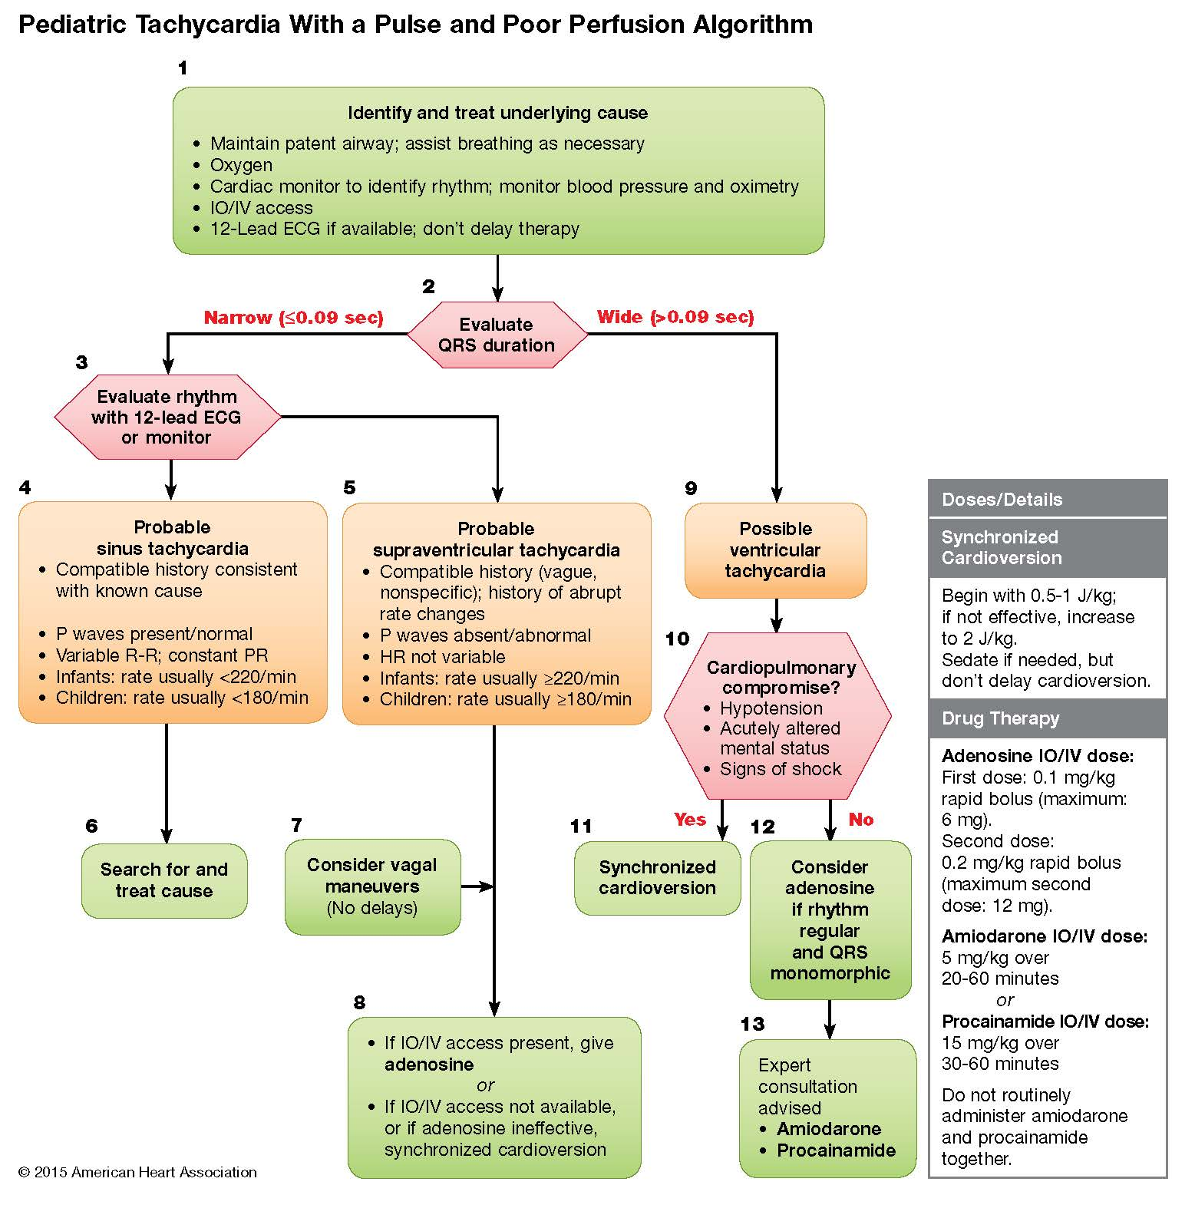
X-RAYS – Click here
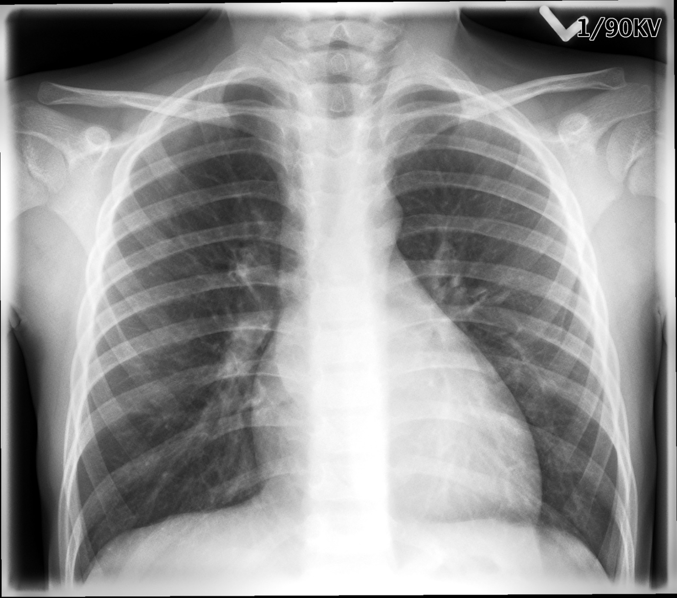

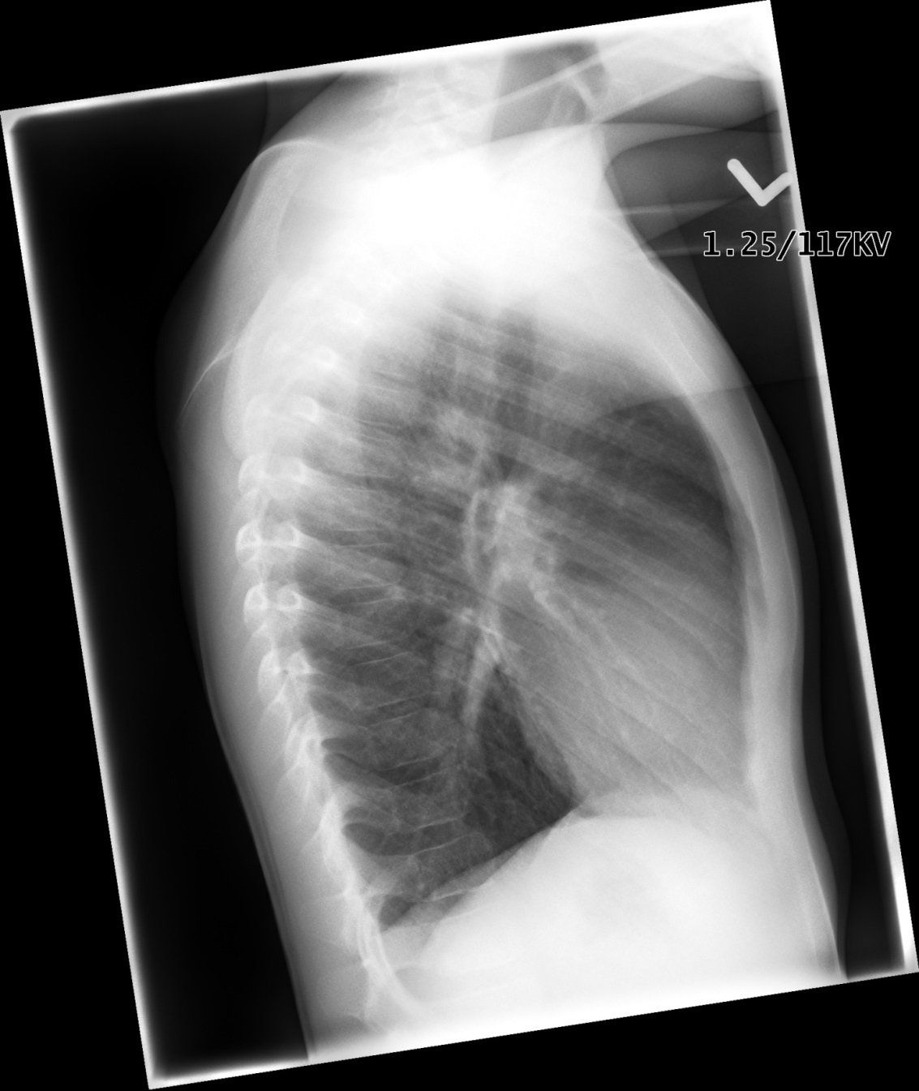

EKGs – click here or paste
