Case Title | PEA - Asystole
Scenario Name | PEA - Asystole

Learning Objectives - Use action words
Knowledge:
- Review the management of PEA and asystole
- Review the ddx of PEA
- Discuss when it is appropriate to stop running a resuscitation
Skills:
- Recognize PEA and asystole
- Recognize the importance of airway management when dealing with cardiac arrythmias
Attitude/Behaviours:
- Demonstrate Team skills
- Demonstrate Situational awareness
- Demonstrate Graded Assertiveness
Scenario Environment
Location | ED
Monitors
Props/Equipment | CXR  EKG  Crash cart
Make-up/Moulage
Potential Distractors

Case Introduction:
5 year old boy. Sudden collapse while running in the park. Bystander called 911. Paramedics arrived, child unconscious and not breathing. Intubated on scene with 5.0 ETT. Pulse weak initially, then absent. CPR x3 min, pulse returned, ? rhythm at time. Sinus rhythm enroute, bagged at 15/min on arrival. Paramedic team unable to obtain IV access

Patient Parameters | Effective Management | Notes
Phase 1: Presentation  Condition: I&V . Unresponsive. Apneic.  Initial Assessment  - Heart Rhythm: SR (PEA)  - HR: 80  - BP: not palpable  - RR: apneic  - SP02: 50% with bagging  - T: 37  - Glucose:  - Chest: poor air entry bilaterally. No chest rise  - CNS: GCS 3  - CVS: faint HS, NO PULSES PALPABLE, cap refill 6 secs  - Weight: 16 kg | - Take a focused history (see notes)  - Patient Assessment (see notes)  - Medical Management  - Give epinephrine 1:10000 : 0.1 cc/kg via IO  - Reassess pulse and rhythm after 2-3 min  - Continue CPR  - Repeat Epinephrine 1:10000 : 0.1 cc/kg  - Emphasize that atropine is NOT an alternative in this case  - Consider alternative diagnosis, 4H’s and 4T’s  - Send bloodwork  Intubation, IO, adrenaline, and defibrillation pad placement with a diagnosis of rhythm all need to have been completed within first 3-5 minutes  A  - Check tube placement with auscultation &/or ETC02 (not reliable min PEA) & CXR  B  - Auscultate chest, identify no air entry, no chest rise  - IDENTIFTY tube not in position  - REMOVE tube and REINTUBATE  - Ensure approp vol and rate of bagging  C  - Monitors on  - IV (3 attempts/max 90 secs) or IO access  - Meds  - CPR compressions 1/3-1/2 AP diam of chest | - Focused history  - Previously healthy  - Running in park  - Witnesses said he fell down, and then was unconscious and turned blue  - Mom called and on the way to hospital  PMHx  - Previously healthy  Meds  - none  Allergies  - none  - Patient Assessment  Airway  - open  - intubated with 5 ETT  Breathing  - No resp effort  - Poor chest movement with bagging  - Identify APNEA  Circulation  - No palpable pulses  - BP not reading  - Faint HS  - Identify PEA
Phase 2: Asystole  Condition: No change  Physical Examination  - Heart Rhythm: Asystole  - RR: Apneic  - SP02: 10% with bagging  - T:37  - CVS: no HS, NO PULSES PALPABLE, cap refill 6 secs  - RESP: clear | - Reassessment of Patient (see notes)  - Medical Management  - Calls ICU for help  - Discusses with team any other options for treatment  A  - Reassess tube often  - Suction tube prn  B  - Auscultates chest  - Looks for chest rise  C  - Repeat epinephrine 1:10000, 0.1 cc/kg  - Considers giving a fluid bolus  - Continues chest compressions and trade off every 2 minutes as per PALS guidelines  - Ensures adequacy of chest compressions by feeling for a pulse during compressions | - Reassessment of Patient  Airway  - Intubated by now (hopefully)  Breathing  - Bagging patient  Circulation  - Checks blood pressure, pulse, cap refill  - Identifies asystole
Phase 1: No Change  Condition: same  Physical Examination  - Heart Rhythm: Asystole  - RR: absent, no effort  - SP02: no pick up  - Chest: air entry with bagging  - CNS: GCS 3, unconscious, unresponsive  - CVS: NO pulses, no HS, cap refill 7 secs | - Reassessment of patient (see notes)  - Medical Management  - Consider SW or other family support  A  - Designated a/w person, protecting tube placement  B  - Continues to bag  C  - Reviews H’s And T’s  - Consider withdrawing care  - Consider having family at bedside during review and discussion regarding likely outcomes | - Reassessment of patient  Airway  - Continues to protect the airway  Breathing  - Reassesses breathing  - Identifies no effort  Circulation  - Identifies Asystole  - Identifies no HS, no pulses, worsening cap refill

Insert more lines if more phases required.

Expected Patient Management | Debriefing Points
- Student

- R1

- Senior IM resident

References:

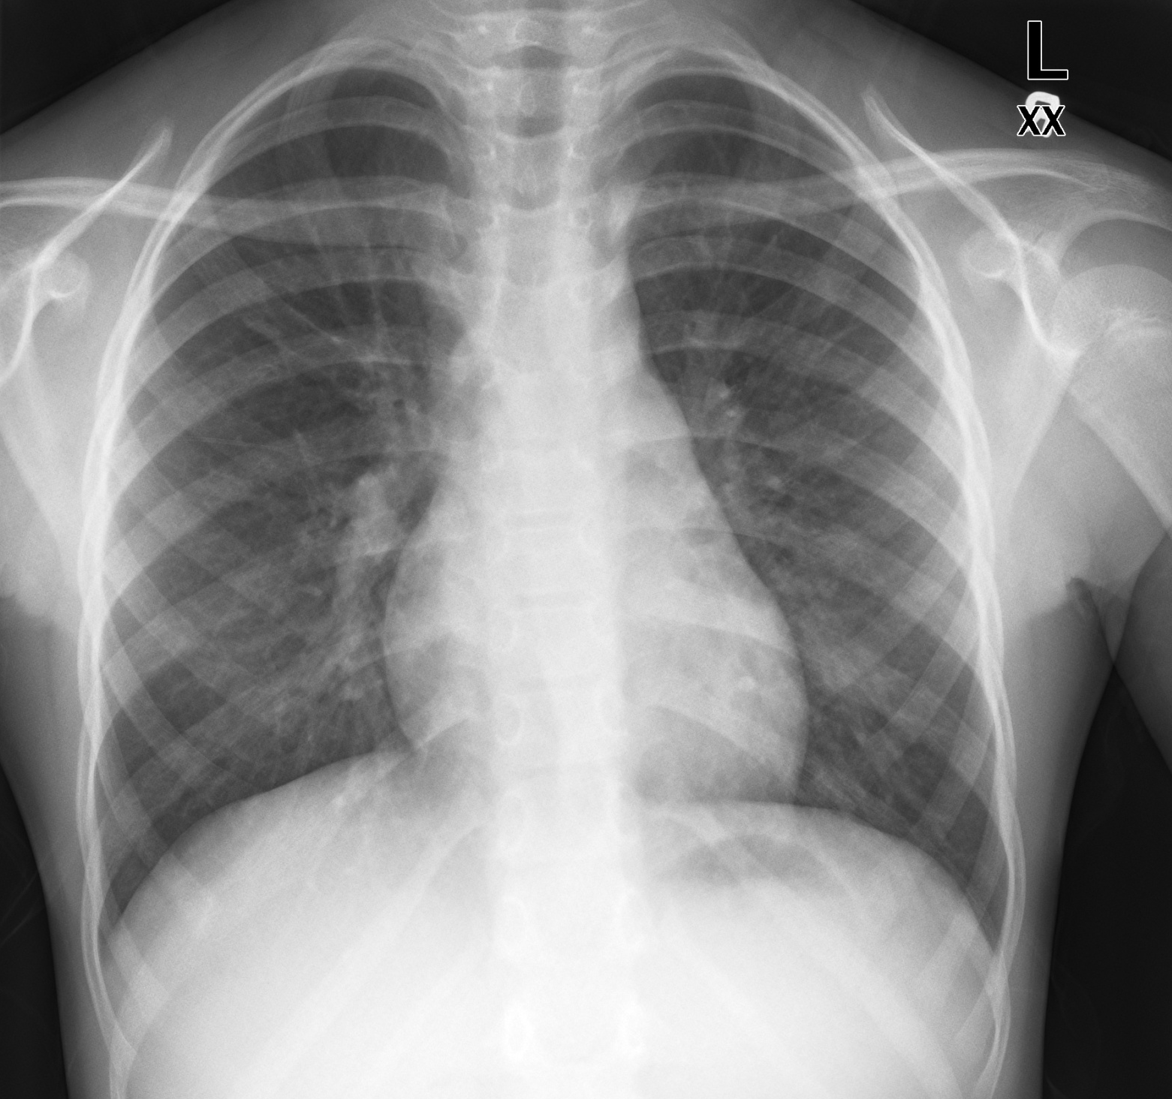
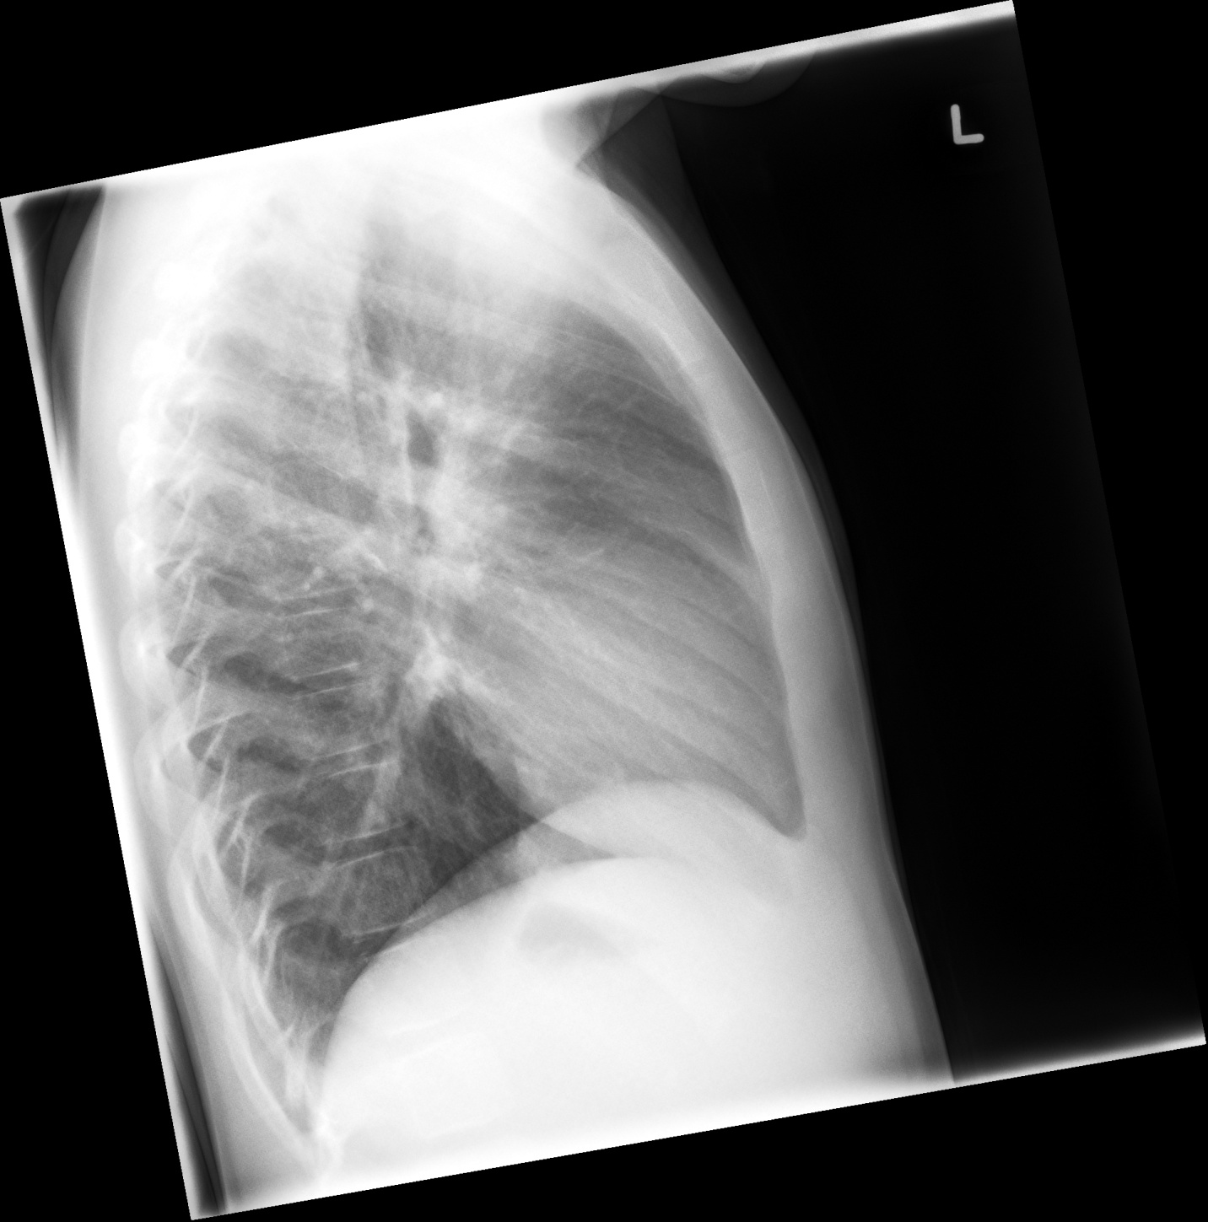
LABS – click here OR fill out below

  MRP: |  | Name:
  FamPhy: |  | Sex: |  |  | Acct:
   |  | DOB: |  |  | MedRec:
   |  | PHN: |  |  | Adm
   |  | Ph: |  |  | Dis:
   |  | Loc: |  |  | Type:
  Laboratory Specimen Report
  SPEC #: | COLL: |  |  | SUBM DR:
  STATUS: | RECD: |  |  | OTHR DR:
  QUERIES:
  Test | Result |  | Flag |  |  | Reference
  CBC
  WBC |  |  |  |  |  | 3.1-9.7 10ˆ9/L
  RBC |  |  |  |  |  | 3.7-5.0 10 ˆ 12/L
  Hgb |  |  |  |  |  | 118-151 g/L
  HCT |  |  |  |  |  | 0.33-1.45 L/L
  MCV |  |  |  |  |  | 84.0-98.0 fL
  MCH |  |  |  |  |  | 28.3-33.5 pg
  MCHC |  |  |  |  |  | 329-352 g/L
  RDW |  |  |  |  |  | 12.0/15.0 %
  Platelets |  |  |  |  |  | 147-375 10 ˆ 9/L
  Manual Diff
  Neuts |  |  |  |  |  | 1.20-6.00 10 ˆ 9/L
  Lymphocytes |  |  |  |  |  | 0.60-3.10 10 ˆ 9/L
  WBC Com
  Toxic Changes
  Morph
  Hypochromia
  Polychromasia
  Microcytosis
  Target Cells
  Plt Estimate
  Plt Morphology
  MRP: |  | Name:
  FamPhy: |  | Sex: |  |  | Acct:
   |  | DOB: |  |  | MedRec:
   |  | PHN: |  |  | Adm
   |  | Ph: |  |  | Dis:
   |  | Loc: |  |  | Type:
  Laboratory Specimen Report
  SPEC #: | COLL: |  |  | SUBM DR:
  STATUS: | RECD: |  |  | OTHR DR:
  QUERIES:
  Test | Result |  | Flag |  |  | Reference
  Na |  |  |  |  |  | 137-145 mmol/L
  K |  |  |  |  |  | 3.5-5.0 mmol/L
  CL |  |  |  |  |  | 98-107 mmol/L
  CO2 |  |  |  |  |  | 22-30 mmol/L
  AGAP |  |  |  |  |  | 5-14 mmol/L
  Lactate
  Glucose Random
  Urea |  |  |  |  |  | 2.5-6.1 mmol/L
  Creat |  |  |  |  |  | 46-92 umol/L
  GFR Est |  |  |  |  |  | >=60mL/min
  Ca
  PO4
  Mg
  Bili Total |  |  |  |  |  | 3-22 umol/L
  Albumin
  CK
  Trop
  Alk Phos |  |  |  |  |  | 38-126 U/L
  AST
  LDH
  GGT
  ALT |  |  |  |  |  | 10-65 U/L
  Lipase
  Ferritin
  Iron
  Ammonia
  TSH
  CHOL
  TRIG
  HDL
  LDL

  MRP: |  | Name:
  FamPhy: |  | Sex: |  |  | Acct:
   |  | DOB: |  |  | MedRec:
   |  | PHN: |  |  | Adm
   |  | Ph: |  |  | Dis:
   |  | Loc: |  |  | Type:
  Laboratory Specimen Report
  SPEC #: | COLL: |  |  | SUBM DR:
  STATUS: | RECD: |  |  | OTHR DR:
  QUERIES:
  Test | Result |  | Flag |  |  | Reference
  BG - Arterial
  pH | 6.80 |  |  |  |  | 7.35-7.45
  pCO2 | 70 |  |  |  |  | 35-45 mmHg
  pO2 | 35 |  |  |  |  | 83-108 mmHg
  BE | -22 |  |  |  |  | -2.0 t0 3.0
  HCO3 | 3 |  |  |  |  | 21-28 mmol/L
  CO Hgb |  |  |  |  |  | < 3.0 %
  Met Hgb |  |  |  |  |  | < 3.0
  Reduced Hgb |  |  |  |  |  | - 5.0 %
  O2 Hgb |  |  |  |  |  | 95.0 – 98.0 %
  O2 Sat |  |  |  |  |  | 95-98 %
  O2 Route
  FiO2
  Na – Whole Blood |  |  |  |  |  | 136-145 mmol/L
  K – Whole Blood |  |  |  |  |  | 3.4-4.5 mmol/L
  Cl – Whole Blood |  |  |  |  |  | 98-107 mmol/L
  Gluc – Whole Blood |  |  |  |  |  | 3.6-11.0 mmol/L
  Lac – Whole Blood |  |  |  |  |  | 0.7-2.1 mmol/L
  Ionaized Ca |  |  |  |  |  | 1.15-1.27 mmol
  Ionized Ca @ |  |  |  |  |  | 1.15 – 1.27 mmol/L
  MRP: |  | Name:
  FamPhy: |  | Sex: |  |  | Acct:
   |  | DOB: |  |  | MedRec:
   |  | PHN: |  |  | Adm
   |  | Ph: |  |  | Dis:
   |  | Loc: |  |  | Type:
  Laboratory Specimen Report
  SPEC #: | COLL: |  |  | SUBM DR:
  STATUS: | RECD: |  |  | OTHR DR:
  QUERIES:
  Test | Result |  | Flag |  |  | Reference
  INR |  |  |  |  |  | 0.8-1.2
  PTT |  |  |  |  |  | 24-40 s
EKGs – click here or paste
