Case Title | Supraventricular Tachycardia
Scenario Name | SVT

Learning Objectives - Use action words
Knowledge:
- Learn proper management of stable and unstable supraventricular tachycardia
- Recognize the importance of airway management when dealing with cardiac arrhythmias
Skills:
- Recognize supraventricular tachycardia
- Differentiate between stable and unstable supraventricular tachycardia
- Learn how to properly use the defibrillator
Attitude/Behaviours:
- Demonstrate Team skills
- Demonstrate Situational awareness
- Demonstrate Graded Assertiveness
Scenario Environment
Location | ED
Monitors
Props/Equipment | CXR  EKG  Crash Cart
Make-up/Moulage
Potential Distractors

Case Introduction:
- 5 year old boy
- Admitted to hospital recently with osteomyelitis
- Had PICC line inserted in left arm for IV antibiotics at home
- Diaphoretic and feeling unwell today
- Taken to the emerg for assessment

Patient Parameters | Effective Management | Notes
Phase 1: Stable SVT  Condition: Looks non toxic but uncomfortable  Initial Assessment  - Heart Rhythm: SVT  - HR: 150-160  - BP: 100/P  - RR: 26  - SP02: 99%  - T: 37 C  - Chest: Clear  - CNS: GCS 15. Awake and alert.  - CVS: soft murmur, cap refill 2 secs, pulses normal  - GI: soft  - Weight:  - Height: | - Take a focused history (see Notes column)  - Medical Management  A  - Optimize airway position  - Prepare airway equipment  B  - Apply monitors  - Have oxygen ready  - Assemble airway equipment & bag/mask at bedside  C  - Monitors (if not done yet)  - 12 lead EKG to confirm diagnosis  - Do CXR to assess PICC line placement  - Vagal maneuvers : blow in straw  - Adenosine 0.1 mg/kg given by rapid saline flush immediately afterwards using double barrel technique  - Reassessment of patient after adenosine is given  - Adenosine 0.2 mg/kg repeat is given by rapid flush  - Consult cardiology | - Focused History  - Discharged from hospital 2 days ago after being admitted for 5 days  - Osetomyelitis of right tibia  - On IV antibiotics at home  - Had PICC line inserted 3 days ago (day prior to discharge)  - No fever  - Unwell today, slept most of the day  - Given tylenol only  - Any previous history of SVT?  Airway  - Talk to the patient  - Open airway  Breathing  - Check oxygen saturation  - Auscultate chest  Circulation  - Check pulse, cap refill, BP  - Identify the rhythm (SVT) and determine that the patient is in stable SVT  - Checks to see if PICC line is flushing  - Insert IV is PICC line not flushing
Phase 2: Unstable SVT  Condition: Looks more unwell and uncomfortable, groaning now, more drowsy  Physical Examination  - Heart Rhythm: SVT  - HR: 150-160  - BP: 70/P  - RR: 26  - SP02: 95%  - T: 37  - Chest: clear  - CNS: Drowsy  - CVS: soft murmur, cap refill 2 secs, pulses weak | - Reassessment of patient (see Notes column)  - Medical Management  - Orders bloodwork : CBC, diff, lytes, gas, lactate  A  - Has suction nearby  - Prepares airway equipment  - Assigns someone to attend to the airway  - calls RT  B  - Applies oxygen  - Prepares bag/mask equipment  C  - Orders medication for sedation : midazolam 0.1 mg/kg with fentanyl 1mcg/kg or ketamine 1mg/kg  - Calls cardiology and ICU for help  - Synchronized cardioversion at 0.5-1 J/kg  - Repeat synchronized cardioversion at 2 J/kg | - Reassessment of patient  Airway  - Maintains the airway : jaw thrust, chin lift, head tilt  Breathing  - Rechecks oxygen saturation  Circulation  - Checks blood pressure, pulse, cap refill  - Identifies Unstable SVT
Phase 3: Unresponsive  Condition: sedated, unresponsive  Physical Examination  - Heart Rhythm: Sinus bradycardia  - HR: 60-70  - BP: 90-100/P  - RR: 26  - SP02: 95%  - T: 37  - CNS: Drowsy  - CVS: soft murmur, cap refill 2 secs, pulses weak  - RESP: Clear | - Reassessment of Patient (see Notes column)  - Medical Management  A  - Designated airway person  B  - Bags patient if needed  C  - Does not do CPR as patient is well perfused now and HR > 60  - 12 lead EKG post Cardioversion | - Reassessment of Patient  Airway  - Continues to protect the airway  Breathing  - Reassesses breathing  - Monitors resp rate  Circulation  - Identifies bradycardia  Reassesses circulation
Phase 4: Sinus Rhythm  Condition: Stabilizing  Physical Examination  - Heart Rhythm: Sinus Rhythm  - HR: 120  - BP: 90-100/P  - RR: 26  - SP02: 95%  - T: 37  - Chest: clear  - CNS: Drowsy  - CVS: soft murmur, cap refill 2 secs, pulses weak | - Reassessment of patient (see Notes column)  - Medical Management  - Reviews blood tests  - Reviews CXR : PICC line in RA  - Reviews 12 lead EKG  - Arranges to have PICC line removed or fixed | - Reassessment of patient  Airway  - Continues to protect the airway  Breathing  - Assesses breathing  - No need to bag patient  Circulation  - Reassesses circulation  - Discovers that BP is normal and HR is normal  - Identifies NSR

Insert more lines if more phases required.

Expected Patient Management | Debriefing Points
- Student

- R1

- Senior IM resident

References:

X-RAYS – Click here
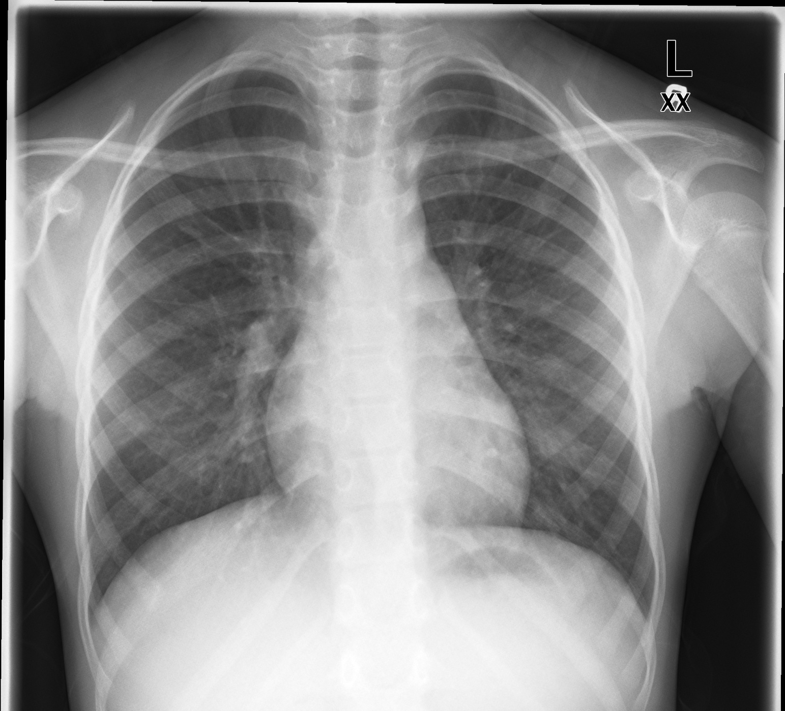
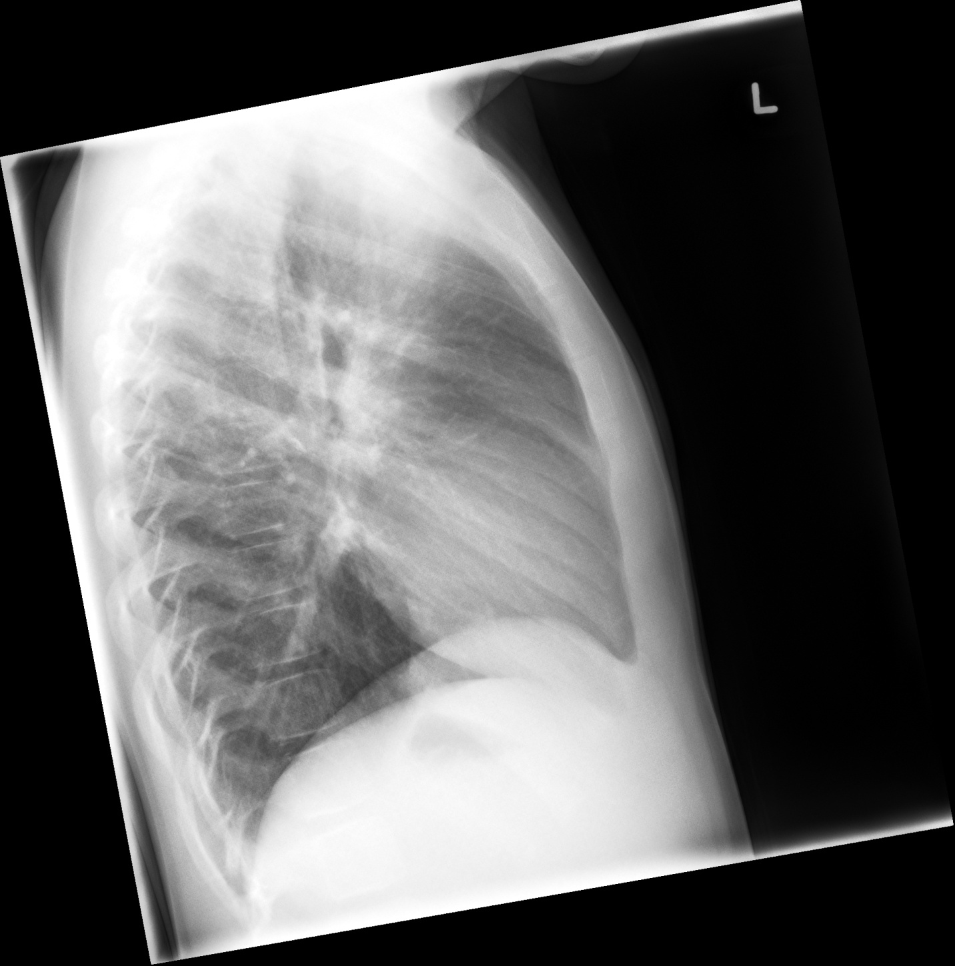

LABS – click here OR fill out below
LABORATORY *LIVE* Lab Summary Report

Test | DATE/TIME here | Flag (H or L) | Reference
CBC
WBC | 14.7 | H | 3.5 – 10.8 10^9/L
Hgb | 130 | L | 130 – 170 g/L
Platelets | 250 |  | 150 – 400 10^9/L
Chemistry
Na | 138 |  | 137 – 145 mmol/L
K | 4.5 |  | 3.5 – 5.0 mmol/L
Cl | 109 |  | 98 – 107 mmol/L
Urea | 3 |  | 2.5 – 6.1 mmol/L
Creat | 30 |  | 62 – 106 umol/L
Glucose - Random | 4.0 |  | 3.0 – 11.0 mmol/L

EKGs – click here or paste
