Case Title | SVT in a Cardiac Patient
Scenario Name

Learning Objectives - Use action words
Knowledge:
- Learn proper management of stable and unstable supraventricular tachycardia
- Recognize the importance of airway management when dealing with cardiac arrhythmias
Skills:
- Recognize supraventricular tachycardia
- Differentiate between stable and unstable supraventricular tachycardia
- Learn how to properly use the defibrillator
Attitude/Behaviours:
- Demonstrate Team skills
- Demonstrate Situational awareness
- Demonstrate Graded Assertiveness
Scenario Environment
Location | ED
Monitors | Cardiac
Props/Equipment | CXR  EKG  Crash Cart
Make-up/Moulage | None
Potential Distractors | None

Case Introduction:
8 year old boy. Unwell with a viral illness recently. SOB and feeling dizzy today. Brought in by BCAS.

Patient Parameters | Effective Management | Notes
Phase 1: Stable SVT  Condition: Looks nontoxic but uncomfortable  Initial Assessment  - Heart Rhythm: SVT  - HR: 200  - BP: 100/60  - RR: 26  - SP02: 99%  - T: 37.8 C  - Chest: Clear  - CNS: GCS 15. Awake and alert.  - CVS: soft murmur, cap refill 2 secs, pulses normal  - GI: soft  - Weight: 20 kg (but should be obtained by Broselow)  - Height: | - Take a focused history (see Notes column)  - Medical Management  Airway  - Optimize airway position  - Prepare airway equipment  Breathing  - Apply monitors  - Have oxygen ready  - Auscultate chest  - Assemble airway equipment & bag/mask at bedside  C  - Monitors (if not done yet)  - Check pulse, cap refill, BP  - Obtains vascular access  - 12 lead EKG to confirm diagnosis  - Vagal maneuvers : blow in straw or syringe  - Adenosine 0.1 mg/kg given by rapid saline flush immediately afterwards using double barrel technique  - Reassessment of patient after adenosine is given  - Adenosine 0.2 mg/kg repeat is given by rapid flush  - Consult pediatrician and cardiology | - Focused History  - Low grade fever, cough, runny nose x 4 days  PMHx  - Past history of Tetralogy of Fallot repair  - Healthy  - Immunization up to date  Meds  - Tylenol last dose last night at 2000  - No scheduled meds  Allergies  - None
Phase 2: Unstable SVT  Condition: Looks more unwell and uncomfortable, groaning now, more drowsy  Physical Examination  - Heart Rhythm: SVT  - HR: 200  - BP: 70/50  - RR: 26  - SP02: 95%  - Chest: clear  - CNS: Drowsy. GCS 14 (eyes open to voice)  - CVS: soft murmur, cap refill 2 secs, pulses weak | - Reassessment of patient (see Notes column)  - Medical Management  - Orders bloodwork : CBC, diff, lytes, gas, lactate  Airway  - Maintains the airway : jaw thrust, chin lift, head tilt  - Has suction nearby  - Prepares airway equipment  - Assigns someone to attend to the airway  - calls RT  Breathing  - Applies oxygen  - Prepares bag/mask equipment  Circulation  - Orders medication for sedation : midazolam 0.1 mg/kg with fentanyl 1mcg/kg or ketamine 1mg/kg  - Calls cardiology and ICU for help  - Synchronized cardioversion at 0.5-1 J/kg  - Repeat synchronized cardioversion at 2 J/kg | - Reassessment of patient  Airway  - Patent, but falling LOC  Breathing  - O2 falling  Circulation  - Hypotensive (low for pt is < SBP 86 mmHg) – to calculate 70 + (2 x age in years)
Phase 3: Sinus Rhythm, Drowsy  Condition: sedated, drowsy but responsive  Physical Examination  - Heart Rhythm: Sinus Rhythm  - HR: 80  - BP: 106/60  - RR: 26  - SP02: 95%  - CNS: Drowsy. GCS 10 (E3, V2- mumbling, M5)  - CVS: soft murmur, cap refill 2 secs, pulses weak  - RESP: Clear | - Reassessment of Patient (see Notes column)  - Medical Management  Airway  - Designated airway person  - Continues to protect airway  Breathing  - Bags patient if needed  Circulation  - 12 lead EKG post Cardioversion | - Reassessment of Patient  Airway  - Patent  Breathing  - Adequate  Circulation  - Bradycardia, but adequate perfusion (normal for pt is SBP 106 mmHg) – to calculate 90 + (2 x age in years)
Phase 4: Sinus Rhythm  Condition: Stabilizing  Physical Examination  - Heart Rhythm: Sinus Rhythm  - HR: 120  - BP: 110/60  - RR: 26  - SP02: 97%  - Chest: clear  - CNS: More alert. GCS 13 (E3, V4 – disoriented, M5)  - CVS: soft murmur, cap refill 2 secs, pulses weak | - Reassessment of patient (see Notes column)  - Medical Management  - Reviews blood tests  - Reviews 12 lead EKG | - Reassessment of patient  Airway  - Patent  Breathing  - Adequate  Circulation  - NSR with good BP

Insert more lines if more phases required.

Expected Patient Management | Debriefing Points
- Student

- Junior Resident

- Senior Resident

References:

X-RAYS
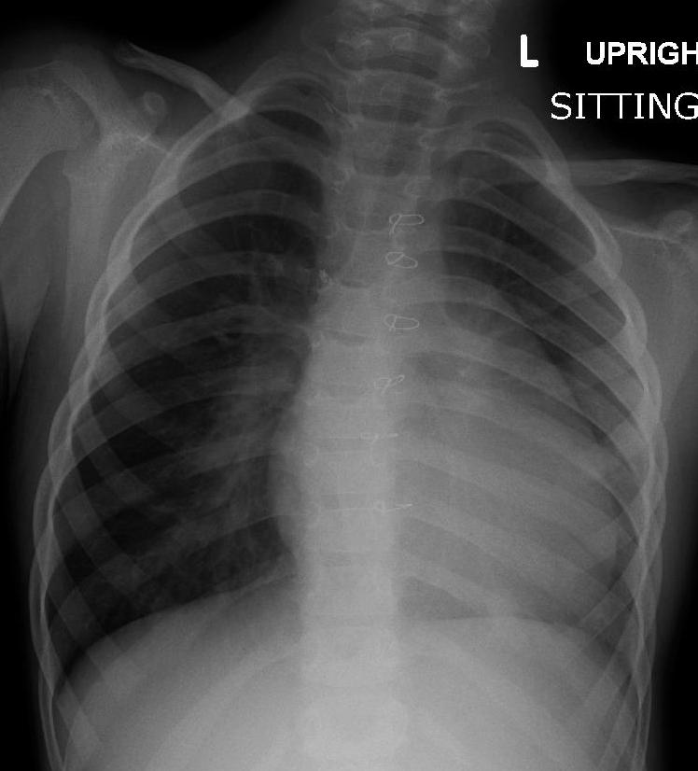

LABS – click here OR fill out below
LABORATORY *LIVE* Lab Summary Report

Test | DATE/TIME here | Flag (H or L) | Reference
CBC
WBC | 14.7 | H | 3.5 – 10.8 10^9/L
Hgb | 130 | L | 130 – 170 g/L
Platelets | 250 |  | 150 – 400 10^9/L
Chemistry
Na | 138 |  | 137 – 145 mmol/L
K | 4.5 |  | 3.5 – 5.0 mmol/L
Cl | 109 |  | 98 – 107 mmol/L
Urea | 3 |  | 2.5 – 6.1 mmol/L
Creat | 30 |  | 62 – 106 umol/L
Glucose - Random | 4.0 |  | 3.0 – 11.0 mmol/L

EKGs – click here or paste
