Section 1: Case Summary

Scenario Title: | COVID- MIS-C
Keywords:
Brief Description of Case: | 14 year old female presents to ED with 48 hrs of vomiting, and diarrhea

Goals and Objectives
Educational Goal: | - Recognition of possible MIS-C  - Management of MIS-C
Objectives:  (Medical and CRM) | - Recognition of a critically ill child and call for help early  - Anticipate and Plan  - Mobilize Resources

Learners, Setting and Personnel
Target Learners: | ☒ Junior Learners |  | ☒ Senior Learners |  |  | ☐ Staff
Target Learners: | ☒ Physicians | ☒ Nurses |  | ☒ RTs | ☒ Inter-professional
Target Learners: | ☐ Other Learners:
Location: | ☐ Sim Lab |  | ☒ In Situ |  |  | ☐ Other:
Recommended Number of Facilitators: | Instructors:
Recommended Number of Facilitators: | Confederates:
Recommended Number of Facilitators: | Sim Techs:

Scenario Development
Date of Development: | June 30th/ 2020
Scenario Developer(s): | Dr. Alysha Mackenzie-Feder
Affiliations/Institutions(s): | Pediatrician
Contact E-mail: | Alysha.Mackenzie-feder@interiorhealth.ca
Last Revision Date:
Revised By:
Version Number:

Section 2A: Initial Patient Information

- Patient Chart
Patient Name: Anna K |  |  |  | Age: 14 | Gender: F | Weight: 44 kg
Presenting complaint: Fever/Nausea/Vomiting
Temp: 37.5 | HR: 130 | BP: 70/30 |  | RR: 12 and shallow | O₂Sat: 98% | FiO₂: RA
Cap glucose: 5.2 |  |  |  | GCS: (E V M ) Alert
Triage note:
14 year old female with fever, vomiting, and diarrhea for 48 hours. Recent history of fall from bike with multiple abrasions to shins and arms. Previously well. No know sick contacts or COVID contacts. Patient ate a burger at a BBQ 2 days ago. Mother also complaining of GI symptoms.

Allergies: NKA
Past Medical History:  Previously healthy  Fully Vaccinated |  |  | Current Medications:  No meds

Section 2B: Extra Patient Information

A. Further History
Include any relevant history not included in triage note above. What information will only be given to learners if they ask? Who will provide this information (mannequin’s voice, confederate, SP, etc.)?

B. Physical Exam
List any pertinent positive and negative findings
Cardio: Sinus Rhythm; hypotensive | Neuro: Alert ; GCS 15
Resp: 12 and shallow breathing | Head & Neck: Dry Mucus Membranes
Abdo: Tender diffusely, | MSK/skin: Superficial Abrasions to shins and left elbow
Other:

Section 3: Technical Requirements/Room Vision

A. Patient
☒ Mannequin High Fidelity Sim Junior
☐ Standardized Patient
☐ Task Trainer
☐ Hybrid
B. Special Equipment Required
Cardiopulmonary monitor
Nasal prong
Optiflow/airvo
IV Access
Broselow tape
Bedside ultrasound
Glucometer

C. Required Medications
NS for fluid boluses
D5 NS
Epinephrine
Clindamycin
Ceftriaxone

D. Moulage
None

E. Monitors at Case Onset
☐ Patient on monitor with vitals displayed
☒ Patient not yet on monitor
F. Patient Reactions and Exam
Include any relevant physical exam findings that require mannequin programming or cues from patient
(e.g. – abnormal breath sounds, moaning when RUQ palpated, etc.) May be helpful to frame in ABCDE format.

Alter, speaking in sentences, appears tired. Moaning and painful with palpation of abdomen.

Section 4: Confederates and Standardized Patients

Confederate and Standardized Patient Roles and Scripts
Role | Description of role, expected behavior, and key moments to intervene/prompt learners. Include any script required (including conveying patient information if patient is unable)

Section 5: Scenario Progression

Scenario States, Modifiers and Triggers
Patient State/Vitals | Patient Status | Learner Actions, Modifiers & Triggers to Move to Next State |  | Facilitator Notes
1. Baseline State  Rhythm: Sinus  HR: 130  BP: 70/30  RR: 12 (shallow)  O₂SAT: 98%  T: 37.5 º C  GCS: 15 | Alert  Appears Tired | Expected Learner Actions  IV access  Broselow tape to estimate weight  Fluid bolus 20ml/kg NS  Check Glucose | Modifiers  Changes to patient condition based on learner action  -Decreasing LOC if low BP not noted  -  Triggers  For progression to next state  - Bolus given  -
2. Hypotension  Heart Rhythm: Sinus  HR: 130  BP: 75/40  RR: 12 Shallow  Spo2: 97%  Rash noted on torso | Alert  Appears Tired  Rash noted on Torso when exposed | Expected Learner Actions  Second fluid bolus 20ml/kg NS  Lab work  Start second IV  Call Peds | Modifiers  - Increasing HR if second bolus not given  -  -  Triggers  - Bolus and repeat BP  -
3. Hypotension  Heart Rhythm: Sinus  HR: 120  BP: 75/40  RR: 12 and shallow  SpO2: 90% |  | Expected Learner Actions  Third fluid bolus 20ml/kg NS  If not done send cardiac enzymes  Bedside ECHO  O2 by Nasal Prong  Consider TELE PICU  Lab Calls with initial results | Modifiers  - Work of breathing if low sats not noted  -  -  Triggers  - Persistent Hypotension  - | Put Labs up on screen
4.Refractory Hypotension  Heart Rhythm: Sinus  HR: 150  BP: 70/35  RR: 10, shallow  SpO2: 88-90% |  | Expected Learner Actions  Start Epinephrine 0.1-0.7 mcg/kg/min  Add clindamycin  Start HiFlo  Request Central access/Artline  Call PTN/PICU to initiate transfer | Modifiers  -  -  -  Triggers  -  -
5, Stabilization  Heat Rhythm: Sinus  HR: 120  BP: 80/50  RR: 12  SpO2: 94% |  | Expected Leaner Actions:  Run D5NS at maintenance  Titrate Epi  Chest X-ray  Lab calls: CPR 300, Troponin 40, BNP 2000

Appendix A: Laboratory Results

CBC  WBC 16  Hgb 110  Plt 90  Lytes  Na 140  K 4.5  Cl 110  HCO₃ 14  AG  Urea 10  Cr 370  Glucose 4.5  Extended Lytes NOT DONE  Ca  Mg  PO₄  Albumin  TSH  VBG  pH 7.23  pCO₂ 40  pO₂ 30  HCO₃ 12  Lactate 5 | Cardiac/Coags  Trop 40  D-dimer 1000  INR 1.4  aPTT 37  Biliary- NORMAL PANEL  AST  ALT  GGT  ALP  Bili  Lipase  Tox NOT DONE  EtOH  ASA  Tylenol  Dig level  Osmols  Other  B-HCG: Negative

Appendix B: ECGs, X-rays, Ultrasounds and Pictures

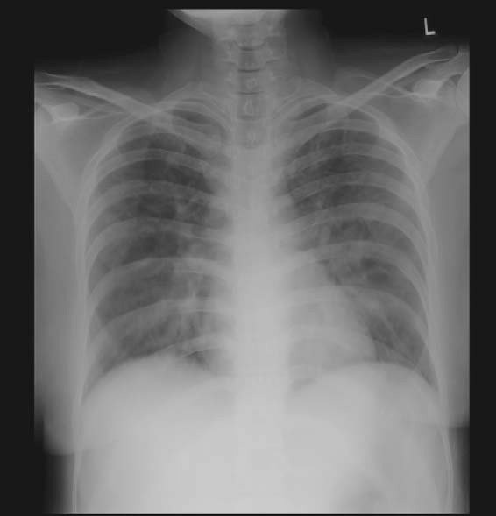

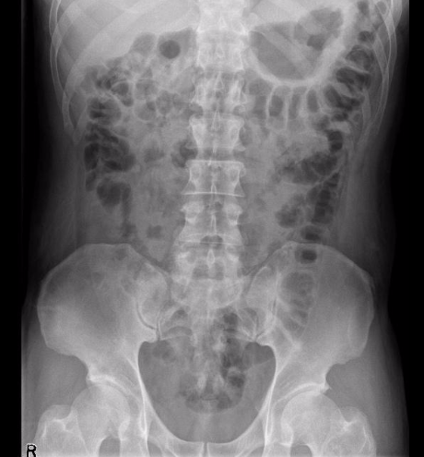

Appendix C: Facilitator Cheat Sheet & Debriefing Tips

Include key errors to watch for and common challenges with the case. List issues expected to be part of the debriefing discussion. Supplemental information regarding any relevant pathophysiology, guidelines, or management information that may be reviewed during debriefing should be provided for facilitators to have as a reference.

References

1. http://www.bccdc.ca/Health-Professionals-Site/Documents/COVID19_MIS-C_ClinicianGuidance.pdf

2. Hyperinflammatory shock in children during COVID-19 pandemic; Published Online
May 6, 2020https://doi.org/10.1016/S0140-6736(20)31094-1
3.

