Case Title | Encephalitis
Scenario Name | Decreased LOC

Learning Objectives - Use action words
Knowledge:
- Describe the investigations required to workup altered LOC
- Describe the management of altered LOC
- Discuss rapid sequence intubation

Skills:
- Deomontrate management of altered LOC
- Demonstrated RSI
Attitude/Behaviours:
- Demonstrate Team skills
- Demonstrate Situational awareness
- Demonstrate Graded Assertiveness
Scenario Environment
Location | ED
Monitors | Bedside monitor
Props/Equipment | Intubation equipment  IV supplies and meds
Make-up/Moulage
Potential Distractors | Concerned parents

Case Introduction:
8 year old boy presented to ER via ambulance post seizure - accompanied by parents. Awakened from nap this afternoon confused and disoriented. Was playing at a friend’s house all afternoon; complained of headache, felt hot when he got home. Went to bed – parents checked on him and found him seizing. Called 911.

Patient Parameters | Effective Management | Notes
Phase 1: Initial Assessment  Condition: Drowsy, confused, disorientated.  Initial Assessment  - Heart Rhythm: ST  - HR: 140  - BP: 110/P  - RR: 25  - SP02: 99% RA  - T: 38.5  - CNS: awake but drowsy and confused, pupils normal  - Chest:  - CVS: normal HS, cap refill 2 secs, pulses strong  - Weight: 25 kg | - Take a focused history (see Notes column)  - Medical Management  - Identifies altered LOC  - Checks blood sugar – 2.9  - Open Airway – head tilt, chin lift, jaw thrust  - Apply monitors – obtain VS  - Insert IV x2  - Orders bloodwork : CBC, lytes, gas, lactate, renal function, coags , blood culture  - Discuss need to LP vs. CT  - Drug/tox screen  - Ceftriaxone /vancomycin/acyclovir | - Focused history  PMHx  - Previously healthy  - Fully immunized  - No prior seizures  Meds  - Nil  Allergies  - NKA
Phase 2: Decreased LOC  Condition: Drowsy. Very difficult to arouse.  Physical Examination  - Heart Rhythm: ST  - HR: 140  - BP: 110/P  - RR: 25  - SP02: 97% RA  - T: 38.5  - CNS: GCS 7. Difficult to arouse  - Chest: poor a/e bilaterally  - CVS: normal HS, cap refill 2 secs, pulses strong | - Patient Reassessment (see Notes column)  - Medical Management  - Review labs  Airway  - Maintains the airway : jaw thrust, chin lift, head tilt  - Prepares for and Intubates (see notes)  - Orders CXR  Breathing  - Reassess  - Identify airway risk due to decreased LOC  Circulation  - Cycles BP q 3-5 min | - Patient Reassessment  Airway  - Compromised  Breathing  - Decreased a/e bilaterally  Circulation  - Present  Intubation  - Preoxygenation  - Premedication :optional  - Cricoid pressure  - Sedation : etomidate 0.3 mg/kg or ketamine 1 mg/kg  - Paralysis : succs 2 mg/kg  - Check tube placement
Phase 3: Seizures  Condition: Seizing and desaturation  Physical Examination  - Heart Rhythm: ST  - HR: 160  - BP: 90/P  - RR: 12  - SP02: 89%  - T: 39.5  - Glucose:  - CNS: GCS 7  - Chest: poor A/E bilat  - CVS: normal HS, cap refill 3 secs, pulses weak | - Patient Reassessment (see Notes column)  - Medical Management  - Calls ICU  - Gives Ativan 0.1 mg/kg and orders dilantin 20mg/kg IV  A  - Goes through the DOPE pneumonic  B  - Starts to bag ventilate the patient  C  - Give IV bolus 20cc/kg NS | - Patient Reassessment  Airway  - Airway protected (intubation)  Breathing  - Poor oxygenation  Circulation  - Hypotension

Insert more lines if more phases required.

Expected Patient Management | Debriefing Points
- Student

- R1

- Senior IM resident

References:

X-RAYS – Click here

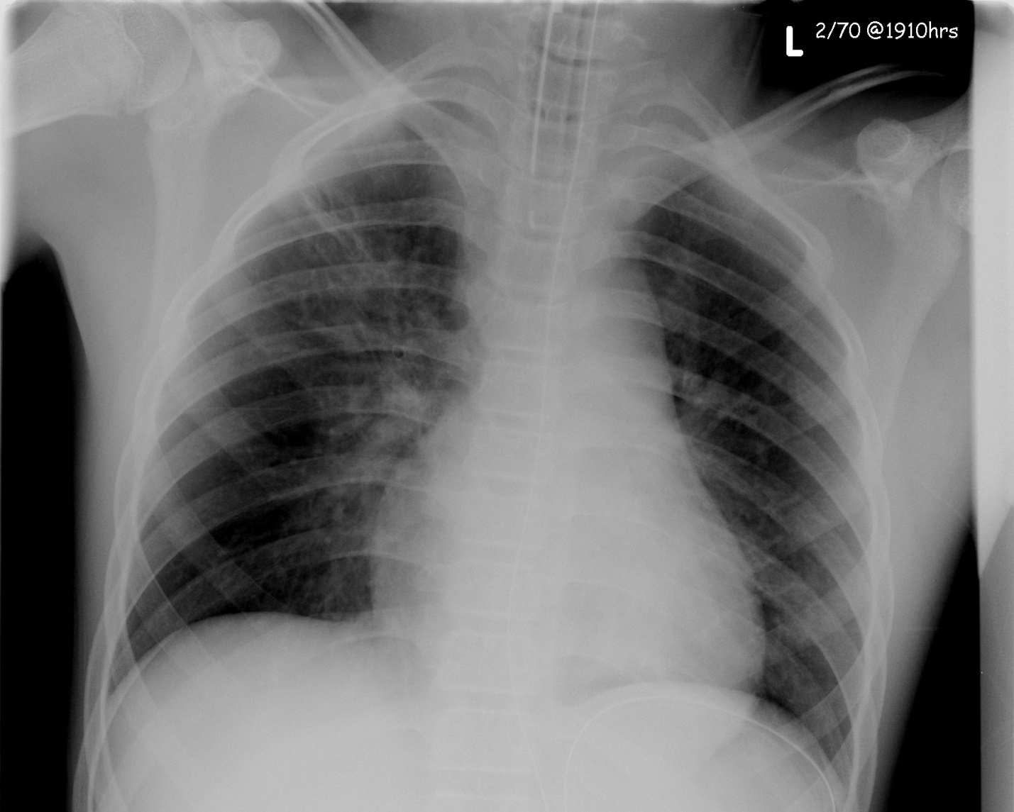

LABS – click here OR fill out below

LABORATORY *LIVE* Lab Summary Report

Test | Phase 2 | Flag (H or L) | Reference
CBC
WBC | 25 | H | 3.5 – 10.8 10^9/L
Neutrophils | 18.3
Chemistry
Na | 135 | L | 137 – 145 mmol/L
K | 4.5 |  | 3.5 – 5.0 mmol/L
Cl | 109 |  | 98 – 107 mmol/L
Urea | 6.4 | H | 2.5 – 6.1 mmol/L
Creat | 24 | L | 62 – 106 umol/L
Glucose - Random | 2.6 | L | 3.0 – 11.0 mmol/L
ABGs
Arterial
pH | 7.38 |  | 7.35- 7.45
pCO2 | 45 |  | 35 – 45 mmHg
PO2 | 90 |  | 80-100 mmHg
BE | -2 |  | -2.0 to +2.0 mmol/L
HCO3 | 23 |  | 22 – 26 mmol/L
O2 Sat |  |  | 95 – 100%

