Case Title | Intracranial Bleed
Scenario Name | Intubated with Increased Intracranial Bleed

Learning Objectives - Use action words
Knowledge:
- Goal audience: PEM fellows/staff, senior pediatric residents, transport physicians/ITT, Community EM Physicians
- Develop some familiarity with the ventilator and practice making setting adjustments
- Discussion of neuroprotective strategies for intubation and sedation

Skills:
- Initiate ventilator parameters for a child with respiratory failure due to increased intracranial pressure (normal lung parenchyma)
- Adjust ventilation to allow for moderate hyperventilation

Attitude/Behaviours:
- Demonstrate Team skills
- Demonstrate Situational awareness
- Demonstrate Graded Assertiveness
Scenario Environment
Location | Emergency Department
Monitors | Cardiac, BP, pulse oximeter
Props/Equipment | Ventilator  CT scans of ruptured AVM  CXR of well placed ETT
Make-up/Moulage | None
Potential Distractors | None

Case Introduction:
11y.o. previously well boy. Had sudden onset headache this am, vomited x2, progressive obtundation over past 20 minutes. No visible signs of trauma. No movement left arm or left leg. Pupils right: 5mm left: 3mm.

Patient Parameters | Effective Management | Notes
Phase 1: Obtunded  Condition: No visible signs of trauma. No movement left arm or left leg. Pupils right: 5mm left: 3mm.  Initial Assessment  - Heart Rhythm: Sinus Bradycardia  - HR: 34  - BP: 115/65  - RR: 10 with periodic apnea  - SP02: 92-100% with O2  - T: 36.6 C  - CNS: GCS 7 (E1, V2, M4)  - Chest: chest clear (upper airway obstruction)  - CVS: Cap refill 3 secs  - GI: Abd soft  - Weight: 35 kg | - Take a focused history (see Notes column)  - Medical Management  - Recognize Cushing Triad with impending herniation  - Open airway (positioning) and assist ventilation  - Intubate using neuroprotective strategy  - Sedation and paralysis  - Maintain BP (avoid hypotension)  - Midline head midline  - HOB at 30 degrees  - Maintain sedation post intubation (midaz or morphine or fentanyl etc)  - Mild hyperventilation to etCO2 30-35  - Ensure tube placement quickly and transfer to CT scan  - Mannitol (1 gram/kg) or hypertonic saline  - Involve neurosurgery early  - Hand ventilation for CT Scan or start on Mechanical Ventilation  - Ensure in-line CO2 monitor in place | - Focused history  - As above  PMHx  - Healthy  - Immunization up to date  Meds  - None  Allergies  - NKDA
Phase 2: Slight Improvement on Ventilator  Condition: Initial set up of ventilator while awaiting neurosurgery. Patient improves clinically with hyperventilation and Mannitol. Ventilator arrives in ER  Physical Examination  - Heart Rhythm: NSR  - HR: 73  - BP: 103/60  - RR: Sedated and ventilated  - SP02: 100% with BVM and ventilator  - T: 36.6  - CNS: Sedated. Pupils: R-4, L-4. No movement LUE. Upgoing Babinski LLE.  - CVS: HR improving | - Patient Reassessment (see Notes column)  - Medical Management  - Set-up Ventilator and program initial settings  - Suggestions for parameters:  - Rate: 25  - TV: 8/kg = 280cc  - Peep: 5 PIP: 25 and wean quickly  - FIO2: start at 100% and wean down quickly to room air  - Titrate parameters to:  - Chest rise, etCO2 (goal 30-35)  - 1st cap gas: 7.31/36/-/22/-2 | - Patient Reassessment  Airway  - Intubated  Breathing  - Ventilated  Circulation  - Improved pulse
Phase 3: Transfer to OR  Condition: Increasing CO₂ on the capillary gas: 7.23/49/-21/-3. Transfer patient to OR  Physical Examination  - Heart Rhythm: NSR  - HR: 62  - BP: 107/65  - RR: ventilated  - SP02: 100% on 21% (or whatever is used)  - T: 36.6 C  - CNS: Sedated | - Patient Reassessment (see Notes column)  - Medical Management  - Ensure no equipment problem:  - Good air entry and chest rise bilaterally  - No extra tubing being used  - Tube is not dislodged  - No secretions to suction  - Increase tidal volume (strategy based on mode of ventilation)  - Increase respiratory rate  - Decrease I-time (decrease I:E ratio)  - Increasing CO₂ on the capillary gas: 7.23/49/-21/-3.  - Transfer patient to OR | - Patient Reassessment  Airway  - Intubated  Breathing  - Ventilated  Circulation  - Improved pulse

Insert more lines if more phases required.

Expected Patient Management | Debriefing Points
- Student  - R1  - Senior IM resident | - Discussion points:Increasing tidal volume vs increasing respiratory rate on decreasing CO2

References:
X-RAYS

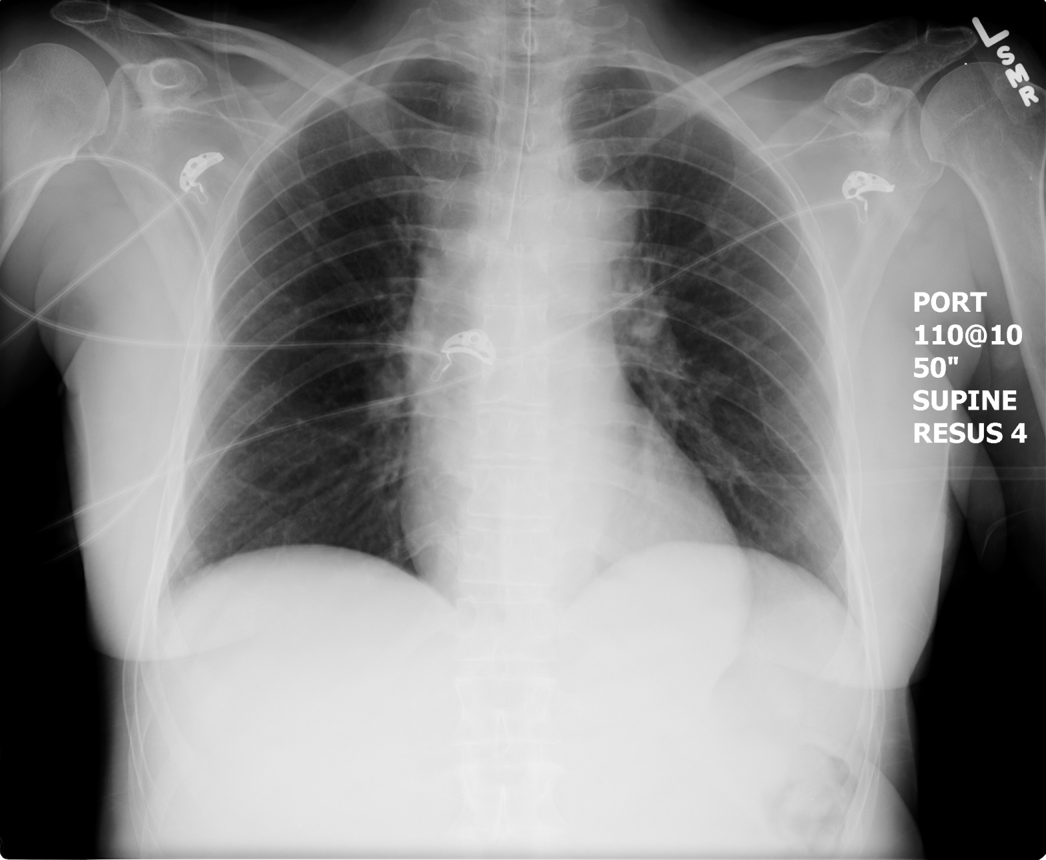

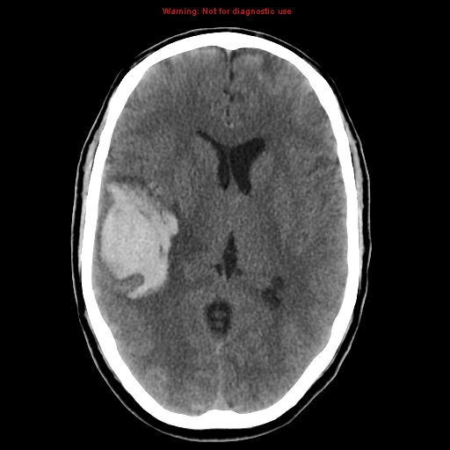
LABS – click here OR fill out below
LABORATORY *LIVE* Lab Summary Report

Test | DATE/TIME here | Flag (H or L) | Reference
CBC
WBC |  |  | 3.5 – 10.8 10^9/L
RBC |  |  | 4.3 – 5.7 10^12/L
Hgb |  |  | 130 – 170 g/L
HCT |  |  | 0.37 – 0.47 L/L
Platelets |  |  | 150 – 400 10^9/L
Chemistry
Na |  |  | 137 – 145 mmol/L
K |  |  | 3.5 – 5.0 mmol/L
Cl |  |  | 98 – 107 mmol/L
HCO3 |  |  | 22-26 mmol/L
Urea |  |  | 2.5 – 6.1 mmol/L
Creat |  |  | 62 – 106 umol/L
GFR Est |  |  | > 60 ml/min
Glucose - Random |  |  | 3.0 – 11.0 mmol/L
Lactate |  |  | 0.9 – 1.8 mmol/L
CK |  |  | 5 – 130 U/L
Troponin |  |  | <0.03 mcg/L
Coags
INR |  |  | 0.9 – 1.2
PTT |  |  | 28 – 38 s
VBGs- 1st cap gas
Venous
pH | 7.31 | L | 7.35- 7.45
pCO2 | 36 | H | 35 – 45 mmHg
PO2 | 80 |  | 80-100 mmHg
BE | -2 |  | -2.0 to +2.0 mmol/L
HCO3 | 22 |  | 22 – 26 mmol/L
O2 Sat |  |  | 95 – 100%

VBGs- 2nd cap gas
Venous
pH | 7.23 | L | 7.35- 7.45
pCO2 | 49 | H | 35 – 45 mmHg
PO2 | 90 |  | 80-100 mmHg
BE | -3 | L | -2.0 to +2.0 mmol/L
HCO3 | 21 | L | 22 – 26 mmol/L
O2 Sat |  |  | 95 – 100%

