Case Title | Status Epilepticus
Scenario Name | Status Epilepticus

Learning Objectives - Use action words
Knowledge:
- Review the management of status epilepticus
- Understand the complications associated with the treatment of status epilepticus
- Review rapid sequence intubation for a seizing patient
Skills:
- Demonstrate seizure management
- Demonstrate airway management
Attitude/Behaviours:
- Demonstrate Team skills
- Demonstrate Situational awareness
- Demonstrate Graded Assertiveness
Scenario Environment
Location | ED
Monitors | Bedside
Props/Equipment | Intubation equipment  IV equipment/infusions
Make-up/Moulage
Potential Distractors

Case Introduction:
4 year old boy who has had a fever x3 days. Headache and neck pain x2 days. Irritable today and found unconscious at home on the floor. Paramedics bringing child to the emergency. Seizing enroute x5minutes.

Patient Parameters | Effective Management | Notes
Phase 1: Seizing on arrival  Condition: seizing  Initial Assessment  - Heart Rhythm: ST  - HR: 160  - BP: 110/P  - RR: 25  - SP02: 92% RA  - T: 39.5  - CNS: Generalized seizures  - Chest: Clear. Poor a/e bilat  - CVS: Normal  - Weight: 15 kg | - Take a focused history (see Notes column)  - Medical Management  - Open airway (tilt, lift, thrust), suction if needed  - Check O2 – apply O2 by face mask  - Apply monitors – check VS  - Call RT for help. Assign someone to airway  - How is the patient positioned: on back vs. side  - Initiate IV x2  - Checks blood sugar :: 5.0  - Gives ativan pr, then ativan IV x 2  - Orders phenobarb or dilantin 20mg/kg and gives it  - Orders bloodwork : CBC, lytes, gas, lactate, renal function, coags , blood culture  - Ceftriaxone /vancomycin/acyclovir | - Focused history  PMHx  - Healthy – no prior seizures  - Fully Immunized  Meds  - Nil  Allergies  - NKA
Phase 2: Desaturation  Condition: actively seizing patient, vomiting profusely and frothing at the mouth, de-saturates  Physical Examination  - Heart Rhythm: ST  - HR: 160  - BP: 110/P  - RR: 25  - SP02: 85% O2 by face mask  - T: 39.5  - CNS: seizing  - CVS: Normal | - Patient Reassessment (see Notes column)  - Medical Management  - Review labs  Airway  - Maintains the airway : jaw thrust, chin lift, head tilt  - Suction vigorously  - Think about intubation and prepares equipment  Breathing  - May decide to use anesthesia bag at this point  - Prepares bag/mask equipment  Circulation  - Checks HR, BP, cap refill, pulses  - Cycles BP q3-5 min | - Patient Reassessment  Airway  - Desaturation  - Frothing at mouth  - Vomit in airway  Breathing  - Risk for deterioration  Circulation  - Present
Phase 3: Hypotension  Condition: actively seizing, BP falling after phenoarb/Dilantin infusion goes through, RR starts to drop  Physical Examination  - Heart Rhythm: ST  - HR: 160  - BP: 70/P  - RR: 12  - SP02: 89% O2 by face mask  - T: 39.5  - CNS: seizing  - Chest: poor a/e bilat  - CVS: pulses weak | - Patient Reassessment (see Notes column)  - Medical Management  - Calls ICU  - Starts second infusion of dilantin (if gave Phenobarb previously) or Phenobarbital (if given dilantin previously)  Airway  - Intubate  - Preoxygenation  - Premedication  - Cricoid pressure  - Sedation : etomidate 0.3 mg/kg or midazolam 0.1 mg/kg and fentanyl 1mcg/kg  - Paralysis : succs 2 mg/kg  - Check tube placement (CO2/CXR)  Breathing  - Reassesses breathing  - Bag ventilate the patient  Circulation  - Identifies hypoxia and worsening hypotension  - Gives IV NS bolus 20 cc/kg  - Draws up more NS to give after first bolus | - Patient Reassessment  Airway  - Compromised  - Desaturation  Breathing  - Tiring. RR falling  Circulation  - Hypotension  - Weak pulses
Phase 4: SpO2 improves  Condition: actively seizing, blood pressure still low, but sats, improved after intubation  Physical Examination  - Heart Rhythm: ST  - HR: 160  - BP: 70/P  - RR: 12  - SP02: 95% intubated  - T: 39.5  - CNS: Seizing  - Chest: TUAS, poor A/E bilat | - Patient Reassessment (see Notes column)  - Medical Management  - Priority – Hypotension  - Gives IV NS bolus 20cc/kg – prepare for second bolus if needed  - Calls ICU  - Paraldehyde PR  - Midaz infusion @ 1 mcg/kg/min  - Prepare transfer to ICU | - Patient Reassessment  Airway  - Correct placement of ET-tube  Breathing  - Manual bag ventilation  Circulation  - Worsening hypotension

Insert more lines if more phases required.

Expected Patient Management | Debriefing Points
- Student

- R1

- Senior IM resident

References:

X-RAYS – Click here

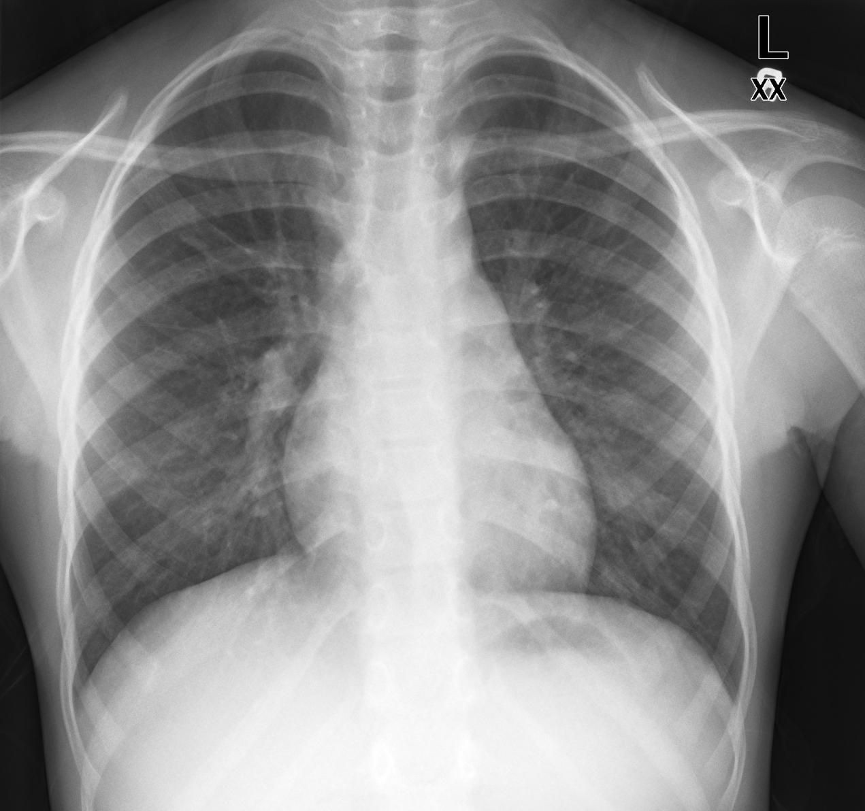

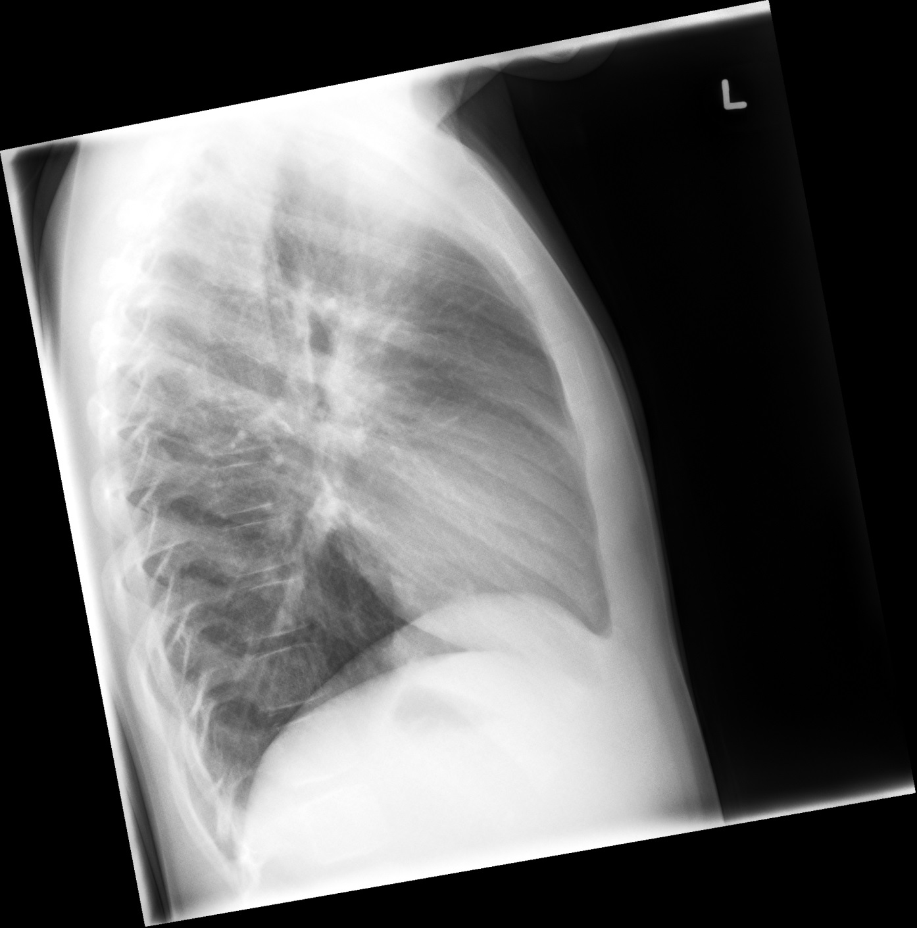

LABS – click here OR fill out below

LABORATORY *LIVE* Lab Summary Report

Test | Phase 2 | Flag (H or L) | Reference
CBC
WBC | 27 | H | 3.5 – 10.8 10^9/L
Hgb | 124 | L | 130 – 170 g/L
Platelets | 310 |  | 150 – 400 10^9/L
Chemistry
Na | 130 | L | 137 – 145 mmol/L
K | 3.5 |  | 3.5 – 5.0 mmol/L
Cl | 109 |  | 98 – 107 mmol/L
Urea | 3.4 |  | 2.5 – 6.1 mmol/L
Glucose - Random | 5.0 |  | 3.0 – 11.0 mmol/L
ABGs
Arterial
pH | 7.15 | L | 7.35- 7.45
pCO2 | 60 | H | 35 – 45 mmHg
PO2 | 90 |  | 80-100 mmHg
BE | -8 |  | -2.0 to +2.0 mmol/L
HCO3 | 26 |  | 22 – 26 mmol/L

