Case Title | Anaphylactic Shock
Scenario Name | Anaphylactic Shock

Learning Objectives (3 or more) - Use action words
Knowledge:
- Recognize anaphylactic shock
- Understand clinical course of anaphylactic shock
- Learn management of anaphylactic shock
- Recognize the importance of early airway management and fluid therapy

Skills:
- Demonstrate management of anaphylactic shock
Attitude/Behaviours
- Demonstrate team skills
- Demonstrate situational awareness
- Demonstrate graded assertiveness
Scenario Environment
Location | Pediatric Unit
Monitors | Cardiac
Props/Equipment | Crash cart  CXR : hyperinflation  CXR : post intubation
Make-up/Moulage | None
Potential Distractors | None

Case Introduction:
8 yo girl admitted to the hospital with pneumonia. Was given first dose of antibiotic in ER via IV. In the ER, RR 34, Sat 92% in room air therefore started on oxygen by mask (5L). Sent to the ward.

Upon arrival to the ward: you are asked to see the child as the mother is worried that her condition has changed

Patient Parameters | Effective Management | Notes
Phase 1: Anaphylaxis  Condition: Unstable  Initial Assessment  - Heart Rhythm: Sinus Tachycardia  - HR: 140  - BP: 100/55  - RR: 36  - SP02: 90% on 5L of O2  - T: 39.0 C  - Glucose: 5.0  - Chest: bilateral wheezes with I/D  - CNS: awake & responds, but SOB  - CVS: well perfused, pulses strong  - Weight: 22 kg | - Take a focused history (see Notes column)  - Medical Management  Airway  - Talk to the patient  - Optimize airway position  Breathing  - Check oxygen saturation  - Apply monitors  - Increase oxygen delivery  - Auscultate chest and detect wheezes  Circulation  - Monitors (if not done yet) Check pulse, cap refill, BP  - Stop current IV  - Reinsert another IV with NS  Expose the patient  - Rash (urticarial) on the chest, abdomen and arms  - Mom (actor) or patient says it wasn’t there before  - Expect student to recognize allergic reaction | - Focused history  - More short of breath than before  - Antibiotic just completed  - 1 IV line in place  - Review bloodwork from ER  - WBC 20, no left shift  - Electrolytes normal  - Glc 5.0  PMHx  - No other significant history  Meds  - Antibiotic just completed  - Not on home meds  Allergies  - None Known
Phase 2: Anaphylaxis with stridor  Condition: Unstable  Patient’s condition worsens. More distressed now, mild stridor noted.  Physical Examination  - Heart Rhythm: Sinus tachycardia  - HR: 150  - BP: 95/50  - RR: 32  - SP02: 94% on 15 L of oxygen  - T: 39.0 C  - Chest: bilateral wheezes still, mod I/D  - CNS: still awake but notable SOB when talking  - CVS: pulses normal, CRT 2 secs | - Patient Reassessment (see Notes column)  - Medical Management:  Airway  - Prepare suction  - Call for help, or RT  - Prepare equipment for intubation  Breathing  - Repeat Ventolin 5mg in 3 cc NS  - Give racemic epinephrine 0.5 cc inhalation for stridor  - Apply 100% oxygen  Circulation  - Consider giving fluid bolus 20 cc/kg NS  Anaphylaxis management:  - Epinephrine IM : 0.01 cc/kg of 1:1000  - Steroids : Hydrocort 5mg/kg IV  - Ranitidine : IV  - Fluids : 20 cc/kg NS  - Ventolin : wheezing  - Epi inhaled : stridor  - Benadryl 1-2 mg/kg/dose IV  Investigations:  - Repeat bloodwork: gas, lytes, glucose, lactate  - CXR | - Patient Reassessment  Airway  - Mild stridor  Breathing  - Bilat wheezes, increased resp effort with moderate indrawing noted  Circulation  - Reassess HR, pulse, BP
Phase 3: Vomiting with Choking  Condition: Unstable  The patient vomits continuously: gagging, choking after vomiting  Physical Examination  - Heart Rhythm: Sinus tachycardia  - HR: 155  - BP: 90/50  - RR: 40  - SP02: 89% on 100% O2, if not 100% O2, desats to 84%  - Chest: mod-severe I/D, coarse crackles and wheezing now. Stridor worsening  - CNS: drowsy post emesis, will awaken with stimulation and loud commands  - CVS: pulses weaker, CR 3 secs | - Patient Reassessment (see Notes column)  - Medical Management:  Airway  - Suction, suction, suction  - Reposition airway  - Towel roll  - If use OP airway, patient gags and throws up again  Breathing  - Considers giving PPV/CPAP; Patient allows this but is difficult to bag  - Prepares intubation equipment  - Orders RSI drugs : etomidate 0.3 mg/kg or midaz 0.1 mg/kg + fent 1 mcg/kg; plus Succs 2 mg/kg  - ETT size 0.5 – 1 size smaller than normal  - May try to give more masks  Circulation  - Repeat bolus NS 20 cc/kg : give more fluid, up to 60-80 cc/kg  - DO NOT give epinephrine IV bolus | - Patient Reassessment  Airway  - Recognize at risk due to vomiting  Breathing  - Reassess auscultation: wheezing now and crackles, breathing: increased rate, increased stridor, increased indrawing  Circulation  - Reassess HR, pulse, BP, Cap refill
Phase 4: Intubated and Sedated  Condition: Unstable  Physical Examination  - Heart Rhythm: Sinus Tachycardia  - HR: 160  - BP: 75/30  - RR: bagged  - SP02: 94% on 100% O2  - Chest: good chest rise  - CNS: as above  - CVS: pulses weak and thready, CRT 3-4secs | - Patient Reassessment (see Notes column)  - Medical Management:  Airway  - Ensure proper position is maintained  Breathing  - Ensure bilat chest rise  - Monitor tidal volumes  Circulation  - Give more fluid to 60-80 cc/kg  - Draw up inotrope infusion : epinephrine infusion  Other:  - Check blood sugar  - Call ICU (if not done already)  - Prepare for transport after stabilized | - Patient Reassessment  Airway  - Intubated  Breathing  - Intubated  Circulation  - Still hypotensive, with weak, thready pulses

Expected Patient Management | Debriefing Points
- Student

- R1

- Senior IM resident

References:

X-RAYS – Click here

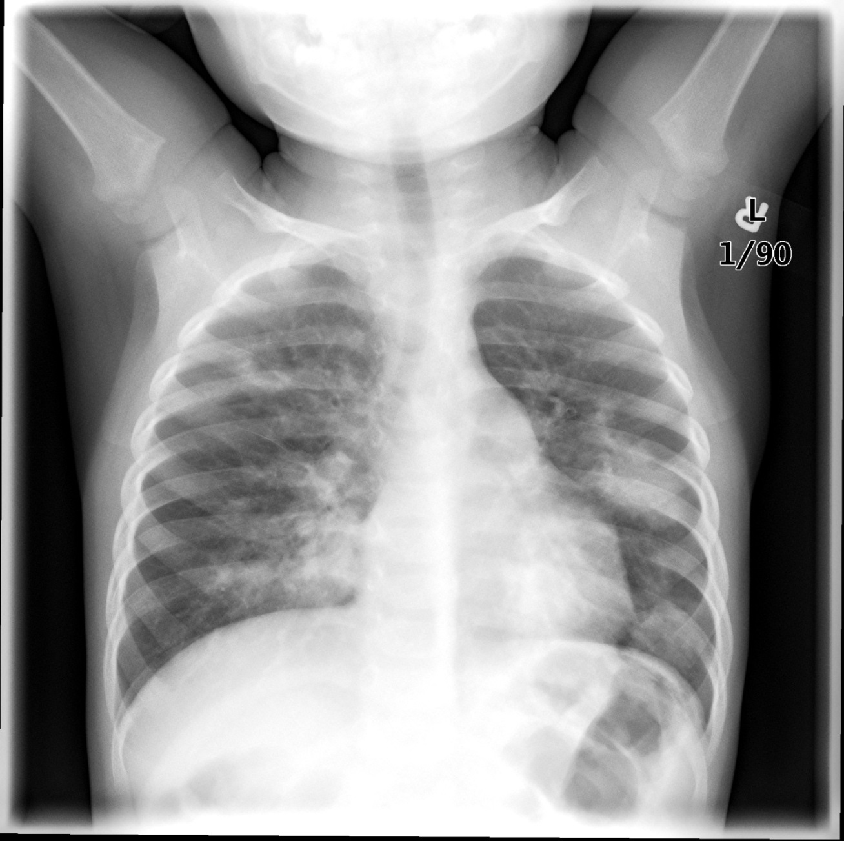
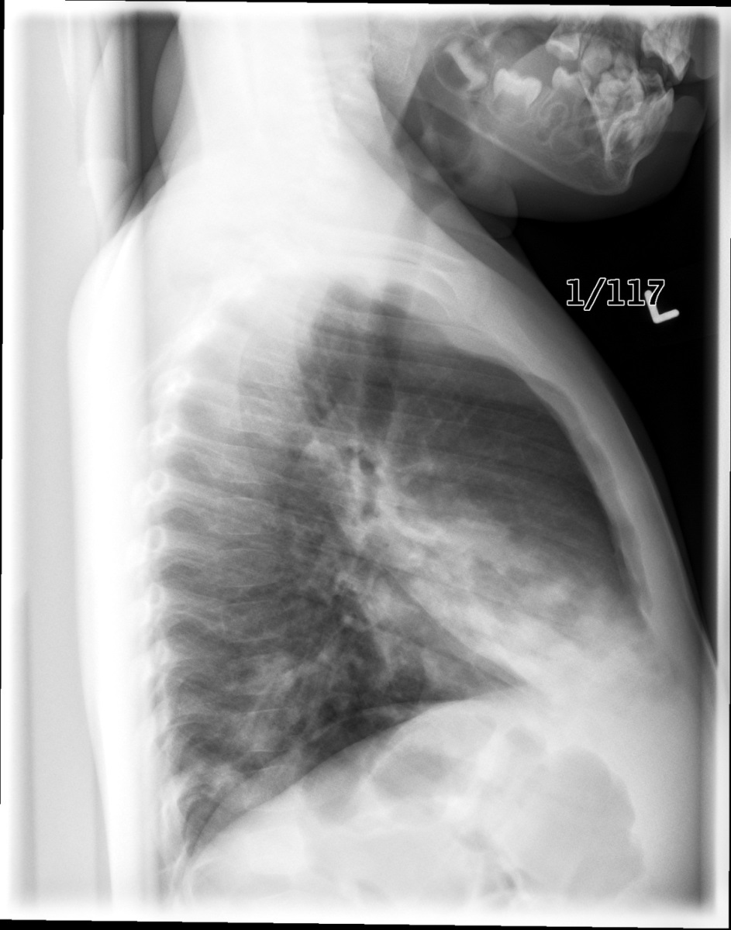
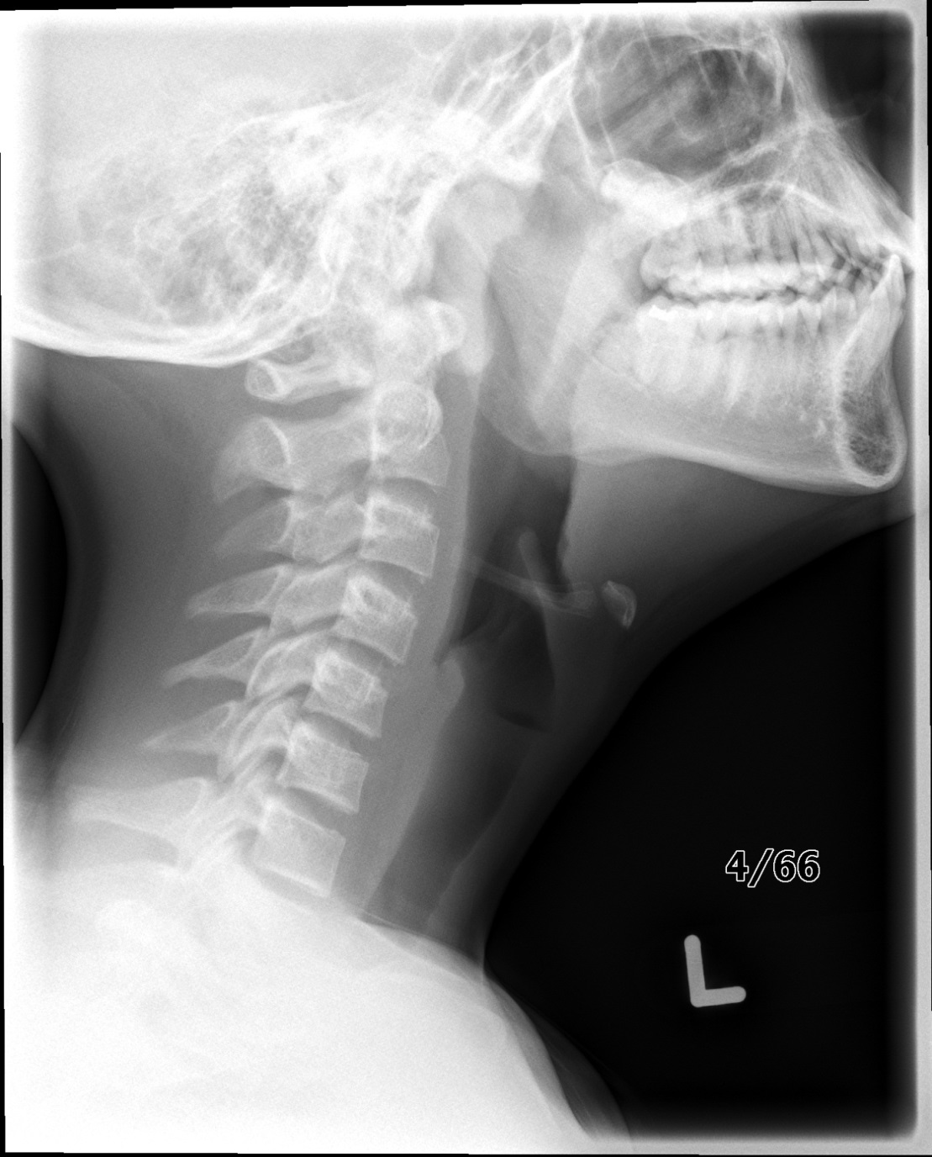

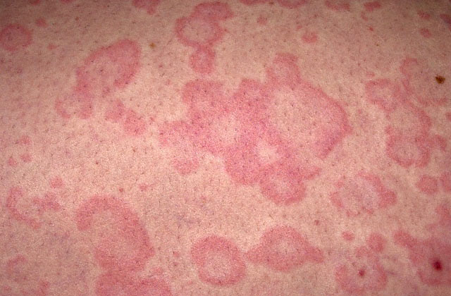

LABS – click here OR fill out below

LABORATORY *LIVE* Lab Summary Report

Test | DATE/TIME here | Flag (H or L) | Reference
CBC
WBC | 22 | H | 3.5 – 10.8 10^9/L
Neutrophils | 16.6
Hgb | 120 | L | 130 – 170 g/L
Chemistry
Na | 138 | H | 137 – 145 mmol/L
K | 3.9 |  | 3.5 – 5.0 mmol/L
Cl | 105 |  | 98 – 107 mmol/L
Urea | 2.9 |  | 2.5 – 6.1 mmol/L
Creat | 35 | L | 62 – 106 umol/L
ABGs
Arterial
pH | 7.35 |  | 7.35- 7.45
pCO2 | 42 |  | 35 – 45 mmHg
PO2 | 90 |  | 80-100 mmHg
BE | -4 |  | -2.0 to +2.0 mmol/L
HCO3 | 21 | L | 22 – 26 mmol/L
O2 Sat |  |  | 95 – 100%

