Case Title | Sepsis
Scenario Name | Intubated Patient with ARDS

Learning Objectives - Use action words
Knowledge:
- Review the ARDS Ventilation protocol and use to titrate ventilator settings
- Recognize limits of mechanical ventilation and discuss options for management when those limits are reached (ECMO, HFOV)
- Summarize and assess fragility of septic patients around the time of intubation

Skills:
- Initiate ventilation for patients with parenchymal lung disease
- Manage ventilator to ajust parameters to compensate for oxygenation difficulties
- Demonstrate approach to severely ill children (early and frequent ICU involvement)
Attitude/Behaviours:
- Demonstrate Team skills
- Demonstrate Situational awareness
- Demonstrate Graded Assertiveness
Scenario Environment
Location | ED
Monitors | Bedside
Props/Equipment | Intubation equipment
Make-up/Moulage
Potential Distractors

Case Introduction:
Septic 8 year patient. Gram – line sepsis (pseudomonas) transferred in from peripheral hospital via ITT. Sepsis protocol underway: fluid bolus in, at intubate and inotrope stage of protocol.

Patient Parameters | Effective Management | Notes
Phase 1: Presentation - Unstable  Condition: Flushed, hot, toxic looking child,  few petechiae on legs  Initial Assessment  - Heart Rhythm: Sinus tach  - HR: 145  - BP: 80/P  - RR: 32 – quiet, apneic periods  - SP02: ?  - T: 40.5  - CNS: Responds only to painful stimulus GCS 8: (E 1 V 2 M 5), no focal neurologic deficits  - Chest: few crackles  - CVS: S1 S2 soft systolic murmur, cap refill 5 secs  - GI: Liver 2cm BCM  - Integ: petechiae on legs  - Weight: 25 kg | - Take a focused history (see Notes column)  - Medical Management  - Recognize decompensated shock with impending airway compromise  - Intubation with plan for blood pressure control  - Treat aggressively with fluids  - 3-way stopcock or rapid infuser  - CVC or IO or PIV  - 60cc/kg (1500 cc)  - Early inotropic support  - Dopamine or Epi  - Boluses of epi (0.001 mg/kg = 1/10 of resus. Dose) as needed  - Early Antibiotics  - Broad Spectrum Gram – and Gram + WITH PSEUMONAS coverage | - Focused history  - Feeling well until 2 hours ago  - Started febrile, complained of feeling unwell and then became progressively obtunded  - Went to local hospital and they started sepsis protocol and transferred to BCCH  PMHx  - 8 year boy undergoing maintenance treatment for ALL  Meds  Allergies
Phase 2: Intubated  Condition: BP initially drops with intubation (less if fluids and inotropes given). Comes up quickly with treatment  Physical Examination  - Heart Rhythm: Sinus tach  - HR: 155  - BP: 85/50  - RR: 25-35 - ventilator  - SP02: 92% - ventilated  - Chest: Diffuse crackles in chest  - CVS: Diffuse crackles in chest  - GI: Liver 3cm BCM | - Patient Reassessment (see Notes column)  - Medical Management  - Use ARDSNET card to initiate ventilator setting  - PC or PRVC (any mode will do)  - TV = 8cc/kg  - Rate 25  - I-time 0.7  - Ideally, start with higher PEEP (8-10)  - PIP 25  - Changes:  - Wean TV to 7 then 6cc/kg  - Increase RR up to max of 35  - Increase PEEP up to max of 20  - Maintain Plateau pressures <30  - Medical management of acidosis (bicarbonate administration, fluids, epi/dop/Norepi)  - Discussion with ICU re: management changes, and possible need for ECMO | - Patient Reassessment  Airway  - Ventilated  Breathing  - Crackles  Circulation  - Present
Phase 3: No improvement  Condition: No improvement. Recognition of limits of capabilities  Physical Examination  - Heart Rhythm: sinus tachy  - HR: 185  - BP: 90/50  - RR: ventilator  - SP02: 89% | - Patient Reassessment (see Notes column)  - Medical Management  - Recognition of limits of current ventilation strategy  - Intensive care arrives and states that they will take the patient (ECMO likely) | - Patient Reassessment  Airway  - Ventilated  Breathing  - Crackles  Circulation  - Present

Insert more lines if more phases required.

Expected Patient Management | Debriefing Points
- Student

- R1

- Senior IM resident

References:

X-RAYS – Click here
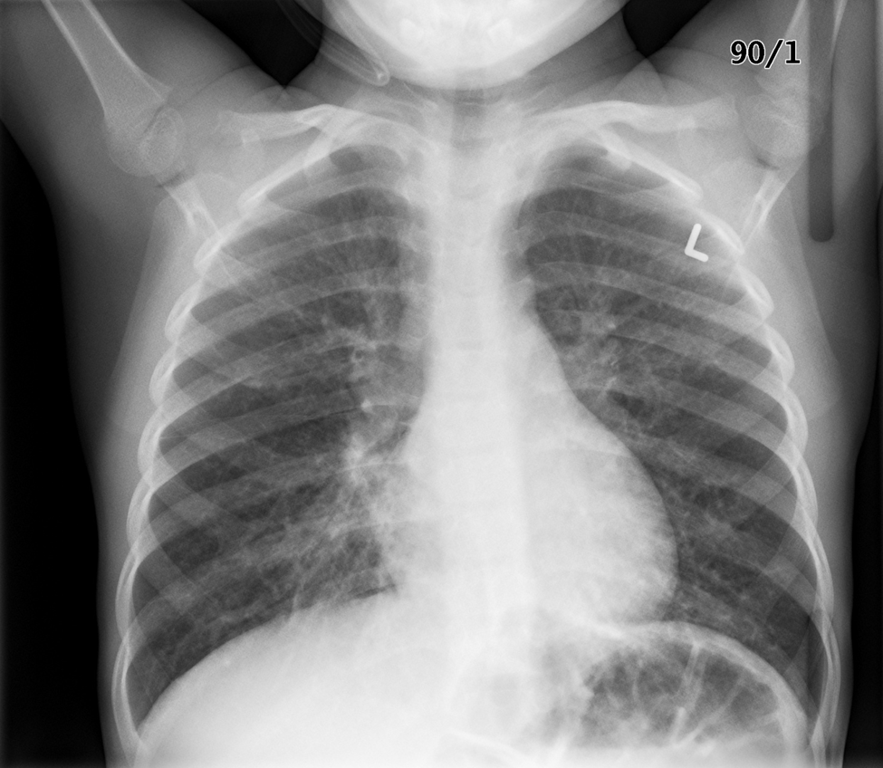

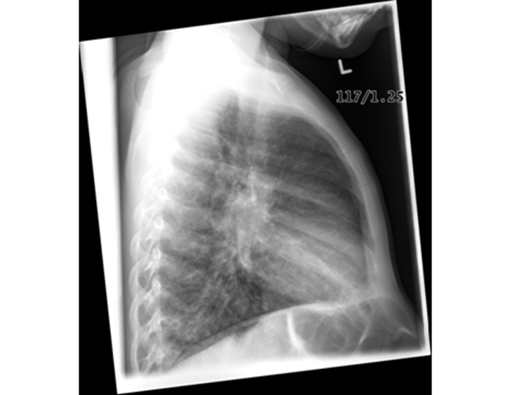

LABS – click here OR fill out below

LABORATORY *LIVE* Lab Summary Report

Test | Phase 2 | Flag (H or L) | Reference
CBC
WBC | 33 | H | 3.5 – 10.8 10^9/L
Hgb | 101 | L | 130 – 170 g/L
Platelets | 77 | L | 150 – 400 10^9/L
Fibrinogen | Low normal
D-Dimer | Mildly elevated |  | <250 mcg/L
Chemistry
Na | 132 | L | 137 – 145 mmol/L
K | 4 |  | 3.5 – 5.0 mmol/L
Cl | 111 | H | 98 – 107 mmol/L
Urea | 22 | H | 2.5 – 6.1 mmol/L
Creat | 125 | H | 62 – 106 umol/L
Glucose - Random | 6.5 |  | 3.0 – 11.0 mmol/L
Lactate | 12 | H | 0.9 – 1.8 mmol/L
Coags
INR | 1.3 | H | 0.9 – 1.2
PTT | 52 | H | 28 – 38 s
ABGs
Arterial
pH | 7.08 | L | 7.35- 7.45
pCO2 | 48 | H | 35 – 45 mmHg
PO2 | 62 | L | 80-100 mmHg
BE | -13 |  | -2.0 to +2.0 mmol/L
HCO3 | 10 | L | 22 – 26 mmol/L
O2 Sat |  |  | 95 – 100%

LABORATORY *LIVE* Lab Summary Report

Test | Phase 3 | Flag (H or L) | Reference
Lactate | 14 | H | 0.9 – 1.8 mmol/L
ABGs
Arterial
pH | 7.1 | L | 7.35- 7.45
pCO2 | 49 | H | 35 – 45 mmHg
PO2 | 64 | L | 80-100 mmHg
BE | -8 |  | -2.0 to +2.0 mmol/L
HCO3 | 16 | L | 22 – 26 mmol/L
O2 Sat |  |  | 95 – 100%

EKGs – click here or paste

