Case Title | Abdominal Trauma
Scenario Name | Liver Laceration and Splenic Injury

Learning Objectives - Use action words
Knowledge:
- Review the approach to pediatric trauma : primary and secondary assessment
- Review fluid resuscitation in patients with profound blood loss
- Review use of rapid infuser in trauma care
Skills:
- Identify and manage abdominal injury in a trauma patient
Attitude/Behaviours:
- Demonstrate Team skills
- Demonstrate Situational awareness
- Demonstrate Graded Assertiveness
Scenario Environment
Location | Emergency Department
Monitors | Cardiac, BP, pulse oximeter
Props/Equipment | Rapid Infuser  Xray : Pelvis normal - NEEDED  Xray : normal chest, normal cspine  C-collar  Mock blood products for infusion
Make-up/Moulage | Bruising on abdomen
Potential Distractors | None

Case Introduction:
5 y.o. boy who was playing in the driveway. Found by parents crushed and trapped underneath garage door. Garage door directly over his abdomen. No witnesses to the accident. Ambulance arrived within 12 min.

Patient Parameters | Effective Management | Notes
Phase 1: Initial Presentation  Condition: Unstable  Moaning in pain, confused at times, asking for mom.  Initial Assessment  - Heart Rhythm: Sinus Tachycardia  - HR: 150  - BP: 85/50  - RR: 30  - SP02: 96% on RA  - T: 36.0 C  - CNS: GCS 14. Moaning in pain, answers questions but confused at times, asking for mom. C-spine collar on patient.  - Chest: clear  - CVS: Cap refill 4 secs, pulses palpable but weak  - GI: Bruising all over abdomen  - H/N: C-spine non-tender. No obvious facial injury  - MSK: normal  - Weight: 20 kg (but should be determined per Broselow for unstable child) | - Take a focused history (see Notes column)  - Medical Management  - Airway:  - Assesses airway and talks to the patient  - Maintains C-spine precautions  - Suctions airway as needed  - Breathing:  - Checks oxygen saturation  - Auscultates the chest  - Checks for adequacy of chest rise  - Apply monitors  - Applies oxygen by simple mask  - Circulation:  - Checks pulse, cap refill, BP  - Identifies the rhythm of ST  - Monitors (if not done yet)  - Checks first IV line, asks for second large bore IV  - Asks for rapid infuser and bolus 20 mL/kg NS  - Other:  - Activates trauma team  - Applies warm blankets  - Orders trauma bloodwork including type and cross for 4 units or asks for 4 units of O-blood stat or activates MHP | - Focused history  - Upon EMT arrival, HR-120, RR-40, BP-110/70, O2 sat-95%  - Initially delirious, screaming, GCS 15/15  - Extraction took 10 min in total  - IV x 1 antecubital  - Given NS 1 L wide open  - Transport time 15 minutes  PMHx  - Healthy  - Immunization up to date  Meds  - None  Allergies  - None
Phase 2: Condition Worsens  Condition: Unstable  The patient’s condition has worsened slightly. BP lower. GCS unchanged.  Physical Examination  - Heart Rhythm: Sinus Tachycardia  - HR: 170  - BP: 80/40  - RR: 40  - SP02: 100% with oxygen by mask  - T: 36.0 C  - CNS: GCS 14. Moaning in pain, answers questions but confused at times, asking for mom. C-spine collar on. PERL. No neuro deficits.  - Chest: trachea midline, chest clear  - CVS: Cap refill 5 secs, pulses palpable but weak, color mottled  - GI: Bruising all over abdomen, abdomen soft, BS absent, tender all over abdomen (screams in pain)  - GU: No blood at meatus of genitalia  - H/N: C-Spine non-tender. No obvious facial injury. PERL, facial bones not tender, neck supple, and not tender  - MSK: Pelvis stable  - Back: Good rectal tone, no back tenderness | - Patient Reassessment (see Notes column)  - Medical Management  - Airway:  - Maintains C-spine, continues talking to patient  - Breathing:  - Continues to give oxygen and monitor sats  - Circulation:  - Asks for second bolus of 20 mL/kg of NS through second IV  - Reaffirms need for rapid infuser  - Orders blood (not yet arrived)  - Inserts Foley catheter  - Other:  - Pain control: Morphine 0.1 mg/kg  - Stat consultation: General Surgery  - Orders xrays: C-Spine, Chest, Pelvis  - Inserts NG tube | - Patient Reassessment  Airway  - Awake, C-collar still in place  - Continues to protect own airway spontaneously  Breathing  - Chest clear  Circulation  - Profoundly tachycardic, BP dropping, cap refill 5 secs, pulses palpable but weak, skin mottled
Phase 3: Decompensation  Condition: Unstable  The patient is less responsive. BP is falling. Eyes still closed. GCS 13.  Physical Examination  - Heart Rhythm: Sinus Tachycardia  - HR: 180  - BP: 70/30  - RR: 40  - SP02: 100% with oxygen by mask  - T: 36.0 C  - CNS: GCS 13. Moaning in pain, intermittently answers questions, confused and delirious at times. C-collar remains on.  - Chest: clear  - CVS: Cap refill 6 secs, only central pulses palpable but weak, color mottled  - GI: Bruising all over abdomen | - Patient Reassessment (see Notes column)  - Medical Management  - Airway:  - Prepare for intubation due to decreasing LOC : no urgent need to intubate at present  - Pre-oxygenates  - Prepares equipment and ET CO2  - Orders drugs for RSI:  - Atropine 0.02 mg/kg  - Etomidate 0.3 mg/kg  - Succs 1.5 – 2 mg/kg  - Checks tube placement post intubation, orders CXR if intubation is carried out  - Breathing:  - Assesses chest pre-/post-intubation  - Continues to give oxygen and monitor sats  - Circulation:  - Identifies worsening shock  - Orders 3rd bolus of NS 20 mL/kg and more blood (O neg if crossmatch not available)  - Other:  - General Surgery arrives – discuss need to CT abdomen vs direct to operating room  - Consider FAST  - Discusses need for CT Head/Neck and Chest – not necessary | - Patient Reassessment  Airway  - Decreasing LOC may put airway at risk  Breathing  - Chest clear, maintaining sats  Circulation  - Worsening shock

Insert more lines if more phases required.

Expected Patient Management | Debriefing Points
- Student

- R1

- Senior IM resident

References:

X-RAYS – Click here

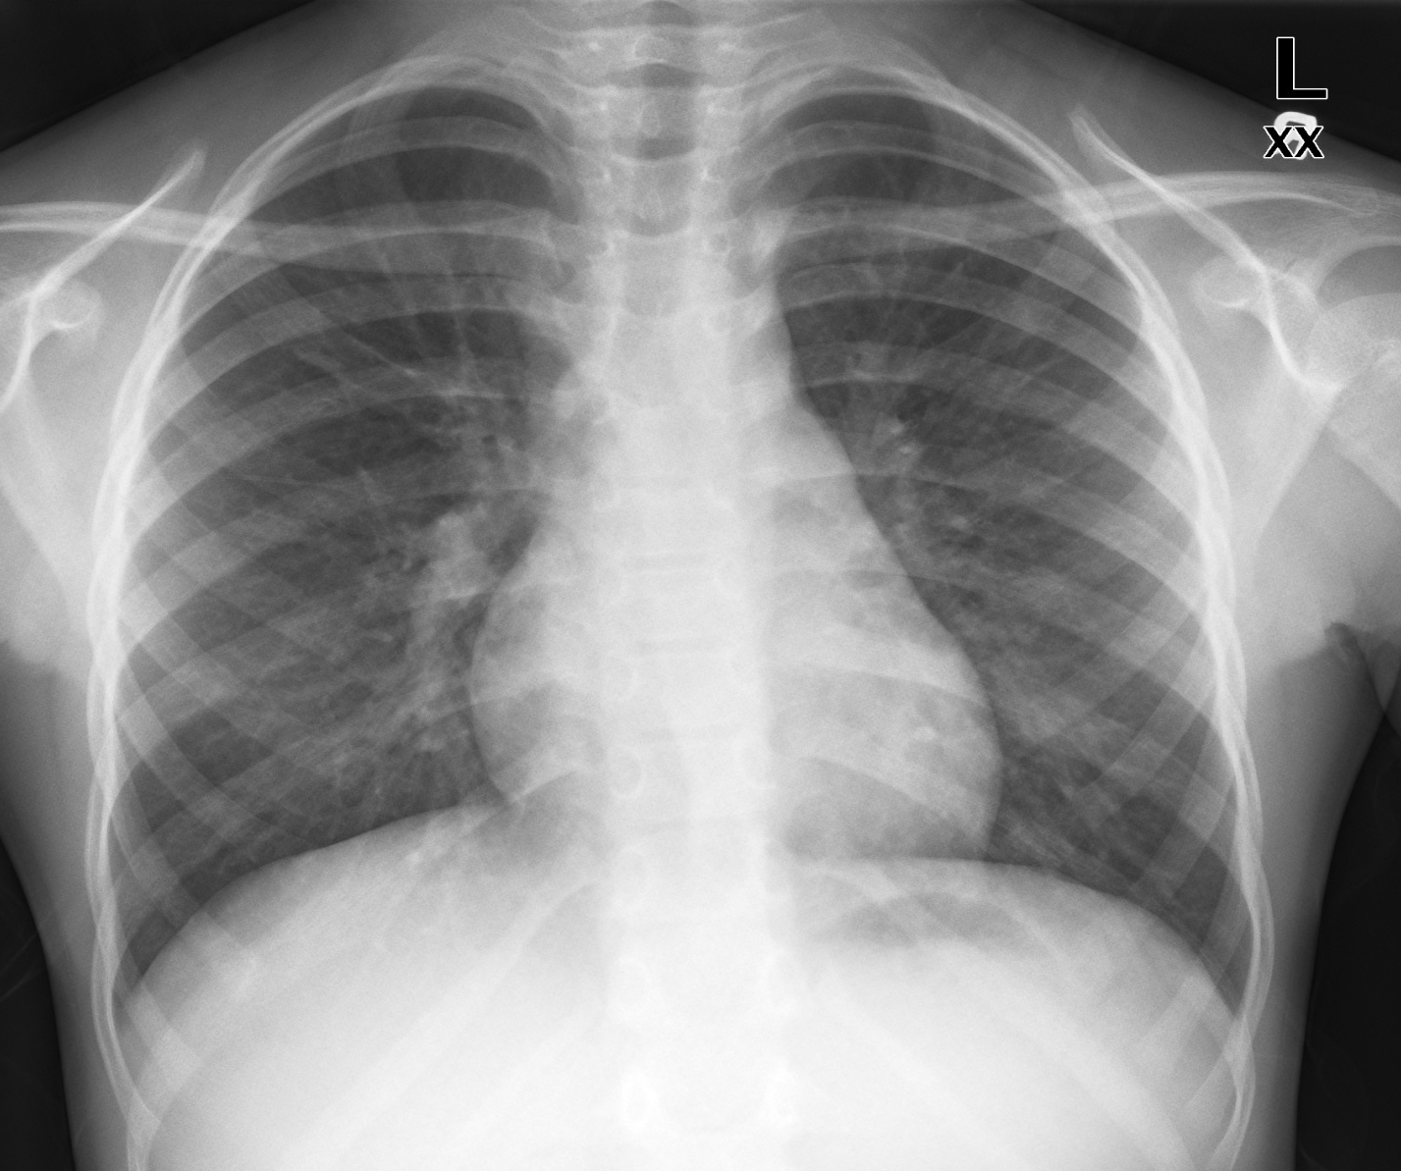

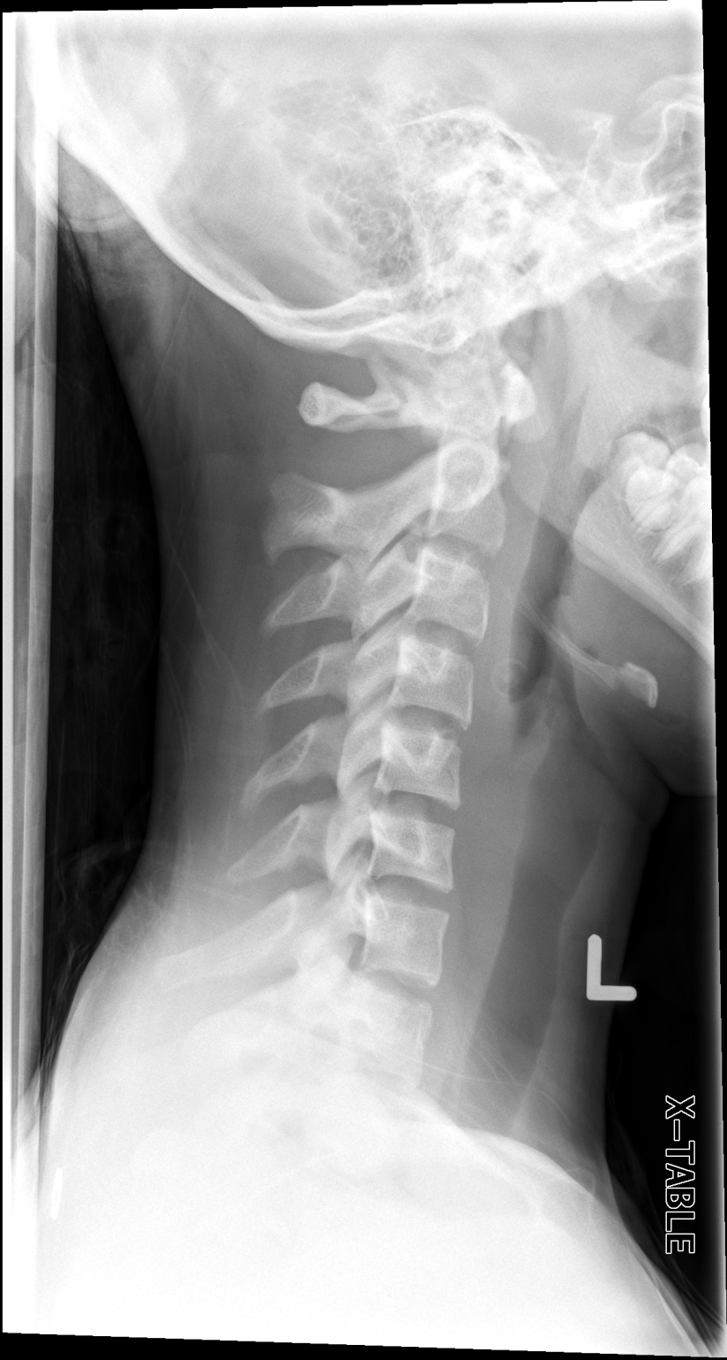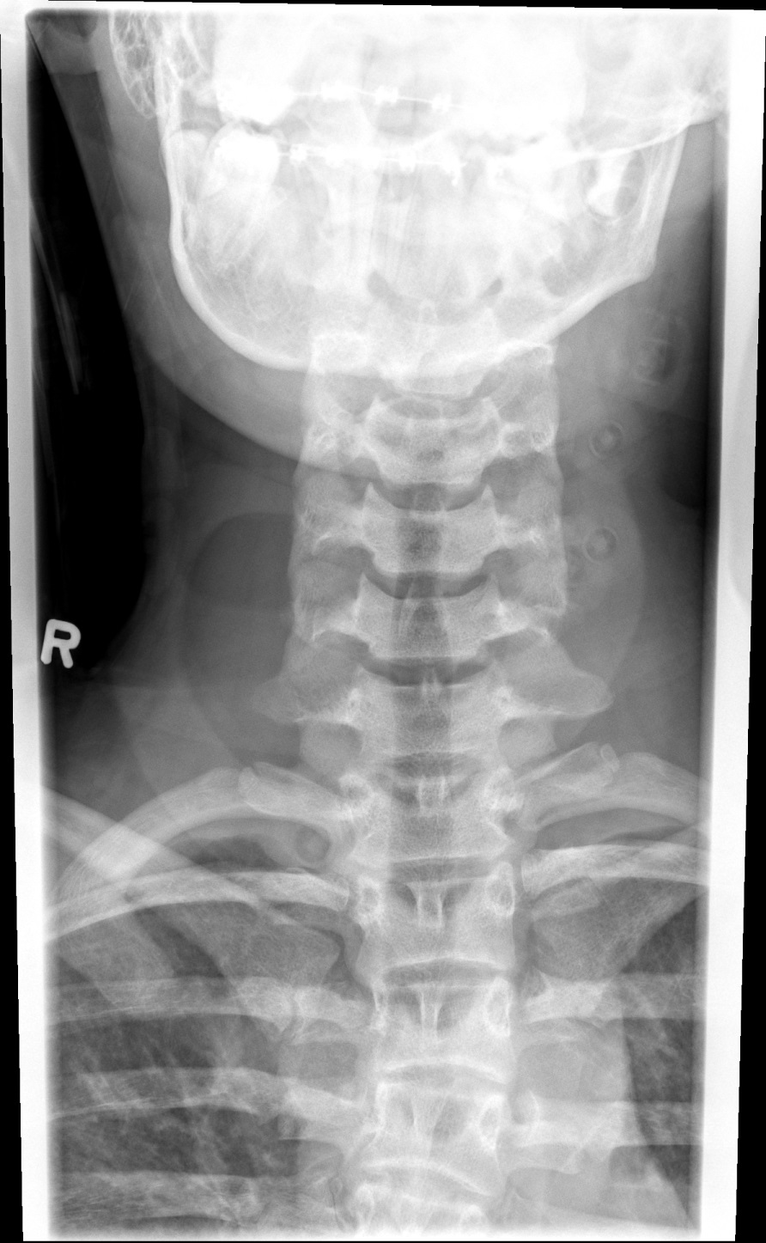

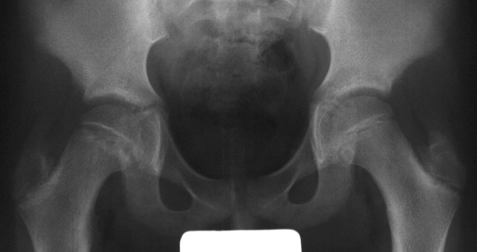
LABS – click here OR fill out below
LABORATORY *LIVE* Lab Summary Report

Test | DATE/TIME here | Flag (H or L) | Reference
CBC
WBC | 15.5 | H | 3.5 – 10.8 10^9/L
RBC |  |  | 4.3 – 5.7 10^12/L
Hgb | 70 | L | 130 – 170 g/L
HCT |  |  | 0.37 – 0.47 L/L
Platelets | 500 | H | 150 – 400 10^9/L
Chemistry
Na | 135 | L | 137 – 145 mmol/L
K | 4.5 |  | 3.5 – 5.0 mmol/L
Cl | 103 | L | 98 – 107 mmol/L
HCO3 |  |  | 22-26 mmol/L
Urea | 4.2 |  | 2.5 – 6.1 mmol/L
Creat | 46 | L | 62 – 106 umol/L
GFR Est |  |  | > 60 ml/min
Glucose - Random | 4.6 |  | 3.0 – 11.0 mmol/L
Lactate |  |  | 0.9 – 1.8 mmol/L
CK |  |  | 5 – 130 U/L
Troponin |  |  | <0.03 mcg/L
Coags
INR | 1.2 |  | 0.9 – 1.2
PTT | 42 | H | 28 – 38 s
ABGs
Arterial
pH | 7.20 | L | 7.35- 7.45
pCO2 | 40 | H | 35 – 45 mmHg
PO2 | 80 |  | 80-100 mmHg
BE | -15 | L | -2.0 to +2.0 mmol/L
HCO3 | 10 | L | 22 – 26 mmol/L
O2 Sat |  |  | 95 – 100%

