Case Title | Drowning and Hypothermia
Scenario Name | Submersion Injury

Learning Objectives - Use action words
Knowledge:
- Review management of submersion injury
- Identify the importance of airway management and C-spine protection in submersion injury
- Recognize and define hypothermia
- Understands when it is appropriate to stop running a resuscitation
Skills:
- Learn passive and active rewarming techniques
- Review management of arrhythmias when hypothermic
Attitude/Behaviours:
- Demonstrate Team skills
- Demonstrate Situational awareness
- Demonstrate Graded Assertiveness
Scenario Environment
Location | Emergency Department
Monitors | Cardiac, BP, pulse oximeter
Props/Equipment | CXR : wet lungs :post intubation  Defibrillator  Gel pads  Rewarming equipment :bear hugger, warm IV fluids, warm blankets  C-collar  Intraosseous needle
Make-up/Moulage | Bruises and cuts on face, bruising all over abdomen
Potential Distractors | None

Case Introduction:
6 y.o. boy who was boating with his father when the small boat inadvertently hit a large wave and flipped over. Child was not wearing a life jacket. Father survived, and swam with unconscious child to shore. CPR initiated on the scene, and 911 called. Upon arrival, paramedics noted child was apneic, pulseless, and blue. CPR initiated by paramedics with bag/mask ventilation. C-collar applied. Child brought to ED by paramedics with CPR in progress.

Patient Parameters | Effective Management | Notes
Phase 1: V. Fib Arrest  Condition: Coding  Initial Assessment  - Heart Rhythm: Ventricular Fibrillation  - HR: 0  - BP: -/-  - RR: apneic  - SP02: unable to obtain  - T: 28.0 C  - CNS: GCS 3, non-responsive, C-spine collar on, bruises and cuts on face  - Chest: Coarse crackles bilaterally  - CVS: Cap refill 6-7 secs, no pulse palpable  - GI: Bruising all over abdomen  - Weight: 20 kg (but should be determined per Broselow) | - Take a focused history (see Notes column)  - Medical Management  - Airway:  - Take over bagging and CPR immediately  - Clear/suction the airway  - Identifies need for immediate intubation  - Intubates patient without RSI  - ETT: 5.5  - Breathing:  - Check oxygen saturation  - Auscultate the chest  - Check for adequacy of chest rise after tube is placed  - Apply monitors  - Identify that ET CO2 detection not helpful because child is pulseless  - Order CXR to confirm tube position  - Circulation:  - Check pulse, cap refill, BP  - Identify the rhythm (V. fib)  - Does not order Epi as core temp is below 32 C  - Monitors (if not done yet)  - Insert IO x 1  - Consider 1 round of shocking  - Disability and Exposure  - Check AVPU/ GCS  - Expose patient completely to conduct a secondary survey  - Apply warm blankets  - Give warm IV fluids (NS 20 mL/kg) through IO and attempt to obtain more IV or IO access  - Consider internal re-warming techniques: gastric lavage, bladder irrigation, and potentially peritoneal irrigation to see if there is any intra-abdominal bleeding  - Other:  - Orders bloodwork : arterial blood gas, lactate, lytes, BUN, Cr, CBC, LFTs, glc, crossmatch  - Activate ECLS team – only because it appears that the injury was in a reasonable time frame) | - Focused history  - Paramedics have been doing CPR x 13 mins  - They arrived on the beach 5 min into CPR performed by father  PMHx  - Previously healthy  - Immunization up to date  Meds  - None  Allergies  - None
Phase 2: No Change  Condition: Coding  The patient’s condition has not changed apart from the temperature.  Physical Examination  - Heart Rhythm: V. fib  - HR: 0  - BP: -/-  - RR: 10 (bagged)  - SP02: 100% with oxygen by mask  - T: 32.0 C  - Glucose: 1.4  - CNS: GCS 3, non-responsive, C-spine collar on, bruises and cuts on face.  - Chest: Coarse crackles bilaterally  - CVS: Cap refill 6-7 secs, no pulse palpable  - GI: Bruising all over abdomen | - Patient Reassessment (see Notes column)  - Medical Management  - Airway:  - Pt must be intubated and bagged  - Breathing:  - Continues to bag at rate of 8-10  - Orders CXR : bilateral hazy lung fields (wet), ETT in good position  - Circulation:  - Identifies v.fib  - Continues CPR  - Delivers defibrillation at 2 J/kg  - Continues CPR and orders Epinephrine  - Gives Epi 1:10,000- 0.01 mg/kg via IO  - Continues CPR  - Delivers shock and then gives Amiodarone 5 mg/kg IV x 1  - Calls for help (ICU)  - Other:  - ABG : 6.9/ 11/ 60/ 3/ -22  - Lactate 8.0  - Glucometer 1.4: corrects with 5 mL/kg of D10W  - Unable to obtain other labs | - Patient Reassessment  Airway  - Intubated  Breathing  - No spontaneous resps, bagged at rate of 8-10  Circulation  - V. fib arrest, must do CPR  - Temp has now gone up to 32.0 C
Phase 3: Sinus Bradycardia  Condition: Unstable  The patient’s rhythm changes after the dose of amiodarone  Physical Examination  - Heart Rhythm: Sinus Bradycardia  - HR: 40  - BP: 40/P  - RR: 10 (bagged)  - SP02: 80% with oxygen  - T: 33.0 C  - CNS: GCS 3  - Chest: coarse crackles bilaterally  - CVS: Cap refill 5-6 secs, pulses very weak | - Patient Reassessment (see Notes column)  - Medical Management  - Airway:  - Pt intubated and continues bagging  - Breathing:  - Continues to bag at rate of 8-10  - Circulation:  - Continues CPR  - Gives Epi 1:10,000- 0.01 mg/kg  - Gives NS bolus 20 mL/kg  - Other:  - Asks for repeat glc  - Thinks about duration of code and when it would be appropriate to “call” the code  - Discusses current status with ICU fellow  - Should be avoiding paralysis and sedation at this stage as there has not been any indication that he has moved and we need to assess CNS function sooner rather than later. | - Patient Reassessment  Airway  - Intubated  Breathing  - No spontaneous resps, bagged at rate of 8-10  Circulation  - Sinus brady with poor perfusion, continues CPR
Phase 4: ROSC  Condition: Unstable  The patient is back to a perfusing rhythm  Physical Examination  - Heart Rhythm: Sinus Rhythm  - HR: 80  - BP: 60/P  - RR: 10 (bagged)  - SP02: 88% with oxygen  - T: 33.5 C  - CNS: Intubated and sedated  - Chest: coarse crackles bilaterally  - CVS: Cap refill 4 secs, pulses weak | - Patient Reassessment (see Notes column)  - Medical Management  - Airway:  - Pt intubated and continues bagging  - Breathing:  - Assesses breathing  - Circulation:  - Identifies hypotension  - Identifies Sinus Rhythm  - Gives fluids  - Start Inotropes: dopamine or epinephrine infusion after 3rd bolus  - Arrange transfer to ICU for admission to hospital  - Other:  - Needs urgent CT scan of head, neck and abdomen on the way to PICU  - Gen surgery consulted  - Neurosurgery consulted  - Parents notified | - Patient Reassessment  Airway  - Intubated and sedated  Breathing  - No spontaneous resps, bagged at rate of 8-10  Circulation  - Sinus Rhythm

Insert more lines if more phases required.

Expected Patient Management | Debriefing Points
- Student

- R1

- Senior IM resident

References:

X-RAYS – Click here

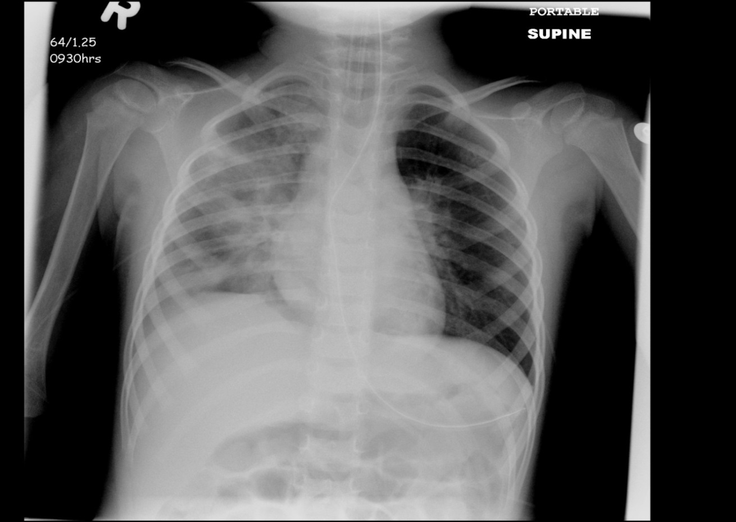

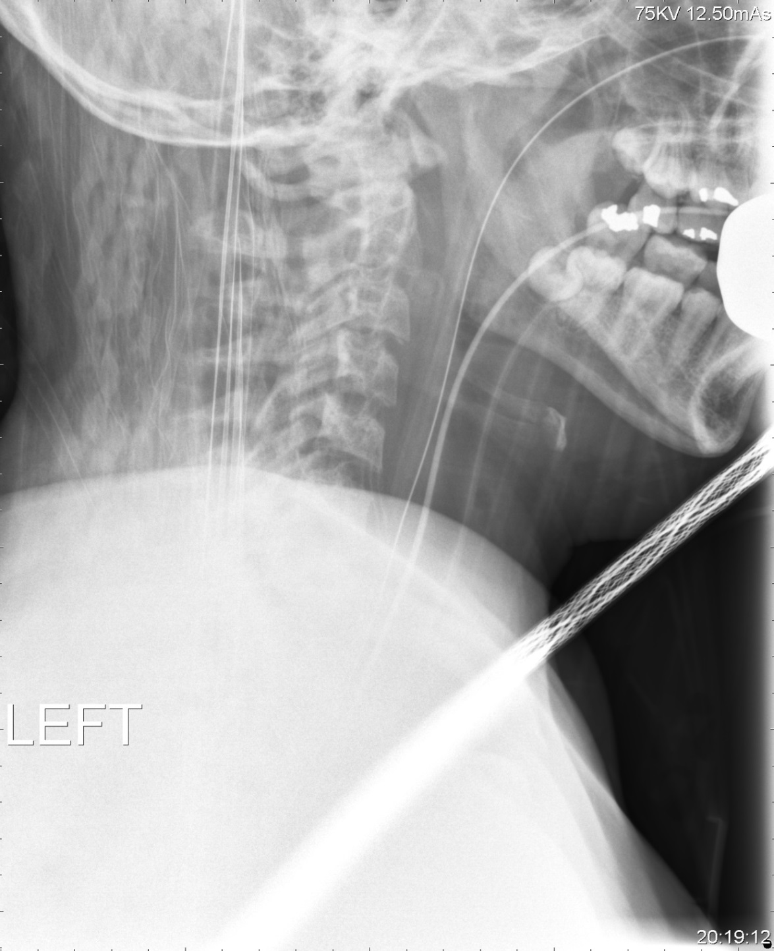

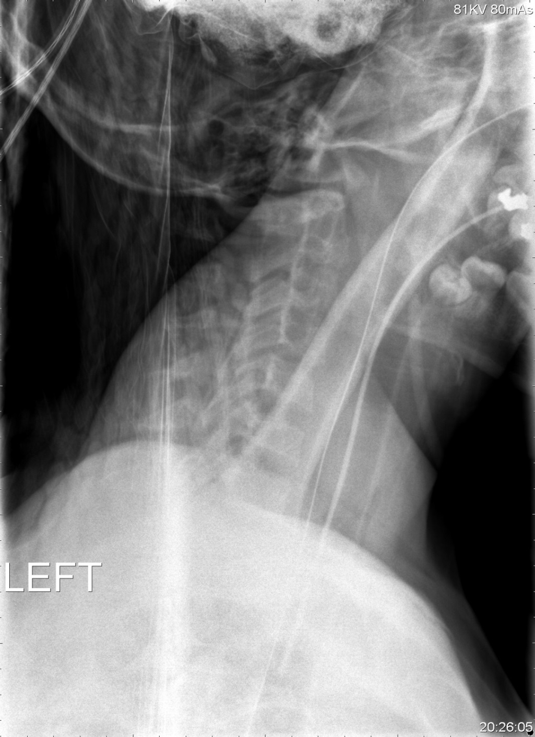
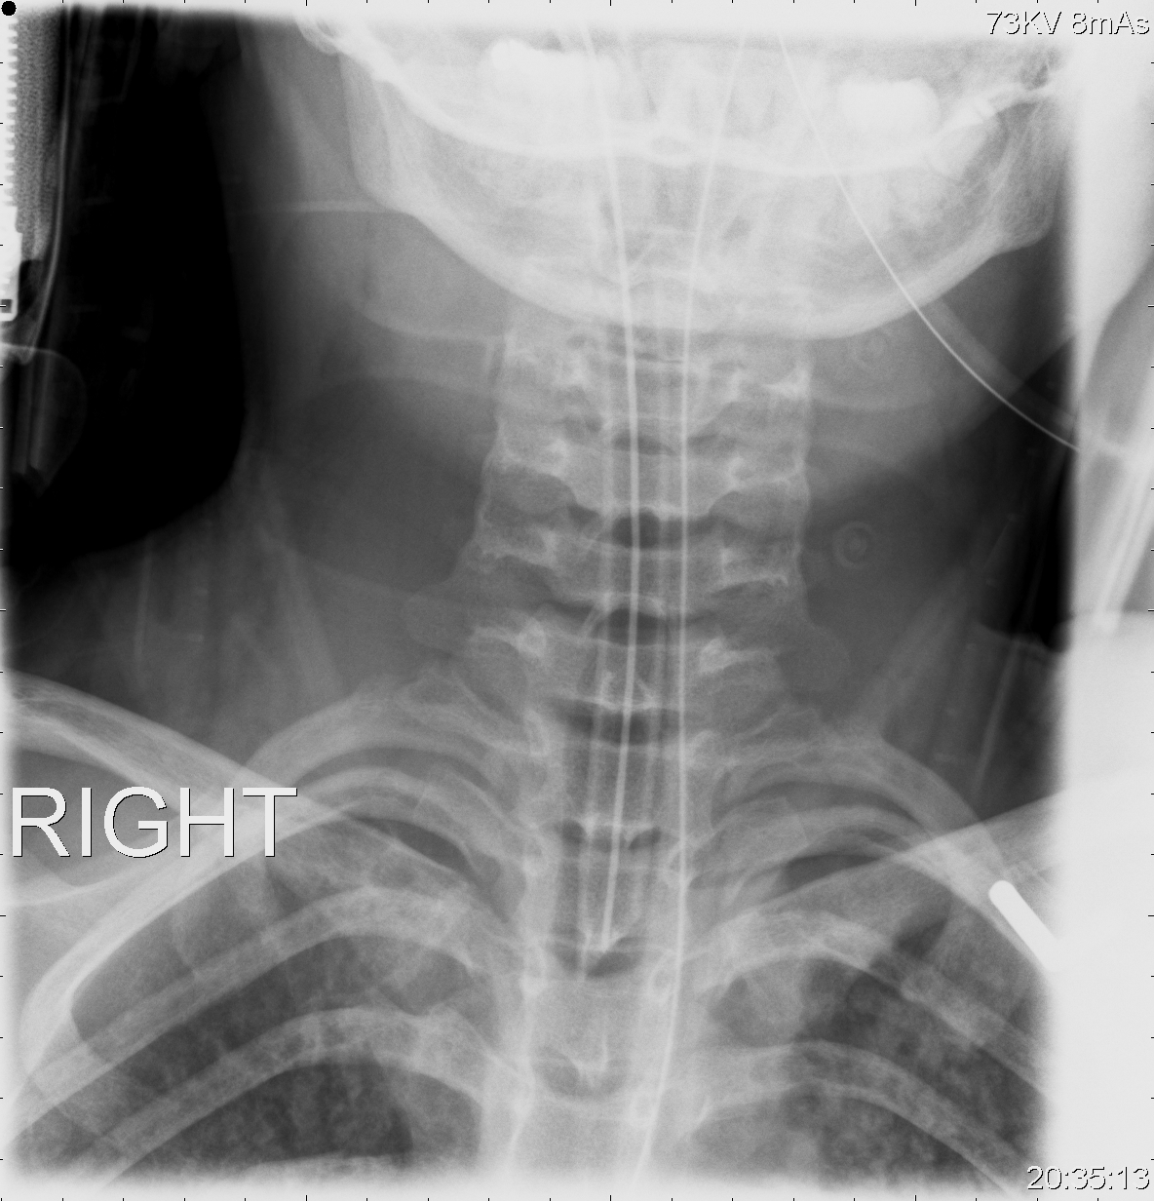

LABS – click here OR fill out below
LABORATORY *LIVE* Lab Summary Report

Test | DATE/TIME here | Flag (H or L) | Reference
CBC
WBC |  |  | 3.5 – 10.8 10^9/L
RBC |  |  | 4.3 – 5.7 10^12/L
Hgb |  |  | 130 – 170 g/L
HCT |  |  | 0.37 – 0.47 L/L
Platelets |  |  | 150 – 400 10^9/L
Chemistry
Na |  |  | 137 – 145 mmol/L
K |  |  | 3.5 – 5.0 mmol/L
Cl |  |  | 98 – 107 mmol/L
HCO3 |  |  | 22-26 mmol/L
Urea |  |  | 2.5 – 6.1 mmol/L
Creat |  |  | 62 – 106 umol/L
GFR Est |  |  | > 60 ml/min
Glucose - Random | 1.4 | L | 3.0 – 11.0 mmol/L
Lactate | 8.0 | H | 0.9 – 1.8 mmol/L
CK |  |  | 5 – 130 U/L
Troponin |  |  | <0.03 mcg/L
Coags
ABGs
Arterial
pH | 6.90 | L | 7.35- 7.45
pCO2 | 11 | L | 35 – 45 mmHg
PO2 | 60 | L | 80-100 mmHg
BE | -22 | L | -2.0 to +2.0 mmol/L
HCO3 | 3 | L | 22 – 26 mmol/L
O2 Sat |  |  | 95 – 100%

