Case Title | Electrical Injury
Scenario Name | Electrical Injury, Ventricular Tachycardia, Hyperkalemia, Myoglobinuria

Learning Objectives (3 or more) - Use action words
Knowledge:
- Recognizes electrical injury
- Recognizes and manages ventricular tachycardia
- Recognizes complications of electrical injury
Skills:
- Demonstrates ability to perform primary and secondary survey
- Demonstrate appropriate use of defibrillator
Attitude/Behaviours
- Demonstrate Team skills
- Demonstrate Situational awareness
- Demonstrate Graded Assertiveness
Scenario Environment
Location | ER
Monitors | Cardiac, Defibrillator
Props/Equipment | CXR (pre-intubation) N  CXR (post –intubation) right mainstem  Defibrillator and pads  Foley with red urine in bag
Make-up/Moulage | Electrical entry and exit wounds
Potential Distractors | None

Case Introduction:
4 y.o. boy found unconscious by a friend while they were playing in a construction site. BCAS called and transferred to hospital.

Patient Parameters | Effective Management | Notes
Phase 1: Unstable, Unresponsive  Condition: Unstable  Unresponsive, pale, BVM ventilations in progress by paramedics.  Initial Assessment  - Heart Rhythm: Sinus Tachycardia  - HR: 160  - BP: 80/40  - RR: assisted at 20  - SP02: 86% on BVM  - T: 38.0 C  - Chest: clear  - CNS: GCS 3 (E1, V1, M1), PERL 3-4 mm bilat, back-N  - CVS: cap refill 4 sec, pulses weak, HS N  - GI: Normal  - HEENT: No signs of head trauma, C-collar in place  - Extremities: Entry wound on palm of left hand, exit wound on sole of right foot  - Weight: Use Broselow tape (15 kg) | - Take a focused history (see Notes column)  - Medical Management  Airway  - maintain C-spine immobilization  - Intubation/RSI  - CXR  Breathing  - RT bag/ventilator  Circulation  - monitors  - IV x 2, NS bolus 20ml/kg  Other:  - consider sedation (midazolam 0.1mg/kg or infusion)  Investigations:  ECG: NS tachy  Labs:  CXR: N pre intubation/ right mainstem post  CT Head: N | - Focused history  - CPR x 4-5 mins until “AED applied”.  - AED on scene advised “shock” Paramedics think “vfib”. C-collar in situ  PMHx  - Healthy  - Immunizations up to date  Meds  - None  Allergies  - None
Phase 2: Shock, right mainstem intubation  Condition: Unstable  Physical Examination  - Heart Rhythm: Sinus Tachycardia  - HR: 165  - BP: 84/46  - RR: assisted at 8-10  - SPO2: 88%  - Chest: good a/e right, poor a/e left. Asymmetrical chest rise (more on right as tube is right mainstem)  - CNS: PERL  - CVS: cap refill 4 secs, pulses still weak  - GU: Red urine in foley bag | - Patient Reassessment (see Notes column)-  Recognizes change in condition  - Medical Management  Airway  - Secure tube  - Maintain C spine precautions  Breathing  - Adjust ETT (pull back), reassess & secure  - CXR for tube placement  Circulation  - IV bolus 20ml/kg NS  Assessment:  - Identifies entry and exit wounds from electrical injury  - Identify neurovascular injury: all pulses  - Rule out compartment syndromes  - Identify red urine in foley bag  Other:  - Foley  - Review lab work:  Na 130, K 6.7, Cl 100, BUN 7.6, Cr 110  CBC WBC 22, Hgb 100, Plt 550  CPK 1200  Urine WBC +++ | - Patient Reassessment  Airway  - Intubated  Breathing  - Asymmetrical chest rise, auscultation good a/e right, poor a/e left  Circulation  - Reassess cap refill, BP, pulses, recognize still in shock
Phase 3: Deterioration, V. Tach with pulse  Condition: Severely unstable  Physical Examination  - Heart Rhythm: Ventricular Tachycardia  - HR: 180  - BP: 78/30  - RR: assisted at 8-10  - SPO2: 94% with O2  - T: 38.0 C  - Chest: Good a/e bilat  - CNS: intubated and sedated, PERL  - CVS: cap refill 4 sec, weak pulse palpable | - Patient Reassessment (see Notes column)-  Recognizes change in condition  - Medical Management  Airway  - Continue to protect airway  Breathing  - Continue bagging at rate of 8-10  Circulation  - Cardioversion @ 0.5-1.0 J/Kg  - Cardioversion @ 2 J/kg  - Cardioversion @ 2 J/kg  - Epi 1:10 000, 0.1cc/kg  - Amiodarone 5mg/kg  - Fluids: repeat bolus 20ml/kg NS  Investigations:  - Repeat labs: lytes,BUN,Cr,gluc,gas,CBC  Other:  - Consult ICU  - Consult Cardiology  - Treat hyperkalemia  - Ca gluconate/ Ca chloride  - Na HCO3  - Ventolin meds  - Glucose bolus followed by insulin infusion | - Patient Reassessment  Airway  - Protected, pt intubated and bagged  Breathing  - Good a/e bilat  Circulation  - Unstable V Tach with pulse  - Hyperkalemia
Phase 4: Stabilizing, Sinus Tach  Condition: Stabilizing  Physical Examination  - Heart Rhythm: Sinus Tachycardia  - HR: 170  - BP: 85/40  - RR: assisted at 8-10  - SPO2: 94% on O2  - T: no change  - Chest: good a/e bilat  - CNS: intubated and sedated, PERL, c-collar on  - CVS: cap refill 4 sec, weak pulse palpable | - Patient Reassessment (see Notes column)-  Recognizes change in condition  - Medical Management  Airway  - Continue to protect airway  Breathing  - Continue bagging at rate of 8-10  Circulation  - Gives NS bolus 20ml/kg  - Consider inotropes; give epi/dopamine infusion  Other:  - Review repeat bloodwork:  Na 131, K 8.2, Cl 102, BUN 9, Cr 150  Art gas 7.10 / 15 / 90 / 8 / -17  CBC pending  - Discuss current status with ICU  - Consult nephrology for urgent dialysis due to hyperkalemia  - Consider CT head  - Neck and abd imaging | - Patient Reassessment  Airway  - Protected, intubated and bagged  Breathing  - Auscultates chest= good a/e bilat  Circulation  - Identifies sinus tachycardia, checks perfusion and BP

Expected Patient Management | Debriefing Points
- Student

- R1

- Senior IM resident

References:

X-RAYS

Pre- intubation CXR
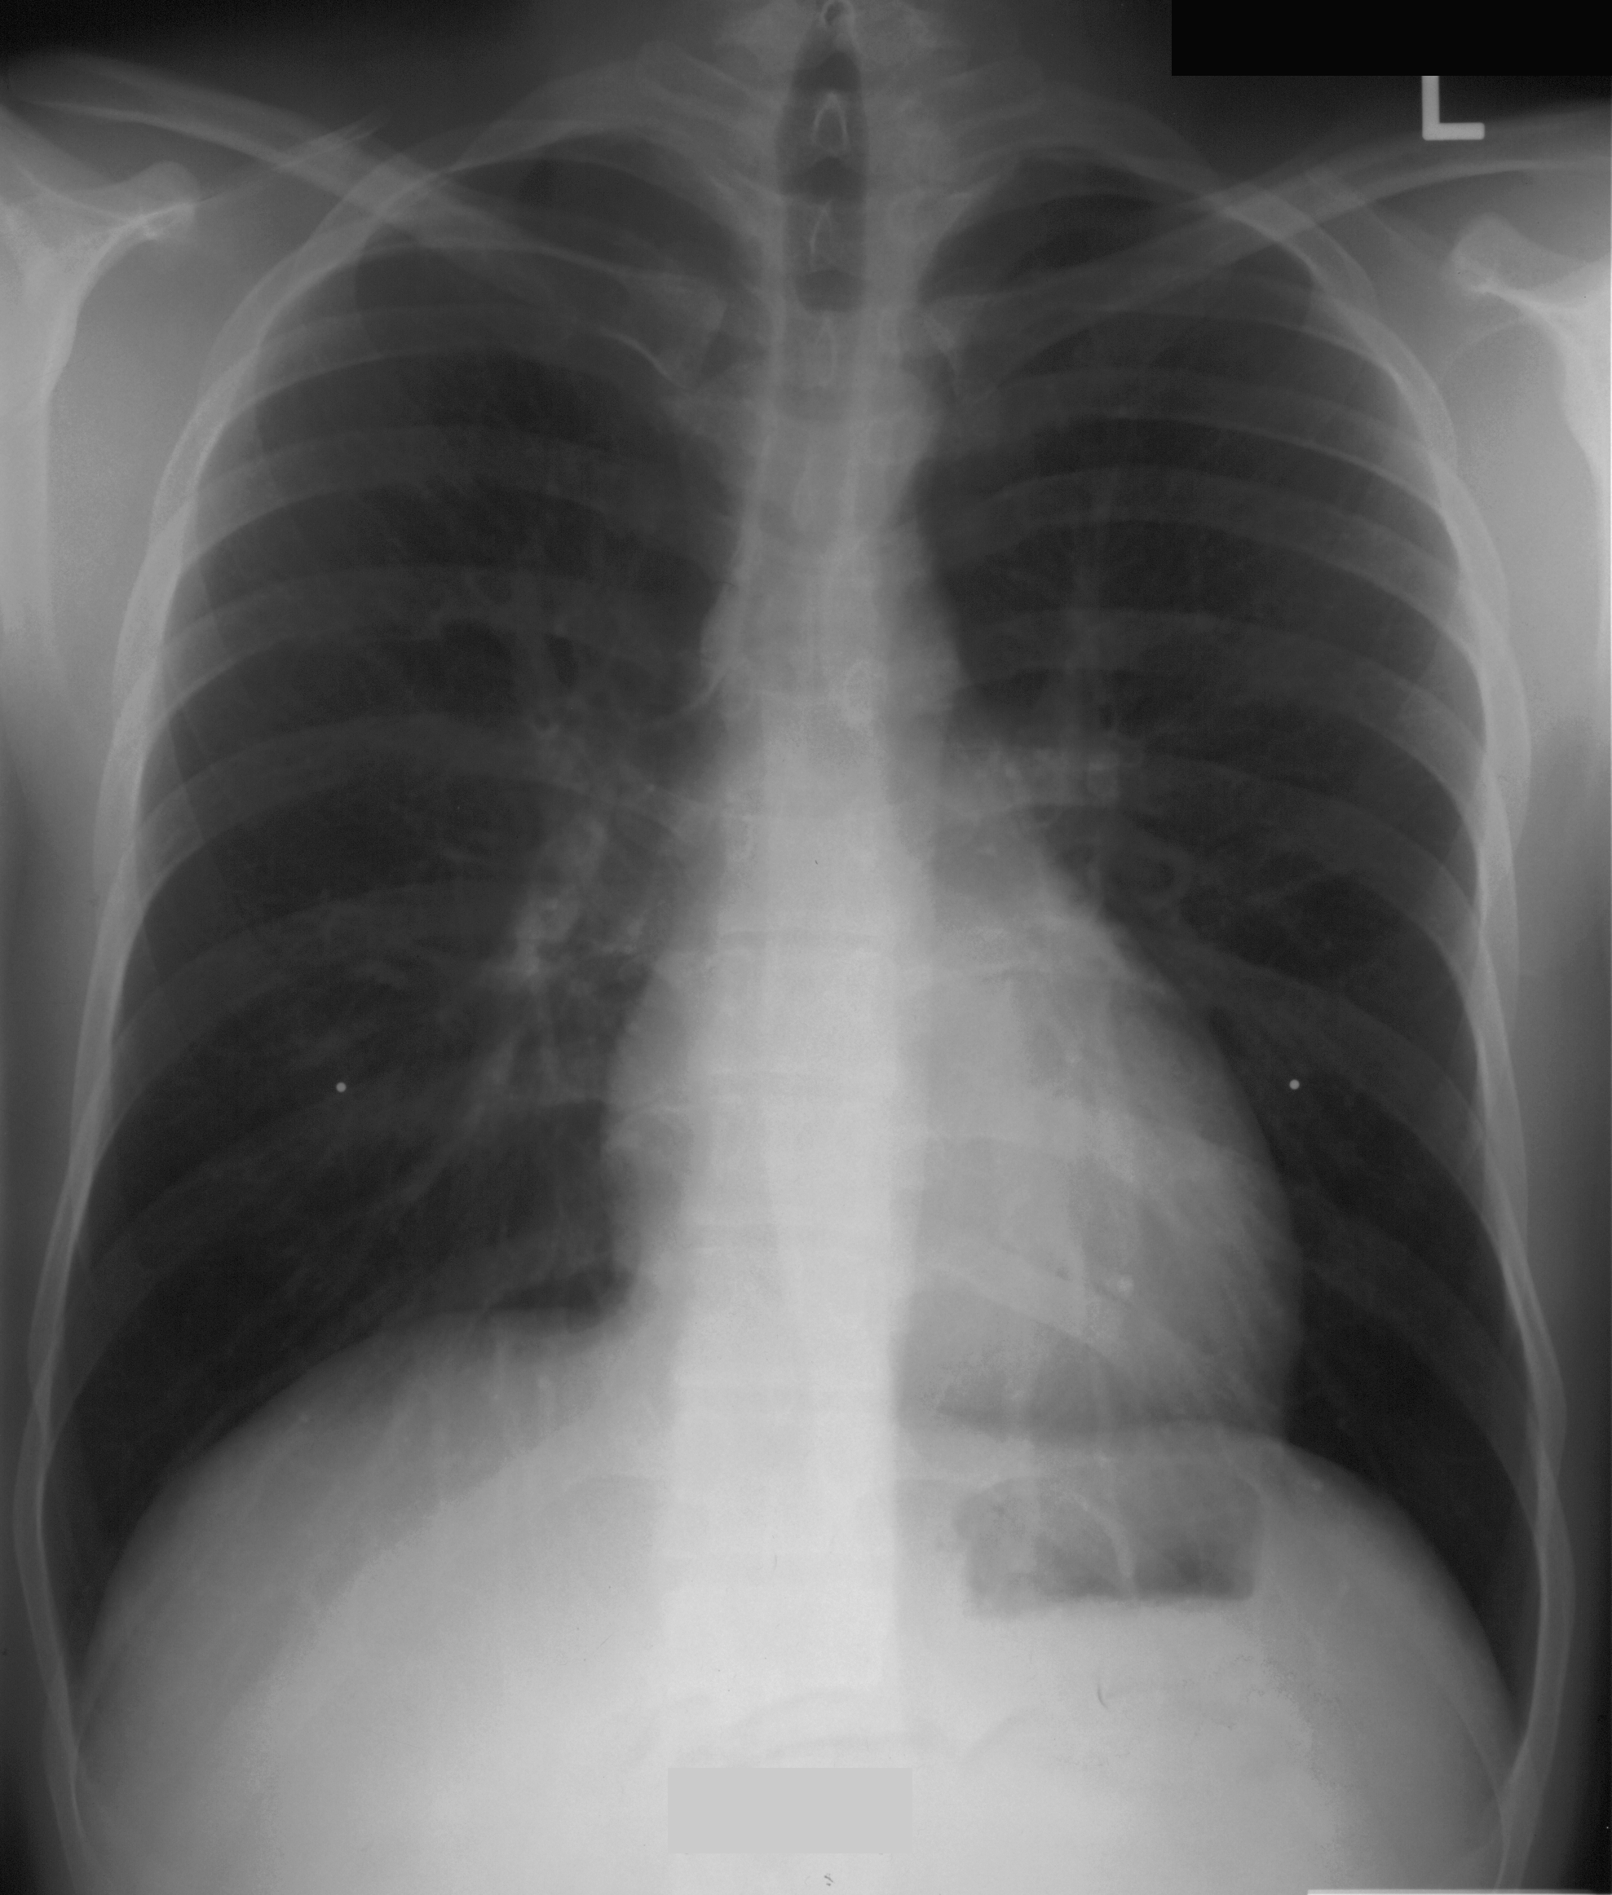

Post- intubation CXR
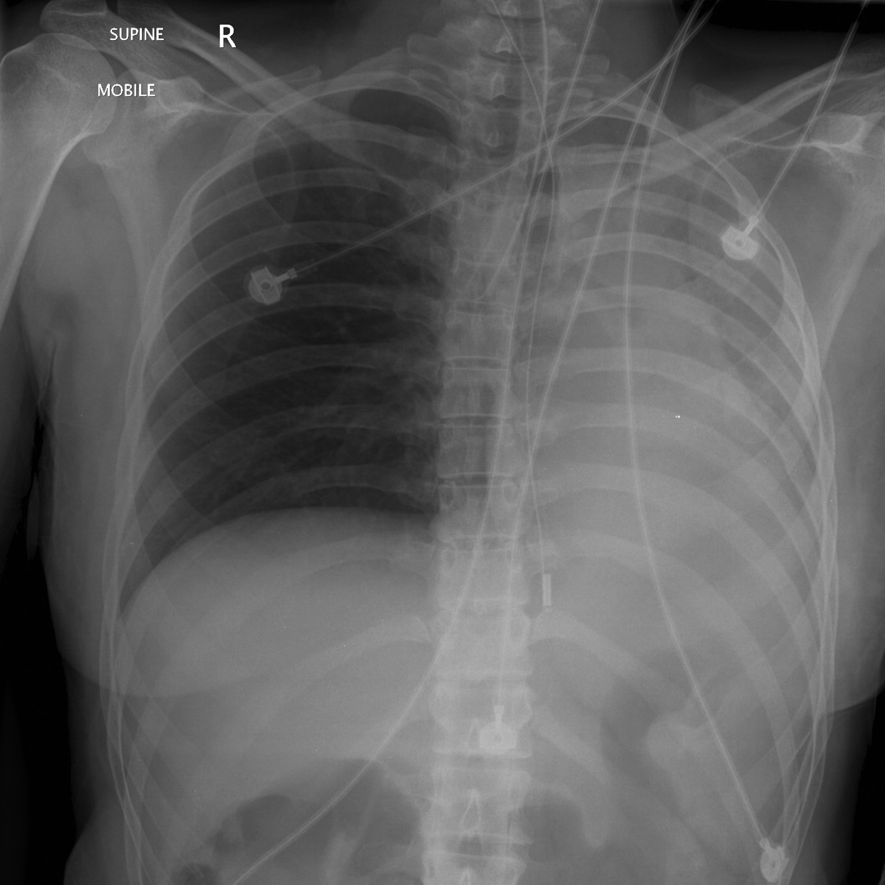

LABS – click here OR fill out below
LABORATORY INITIAL LABS Lab Summary Report

Test | INITIAL LABS | Flag (H or L) | Reference
CBC
WBC | 22 | H | 3.5 – 10.8 10^9/L
Hgb | 100 | L | 130 – 170 g/L
Platelets | 550 | H | 150 – 400 10^9/L
Chemistry
Na | 130 | L | 137 – 145 mmol/L
K | 6.7 | H | 3.5 – 5.0 mmol/L
Cl | 110 | H | 98 – 107 mmol/L
Urea | 7.6 | H | 2.5 – 6.1 mmol/L
Creat | 110 | H | 62 – 106 umol/L
Glucose - Random | 4.0 |  | 3.0 – 11.0 mmol/L
CK | 1200 | H | 5 – 130 U/L
Coags
INR |  |  | 0.9 – 1.2
PTT |  |  | 28 – 38 s
ABGs
Arterial
pH |  |  | 7.35- 7.45
pCO2 |  |  | 35 – 45 mmHg
PO2 |  |  | 80-100 mmHg
BE |  |  | -2.0 to +2.0 mmol/L
HCO3 |  |  | 22 – 26 mmol/L
O2 Sat |  |  | 95 – 100%

LABORATORY REPEAT LABS Lab Summary Report

Test | REPEAT LABS | Flag (H or L) | Reference
CBC- Pending
WBC |  |  | 3.5 – 10.8 10^9/L
Hgb |  |  | 130 – 170 g/L
Platelets |  |  | 150 – 400 10^9/L
Chemistry
Na | 131 | L | 137 – 145 mmol/L
K | 8.2. | H | 3.5 – 5.0 mmol/L
Cl | 102 |  | 98 – 107 mmol/L
Urea | 9.0 | H | 2.5 – 6.1 mmol/L
Creat | 150 | H | 62 – 106 umol/L
Glucose - Random | 4.5 |  | 3.0 – 11.0 mmol/L
CK |  |  | 5 – 130 U/L
Coags
INR |  |  | 0.9 – 1.2
PTT |  |  | 28 – 38 s
ABGs
Arterial
pH | 7.10 | L | 7.35- 7.45
pCO2 | 15 | L | 35 – 45 mmHg
PO2 | 90 |  | 80-100 mmHg
BE | -17 | L | -2.0 to +2.0 mmol/L
HCO3 | 8 | L | 22 – 26 mmol/L
O2 Sat |  |  | 95 – 100%

EKGs

