Case Title | Head and Abdominal Trauma
Scenario Name | Head Injury and Liver Laceration

Learning Objectives - Use action words
Knowledge:
- Review the approach to pediatric trauma : primary and secondary assessment
- Review management of increased ICP with severe head injury
- Review fluid resuscitation in patients with profound blood loss
- Review use of rapid infuser in trauma care
Skills:
- Identify and manage abdominal injury in a trauma patient
- Identify and manage severe head injury in a trauma patient
- Demonstrate airway management
Attitude/Behaviours:
- Demonstrate Team skills
- Demonstrate Situational awareness
- Demonstrate Graded Assertiveness
Scenario Environment
Location | Emergency Department
Monitors | Cardiac, BP, pulse oximeter
Props/Equipment | Rapid Infuser  FAST U/S clips: normal lung slide, free fluid in RUQ  Xray : Pelvis normal  Xray : normal chest, normal cspine  C-collar  Mock blood products for infusion
Make-up/Moulage | Bruising on abdomen, bruising on forehead
Potential Distractors | None

Case Introduction:
8 y.o. boy who was a restrained passenger in the front seat of a sport utility vehicle that was involved in a head on high speed collision on a busy highway. Child wearing lap belt only. Air bags were deployed. Sustained head injury with LOC x 10 minutes and brief seizure (<1 min) on scene. Bruising to abdomen.

Patient Parameters | Effective Management | Notes
Phase 1: Initial Presentation  Condition: Unstable  Moaning in pain. C-collar on.  Initial Assessment  - Heart Rhythm: Sinus Tachycardia  - HR: 150  - BP: 85/50  - RR: 30  - SP02: 96% on RA  - T: 36.0 C  - CNS: GCS 10. Moaning in pain, doesn’t answers questions. C-spine collar on patient. PERL.  - Chest: clear  - CVS: Cap refill 4 secs, pulses palpable but weak  - GI: Bruising all over abdomen. Abdomen soft, BS absent, tender all over abdomen (moans in pain)  - GU: No blood at meatus of genitalia  - H/N: C-spine non-tender. Bruising to forehead  - MSK: Pelvis stable. MSK normal.  - Back: Good rectal tone, no tenderness.  - Weight: 20 kg (but should be determined per Broselow for unstable child) | - Take a focused history (see Notes column)  - Medical Management  - Airway:  - Assesses airway and talks to the patient  - Maintains C-spine precautions  - Suctions airway as needed  - Breathing:  - Checks oxygen saturation  - Auscultates the chest  - Checks for adequacy of chest rise  - Apply monitors  - Applies oxygen by simple mask  - Circulation:  - Checks pulse, cap refill, BP  - Identifies the rhythm of ST  - Monitors (if not done yet)  - Attempt IV access (unable to obtain – must insert IO)  - Asks for rapid infuser and bolus 20 mL/kg NS  - Does FAST  - Other:  - Activates trauma team  - Applies warm blankets  - Calls PTN  - Orders trauma bloodwork including type and cross for 4 units or asks for 4 units of O-blood stat or activates MHP | - Focused history  - Upon EMT arrival, HR-120, RR-40, BP-110/70, O2 sat-95%  - Initially GCS 10/15  - Extraction took 10 min in total  - IV x 1 antecubital  - Given NS 1 L wide open  - Transport time 15 minutes  PMHx  - Healthy  - Immunization up to date  Meds  - None  Allergies  - None
Phase 2: Condition Worsens  Condition: Unstable  The patient’s condition has worsened slightly. BP lower. Unresponsive with occasional moan. Gag lost.  Physical Examination  - Heart Rhythm: Sinus Tachycardia  - HR: 170  - BP: 80/40  - RR: 40  - SP02: 100% with oxygen by mask  - T: 36.0 C  - CNS: GCS 8. C-collar on.  - Chest: trachea midline, chest clear  - CVS: Cap refill 5 secs, pulses palpable but weak, color mottled | - Patient Reassessment (see Notes column)  - Medical Management  - Airway:  - Maintains C-spine, continues talking to patient  - Prepares to intubate due to decreasing LOC  - Orders drugs for RSI  - Pre oxygenates  - Prepares equipment and ET CO2  - Atropine 0.02 mg/kg  - Lidocaine 1 mg/kg  - Etomidate 0.3 mg/kg  - Succs 1.5 – 2 mg/kg  - Checks tube placement post intubation, orders CXR if intubation is carried out  - Breathing:  - Auscultates chest  - Continues to give oxygen and monitor sats  - Circulation:  - Asks for second bolus of 20 mL/kg of NS through second IV  - Reaffirms need for rapid infuser  - Orders blood (not yet arrived)  - Does FAST if not yet completed  - Other:  - Pain control: Morphine 0.1 mg/kg  - Stat consultation: General Surgery and Neurosurgery  - Orders xrays: C-Spine, Chest, Pelvis  - Inserts NG tube  - Inserts Foley catheter  - Calls PTN if not yet done. | - Patient Reassessment  Airway  - Decreasing LOC, must intubate.  Breathing  - Chest clear  Circulation  - Profoundly tachycardic, BP dropping, cap refill 5 secs, pulses palpable but weak, skin mottled

Insert more lines if more phases required.

Expected Patient Management | Debriefing Points
- Student

- R1

- Senior IM resident

References:

FAST Ultrasound:

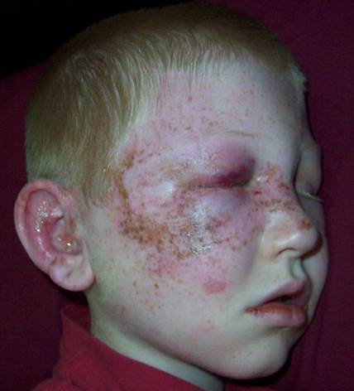

X-RAYS – Click here

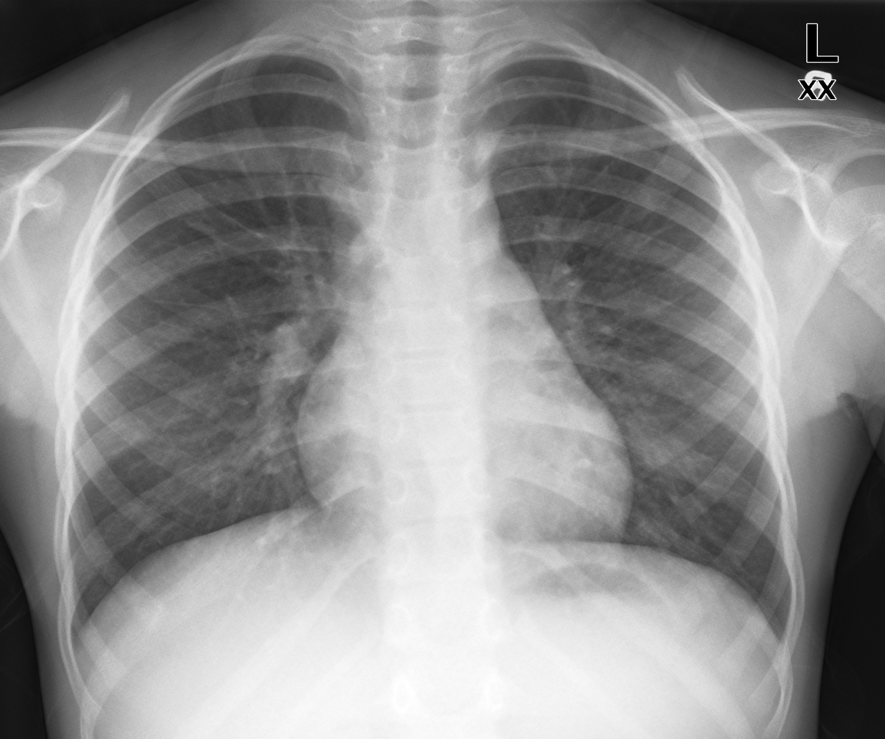

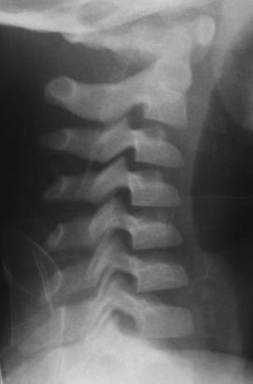

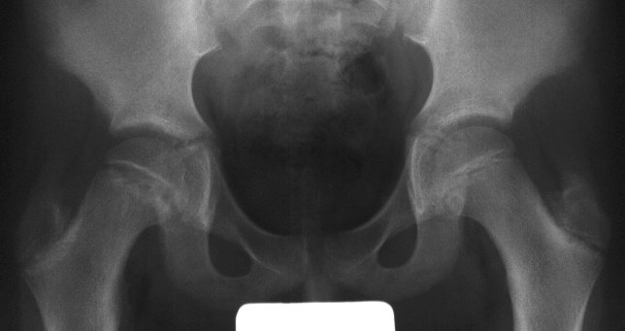
LABS – click here OR fill out below
LABORATORY *LIVE* Lab Summary Report

Test | DATE/TIME here | Flag (H or L) | Reference
CBC
WBC | 15.5 | H | 3.5 – 10.8 10^9/L
RBC |  |  | 4.3 – 5.7 10^12/L
Hgb | 70 | L | 130 – 170 g/L
HCT |  |  | 0.37 – 0.47 L/L
Platelets | 500 | H | 150 – 400 10^9/L
Chemistry
Na | 135 | L | 137 – 145 mmol/L
K | 4.5 |  | 3.5 – 5.0 mmol/L
Cl | 103 |  | 98 – 107 mmol/L
HCO3 |  |  | 22-26 mmol/L
Urea | 4.2 |  | 2.5 – 6.1 mmol/L
Creat | 46 | L | 62 – 106 umol/L
GFR Est |  |  | > 60 ml/min
Glucose - Random | 4.6 |  | 3.0 – 11.0 mmol/L
Lactate |  |  | 0.9 – 1.8 mmol/L
CK |  |  | 5 – 130 U/L
Troponin |  |  | <0.03 mcg/L
Coags
INR | 1.2 |  | 0.9 – 1.2
PTT | 42 | H | 28 – 38 s
ABGs
Arterial
pH | 7.20 | L | 7.35- 7.45
pCO2 | 40 | H | 35 – 45 mmHg
PO2 | 80 |  | 80-100 mmHg
BE | -15 | L | -2.0 to +2.0 mmol/L
HCO3 | 10 | L | 22 – 26 mmol/L
O2 Sat |  |  | 95 – 100%

