Case Title | Tramuma – Smoke Inhalation
Scenario Name | Smoke Inhalation, Burn, CO poisoning, CN poisoning, Head inury?

Learning Objectives - Use action words
Knowledge:
- Identify the importance of airway management with smoke inhalation
- Recognize the importance of fluid resuscitation with severe burn injuries
- Understand the presentation and risk factors for CO poisoning
Skills:
- Demonstrate effective management of CO poisoning
- Demonstrate effective management of cyanide poisoning
Attitude/Behaviours:
- Demonstrate Team skills
- Demonstrate Situational awareness
- Demonstrate Graded Assertiveness
Scenario Environment
Location | ED
Monitors | Bedside monitor
Props/Equipment | IV equipment and meds  Intubation equipment  Dressing supplies  C-spine collar
Make-up/Moulage | Burns, soot, scalp laceration and bleeding
Potential Distractors

Case Introduction:
6 year old boy, was stuck in his room during a house fire. When firefighters arrived, he was found underneath his bed, which had collapsed on top of him. His 75 year old grandmother passed away during the fire. Brought to hospital by the paramedics in a C-spine collar. Vomited twice en route to hospital.

Patient Parameters | Effective Management | Notes
Phase 1: Presentation to ED  Condition: : Confused, disoriented.  Soot around mouth/lips; second degree burns to cheeks. C-spine collar in place. Neck not tender. Bleeding laceration and hematoma on scalp; HS normal. Second and third degree burns on legs and arms, but no burns on chest/abdomen or back  Initial Assessment  - Heart Rhythm: ST  - HR: 170  - BP: 100/P  - RR: 40  - SP02: 94% RA  - T: 35  - CNS: Awake, confused, disoriented. Talking. Following commands occasionally. Screaming in pain when touched.  - Chest: clear,no obv stridor.  - CVS: cap refill 3 seconds  - GI: clear  - Weight: 20 kg | - Take a focused history and assessment(see Notes column)  - Medical Management  - Apply monitors  - Orders bloodwork : arterial blood gas, lactate, lytes, BUN, Cr, CBC, LFTs, glc, crossmatch, CO level  - Orders imaging : CXR, Cspine and pelvis xrays  - Gives analgesia : Morphine 0.1 mg/kg IV and considers infusion  - Mentions need to insert foley catheter to monitor urine output  - Attends to scalp laceration by direct pressure and proper dressing +/- staples  - Identifies rest of burn injuries, and risk for compartment syndrome in arms  - Acknowledges need to dress wounds eventually  A  - Prepares equipment for intubation and calls for RT and anesthesia help  B  - Apply 100% oxygen  C  - Inserts IV x 2  - Gives NS bolus 20 cc/kg Asks for cycling BP’s  - Identifies rest of burn injuries, and risk for compartment syndrome in arms  - Acknowledges need to dress wounds eventually | - Focused history  - Parents taken to different hospital with severe burn injuries  - Infant sister on the way to hospital as well  PMHx  - Previously healthy  - Immunizations up to date  Meds  - Nil  Allergies  - NKA  Airway  - Clears / suctions the airway  - Head tilt, chin lift  - Maintains Cspine precautions  - Identifies soot around mouth and potential need for early intubation  Breathing  - Check oxygen saturation, ausculatate chest  - Identifies patient is at risk for CO poisoning  Circulation  - VS, identify rhythm  - Identifies that patient is at risk for fluid loss due to burns and potential abdominal injury  Other  - Checks AVPU / GCS  - Exposes patient completely to conduct a secondary survey
Phase 2: Deterioration  Condition: Condition deteriorates as he becomes more drowsy and unresponsive (CO poisoning). Mild stridor. Desaturating. Airway swollen.  Physical Examination  - Heart Rhythm: ST  - HR: 170  - BP: 80/P  - RR: 40  - SP02: 90% with O2  - T: 35  - CNS: obtunded, non responsive, GCS 11, cspine collar on patient, pupils 4 mm and reactive  - Chest: Mild stridor, airway swollen  - CVS: cap refill 4 secs, pulses normal  - GI: soft, no change | - Patient Reassessment (see Notes column)  - Medical Management  - Sedates patient with midazolam 0.1 mg/kg  - Conisders maintenance of paralysis with pancuronium or rocuronium until transfer for definitive care  - Asks for ICU, neurosurgery, general surgery consultation, radiology, plastic surgery  - Thinks about need to call hyperbaric MD on call if CO level is elevated (decreasing LOC)  A  - Intubation (see notes)  B  - Checks tube placement by assessing chest rise, air entry, end tidal CO2, position at lips, CXR  - Secures ETT  C  - Gives second bolus of 20 cc / kg NS | - Patient Reassessment  Airway  - Stridor. Airway swollen  - Check gag and consider use of oropharyngeal airway  - Rocognize need for advanced airway  Breathing  - Desaturation  Circulation  - Lower BP  Intubation  - Intubates patient with small endotracheal tube as airway is markedly swollen with laryngospasm  - Preoxygenation  - Premedication : atropine 0.02mg/kg  - Cricoid pressure  - Sedation : etomidate 0.3 mg/kg or ketamine 1mg/kg  - Paralysis : succs 2 mg/kg vs. no succs (impending airway obstruction)
Phase 3: Intubated  Condition: Intubated and sedated. BP is falling from third spacing of fluids, and patient’s bloodwork comes back suggesting there may be an element of CN poisoning.  Physical Examination  - Heart Rhythm: ST  - HR: 160  - BP: 85/P  - RR: 16 (ventilated )  - SP02: 96% (ventilated)  - T: 35  - CNS: PERL @ 4 mm. Sedated.  - Chest: clear  - CVS: cap refill 4 secs | - Patient Reassessment (see Notes column)  - Medical Management  - Coordinates care and determines order of tests  - Identifies main issues  - Decreasing LOC : will need CT head to r/o head injury  - Cspine : not cleared, will likely need CT  - CO poisoning : will need hyperbaric therapy and 100% oxygen in the meantime  - Burns : pain control and dressing required  - Acidosis : Consider Cyanide poisoning, need to treat patient for this :  - Amyl nitrate  - Sodium nitrite  - Sodium thiosulfate | - Patient Reassessment  Airway  - Intubated – secure airway  Breathing  - Assess air entry and chest rise  - Assess ET CO2  Circulation  - Recognizes falling BP  - Identifies need for 3rd bolus of NS  - Identifies need for more fluid in future
Phase 4: BP Stabilizing  Condition: Intubated and sedated. BP is stabilizing after 3rd bolus.  Physical Examination  - Heart Rhythm: ST  - HR: 150  - BP: 95/P  - RR: 16 (ventilated)  - SP02: 96% (ventilated)  - T: 36  - Chest: clear | - Patient Reassessment (see Notes column)  - Medical Management  - Coordinates care and determines order of tests  - Determines sequence of testing  - Arranges CT head / neck  - Calls ENT to arrange for tympanostomy tubes  - Arranges for hyperbaric therapy to occur at VGH  - Addresses pain control by increasing morphine infusion  - Dresses burn properly  - Maintains Cspine control  - Directs administration of therapy for CN poisoning and calls DPIC (poison control) | - Patient Reassessment  Airway  - Intubated and sedated  Breathing  - Assesses breathing  Circulation  - Identifies improvement in BP  - Orders more blood and fluid  - Monitors urine output  - Considers insertion of arterial line

Insert more lines if more phases required.

Expected Patient Management | Debriefing Points
- Student

- R1

- Senior IM resident

References:

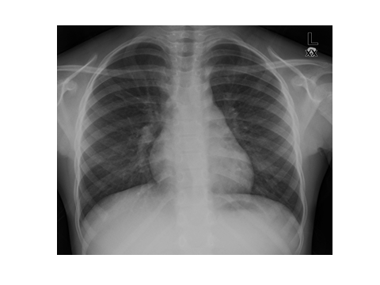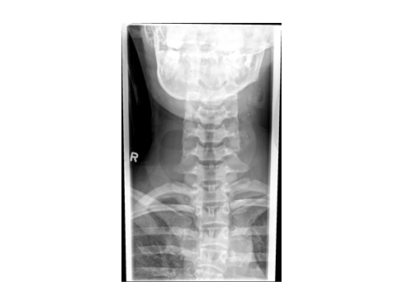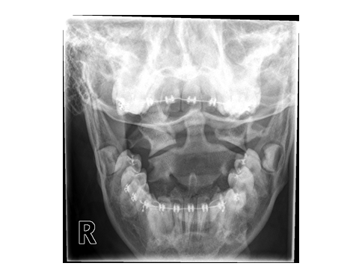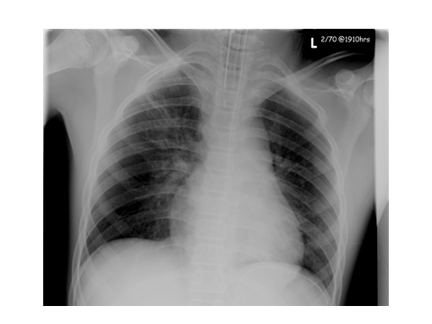

LABS – click here OR fill out below

LABORATORY *LIVE* Lab Summary Report

Test | DATE/TIME here | Flag (H or L) | Reference
CBC
WBC | 18 | H | 3.5 – 10.8 10^9/L
Hgb | 110 | L | 130 – 170 g/L
Platelets | 450 | H | 150 – 400 10^9/L
Chemistry
Na | 131 | L | 137 – 145 mmol/L
K | 5.5 | H | 3.5 – 5.0 mmol/L
Cl | 103 |  | 98 – 107 mmol/L
Urea | 5.7 |  | 2.5 – 6.1 mmol/L
Creat | 80 |  | 62 – 106 umol/L
Glucose - Random | 3.5 |  | 3.0 – 11.0 mmol/L
Lactate | 11 | H | 0.9 – 1.8 mmol/L
Other
CO | 0.38
ABGs
Arterial
pH | 7.05 | L | 7.35- 7.45
pCO2 | 25 | L | 35 – 45 mmHg
PO2 | 90 |  | 80-100 mmHg
BE | -18 |  | -2.0 to +2.0 mmol/L
HCO3 | 7 | L | 22 – 26 mmol/L
O2 Sat |  |  | 95 – 100%

LABORATORY *LIVE* Lab Summary Report

Test | DATE/TIME here | Flag (H or L) | Reference
Chemistry
Na | 131 | L | 137 – 145 mmol/L
K | 8.2 | H | 3.5 – 5.0 mmol/L
Cl | 102 |  | 98 – 107 mmol/L
Glucose - Random | 4.5 |  | 3.0 – 11.0 mmol/L
ABGs
Arterial
pH | 7.10 | L | 7.35- 7.45
pCO2 | 15 | L | 35 – 45 mmHg
PO2 | 90 |  | 80-100 mmHg
BE | -17 |  | -2.0 to +2.0 mmol/L
HCO3 | 8 | L | 22 – 26 mmol/L
O2 Sat |  |  | 95 – 100%

EKGs – click here or paste

