Case Title | Pelvic and Femur Fracture
Scenario Name | Pelvic and Femur Fracture

Learning Objectives - Use action words
Knowledge:
- Describe the approach to pediatric trauma: Primary and secondary assessment
- Review fluid resuscitation in patients with profound blood loss
- Review use of rapid infuser in trauma care
Skills:
- Demonstrate management of pelvic and femur fractures
- Demonstrate and practice use of rapid infuser
Attitude/Behaviours:
- Demonstrate Team skills
- Demonstrate Situational awareness
- Demonstrate Graded Assertiveness
Scenario Environment
Location | ED
Monitors | Bedside
Props/Equipment | - Rapid Infuser  - C-collar  - Blood in bag for infusion  - Intubation equipment  - Towel/sheet for pelvis stabilization
Make-up/Moulage | Bruising over left temporal area, lower abdomen, and left thigh
Potential Distractors | None

Case Introduction:
6 yr old girl was a back seat passenger in a car, belted. Car t-boned from the left side causing major damage to that side of the car. The car went over embankment, slid down a hill, rolling over several times. Witnesses were on scene, ambulance arrived within 8mins. The driver (father) was dead at the scene and mother was taken to adult trauma center with non-life threatening injuries.

Patient Parameters | Effective Management | Notes
Phase 1: Arrival in ED  Condition: Moaning in pain. C-Spine collar on.  Initial Assessment  - Heart Rhythm: ST  - HR: 160  - BP: 85/50  - RR: 30  - SP02: 95% RA  - T: 36  - CNS: GCS 13 (spont eye opening, delirious but seems to answer some questions, localizes pain). Moaning in pain, answers some questions, asking for mom, confused at times. Bruising to lt temporal area. C-spine not tender  - Chest: Clear  - CVS: cap refill 4 secs, pulses palpable but weak  - GI: Diffuse bruising to lower abdomen  - MSK: Tender over left thigh with overlaying bruising and ecchymosis  - Weight: 20 kg | - Take a focused history (see Notes column)  - Medical Management – Primary Survey Management  - Activates trauma team  - Applies warm blankets  Airway  - Assesses airway and talks to the patient  - Clears / suctions the airway as needed  - Maintains C-spine precautions  Breathing  - Apply monitors  - Auscultates chest  - O2 by face mask  - Check for adequacy of chest rise  Circulation  - Checks pulse, cap refill, BP  - Checks first IV line, asks for second large bore IV  - Asks for rapid infuser and bolus 20 mL/kg NS  - Orders trauma bloodwork including type and cross for 4 units or asks for 4 units of O-blood stat | - Focused history  - Upon EMT arrival, HR 120 RR 40, BP 116/76, O2 sat 95%  - Initially delirious, screaming, GCS 14/15  - Extraction took 30 min in total  - IV x 1 antecubital  - Given NS 1 L wide open  - Obvious hematoma to left temporal area  - Bruising over left leg/thigh  - Transport time 25 minutes  PMHx  - Not available. Not clearly answering questions
Phase 2: Declining BP  Condition: Slightly worse. Worsening BP. GCS unchanged.  Physical Examination  - Heart Rhythm: ST  - HR: 170  - BP: 80/40  - RR: 40  - SP02: 100%O2 by face mask  - T: 36.0 C  - CNS: unchanged. GCS 13. Moaning in pain, answers some questions, asking for mom, confused at times  - Chest: clear  - CVS: cap refill 5 secs, pulses palpable but weak  - MSK: tender over left thigh with overlying bruising and ecchymosis, bruising over lower abdomen and pelvis (seatbelt). Pelvis extremely tender and unstable upon assessment | - Patient Reassessment (see Notes column)  - Secondary Survey  - Medical Management  - Pain control : morphine 0.1 mg/kg IV  - Stabilize Pelvis with towel wrap  - Stat consultation : orthopedics  - Orders xrays (c-spine, chest, pelvis, leg)  - Orders blood (not arrived yet)  - Asks for second bolus of 20 mL/kg of NS through second IV  - Reaffirms need for rapid infuser  - Inserts NG tube  - Discusses need for foley, but does not insert | - Patient Reassessment  Airway  - C-collar in place  - Airway protected  Breathing  - Tacypneic  Circulation  - Hypotension and tachycardia  Secondary Survey  - H/N – PERL, hematoma over left temporal side, otherwise N  - Chest – trachea midline, chest clear  - CVS – profoundly tachycardic, color mottled now, pulses weak and cap refill 5 seconds  - Abdomen - soft. BS absent. Tender over lower abdomen (screams in pain)  - Pelvis – very unstable. Screams in pain  - Genitalia – no blood at meatus  - MSK – swelling and tenderness over left thigh with bruising  - Back – good rectal tone, no tenderness
Phase 3: Rapid Deterioration  Condition: hypotension, decreasing LOC – eyes closed.  Physical Examination  - Heart Rhythm: ST  - HR: 180  - BP: 70/40  - RR: 40  - SP02: 100% O2 by mask  - T: 36  - CNS: GCS 9 (eyes closed-1, moans and screams with painful stimuli-3, localizes pain-5). No longer moaning in pain, does not answer some questions. Eyes closed.  - Chest: clear  - CVS: cap refill 5 secs, pulses palpable but weak  - GI: Bruising all over lower abdomen | - Patient Reassessment (see Notes column)  - Medical Management  - Intubates (see Notes column)  - Orthopedics arrives – will take patient to OR  - Discuss need for CT head / neck / chest / abdomen  - Will likely need CT abdomen / pelvis  - Discuss need for CT cystogram or retrograde urethrogram and urology consult  - Discuss need to stabilize femur with thomas splint (may disturb pelvis)  - Orders 3rd bolus of NS 20 cc/kg and more blood (O neg if crossmatch not available) | - Patient Reassessment  Airway  - At risk due to decr LOC  Breathing  - Tachypneic  Circulation  - Worsening shock  Intubation  - Orders drugs for RSI  - Pre oxygenates  - Prepares equipment and ET CO2  - Atropine 0.02 mg/kg  - Etomidate 0.3 mg/kg  - Succs 1.5 – 2 mg/kg  - Checks tube placement post intubation  - orders CXR to confirm tube placement

Insert more lines if more phases required.

Expected Patient Management | Debriefing Points
- Student

- R1

- Senior IM resident

References:

X-RAYS – Click here

Xray results
- Open book fracture pelvis
- Left sided femur fracture
- All other xrays normal

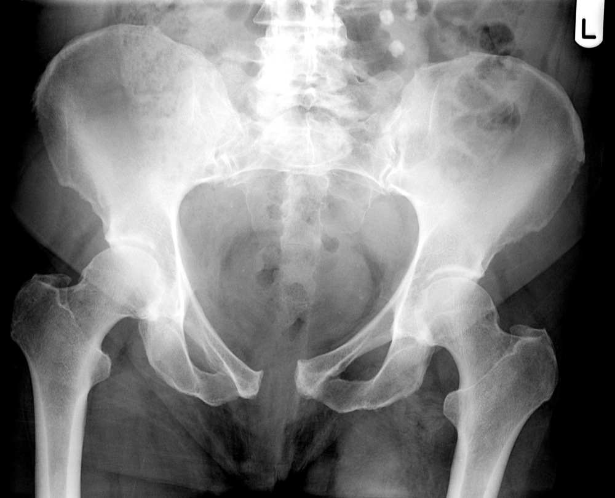

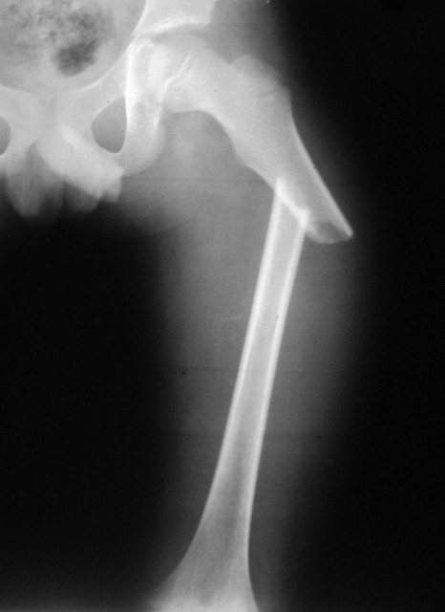

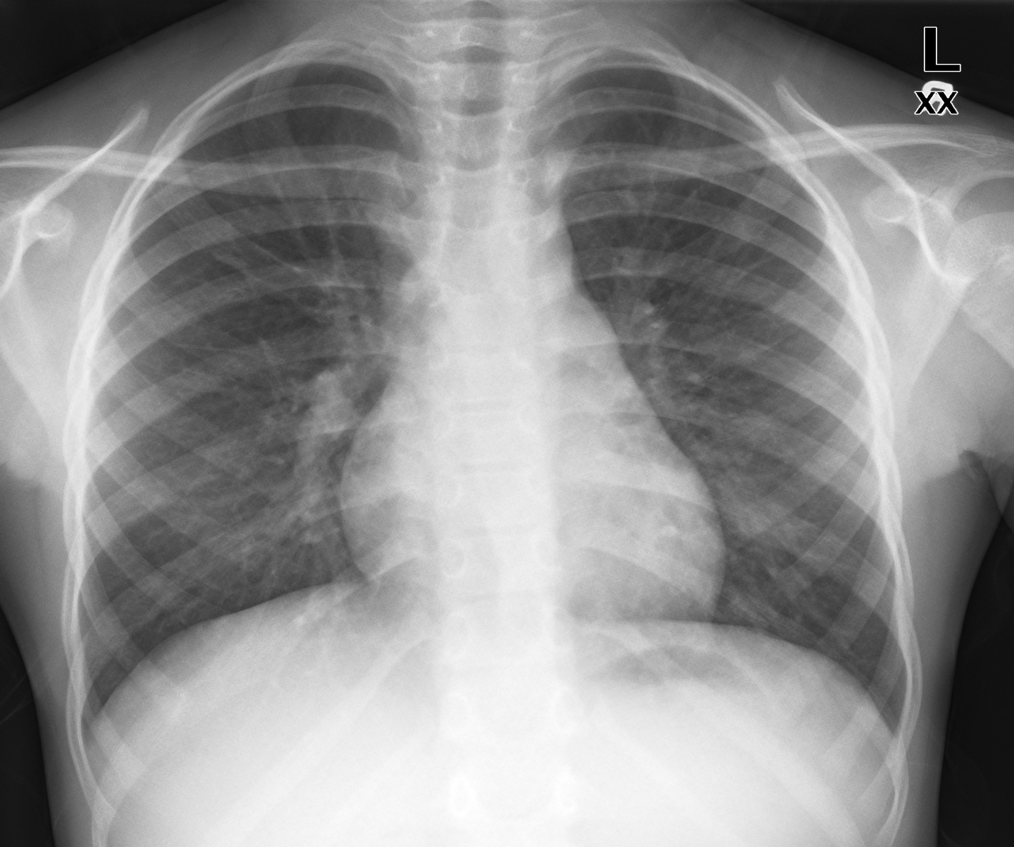

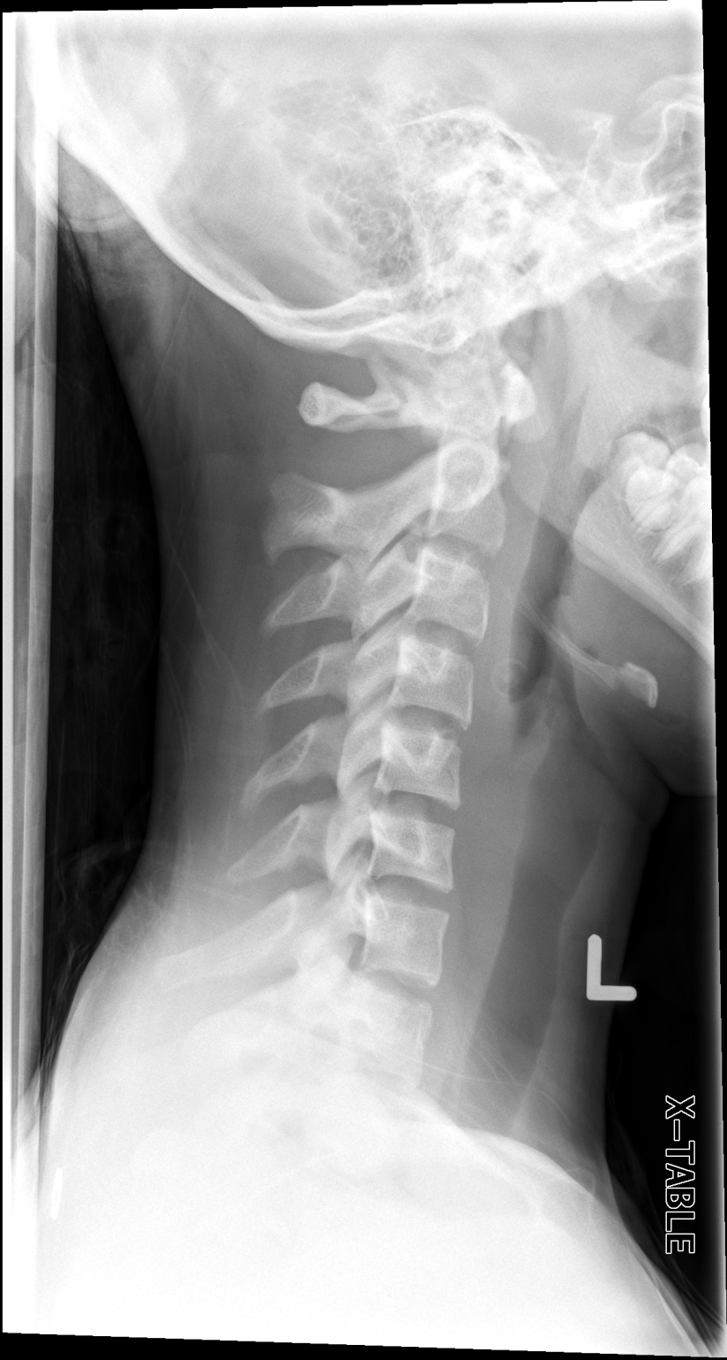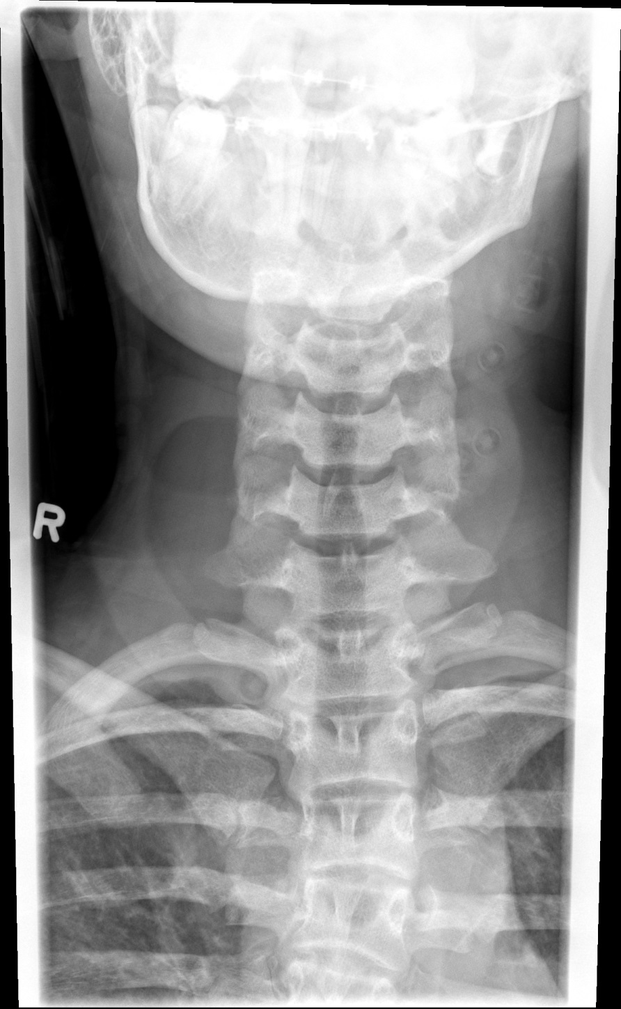
LABS – click here OR fill out below

LABORATORY *LIVE* Lab Summary Report

Test | DATE/TIME here | Flag (H or L) | Reference
CBC
WBC | 12.5 | H | 3.5 – 10.8 10^9/L
Hgb | 80 | L | 130 – 170 g/L
Platelets | 500 | H | 150 – 400 10^9/L
Chemistry
Na | 140 |  | 137 – 145 mmol/L
K | 5.0 |  | 3.5 – 5.0 mmol/L
Urea | 6.2 | H | 2.5 – 6.1 mmol/L
Creat | 46 | L | 62 – 106 umol/L
Glucose - Random | 9.5 |  | 3.0 – 11.0 mmol/L
Coags
INR | 1.2 |  | 0.9 – 1.2
PTT | 46 | H | 28 – 38 s
ABGs
Arterial
pH | 7.24 | L | 7.35- 7.45
pCO2 | 40 |  | 35 – 45 mmHg
PO2 | 56 | L | 80-100 mmHg
BE | -10 | L | -2.0 to +2.0 mmol/L
HCO3 | 15 | L | 22 – 26 mmol/L
O2 Sat |  |  | 95 – 100%

EKGs – click here or paste

