Case Title | Ruptured Ectopic Pregnancy
Scenario Name

Learning Objectives - Use action words
Knowledge:
- Recognize the presentation of ectopic pregnancy
- Describe the management of hemorrhagic shock
Skills:
- Perform resuscitation of hemorrhagic shock
Attitude/Behaviours
- Demonstrate Team skills
- Demonstrate Situational awareness
- Demonstrate Graded Assertiveness
Scenario Environment
Location | ER
Monitors | Telemetry, crash cart
Props/Equipment | Bedside ultrasound
Make-up/Moulage | None
Potential Distractors | None

Case Introduction:
29 yo female presents to emergency complaining of RLQ pain and dizziness. CTAS 3, Triaged to streaming.

Patient Parameters | Effective Management | Notes
Phase 1: Abdominal Pain  Condition: Stable  No distress  Initial Assessment  - Heart Rhythm: Sinus Tachycardia  - HR: 112  - BP: 108/65  - RR: 12  - SP02: 100%  - T: 36.4 C  - Glucose: 6.2  - Chest: Normal  - CNS: GCS 15  - CVS: cap refill 3 secs  - GI: RLQ tenderness with peritonitis  - Weight: 62 kg  - Height: 165 cm | - Take a focused history (see Notes column)  - Medical Management  - Monitor  - 2x large bore IV  - NPO, IV fluids  - EP, BHCG, UA  - Type and screen  - Bedside US  - Consult Gyne STAT  Consequences of ineffective management  - Progress to Phase 2 (Deterioration) if diagnosis of ruptured ectopic NOT recognized | - Focused history  - OPQRST, RLQ pain intermittent x5 days, orthostatic lightheadedness x4 hrs with increased pain, LNMP 7 weeks ago  PMHx  - Renal colic x2  - G2P2A0  - tubal ligation 2 yrs ag  - no previous STIs/ PID/ ectopic  Meds  - None  Allergies  - None
Phase 2: Deterioration  Condition: Unstable  Patient deteriorates until diagnosis of ruptured ectopic recognized.  Physical Examination  - Heart Rhythm: Sinus Tachycardia  - HR: 140  - BP: 76/42  - RR: 22  - SP02: 93% on RA  - CNS: GCS 15  - CVS: cap refill 5 secs  - GI: Increased RLQ tenderness with peritonitis | - Patient Reassessment (see Notes column)-Recognizes change in condition  - Medical Management:  - Consult to Gyne STAT  - IV fluids | - Patient Reassessment  Airway  - Maintaining own  Breathing  - Decreased sats- apply O2  Circulation  - Absent peripheral pulses

Expected Patient Management | Debriefing Points
- Student

- R1

- Senior IM resident

References:

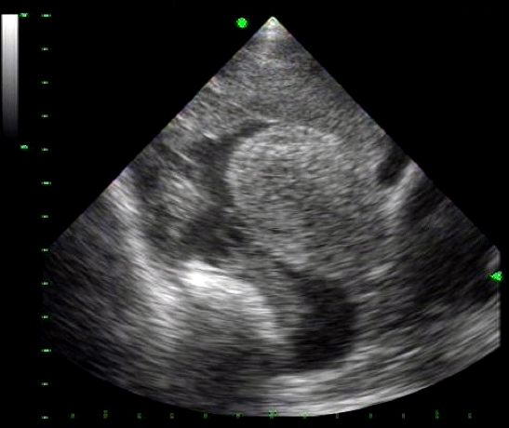
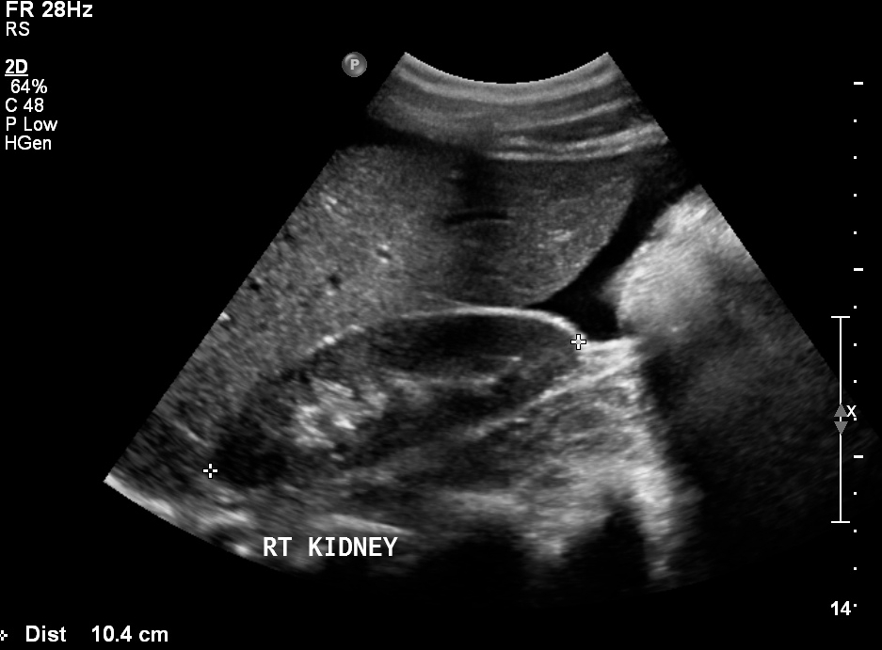

LABS – click here OR fill out below

Test | DATE/TIME here | Flag (H or L) | Reference
CBC
WBC | 11 | H | 3.5 – 10.8 10^9/L
MCV | 90 |  | 0.37 – 0.47 L/L (80-96 fL/rc)
Hgb | 145 | L | 130 – 170 g/L
Platelets | 550 | H | 150 – 400 10^9/L
D-Dimer | Not completed |  | <250 mcg/L
Chemistry
Na | 138 |  | 137 – 145 mmol/L
K | 4.2 |  | 3.5 – 5.0 mmol/L
Cl | 102 |  | 98 – 107 mmol/L
HCO3 | 24 |  | 22-26 mmol/L
Urea | 5.5 |  | 2.5 – 6.1 mmol/L
Creat | 97 |  | 62 – 106 umol/L
GFR Est | 66 |  | > 60 ml/min
Glucose - Random | 6.0 |  | 3.0 – 11.0 mmol/L
BNP | 980 | H | 0 – 99 ng/L
Lactic Acid | 3.7 | H | <2.0 mmol/L
Coags
INR | 1.0 |  | 0.9 – 1.2
PTT | 32 |  | 28 – 38 s
ABGs

EKGs – click here or paste

