Case Title | Acute Respiratory Acidosis
Scenario Name

Learning Objectives - Use action words
Knowledge:
- Describe the evidence for Non Invasive Ventilation, initiate its use and screen for contraindications.
- Utilize the whole team to help, Inspire confidence in your clinical diagnosis and manage the patient

Skills:
- Identify and treat hypercarbic respiratory failure with NIV and commence appropriate treatment
- Identify the most appropriate location for the patient to receive this treatment and what would be objective signs of failure of its use.
Attitude/Behaviours
- Demonstrate Team skills
- Demonstrate Situational awareness
- Demonstrate Graded Assertiveness
Scenario Environment
Location | 6 West
Monitors | None at the beginning, students must as for them
Props/Equipment | Bi-Pap Machine, Airway, Intubation equipment, IV bags with antibiotics, steroids, ECG machine, portable CXR
Make-up/Moulage | None
Potential Distractors | None

Case Introduction:
71 year old transferred from Nakusp (small 6 bed hospital) due to overcapacity. Arrived by inter hospital shuttle not by EMS transfer. Driver says “patient looks much worse now that we have arrived at KGH”. She is a direct to Internal Medicine transfer and the R1 is paged to write admission orders.

Patient Parameters | Effective Management | Notes
Phase 1: Severe Respiratory Distress  Condition: Unstable  “Stable as per EMS transfer summary”  Initial Assessment  - Heart Rhythm: Sinus Rhythm  - HR: 100  - BP: 90/50  - RR: 40  - SP02: 80%  - T: 39 C  - Glucose: 8.0  - Chest: Coarse crackles, some wheeze  - CNS: GCS 15  - CVS: Normal HS  - GI: Normal  - Weight: 60 kg | - Take a focused history (see Notes column)  - Medical Management  - Monitors - Monitors, Oxygen, IV, Call for help if needed  - Take a focused history with pertinent positives and negatives (positive for features of a consolidation syndrome, purulent and productive cough, negative for PE/CHF)  - Identify abnormalities in vital signs and initiate management of IV fluid bolus (500 to 1L given absence of cardiac disease)  - Initiate additional management for investigations - ordering an ECG/Chest Xray/ and ABG  - Synthesize information from stat tests/labwork to make a diagnosis. Be able to correctly identify that the patient has an acute respiratory acidosis that would meet criteria for NIV initiation | - Focused history  - Onset of illness (3 days), productive cough (yellow and green only today), chest pain (none), history of orthopnea/PND (none), No cardiac history, smoker of 1 pack per day for 45 years. No travel, no history of arrhythmia. Talk about RF for PE - she will have none.  PMHx  - COPD  - previous pneumonias  - no heart issues  - Smoker 1 PPD x 45 yrs  - feeling well until this week. Usual exercise capacity is 2 blocks.  Meds  - ‘puffers’  Allergies  - None  Previous Medical Management  - None as of yet, they took bloodwork in Nakusp - results may be back?
Phase 2: Stabilizing Respiratory Distress  Condition: Unstable  Physical Examination  - Heart Rhythm: Sinus Tachycardia  - HR: 110  - BP: 120/80 (post fluid bolus)  - RR: 40  - SP02: 85% with 100% oxygen  - CNS: GCS 15  - Chest: Softer breath sounds, same crackles | - Patient Reassessment (see Notes column)- Student should recognize abnormalities in vital signs - elevated Temp, decreased BP, increased HR and increased WOB  - Medical Management:  - Apply supplemental oxygen to achieve saturations of >95%  - Administer a 500ml-1L fluid bolus. This should have a transient response. The student may clarify if there is a relevant cardiac history (which will be -ve). Therefore a 250ml bolus would be ineffective.  - Identify the most likely cause of shock and initiate management to treat it. Choose an antibiotic that would be indicated (CAP coverage would be respiratory quinolone (levofloxacin/moxifloxacin) or cephalosporin + macrolide (atypical coverage) such as ceftriaxone and azithromycin. If the patient administers broad spectrum antibiotics (carbapenem or piperacillin/tazobactam) then clarify this in the debriefing portion.  - Interpretation of the ECG should rule out acute MI (no ST-T changes, nor chest pain) and should rule out acute right heart strain or long -standing RVH (no Right axis deviation or RBBB). Correct interpretation of the rhythm is Multifocal Atrial Tachycardia (which may be due to COPD or due to the nebulizers she just received!) | - Patient Reassessment  Airway  - Should apply supplementary oxygen. Should comment that there is no stridor and airway is patent  Breathing  - Should comment on coarse crackles and signs of hypoxemia. If the student orders an ABG or CXR - then correct interpretation is expected indicating a RLL infiltrate and an acute respiratory acidosis. The candidate should try to sit the patient forward (try to optimize V/Q) and could try giving a nebulizer.  Circulation  - The student should comment on hypotension and tachycardia and should make attempts to classify the cause of the hypotension (early distributive shock) and tachycardia (fever + shock + decreased effective circulating volume). The candidate should attempt to give a 500cc or 1L fluid bolus.

Expected Patient Management | Debriefing Points
- Student  - Identification of a critically ill patient - takes vitals, applies O2, takes brief/pertinent history and physical examination.  - Involvement of senior physician help/allied health  - Understands limitations - cannot order investigations/lab work/medications  - Synthesizes information in a useful telephone or in-person handover format  - R1  - Acknowledges medical student handover and clarifies pertinent positives/negatives with the patient  - Proceeds with further management / investigations with patient.  - Attempts interpretation of investigations (Labs/ECG/CXR/ABG)  - Refers for senior help as the scope of the patient’s management exceeds that of her current setting  - Senior IM resident  - Acknowledges medical student and resident for their contributions  - Clarifies what treatment has been considered and what has been administered.  - Initiates all suggested ideal management and identifies the need for Non-Invasive Ventilation and the need for Critical Care consultation.  - Demonstrates confidence in team management and patient care. | - See notes at end of case

References:
- UpToDate2014
- Pocket Medicine
- http://www.ncbi.nlm.nih.gov/pmc/articles/PMC3042478/
- BTS GUIDELINE. Non-invasive ventilation in acute respiratory failure. Thorax 2002;57:192-211 © 2002 Thorax.

X-RAYS

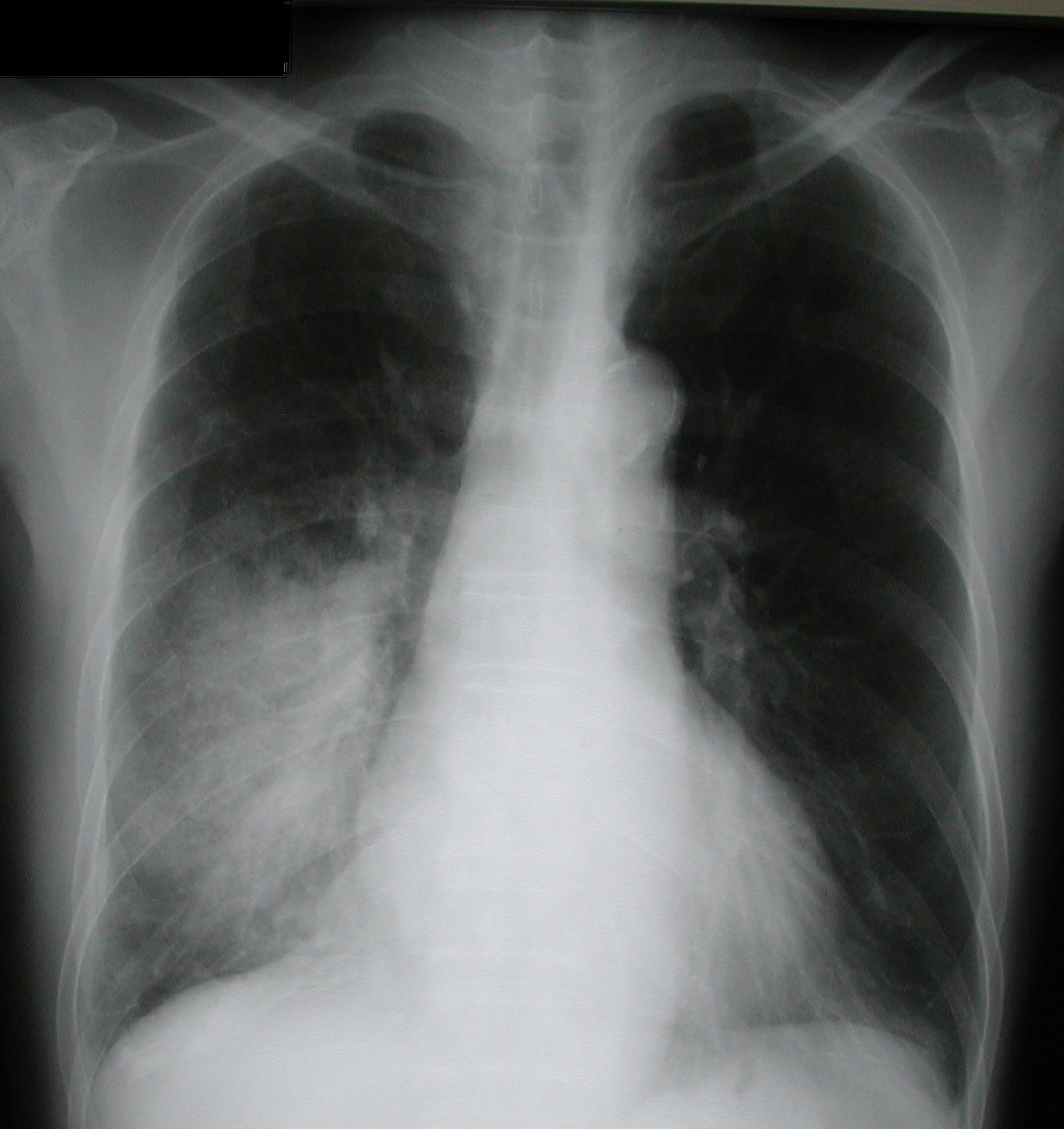

LABS

RUN DATE: Today LABORATORY *LIVE* Lab Summary Report
LOCATION

Test | DATE/TIME here | Flag (H or L) | Reference
CBC
WBC | 19.1 | H | 3.5 – 10.8 10^9/L
Hgb | 120 | L | 130 – 170 g/L
HCT | 82 | L | 0.37 – 0.47 L/L
Platelets | 600 | H | 150 – 400 10^9/L
D-Dimer | -ve |  | <250 mcg/L
Chemistry
Na | 137 | L | 137 – 145 mmol/L
K | 5 | H | 3.5 – 5.0 mmol/L
Cl | 100 |  | 98 – 107 mmol/L
HCO3 | 18 | L | 22-26 mmol/L
Urea | 12 | H | 2.5 – 6.1 mmol/L
Creat | 175 | H | 62 – 106 umol/L
GFR Est | 42 | L | > 60 ml/min
Glucose - Random | 8 |  | 3.0 – 11.0 mmol/L
Lactic Acid | 7 | H | < 2.0 mmol/L
C Reactive Protein | 350 | H | < 10
Coags
INR | 1.3 | H | 0.9 – 1.2
PTT | 23 |  | 28 – 38 s
ABGs
Arterial
pH | 7.15 |  | 7.35- 7.45
pCO2 | 90 |  | 35 – 45 mmHg
PO2 | 45 |  | 80-100 mmHg
BE |  |  | -2.0 to +2.0 mmol/L
HCO3 | 18 |  | 22 – 26 mmol/L
O2 Sat | 80% |  | 95 – 100%

EKGs

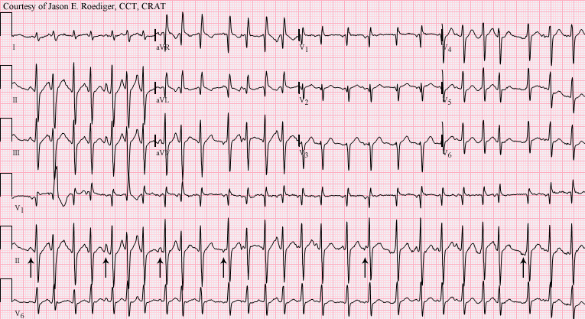

TEACHING OBJECTIVES

- Identification of a critically unwell patient – ask for help, monitor, IV senior help, 02

- Management of CAP
Score of >1 (ie 2) = admission, Score of 3 should consider ICU consult. * A CURB 65 Score of 4 or 5 mortality =28%
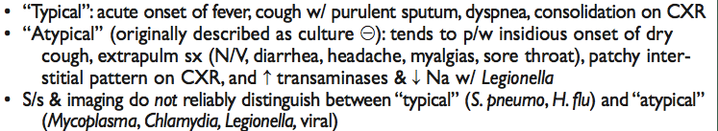
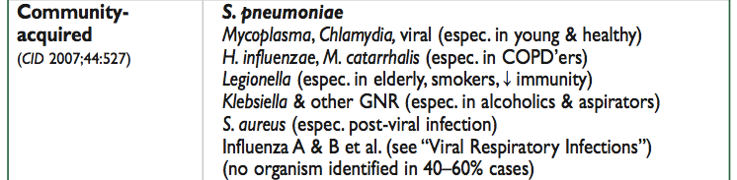
- Use of NIV -
    - Evidence-based uses:
- in patients who have a severe exacerbation of COPD (pH < 7.35 and relative hypercarbia) (grade 1A recommendation).
- in patients who have cardiogenic pulmonary edema and respiratory failure in the absence of shock or acute coronary syndrome requiring urgent coronary revascularization (grade 1A recommendation).
- Also in patients who present with pneumonia and immunosuppression. This is only with a view to save unnecessary intubation.
- OSA/OHS/ Neuromuscular disorders

    - contraindications - facial trauma, severely decreased level of consciousness, systemic shock/hemodynamic instability, poor mask fit, ‘trajectory of patient’, post cardiac arrest, mixed acidosis, vomiting risk/ aspiration risk, untreated pneumothorax

    - Consider intubation if gases fail to improve at 1 and 2 hours.

    - Brief physiology about how it works - Positive end expiratory pressure increases mean airway pressure and therefore acts to both recruit lung units (over time) and also decrease ‘work’ of breathing.

If PaCO2 remains high
- Too much O2? Maintain SpO2 between 85% to 90%
- Excessive mask leakage?
- Is circuit set up correctly?
- Is patient synchronizing with ventilator – adjust breathing rate and/or inspiratory and/or expiratory trigger
- Is re-breathing occurring? - Check patency of expiratory valve (if fitted). Consider increasing EPAP
- Is ventilation adequate – ?increase IPAP (increments of 2cm H2O to alleviate resp distress)

If PaCO2 improves but PaO2 remains low
1. Increase FiO2
- Consider increasing EPAP by increments of 2cm H2O. NB keep difference betw. IPAP and EPAP ≥ 6 cmH2O - so you may need to also increase IPAP.
- Identification and management of distributive shock
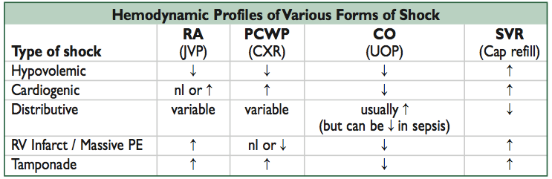
- in your initial 1 minute of examination look for signs of shock

