Case Title | Massive Hemoptysis in anticoagulated lung cancer patient
Scenario Name

Learning Objectives - Use action words
Knowledge:
- Able to recognize massive hemoptysis

Skills:
- Resuscitation
- Intubation
- Appropriate consultation
Attitude/Behaviours
- Demonstrate Team skills
- Demonstrate Situational awareness
- Demonstrate Graded Assertiveness
Scenario Environment
Location | ED Resuscitation Room
Monitors | Standard ED Monitors
Props/Equipment | IV, intubation equipment
Make-up/Moulage | None
Potential Distractors | None

Case Introduction:
60 y.o. male with known LUL bronchogenic cancer, on Coumadin for known L lower segmental PE. Driven to ED by wife after coughing a small amount of blood. At triage he coughs up a large clot, and begins to have difficulty breathing.

Patient Parameters | Effective Management | Notes
Phase 1: Initial Presentation  Condition: Stable  Speaking short sentences, actively coughing bright blood  Initial Assessment  - Heart Rhythm: Sinus Tachycardia  - HR: 120  - BP: 150/90  - RR: 24  - SP02: 89% on RA  - T: 36. 0 C  - Glucose: 6.0  - Chest: Decreased A/E L  - CNS: GCS 15, PERRL  - CVS: S1,S2  - GI: Abd soft, nontender  - Weight: 70 kg  - Height: 180 cm | - Take a focused history (see Notes column)  - Medical Management  - Recognizes massive hemoptysis  - Recognizes/prepares for need for immediate anti-coagulation reversal including vitamin K, octaplex, TXA, and potential transfusion  - Recognizes/prepares for potential need for intubation/crichothyrodotomy  - Calls for help – RT, thoracics, interventional radiology, anesthesia, ICU  - Portable CXR, labs including VBG, full coagulation panel, type and Xmatch 4u PRBC, FFP | - Focused history  - Stable lung cancer.  - Dx’d with small PE 2 weeks ago, on Coumadin.  - Attempts to quantify the amount of hemoptysis. Verifies no symptoms of GIB or epistaxis.  PMHx  - X-smoker  - HTN  - LUL bronchogenic ca in remission  Meds  - Coumadin  - Ramipril  Allergies  - NKDA
Phase 2: Respiratory Distress with Hemoptysis  Condition: Unstable  Respiratory distress, continued hemoptysis.  Physical Examination  - Heart Rhythm: Sinus Tachycardia  - HR: 120-130  - BP: 110/50  - RR: 30  - SP02: 89% optiflow/NRB  - T: 36.0  - Glucose: 6.0  - Chest: Decreased A/E L  - CNS: GCS 14, PERRL 3 mm  - CVS: S1, S2  - GI: Abd soft, nontender | - Patient Reassessment (see Notes column)  - Medical Management  - Has ordered octaplex (80cc/2000IU), vitamin K 10mg IV, O+ blood,  - Prepares for intubation – plan for R mainstem, using ketamine, rocuronium  - 2nd EP in room if needs crich (states wants double set up)  - Calls for anesthesia, IR, thoracics, ICU (no one available, but aware and getting IR suite/OR prepared)  - Successfully intubates patient with direct laryngoscopy using 8-8.5 ETT  - Places pt L lateral decubitus + reverse trendelenberg following intubation/tube confirmation | - Patient Reassessment  Airway  - Continually coughing up bright red blood  Breathing  - Laboured  Circulation  - Good pulses in all extremities

Expected Patient Management | Debriefing Points
- Student

- Junior EM Resident
  - Recognizes massive hemoptysis (defined by patient instability/inadequate gas exchange rather than an absolute quantity of blood)
  - Recognizes need for emergent anticoagulation reversal with octaplex and vitamin K
  - Recognizes need for urgent emergent airway control including double set-up, uses direct laryngoscopy, and right mainstem intubation/left lateral decubitus
  - Recognizes need for additional expertise to manage the patient once intubated (IR/thoracics/anaesthesia/ICU)

- Senior EM resident

References

Yendamuri, S. (2015). Massive Airway Hemorrhage. Thoracic Surgery Clinics. 25(3): 255-260.
http://lifeinthefastlane.com/resources/massive-haemoptysis/
http://www.uptodate.com/contents/overview-of-massive-hemoptysis?source=see_link&sectionName=DIAGNOSTIC+APPROACH&anchor=H2767170#H2767170
http://first10em.com/2015/03/24/massive-hemoptysis/
http://crashingpatient.com/medical-surgical/pulmonology/massive-hemoptysis.htm/

X-RAYS

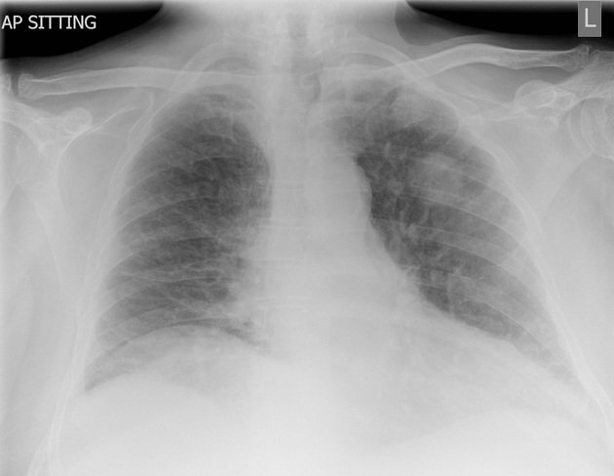

LABS – click here OR fill out below
LABORATORY *LIVE* Lab Summary Report

Test | DATE/TIME here | Flag (H or L) | Reference
CBC
WBC |  |  | 3.5 – 10.8 10^9/L
RBC |  |  | 4.3 – 5.7 10^12/L
Hgb |  |  | 130 – 170 g/L
HCT |  |  | 0.37 – 0.47 L/L
Platelets |  |  | 150 – 400 10^9/L
D-Dimer |  |  | <250 mcg/L
Chemistry
Glucose - Random |  |  | 3.0 – 11.0 mmol/L
Na |  |  | 137 – 145 mmol/L
K |  |  | 3.5 – 5.0 mmol/L
Cl |  |  | 98 – 107 mmol/L
HCO3 |  |  | 22-26 mmol/L
Urea |  |  | 2.5 – 6.1 mmol/L
Creat |  |  | 62 – 106 umol/L
GFR Est |  |  | > 60 ml/min
Lactate |  |  | 0.9 – 1.8 mmol/L
CK |  |  | 5 – 130 U/L
Troponin |  |  | <0.03 mcg/L
Coags
INR |  |  | 0.9 – 1.2
PTT |  |  | 28 – 38 s
ABGs
Arterial
pH |  |  | 7.35- 7.45
pCO2 |  |  | 35 – 45 mmHg
PO2 |  |  | 80-100 mmHg
BE |  |  | -2.0 to +2.0 mmol/L
HCO3 |  |  | 22 – 26 mmol/L
O2 Sat |  |  | 95 – 100%

EKGs

