Case Title | Severe Asthma with Pneumothorax
Scenario Name

Learning Objectives (3 or more) - Use action words
Knowledge
- Manage severe asthma exacerbation
- Identify and manage complications of asthma exacerbation
Skills:
- Manage severe asthma exacerbation
- Identify and manage complications of asthma exacerbation
Attitude/Behaviours
- Demonstrate Team skills
- Demonstrate Situational awareness
- Demonstrate Graded Assertiveness
Scenario Environment
Location | Emergency Department – resuscitation room
Monitors | BP, cardiac, oximeter
Props/Equipment | Vascular access equipment, nebulizer, airway equipment, chest tube set-up
Make-up/Moulage | Nil
Potential Distractors | Nil

Case Introduction:
22 year old female with history of asthma. URI symptoms for 4 days with gradually worsening SOB and increasing puffer usage.
SOB acutely worsened following a coughing spell 1 hour ago.

Patient Parameters | Effective Management | Notes
Phase 1: Severe Respiratory Distress  Condition: Dyspneic/diaphoretic. 3 word phrases.  Initial Assessment  - Heart Rhythm: Sinus Tachycardia  - HR: 120  - BP: 110/76  - RR: 45  - SP02: 81% on RA  - T: 36.5  - Glucose: 6.2  - CNS: GCS 15. Alert.  - Chest: Diffuse wheezes, decreased air entry on left  - CVS: normal  - GI: Abd normal | - Take a focused history (see Notes column)  - Medical Management  - Initial asthma management  - Recognize Severe asthma exacerbation  - RT consultation and advanced airway equipment to bedside  - 100% O2  - Ventolin (3 nebulized treatments back to back 5mg)  - Atrovent (3 nebulized treatments back to back 500mcg)  - IV steroids  - IV MgSO4  - Consideration of PPV (CPAP/BiPAP)  - Vascular access  - 2 large bore IVs  - IV crystalloids – 2L NS  - Investigations  - ECG  - CXR  - Labs/blood gas | - Focused history  - As above  PMHx  - Asthma  - Smoker  - Marijauana use  Meds  - Ventolin  Allergies  - NKDA
Phase 2: Unchanged  Condition: Unchanged after above management.  Physical Examination  - Heart Rhythm: Sinus Tachycardia  - HR: 138  - BP: 105/78  - RR: 45  - SP02: 89% (FiO2 100%)  - T: 36.5  - CNS: GCS 15  - Chest: Diffuse wheezes, decreased air entry on left | - Patient Reassessment  - Medical Management  - Review ECG/CXR/VBG  - Identify left pneumothorax  - Treat left pneumothorax (small bore left sided chest tube)  - Continuous nebulized ventolin  - Consideration of advanced asthma treatments (IV ventolin, IM/IV epi, IV ketamine infusion, Heliox, inhaled anesthetic agents)  - Consult Resp/ICU | - Patient Reassessment  - Patient stabilizes with treatment of pneumothorax, continuous inhaled ventolin, PPV  - Without either of above, patient’s resp status deteriorates to respiratory arrest

Expected Patient Management | Debriefing Points
- Student

- R1

- Senior IM resident

References:
IH Emergency Management of Adult Asthma Physician Decision Tool
http://insidenet.interiorhealth.ca/Clinical/emergservices/Documents/Adult%20Asthma%20Physician%20Decision%20Tool.pdf

X-RAYS – Click here

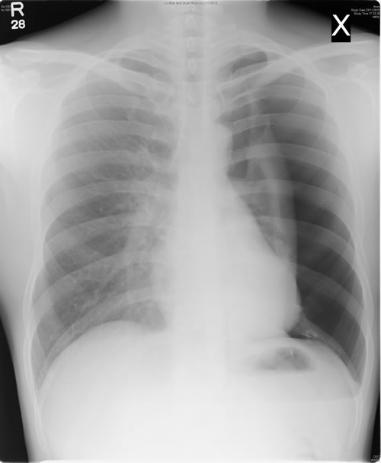

LABS – click here OR fill out below

LABORATORY *LIVE* Lab Summary Report

Test | DATE/TIME here | Flag (H or L) | Reference

VBGs
pH | 7.35 |  | 7.35- 7.45
pCO2 | 38 |  | 35 – 45 mmHg
HCO3 | 20 | L | 22 – 26 mmol/L

EKGs – click here or paste

