Case Title | Pulmonary Embolism – PEA Arrest
Scenario Name

Learning Objectives - Use action words
Knowledge:
- Recognize the presentation of Pulmonary Embolism
- Describe the management of Pulmonary Embolism
- Discusses thrombolysis treatment
Skills:
- Demonstrates airway interventions
- Demonstrates hypotension management
- Demonstrates central line placement

Attitude/Behaviours
- Demonstrate Team skills
- Demonstrate Situational awareness
- Demonstrate Graded Assertiveness
Scenario Environment
Location | ER
Monitors | Telemetry, crash cart
Props/Equipment | RSI meds, intubation equipment, vasopressors, central line supplies, TPA, TPA monograph
Make-up/Moulage | None
Potential Distractors | None

Case Introduction:
Prehospital Notification:
25-year-old female. Collapsed at work with Chest Pain and Shortness of breath. Tachycardic and Hypotensive.

Patient Parameters | Effective Management | Notes
Phase 1: Respiratory Distress  Condition: Unstable  Patient gasping for breath. Cast on the leg.  Initial Assessment  - Heart Rhythm: Sinus Tachycardia  - HR: 170  - BP: 85/45  - RR: 34  - SP02: 92% | - Take a focused history (see Notes column)  - Medical Management  - Airway intervention – Etomidate, Midazolam, Ketamine, Succinylcholine and Rocuronium are OK. Patient de-saturates, arrests and dies if airway not managed.  - Hypotension – central line placement and vasopressor ---norepinephrine, epinephrine, dopamine infusions. BP drops without these.  - Thrombolysis – TPA infusion  Patient deteriorates into PEA without this and does not have return of pulse until TPA is given  Consequences of ineffective management  - Progress to Phase 2 (PEA Arrest) if TPA not given  - Progress to Phase 3 (Condition Improvement) if TPA given | - Focused history  Healthy. Collapsed at work with Chest Pain and Shortness of breath.  PMHx  - Recent ORIF of right tib/fib  - Smoker  Meds  - ASA  Allergies  - None
Phase 2: PEA Arrest  Condition: Coding  Progress to this phase only if TPA NOT given.  Physical Examination  - Heart Rhythm: PEA  - HR: 160  - BP: -/-  - RR: apneic  - CNS: Pt unresponsive | - Patient Reassessment (see Notes column)-Recognizes change in condition  - Medical Management:  - Manage ABCs, intubate, start CPR  - Epi q3 minutes  - Run PEA algorithm- Hs and Ts (TPA will resolve PEA) | - Patient Reassessment  Airway  - Not patent. Needs to intubate if not already done so  Breathing  - Apenic, needs BVM  Circulation  - Pulses absent
Phase 3: Condition Improvement  Condition: Unstable  Progress to this ONLY If TPA given  ROSC. Eyes closed.  Physical Examination  - Heart Rhythm: Sinus Tachycardia  - HR: 110  - BP: 90/50  - RR: Apneic if RSI, spontaneous assisted if not | - Patient Reassessment (see Notes column)-  - Medical Management:  - Consult ICU | - Patient Reassessment  Airway  - Intubated  Breathing  - Apneic if RSI, spontaneous assisted if not  Circulation  - Weak peripheral pulses

Expected Patient Management | Debriefing Points
- Student

- R1

- Senior IM resident

References:

X-RAYS – Click here

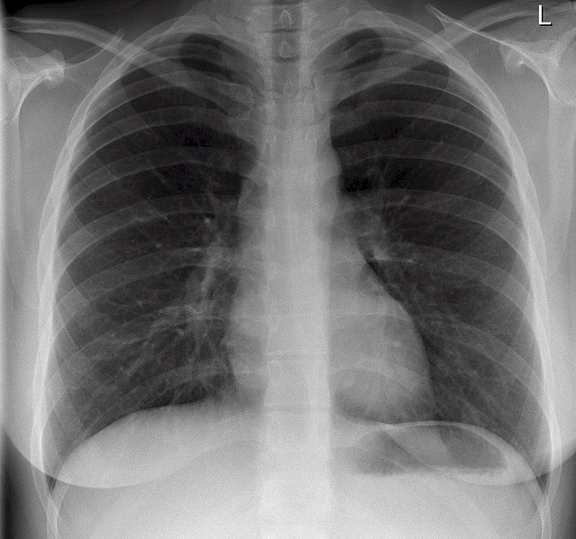

LABS – click here OR fill out below

EKGs – Acute right ventricular dilatation due to massive PE

