Case Title | PE with Recent Intracranial Bleed
Scenario Name

Learning Objectives - Use action words
Knowledge:
- Describe management of significant PE
- Discuss contraindications to thrombolysis

Skills:
- Demonstrate management of PE with recent intracranial bleed
Attitude/Behaviours
- Demonstrate Team skills
- Demonstrate Situational awareness
- Demonstrate Graded Assertiveness
Scenario Environment
Location | ED
Monitors | Telemtry/Crash Cart/defibrillator
Props/Equipment | IV, Meds  Airway equipment  EGC  Heparin, TPA (on hand)
Make-up/Moulage | None
Potential Distractors | None

Case Introduction:
71 y.o. female presenting with acute onset pleuritic chest pain and SOB.

Patient Parameters | Effective Management | Notes
Phase 1: Dyspneic  Condition: Moderate work of breathing, but speaking full sentences  Initial Assessment  - Heart Rhythm: Sinus Tachycardia with some lateral T-wave changes  - HR: 110  - BP: 110/70  - RR: 30-40s  - SP02: 80% on R/A – will require 15L by FM to get her in the 90s  - T: 36.6 C  - Glucose: 6.5  - Chest: Clear  - CNS: GCS 15. Pupils PERL.  - GI: Abd non-tender  - Weight: 140 lbs  - Height: 5’4” | - Take a focused history (see Notes column)  - Medical Management  - Oxygen – 15L by FM  - Monitors  - ECG  - IV access  - Bedside eFAST  - Huge Right Ventricle. Otherwise unremarkable.  - IV fluids  - Heparin | - Focused history  Pleuritic chest pain and SOB started the night before.  PMHx  - HTN  - Cholesterol  - Previous DVT/PE  - Recently admitted for an acute on chronic subdural bleed with Burr hole surgery by neurosurgery 6 days prior. Discharged on Dilantin d/t post-op seizure and warfarin D/Ced.  Meds  - HCTZ  - Ramipril  - Atorvastatin  Allergies  - None
Phase 2: Hypotension  Condition: Hypotension. Remains dyspneic but sats improve on O2 at 15L  Physical Examination  - Heart Rhythm: Sinus Tachycardia  - HR: 120  - BP: 80/40  - RR: 30-40s  - O2 sat: 90 on 15 L  - CNS: GCS 14 (drowsy with eyes open to voice) | - Patient Reassessment (see Notes column)-Recognizes change in condition  - Medical Management:  - Start pressors (levo)  - Investigations: CBC, Trop, Lactate, ABG  - Call ICU and Neurosurgery  - Neurosurgery suggested thrombolysis if she got worse and hope for the best  - ICU will come down | - Patient Reassessment  Airway  - Patent  Breathing  - Dyspneic  Circulation  - Hypotension
Phase 3: Falling LOC  Condition: Declining LOC and persistent dyspnea  Physical Examination  - Heart Rhythm: Sinus Tachycardia  - HR: 110-120  - BP: 88/50 on pressors  - RR: 30  - CNS: GCS 8 | - Patient Reassessment (see Notes column)-Recognizes change in condition  - Medical Management:  - Intubate patient with RSI  - Titrate pressors  - Central Line placement | - Patient Reassessment  Airway  - Declined LOC – must intubate to protect  Breathing  - Dyspnea  Circulation  - Hypotensive
Phase 4: Stabilization  Condition: Intubated and sedated.  Physical Examination  - Heart Rhythm: Sinus Tachycardia  - HR: 100  - BP: 100/50  - RR: 12 on ventilator  - SpO2: 96% vented on high oxygen | - Patient Reassessment (see Notes column)-Recognizes change in condition  - Medical Management:  - Transferred to ICU  Clinical Course (for possible discussion following case):  - Kept getting worse in ICU  - Eventually went for CT – saddle embolus  - Stat catheter- directed thrombolysis  - Demise shortly after | - Patient Reassessment  Airway  - Intubated  Breathing  - Ventilated  Circulation  - Borderline

Expected Patient Management | Debriefing Points
- Student

- Junior Resident

- Senior Resident

References:

Bedside Echo

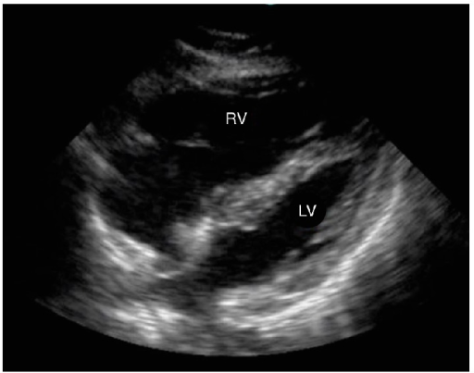

X-RAYS
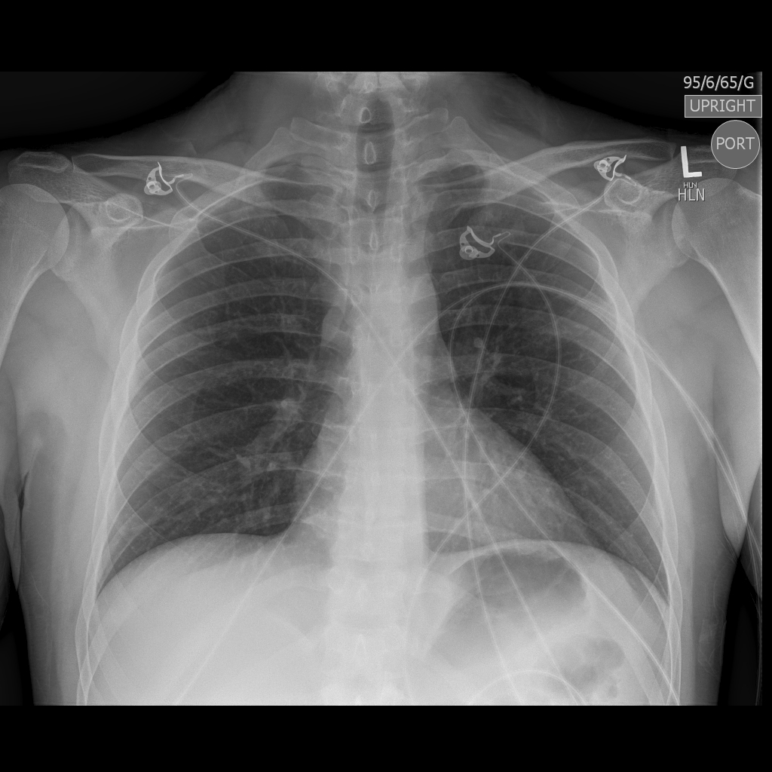

LABS – click here OR fill out below

Test | DATE/TIME here | Flag (H or L) | Reference
CBC
WBC | 12 | H | 3.5 – 10.8 10^9/L
RBC | 5 |  | 4.3 – 5.7 10^12/L
Hgb | 130 |  | 130 – 170 g/L
HCT | 0.38 |  | 0.37 – 0.47 L/L
Platelets | 200 |  | 150 – 400 10^9/L
D-Dimer |  |  | <250 mcg/L
Chemistry
Na | 140 |  | 137 – 145 mmol/L
K | 3.9 |  | 3.5 – 5.0 mmol/L
Cl | 100 |  | 98 – 107 mmol/L
HCO3 | 22 |  | 22-26 mmol/L
Urea | 6.0 |  | 2.5 – 6.1 mmol/L
Creat | 100 |  | 62 – 106 umol/L
GFR Est |  |  | > 60 ml/min
Glucose - Random | 6.5 |  | 3.0 – 11.0 mmol/L
Lactate | 4 | H | 0.9 – 1.8 mmol/L
CK |  |  | 5 – 130 U/L
Troponin | 0.1 | H | <0.03 mcg/L
Coags
INR | 0.9 |  | 0.9 – 1.2
PTT | 30 |  | 28 – 38 s
Blood gas
Venous
pH | 7.30 | L | 7.35- 7.45
pCO2 | 30 | L | 35 – 45 mmHg
BE | -1.0 |  | -2.0 to +2.0 mmol/L
HCO3 | 22 |  | 22 – 26 mmol/L
O2 Sat |  |  | 95 – 100%
Lactate | 4 | H | 0.7-2.1mmol/L

EKGs

