82-Case Title | Pulmonary Edema
Scenario Name | Ella

Learning Objectives - Use action words
Knowledge:
- Recognize the presentation of respiratory distress
- Develop a differential for acute respiratory distress
- Describe the management of pulmonary edema
Skills:
- Interpret ECG
- Interpret CXR

Attitude/Behaviours
- Demonstrate Team skills
- Demonstrate Situational awareness
- Demonstrate Graded Assertiveness
Scenario Environment
Location | ER
Monitors | Telemetry, crash cart
Props/Equipment | BiPAP, SL NTG, Captopril, Lasix IV, Dobutamine
Make-up/Moulage | None
Potential Distractors | None

Case Introduction:
82 year-old female presents to the ER after acutely worsening shortness of breath.

Patient Parameters | Effective Management | Notes
Phase 1: Severe Respiratory Distress  Condition: Unstable  Obvious respiratory distress. JVP elevated, bilateral pitting edema. Resp crepitations throughout.  Initial Assessment  - Heart Rhythm: Paced  - HR: 110  - BP: 180/90  - RR: 30  - SP02: 80% on 10L  - T: 37.1 C  - Chest: Crepitations throughout, increased work of breathing  - CVS: JVP elevated, bilat pitting edema  - GI: Abd soft | - Take a focused history (see Notes column)  - Medical Management  - Initial management of respiratory distress:  - ABC  - IV established  - O2, Monitor  - preparation for advanced airway  - Develop a differential for acute respiratory distress.  5 common causes of SOB:  - Cardiac  - Pulmonary  - Metabolic acidosis  - Neuromuscular  - Abnormal blood, eg, anemia  - Management of acute cardiogenic pulmonary edema  - Early institution of CPAP/BIPAP  - Sublingual NTG followed by IV (60-100ug/min)  - Consider sublingual captopril 12.5mg (<110) 25mg (>110) if  - NTG contraindication  - NTG not improving and patient is still hypertensive  - Intense sympathetic overactivity  - Dialysis pt after hours  - Lasix – given approx.. 30 min. after vasodilatory tx if no initial diuresis  - Dobutamine considered in cases of poor LV and hypotension  Consequences of ineffective management  - Progress to Phase 2 (Impending Respiratory Failure) if NTG and BiPAP not started  - Progress to Phase 3 (Condition Improvement) if NTG and BiPAP started | - Focused history  HPI: after bridge unable to breathe, no CP, no cough, legs getting bigger.  SHx  - Lives with husband  - ½ PPD smoker  PMHx  - Pacemaker  - CHF  - HTN  - Gout  - DM  - Hypothyroid  Meds (see Pharmanet)  - Furosemide  - Allopurinol  - Potassium Chloride  - Spironolactone  - Metformin  - Levothyroxine  - Losartan  - Digoxin  - Warfarin  Allergies  - None
Phase 2: Impending Respiratory Failure  Condition: Unstable  Patients RR and BP drops and HR increases. GCS falls. Eyes closed.  Physical Examination  - Heart Rhythm: Paced  - HR: 130  - BP: 108/62  - RR: 26  - SP02: 80% on NRB @ 15L  - CNS: GCS 7 (E-1, V-2, M-4)  - Chest: Bilateral coarse crackles with decreased A/E throughout | - Patient Reassessment (see Notes column)-Recognizes change in condition  - Medical Management:  - RSI and intubation | - Patient Reassessment  Airway  - Anticipates need to protect airway, begins set-up for intubation  Breathing  - Shallow, ineffective resps  Circulation  - Peripheral pulses weaker
Phase 3: Condition Improvement  Condition: Stable  (progress to this ONLY if NTG and BIPAP started)  Breathing improves, able to speak in full sentences.  Physical Examination  - Heart Rhythm: Paced  - HR: 90  - BP: 148/80  - CNS: GCS 15  - Chest: Bilat fine crackles | - Patient Reassessment (see Notes column)-Recognizes change in condition  - Medical Management:  - May wean NTG when BP improves and resp status improves  - Furosemide IV  - Foley to urometer  - Consult Cardiology, CCU admit | - Patient Reassessment  Airway  - Protecting own  Breathing  - Deeper respirations, less WOB noted  Circulation  - Strong peripheral pulses

Expected Patient Management | Debriefing Points
- Student

- R1

- Senior IM resident

References:

X-RAYS

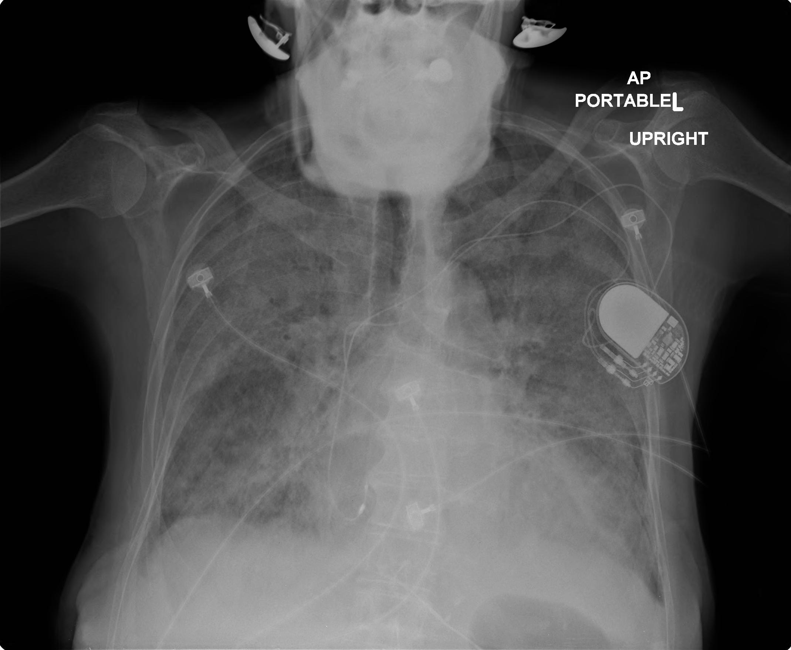
LABS

Test | DATE/TIME here | Flag (H or L) | Reference
CBC
WBC | 11.4 | H | 3.5 – 10.8 10^9/L
RBC | 4.1 |  | 4.3 – 5.7 10^12/L
Hgb | 139 |  | 130 – 170 g/L
HCT | 0.41 |  | 0.37 – 0.47 L/L
MCV | 100.3 | H | 84.0 – 98.0 fL
MCHC | 336 |  | 329 – 352 g/L
RDW | 14.6 |  | 12.0 – 15.0
Platelets | 307 |  | 150 – 400 10^9/L
Neuts | 7.1 | H | 1.2-6.0 10^9/L
Lymphs | 3.2 | H | 0.6 – 3.1 10^9/L
Monos | 0.7 |  | 0.1 – 0.9 10^9/L
Eos | 0.3 |  | 0.0 – 0.5 10^ 9/L
Basos | 0.1 |  | 0.0 – 0.2 10^9/L
Chemistry
Na | 140 |  | 137 – 145 mmol/L
K | 4.6 |  | 3.5 – 5.0 mmol/L
Cl | 102 |  | 98 – 107 mmol/L
CO2 | 27 |  | 22-30 mmol/L
Anion Gap | 11 |  | 5-14 mmol/L
Urea | 13.1 | H | 2.5 – 6.1 mmol/L
Creat | 127 | H | 62 – 106 umol/L
GFR Est | 35 | L | > 60 ml/min
Glucose - Random | 13 | H | 3.0 – 11.0 mmol/L
AST | 49 | H | 15 – 45 U/L
LDH | 662 | H | 313 - 618 U/L
ALT | 20 |  | 10 – 65 U/L
Mg | 0.98 |  | 0.70 – 1.00 mmol/L
CK | 73 |  | 30 – 135 U/L
Coags
INR | 1.3 | H | 0.9 – 1.2
PTT | 30 |  | 28 – 38 s
ABGs
Arterial
pH | 7.24 | L | 7.35- 7.45
pCO2 | 55 | H | 35 – 45 mmHg
PO2 | 66 | L | 80-100 mmHg
BE | -4.6 |  | -2.0 to +2.0 mmol/L
HCO3 | 23.6 |  | 22 – 26 mmol/L
O2 Sat | 90.4 | L | 95 – 100%

EKGs

