Case Title | Acute Hypotension
Scenario Name | Case 3: Year 3/RT/RN students collaborative learning

Learning Objectives (3 or more) - Use action words
Knowledge:
- Recognition of Shock
- Diagnostic Approach to Shock
- Initial Management of Shock
Skills:
- Identify Internal Jugular and femoral veins by landmark, and confirm by ultrasound
- Insert a central venous canula in the femoral vein for resuscitation
Attitude/Behaviours
- Demonstrate Team skills
- Demonstrate Situational awareness
- Demonstrate Graded Assertiveness
Scenario Environment
Location | Ward
Monitors | None at beginning, students must call CCOT
Props/Equipment | Monitor, automatic blood pressure cuff
Make-up/Moulage | Mottling of the skin
Potential Distractors | None

Case Introduction:
62 Year old male admitted with abdominal pain and bloody diarrhea. CCOT called because of decreased LOC.

Patient Parameters | Effective Management | Notes
Phase 1: Hypotension  Condition: Unstable  Initial Assessment  - Heart Rhythm: Sinus Tachycardia  - HR: 160  - BP: 90/40  - RR: 40  - SP02: 92% on RA, drops if no O2 applied  - T: 39.0 C  - Glucose: 8.0  - Chest: clear  - CNS: Moans when spoken to. Eyes half open.  - CVS: hyperemic  - GI: Abd distended  - Weight: 70 kg | - Take a focused history (see Notes column)  - Medical Management  - Take a focused history  - Assess Airway, Breathing Circulation and GCS  - Identify reasons to call for CCOT  - Start an IV and IV fluid | - Focused history  - Recently underwent colonoscopy – evidence of severe ulceration to the bowel.  - Ill for a week with diarrhea and blood and abdominal pain.  - In hospital for 3 days  - colonoscopy yesterday  PMHx  - Hep C with cirrhosis  - COPD  Meds  - Solumedrol 80 mg Q8H  - Puffers  - Heparin started for suspected PE  Allergies  - None
Phase 2: Decreased BP and LOC  Condition: Unstable  Less Responsive  Physical Examination  - Heart Rhythm: Sinus Tachycardia  - HR: 160  - BP: 70/30  - RR: 8  - SPO2: 88%  - T: no change  - Chest: decreased on R side with crackles and airway gurgling  - CNS: GCS 8 (E1, V2, M5), Obtunded. Eyes closed.  - CVS: extremities mottled  - GI: Abd distended | - Patient Reassessment (see Notes column)  - Medical Management  - Call MRP  - Admit to ICU  - Call Code for intubation  - Epinephrine for shock/PEA  - Consider Central venous access  - Differential diagnosis of shock:  - Sepsis  - Internal Bleeding  - Tachycardia | - Patient Reassessment  Airway  - Gurgling  - Decreased GCS  Breathing  - Sats decreasing  Circulation  - Recognition of shock

Expected Patient Management | Debriefing Points
- Student  - Complete ABCD assessment  - Recognize Shock  - Start IV Access  - Call R1 with SBAR  - R1  - Reassess patient ABCD  - Call CCOT  - Give epinephrine for shock  - Formulate Differential Diagnosis  - Call Senior resident with SBAR  - Prepare to intubate  - Senior IM resident  - Safely transfer patient to ICU  - Call MRP with SBAR  - Communicate with family | de-BRIEFING SUGGESTIONS:  - Ask students:  - What did you do particularly well?  - What would you do differently if you could do it over again?  - How were the team dynamics?  - Discuss your observations of what the team did well, and what you think they could have done better.  - Discuss whether the team achieved all of the minimal behaviours (above).  - What was going on with this patient? Why did it happen?  - Write down what you learned during this simulation that you would apply in clinical practice?
References:

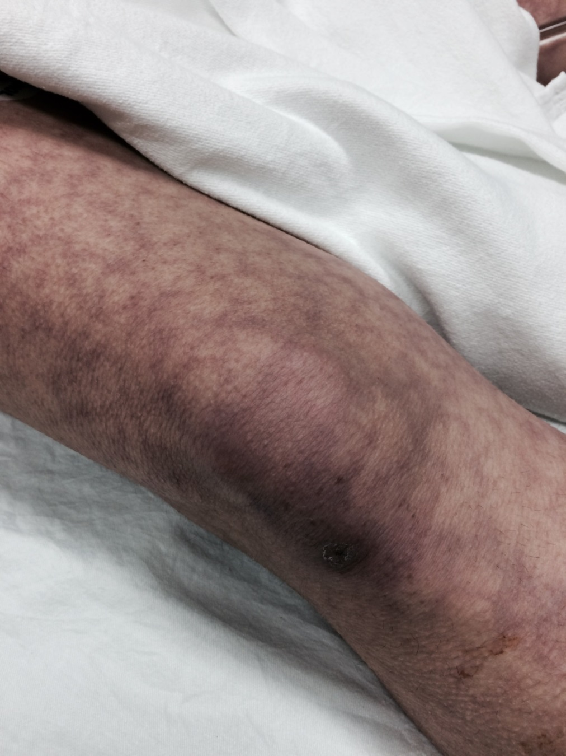

X-RAYS – Click here

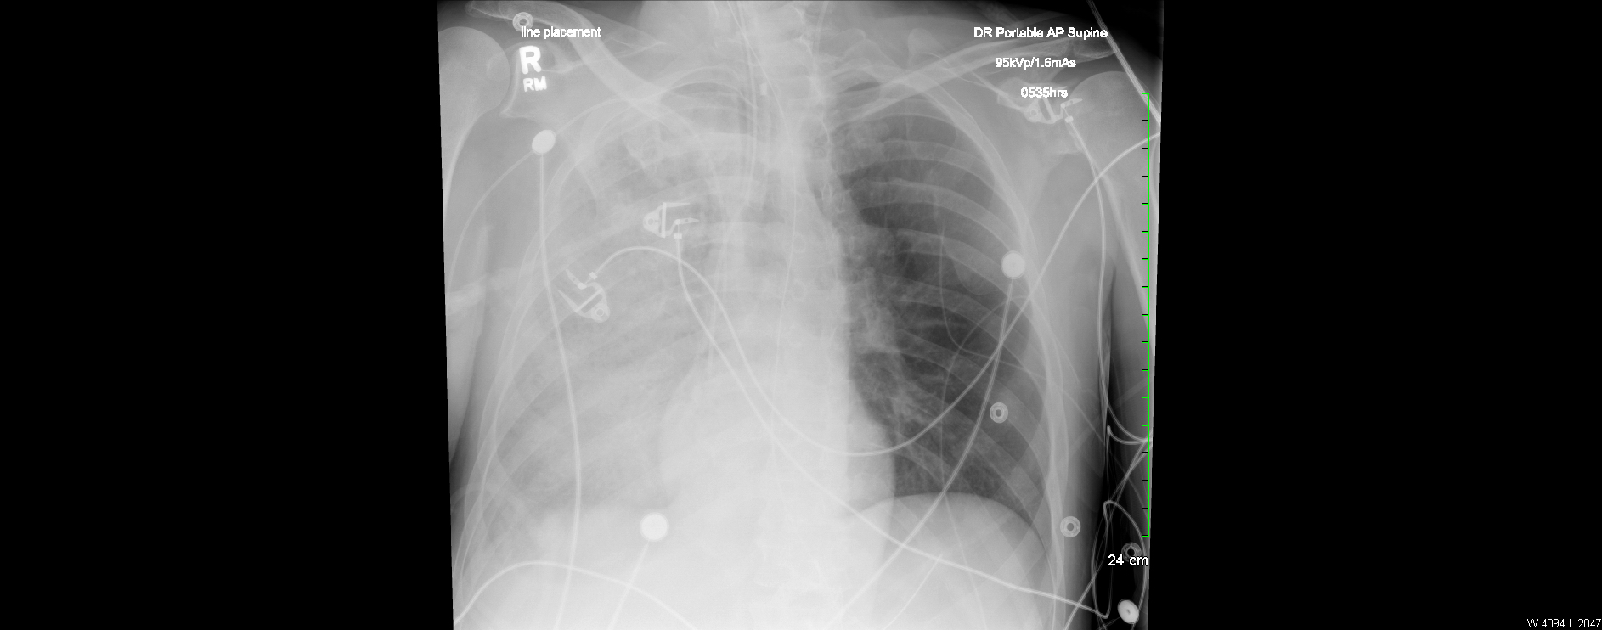

LABS

RUN DATE: Today LABORATORY *LIVE* Lab Summary Report
LOCATION
Test | DATE/TIME here | Flag (H or L) | Reference
CBC
WBC | 14.3 | H | 3.5 – 10.8 10^9/L
RBC |  |  | 4.3 – 5.7 10^12/L
Hgb | 90 | L | 130 – 170 g/L
HCT |  |  | 0.37 – 0.47 L/L
Platelets | 332 |  | 150 – 400 10^9/L
D-Dimer |  |  | <250 mcg/L
Chemistry
Na | 137 |  | 137 – 145 mmol/L
K | 4.6 |  | 3.5 – 5.0 mmol/L
Cl | 103 |  | 98 – 107 mmol/L
HCO3 | 22 |  | 22-26 mmol/L
Urea |  |  | 2.5 – 6.1 mmol/L
Creat | 45 | L | 62 – 106 umol/L
GFR Est | 115 | H | > 60 ml/min
Glucose - Random | 8 |  | 3.0 – 11.0 mmol/L
Lactate | 6.0 | H | 0.9 – 1.8 mmol/L
CK |  |  | 5 – 130 U/L
Troponin |  |  | <0.03 mcg/L
Coags
INR | 1.0 |  | 0.9 – 1.2
PTT | >200 | H | 28 – 38 s
ABGs
Arterial
pH | 7.10 | L | 7.35- 7.45
pCO2 | 40 |  | 35 – 45 mmHg
PO2 | 88 |  | 80-100 mmHg
BE |  |  | -2.0 to +2.0 mmol/L
HCO3 | 19 | L | 22 – 26 mmol/L
O2 Sat | 88 | L | 95 – 100%

EKGs

