Case Title | Anaphylaxis in a Cardiac Patient
Scenario Name

Learning Objectives - Use action words
Knowledge:
- Demonstrate management of Anaphylaxis
- Discuss Epinephrine dosage in a cardiac patient
- Demonstrate management of SVT
Skills:
- Perform intubation with difficult airway
- Demonstrate EKG interpretation
- Perform cardioversion
Attitude/Behaviours
- Demonstrate Team skills
- Demonstrate Situational awareness
- Demonstrate Graded Assertiveness
Scenario Environment
Location | ED
Monitors | Telemtry/Crash Cart/defibrillator
Props/Equipment | IV, Meds  Airway equipment  EKG  Anaphylaxis Protocol from ED  ACLS Algorithms on hand
Make-up/Moulage | None
Potential Distractors | None

Case Introduction:
Nurse alerts you to Trauma/Resuscitation Room. 64 year-old woman arrives with husband. She has been stung by a bee. She forgot her epi-pen and they came straight to emergency. She is feeling weak, dizzy, short of breath and her throat feels like it is swelling. A red itchy rash is breaking out on her skin. She complains of a slight chest pain similar to her angina.

Patient Parameters | Effective Management | Notes
Phase 1: Anaphylaxis  Condition: Alert, talking, voice sounds odd because her tongue is enlarging.  Initial Assessment  - Heart Rhythm: Sinus Tachycardia  - HR: 140  - BP: 100/60  - RR: 30  - SP02: 95% and dropping  - T: 37.0  - Chest: States she is feeling SOB  - CNS: GCS 15  - CVS: complaining of a slight chest pain similar to her angina  - GI: Abd soft, nontender  - Integ: Red itchy rash breaking out on skin  - Weight: 70 kg | - Take a focused history (see Notes column)  - Medical Management  - Oxygen, Monitor, IVs  - the nurses have found her to be a difficult IV start in th past (Unable to get IV access immediately)  - Consider IO if needed  - Epinephrine 0.3-0.5mg SC/IM.  - (The resident may be cautious with epinephrine in a cardiac patient bu it is necessary in this situation, the anaphylaxis trumps the coronary artery disease---you can discuss in brief) | - Focused history  As above  PMHx  - Anaphylaxis  - Hypertension  - Previous MI  - Heavy smoker  Meds  - ASA  - Ramipril  - Lipitor  - +/- metoprolol (for senior resident—complicates treatment)  Allergies  - Bee stings
Phase 2: Airway Obstruction and SVT  Condition: Despite intial epinephrine, tongue continues to swell. Sats dropping. Now in SVT from epinephrine.  Physical Examination  - Heart Rhythm: SVT  - HR: 180  - BP: 90/50  - RR: 34  - SP02: 89%  - Chest: | - Patient Reassessment (see Notes column)-Recognizes change in condition  - Medical Management:  - Airway intervention- difficult airway due to swollen tongue – intubation (with/without paralysis).  - Cardiovert SVT – Adenosine or electrical cardioversion  Consequences of ineffective management  - If intubation not done or unsuccessful, hypoxia and V. fib arrest occurs. | - Patient Reassessment  Airway  - Obstructed – tongue  Breathing  - Increased respiratory effort  Circulation  - Increased HR
Phase 3: BP continues to decline  Condition:  Physical Examination  - Heart Rhythm: Sinus Tachycardia  - HR: 120  - BP: 80/45  - RR: intubated and sedated  - CNS: GCS 3, sedated | - Patient Reassessment (see Notes column)-Recognizes change in condition  - Medical Management:  - More epinephrine IV – 0.1mg doses or IM 0.3mg doses (safer)  - Steroids, Ventolin, Benadryl.  - IV epinephrine infusion for resistant hypotension.  - Glucagon 3-5mg IV doses if patient on B-blocker  - Unopposed alpha-receptor activation – peripheral vasoconstriction occurs which can cause hypertension. | - Patient Reassessment  Airway  - Protected with ETT  Breathing  - Intubated and ventilated  Circulation  - BP dropping
Phase 4: V. Fib Arrest  Condition: Can progress into V. fib from cardiac ischemia and run arrest  Physical Examination  - Heart Rhythm: V. Fib  - HR: 130  - BP: -/-  - RR: apneic, ventilated  - CNS: Pt unresponsive | - Patient Reassessment (see Notes column)-Recognizes change in condition  - Medical Management:  - CPR  - Defibrillate  - Meds: Epi 1 mg Q3-5 mins, Amiodarone  - Review H’s & T’s  Consequences of ineffective management  - If ACLS guidelines not followed correctly remain in PEA or progress to PEA.  - If ACLS guidelines followed correctly, progress to Phase 5 (ROSC) | - Patient Reassessment  Airway  - Protected with ETT  Breathing  - Intubated and ventilated  Circulation  - Need to do CPR and defibrillate
Phase 5: ROSC  Condition: ROSC, boarderline BP  Physical Examination  - Heart Rhythm: Sinus Tachycardia  - HR: 110  - BP: 88/50  - RR: 12 on ventilator  - SpO2: 96% vented on high oxygen | - Patient Reassessment (see Notes column)-Recognizes change in condition  - Medical Management:  - Cardiology Consult  - Post Arrest Care | - Patient Reassessment  Airway  - ETT in place  Breathing  - Some spontaneous effort, allows assistance between and with own resps  Circulation  - ROSC

Expected Patient Management | Debriefing Points
- Student

- R1

- Senior IM resident

References:

X-RAYS

LABS – click here OR fill out below
LABORATORY *LIVE* Lab Summary Report

Test | DATE/TIME here | Flag (H or L) | Reference
CBC
WBC |  |  | 3.5 – 10.8 10^9/L
RBC |  |  | 4.3 – 5.7 10^12/L
Hgb |  |  | 130 – 170 g/L
HCT |  |  | 0.37 – 0.47 L/L
Platelets |  |  | 150 – 400 10^9/L
Chemistry
Na |  |  | 137 – 145 mmol/L
K |  |  | 3.5 – 5.0 mmol/L
Cl |  |  | 98 – 107 mmol/L
HCO3 |  |  | 22-26 mmol/L
Urea |  |  | 2.5 – 6.1 mmol/L
Creat |  |  | 62 – 106 umol/L
GFR Est |  |  | > 60 ml/min
Glucose - Random |  |  | 3.0 – 11.0 mmol/L
Lactate |  |  | 0.9 – 1.8 mmol/L
CK |  |  | 5 – 130 U/L
Troponin |  |  | <0.03 mcg/L
Coags
INR |  |  | 0.9 – 1.2
PTT |  |  | 28 – 38 s
ABGs
Arterial
pH |  |  | 7.35- 7.45
pCO2 |  |  | 35 – 45 mmHg
PO2 |  |  | 80-100 mmHg
BE |  |  | -2.0 to +2.0 mmol/L
HCO3 |  |  | 22 – 26 mmol/L
O2 Sat |  |  | 95 – 100%

EKGs

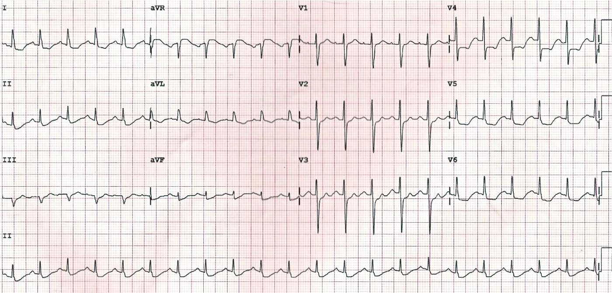

ECG – Tachycardia with ST changes from tachy induced ischemia

