Case Title | Boerhaave’s Syndrome
Scenario Name | Steak Dinner

Learning Objectives - Use action words
Knowledge:
- Resuscitation of a patient with acute sepsis with respiratory difficulties and hypotension.
Skills:
- Intubation
Attitude/Behaviours:
- Demonstrate Team skills
- Demonstrate Situational awareness
- Demonstrate Graded Assertiveness
Scenario Environment
Location | Emergency Trauma/Resuscitation bay
Monitors | Standard ED Monitors
Props/Equipment | Endoscope (mimic)
Make-up/Moulage | None
Potential Distractors | GI Consultant

Case Introduction:
55 year old male presented to ED with food bolus obstruction. In Trauma/resuscitation room sedated and undergoing endoscopy with GI.
EP is called into room because patient is hypotensive with decreasing oxygen saturations. Endoscopy remains in patient.

Patient Parameters | Effective Management | Notes
Phase 1: Sedated, hypotension  Condition: Endoscopy  Initial Assessment  - Heart Rhythm: Sinus Tachycardia  - HR: 125  - BP: 85/45  - RR: 10 Sedated  - SP02: 90%  - CNS: Sedated on Midazolam and Fentanyl  - Chest: Bilateral crackles  - CVS: Hypotension  - GI: Scope in Place | - Take a focused history  - Obtain information gastroenterologist  - Assess current patient status, sedated but low saturations and hypotension.  - How did procedure go? (Difficult and prolonged with patient deterioration)  - Medical Management  - Remove endoscope  - Take control of situation  - Let patient wake up  - 2nd IV start  - Fluid bolus  - Increase oxygenation (currently on nasal prongs)  - Order CXR  Consequences of ineffective management  - Respiratory failure and hypotension leading to PEA arrest | - Focused history  - Patient presented to ED with meat food bolus obstruction in mid esophagus.  - Sedated and endoscopy  - GI just finishing case with obstruction relieved.  - Was prolonged sedation and procedure  - Patient unstable throughout procedure  - Likely aspirated in procedure  - Esophageal perforation likely occurred  PMHx  - Smoker  - Hypertension  Meds  - Ramipril  Allergies  - None
Phase 2: Awakens  Condition: Patient becomes alert but has increased work of breathing with respiratory compromise.  Chest Pain due to esophageal perforation.  Physical Examination  - Heart Rhythm: Sinus Tachycardia  - HR: 135  - BP: 90/50  - RR: 22  - SP02: 90%  - CNS: Alert  - Chest: Crackles | - Patient Reassessment  - Patient now awake but looks pale and unwell with increased work of breathing.  - Bilateral crackles in chest, sats not coming up  - Medical Management  - High flow oxygen  - More IV fluids  - Can consider vasopressor  - EKG, CXR, reassess labs – Emerg. Panel, troponin, ABG/VBG, Lactate  - Eventually requires intubation in low saturation, hypotension situation.  - Should use ketamine, modified RSI, consider succinylcholine or rocuronium, maintain oxygenation throughout intubation  - IV antibiotics for sepsis  - Order CT chest  - Consult ICU  Consequences of ineffective management  - Respiratory failure, hypotension, PEA arrest | - Patient Reassessment  Airway  - Patent, but low sats  Breathing  - Increased WOB  Circulation  - Remains hypotensive

Insert more lines if more phases required.

Expected Patient Management | Debriefing Points
- Student

- R1

- Senior IM resident

References:

X-RAYS – Click here
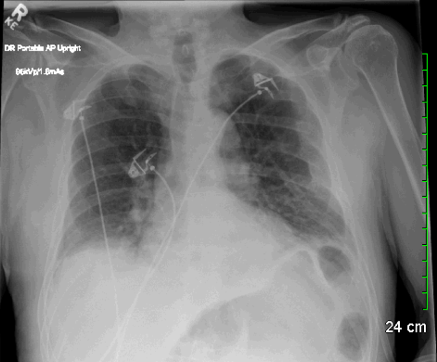

LABS – click here OR fill out below
LABORATORY *LIVE* Lab Summary Report

Test | DATE/TIME here | Flag (H or L) | Reference
CBC
WBC | 7.7 |  | 3.5 – 10.8 10^9/L
RBC |  |  | 4.3 – 5.7 10^12/L
Hgb | 140 |  | 130 – 170 g/L
HCT |  |  | 0.37 – 0.47 L/L
Platelets | 350 |  | 150 – 400 10^9/L
D-Dimer |  |  | <250 mcg/L
Chemistry
Na | 140 |  | 137 – 145 mmol/L
K | 4.5 |  | 3.5 – 5.0 mmol/L
Cl |  |  | 98 – 107 mmol/L
HCO3 |  |  | 22-26 mmol/L
Urea |  |  | 2.5 – 6.1 mmol/L
Creat | 80 |  | 62 – 106 umol/L
GFR Est | 90 |  | > 60 ml/min
Glucose - Random | 6.7 |  | 3.0 – 11.0 mmol/L
Lactate |  |  | 0.9 – 1.8 mmol/L
CK |  |  | 5 – 130 U/L
Troponin | POC 0.02 |  | <0.03 mcg/L
Coags
INR |  |  | 0.9 – 1.2
PTT |  |  | 28 – 38 s
ABGs
Arterial
pH |  |  | 7.35- 7.45
pCO2 |  |  | 35 – 45 mmHg
PO2 |  |  | 80-100 mmHg
BE |  |  | -2.0 to +2.0 mmol/L
HCO3 |  |  | 22 – 26 mmol/L
O2 Sat |  |  | 95 – 100%

EKGs – 