Case Title | Mottled and respiratory distress
Scenario Name | DKA and PE

Learning Objectives - Use action words
Knowledge:
- Recognize potential for massive PE
- Recognize DKA
- Manage unstable PE
- Manage DKA
Skills:
- Interpret US
- Interpret VBG
Attitude/Behaviours:
- Demonstrate Team skills
- Demonstrate Situational awareness
- Demonstrate Graded Assertiveness
Scenario Environment
Location | ED, CT
Monitors | Telemetry, crash cart
Props/Equipment | BiPAP
Make-up/Moulage | Mottled, cyanotic
Potential Distractors

Case Introduction:
62F with severe respiratory distress and mottling since 0300. 5 min pre-notification.

Patient Parameters | Effective Management | Notes
Phase 1: Severe respiratory distress  Condition: Unstable  Initial Assessment  - Heart Rhythm: sinus tach  - HR: 122  - BP: 148/76  - RR: 60  - SP02: 87% NRB  - T: 36.2  - Glucose: undetectable high  - CNS: GCS 15  - Chest: clear  - CVS: normal S1, S2, no S3, S4, no M  - GI: soft, NT  - Integ: severe mottling all extremities, trunk, cyanotic  - Weight: 110kg  - Height: 165cm | - Take a focused history (see Notes column)  - Medical Management  - Initiates BiPAP  - Prepares to intubate  - Bedside US  Consequences of ineffective management  - If intubates PEA – go to phase 2  - If resuscitates, stabilizes – go to phase 3 | - Focused history  - Same since 0300 – relatively well night before  - Need to ask husband  - Unwell x 3 weeks, SOBOE  - Polyuria, polydipsia x 1m  - No CP, F, AP, N/V  - Flight back from Arizona 3 wks ago, relatively sedentary since  PMHx  - Peripheral neuropathy  - “pre-diabetes” 4 years ago  Meds  - Gabapentin  - Carbamazepine  Allergies  - NKDA
Phase 2: PEA  Condition: Unstable  Physical Examination  - Heart Rhythm: Sinus Tachycardia  - HR: 132  - BP: 60/30  - RR: 0  - SP02: 90% on 100% FiO2 intubated  - CNS: E1VTM1  - Chest: GAEB | - Patient Reassessment (see Notes column)-Recognizes change in condition  - Medical Management:  - US – obvious RV dilation  - If gives tPA and hyperventilates ROSC | - Patient Reassessment  - Persistently mottled, cold
Phase 3: Condition Improvement  Condition: Stable  (progress to this ONLY if fluids, heparin given)  Less mottled, improved extremity temperature, decreased WOB  Physical Examination  - Heart Rhythm: Sinus tach  - HR: 120  - BP: 110/60  - CNS: GCS 15  - Chest: clear | - Patient Reassessment (see Notes column)-Recognizes change in condition  - Medical Management:  - Arranges CT PE  - Continues fluid resuscitation  - Initiates broad spectrum antibiotics  - Discusses with ICU  - Accompanies pt to CT with equipment (RSI drugs, tPA) | - Patient Reassessment  Airway  - Protecting own  Breathing  - Respirations fast and deep, less WOB  Circulation  - Warming of extremities, decreased mottling,

Insert more lines if more phases required.

Expected Patient Management | Debriefing Points
- Student

- R1

- Senior IM resident

References:

X-RAYS – Click here

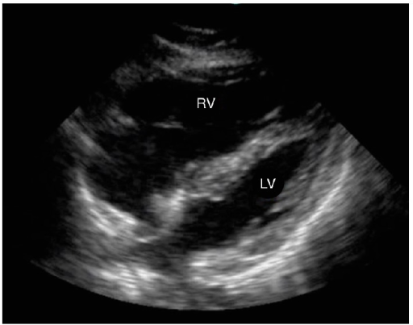

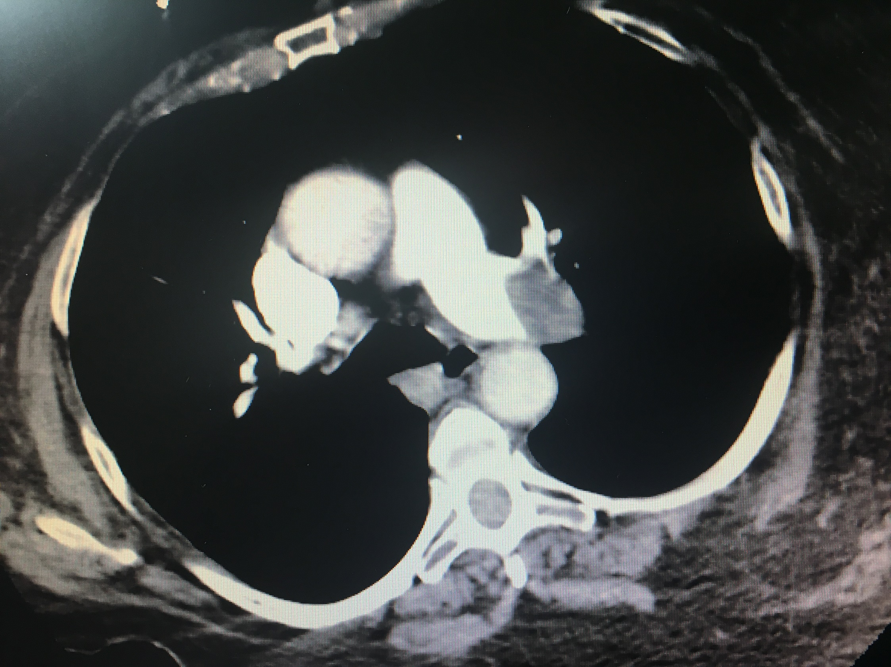
LABS – click here OR fill out below
LABORATORY *LIVE* Lab Summary Report

Test | DATE/TIME here | Flag (H or L) | Reference
CBC
WBC | 4.9 |  | 3.5 – 10.8 10^9/L
RBC |  |  | 4.3 – 5.7 10^12/L
Hgb | 126 | L | 130 – 170 g/L
HCT |  |  | 0.37 – 0.47 L/L
Platelets | 200 |  | 150 – 400 10^9/L
D-Dimer |  |  | <250 mcg/L
Chemistry
Na | 136 | L | 137 – 145 mmol/L
K | 3.9 |  | 3.5 – 5.0 mmol/L
Cl |  |  | 98 – 107 mmol/L
HCO3 | 11 | L | 22-26 mmol/L
Urea | 6.3 | H | 2.5 – 6.1 mmol/L
Creat | 66 |  | 62 – 106 umol/L
GFR Est | 86 |  | > 60 ml/min
Glucose - Random | 36.6 | H | 3.0 – 11.0 mmol/L
Lactate | 6 | H | 0.9 – 1.8 mmol/L
CK |  |  | 5 – 130 U/L
Troponin | 0.27 | H | <0.03 mcg/L
Coags
INR | 0.9 |  | 0.9 – 1.2
PTT | 30 |  | 28 – 38 s
Blood gas
Venous
pH | 6.96 | L | 7.35- 7.45
pCO2 | 44 |  | 35 – 45 mmHg
BE | -21.7 | L | -2.0 to +2.0 mmol/L
HCO3 | 10 | L | 22 – 26 mmol/L
O2 Sat | 98 |  | 95 – 100%
Lactate | 6.1 | H | 0.7-2.1mmol/L

EKGs – click here or paste

