Case Title | Cholecystitis - Sepsis
Scenario Name

Learning Objectives - Use action words
Knowledge:
- Demonstrate management of presumed sepsis
- Demonstrate management of a patient with presumed cholecystitis
Skills:
- Perform bedside US of the GB/biliary tree
Attitude/Behaviours:
- Demonstrate Team skills
- Demonstrate Situational awareness
- Demonstrate Graded Assertiveness
Scenario Environment
Location | ED – monitored bed
Monitors | Cardiac, NIBP,O2 sat
Props/Equipment | Bedside US
Make-up/Moulage | N/A
Potential Distractors | N/A

Case Introduction:
82 year old male complaining of 4 hours of diffuse abdominal pain and vomiting.

Patient Parameters | Effective Management | Notes
Phase 1: Initial Resuscitation  Condition: Pale & uncomfortable.  Initial Assessment  - Heart Rhythm: Sinus tachy  - HR: 120  - BP: 105/75  - RR: 26  - SP02: 99%  - T: 38.9  - Glucose: 5.5 mmol  - CNS: GCS 15  - Chest: clear  - CVS: normal  - GI: Generally tender, especially epigastrium  - Integ: pale, no jaundice | - Take a focused history (see Notes column)  - Medical Management  - Recognize presumed sepsis  - Secure adequate vascular access and initiate crystalloid boluses  - Broad-spectrum early antibiotics  - Bedside US (identify normal aorta and probable cholecystitis)  - Labs (include BCs, lactate, hepatic panel, lipase, VBG, troponin) & 12 lead ECG  Consequences of ineffective management  - Delay in identification and management of sepsis leads to patient deterioration (worsening HR, BP, and level of consciousness) | - Focused history  - As above  - No previous episodes. Normal BM today.  PMHx  - HTN  Meds  - HCTZ  Allergies  - NKDA  - Bedside US (provide video if student demonstrates correct technique)  - Normal aorta (Ultrasound 1)  - Cholecystitis (Ultrasound 2)
Phase 2: Cholecystitis/Sepsis  Condition: Unchanged post 2L IV crystalloids  Physical Examination  - Heart Rhythm: Sinus tachy  - HR: 125  - BP: 100/65  - RR: 26  - SP02: 99%  - CNS: GCS 14 (E3 – M6 – V5)  - Remainder of exam unchanged | - Patient Reassessment (see Notes column)  - Medical Management  - Further IV crystalloids and antibiotics (if not earlier)  - No formal US available. Can go to CT.  - Recognize need for urgent surgical referral  - ICU referral  Consequences of ineffective management  - Septic shock | - Patient Reassessment  Airway  - Patent  Breathing  - Tachypneic, non-distressed  Circulation  - Early shock

Insert more lines if more phases required.

Expected Patient Management | Debriefing Points
- Student  - R1  - Senior IM resident | - Sepsis management  - DDx of AP in this case  - Cholecystitis  - Cholangitis  - Pancreatitis  - Ruptured AAA  - PUD with perforation  - Ischemic bowel

References:

EKGs
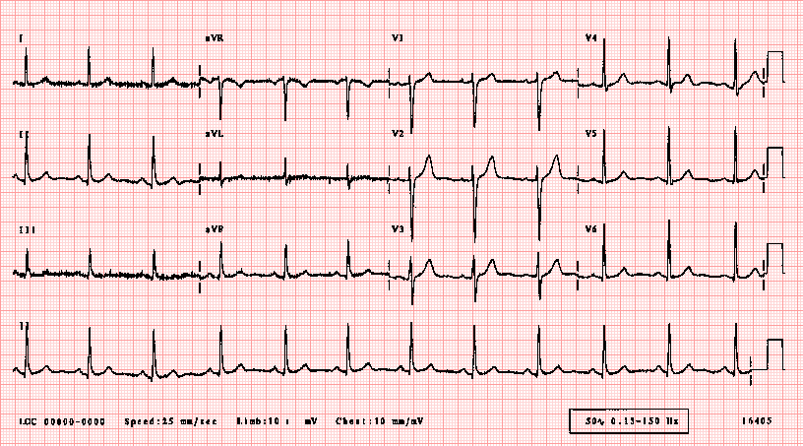
ULTRASOUNDS

LABS
LABORATORY *LIVE* Lab Summary Report

Test | DATE/TIME here | Flag (H or L) | Reference
CBC
WBC | 24.2 | H | 3.5 – 10.8 10^9/L
RBC |  |  | 4.3 – 5.7 10^12/L
Hgb | 145 |  | 130 – 170 g/L
HCT |  |  | 0.37 – 0.47 L/L
Platelets | 460 | H | 150 – 400 10^9/L
D-Dimer |  |  | <250 mcg/L
Chemistry
Na | 140 |  | 137 – 145 mmol/L
K | 4.0 |  | 3.5 – 5.0 mmol/L
Cl | 100 |  | 98 – 107 mmol/L
HCO3 | 15 | L | 22-26 mmol/L
Urea | 6.0 |  | 2.5 – 6.1 mmol/L
Creat | 104 |  | 62 – 106 umol/L
GFR Est |  |  | > 60 ml/min
Glucose - Random |  |  | 3.0 – 11.0 mmol/L
Lactate | 3.3 | H | 0.9 – 1.8 mmol/L
CK | 120 |  | 5 – 130 U/L
Troponin | 0.01 |  | <0.03 mcg/L
ALT | 230 | H | 7 - 63 U/L
AST | 200 | H | 8 – 40 U/L
GGT | 654 | H | 10 – 48 U/L
Alkaline phosphatase | 730 | H | 38 - 126 U/L
Bilirubin | 35 | H | <26 umol/L
Lipase | 50 |  | <160 U/L
Coags
INR |  |  | 0.9 – 1.2
PTT |  |  | 28 – 38 s
VBGs
Venous
pH | 7.29 | L | 7.30-7.40
pCO2 | 33 | L | 40 – 50 mmHg
PO2 |  |  | 30 - 50 mmHg
BE |  |  | -2.0 to +2.0 mmol/L
HCO3 | 15 | L | 22 – 28 mmol/L
O2 Sat |  |  | 70 – 75%

