Case Title | Down and out
Scenario Name | Toxic Alcohols

Learning Objectives - Use action words
Knowledge:
1. Identify the complex differential diagnosis for altered LOC and initiate appropriate workup.
2. Identify the need for airway protection in the severely altered patient and demonstrate a safe approach to intubating.
3. Recognize the presence of severe acidosis with an anion gap and osmolar gap as possibly caused by toxic alcohols and initiate appropriate investigations/treatment.
Skills:
- RSI
- Acid-base and decreased LOC approach

Attitude/Behaviours:
- Demonstrate Team skills
- Demonstrate Situational awareness
- Demonstrate Graded Assertiveness
Scenario Environment
Location | ED
Monitors | Heart monitor, ecg, SP02, NIBP
Props/Equipment | RSI gear, intubation equipment, IV supplies, IV fluids
Make-up/Moulage | Nill
Potential Distractors | Nill

Case Introduction:
EMS has just brought you a patient with a GCS of 3. He was found in the back alley behind a drug store with no identifying information. He is not known to EMS or to your department. He appears to be in his 30s or 40s.

Patient Parameters | Effective Management | Notes
Phase 1: Unresponsive  Condition: Eyes closed. Not responding.  Initial Assessment  - Heart Rhythm: Sinus tach  - HR: 120  - BP: 100/60  - RR: 30  - SP02: 96% on NRB  - T: 36.6  - Glucose: 6.4 (don’t give until asked)  - CNS: GCS 3, PERL  - Chest: Lungs clear  - Abdomen: soft, nontender  - Integ: No track marks. No signs of trauma. | - Take a focused history (see Notes column)  - Medical Management  - IV NS-fluid bolus  - RSI- with paralytic  - ECG  - Bloodwork  Consequences of ineffective management  - Narcan no response  - Recognize need to check sugar | - Focused history  - Found down  PMHx  - Unknown  Meds  - Unknown  Allergies  - Unknown
Phase 2: Intubated and Ventilated  Condition: Remains unresponsive  Physical Examination  - Heart Rhythm: Sinus tach  - HR: 110  - BP: 94/ 58  - RR: 24 (vented)  - SP02: 99% intubated and ventilated | - Patient Reassessment (see Notes column)  Evaluate VBG- recognize anion gap metabolic acidosis.  - Medical Management  - Recognize anion gap (25) & osmolar gap  (Osmolar gap= 339 – 294 = 45)  - Order toxic alcohols  - Call Poison Center  - Call Nephrology, ICU  - Empirically administer fomepizole 15mg/kg IV load  - Administer thiamine 100mg IV, pyridoxine 50mg IV, and folate 50mg IV  Consequences of ineffective management  - Post intubation hypotension- especially if no fluid bolus given. | - Patient Reassessment  Airway  - Tubed  Breathing  - Set ventilation at 24  Circulation  - Post intubation hypotension

Insert more lines if more phases required.

Expected Patient Management | Debriefing Points
- Student  - Junior Resident  - Senior EM Resident  - Good approach to decreased LOC, early recognition for RSI, accurate interpretation of AGMA. | - EMS called to say they found an empty bottle of antifreeze in patient’s apartment.

References:

Adapted from Caners, K. (2015). Toxic alcohol ingestion. Retrieved from https://emsimcases.com/2016/11/08/toxic-alcohol-ingestion/

X-RAYS – Click here

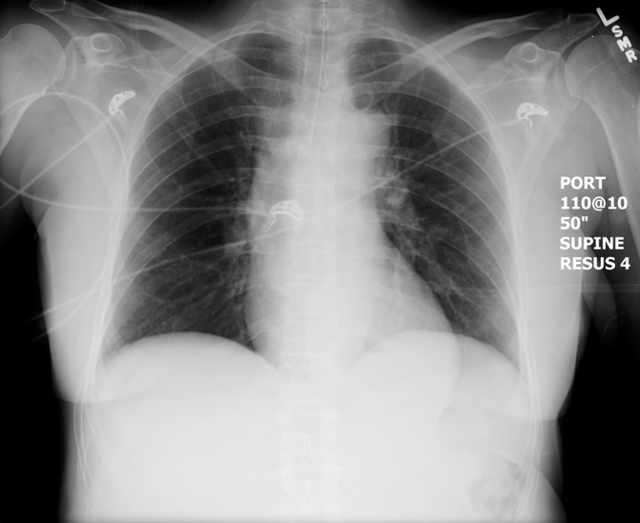
LABS – click here OR fill out below
LABORATORY *LIVE* Lab Summary Report

Test | DATE/TIME here | Flag (H or L) | Reference
CBC
WBC | 13.1 | H | 3.5 – 10.8 10^9/L
Hgb | 136 |  | 130 – 170 g/L
HCT | 0.43 |  | 0.37 – 0.47 L/L
Platelets | 456 | H | 150 – 400 10^9/L
Chemistry
Na | 140 |  | 137 – 145 mmol/L
K | 3.7 |  | 3.5 – 5.0 mmol/L
Cl | 105 |  | 98 – 107 mmol/L
HCO3 | 10 | L | 22-26 mmol/L
Urea | 8 | H | 2.5 – 6.1 mmol/L
Creat | 98 |  | 62 – 106 umol/L
Glucose - Random | 6.0 |  | 3.0 – 11.0 mmol/L
Osmo | 339 | H | 280-300 mmol/kg
EtOH | <2
ASA | negative
Tylenol | negative
Blood Gas
Venous
pH | 7.10 | L | 7.35- 7.45
pCO2 | 22 | L | 35 – 45 mmHg
PO2 | 45 | L | 80-100 mmHg
HCO3 | 10 | L | 22 – 26 mmol/L
Lactate | 4 | H | 0.9 – 1.8 mmol/L

EKGs – click here or paste

