 | Coastal Simulation Program  Scenario Name: Massive Upper GI Bleed

Learning Objectives:

By the end of the debriefing the participants should be able to:

Knowledge & Skills:
- Recognize the need for early blood transfusion and limited crystalloid therapy in the bleeding hypotensive patient and anticipating the need to initiate the Massive Transfusion Protocol (MTP).
- Anticipating and appropriately planning the need for controlling the airway while understanding that a bloody airway is a difficult airway.
- Inserting a Blakemore tube, which is rarely performed procedure in the ED. Identifying and prioritizing the insertion of the Blakemore tube to stabilize the patient with a massive UGIB prior to definitive therapy.
- Recognize and discuss the pharmacologic treatment in a patient with an UGIB including Octreotide IV, IV Proton Pump Inhibitor, and broad-spectrum antibiotics.
- Communicate effectively to team plan of care

Attitudes and Judgement:
- Communicate respectfully
- All learners articulate that they felt free to voice their thoughts
- All learners actively participate in the scenario
- Acknowledge the value of family presence during a critically ill patient
- Demonstrate effective communication during the scenario: constructing clear messages, closed loop
communication, sharing mental model

Patient Description:  Name:  Age: 57 year old male  Weight: 80kg  Hx of current condition:  History of Presenting Illness: The patient presents at triage with a 2-day history of vomiting, which began as coffee grounds and progressed to bright red w clots. His last drink was 3 hours ago and he stopped because of vomiting. He complains of general chest discomfort and nausea. He insists that he is “fine” and just “needs a beer”.  Social Hx:  Smoker 1ppd. ETOH Abuse. Lives with wife on North Shore  Diagnosis: UGIB |  |  | Skills required prior to simulation/learner assessment:  Who are my learners?  Emergency Department Staff:  Emergency Physician, RN, RT’s, Lab, Service Support Aid (assist with collecting Units of blood for transfusion)
Monitors:
Cardiac Monitor, Defib Monitor, Temperature Probe, Central Venous Line, Capnography, Art Line, Level One Rapid Infuser,

Physical Props/Equipment:  Realism: Fake blood (jello for clots), place over clothes.  Units of Blood (Given to Lab to hand out) |  |  |  | References, Resources, Protocols, Algorithms, or Evidence Informed Practice Guidelines:  - Massive Transfusion Protocol (VCH)  - Type and Screen Lab Requisition  - https://emsimcases.com/2015/05/26/massive-variceal-bleed/  - Blakemore Insertion Policy and Procedure
Equipment available in room:

Room set up:  103 | Medications & Fluids:  NS, Plasmalyte,  Blood, Octreotide, Pantoloc, Plasma,  Tranexamic Acid,  RSI medications | Diagnostics:  - https://emsimcases.files.wordpress.com/2015/03/post-intubation-male.png (Post Intubation X-ray)  - http://images.radiopaedia.org/images/585576/652c659aa92ffac9625a44acfa7b9a_big_gallery.jpg (Blakemore Tube X-ray)  - https://emsimcases.files.wordpress.com/2015/04/normal-cxr-male.jpg (CXR - Prior to Intubation)  - http://cdn.lifeinthefastlane.com/wp-content/uploads/2011/12/sinus-tachycardia.jpg (ECG)  Lab Values 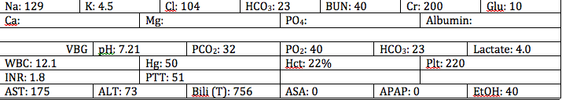 |  |  | Documentation forms:  Nursing Assessment Documentation Form | Confederates
Mannequin:

High Fidelity

Personnel:

Scenario Transitions / Patient Parameter | Effective Management |  | Consequences of Ineffective Management | Notes

Phase 1 Setting: PT BROUGHT INTO RESUS ROOM 103 BY TRIAGE RN

Baseline:  Sinus Tachy  HR: 115/min  BP: 105/60  RR: 24/min  O₂SAT: 96 %  T: 37.8ºC | - Place pt on Monitor  - Obtain history  - Full set of Vitals  - IV Access  - ECG  - Lab

Phase 2

*Pt vomits bright red blood with clots  HR 130  BP 85/50 | Hemorrhagic Shock:  - Call ERP Stat  - 2 Units Unmatched Blood  - Initiate MTP  - Octreotide Bolus and Infusion  - IV PPI Bolus and Infusion  - 2nd IV access (Central Line Access)  - Bolus fluids  - Lab (Including Type and Screen)  - Consult GI |  |  | No improvement with fluids.  *It’s 0200 GI is 30 minutes away

Phase 3

*Pt becomes more drowsy  Pt requires significant suctioning in order to intubate  HR 140  BP 78/48 | Intubation:  RSI  2 suction tips prepared  Difficult Airway prepared |  | PEA Arrest if no intubation | *Able to intubate using direct laryngoscopy

Phase 4

HR 150  BP 76/48 | Blakemore tube insertion  *See attached policy |  |  | 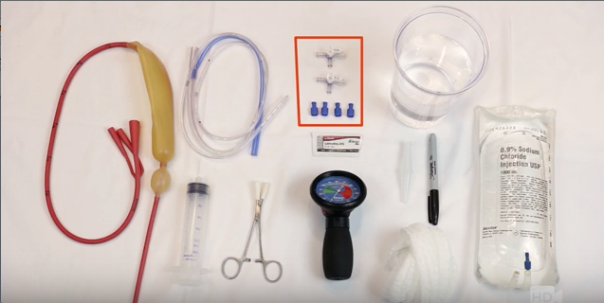
Possible debrief points:  - What are the medical management options for a significant variceal bleeding?  - What are the evidence based outcomes for the use of octreotide in UGIB? Antibiotics? PPI?  - What is a massive transfusion protocol? When and how would you initiate an MTP for a non-trauma patient?  - What are the airway considerations in a patient with a massive UGIB?  - Describe the set up and insertion of a Blakemore tube. |  | Debrief notes

