|  |  |
| --- | --- |
| **Case Title** | Theophylline Overdose |
| **Scenario Name** |  |

|  |  |
| --- | --- |
| **Learning Objectives -** [**Use action words**](http://ubccpd.ca/sites/ubccpd.ca/files/Accreditation_Learning%20Objectives_%20Verbs.pdf) | |
| **Knowledge:**   1. Recognize Theophylline toxicity 2. Manage polysubstance overdose | |
| **Skills:**   1. Lead resuscitation | |
| **Attitude/Behaviours**   1. Demonstrate Team skills 2. Demonstrate Situational awareness 3. Demonstrate Graded Assertiveness | |
| **Scenario Environment** | |
| **Location** | Emergency Department |
| **Monitors** | BP, cardiac, oximeter |
| **Props/Equipment** | Crash cart, CPS |
| **Make-up/Moulage** | None |
| **Potential Distractors** | None |

|  |
| --- |
| **Case Introduction:** |
| 37 ♀ with CP, palpitations, and vomiting. 2h ago smoked crack and ingested 18 Percocet bought on street. Nurse opens pill bottle and alerts you to the fact that pills do not appear to be Percocet. Denies recent IVDU or any other co-ingestants. Denies suicidal ideation – merely wanted to get high. |

| **Patient Parameters** | **Effective Management** | **Notes** |
| --- | --- | --- |
| **Phase 1: Agitated, vomiting**  **Condition:** Unstable  Unwell, agitated, diaphoretic, vomiting  **Initial Assessment**   * **Heart Rhythm:** Sinus tachycardia * **HR:** 165 * **BP:** 165/95 * **RR:** 22 * **SP02:** 99% * **T:** 36.5 C * **Glucose:** 7.6 * **Chest:** Clear * **CNS:** Agitated * **CVS:**  Normal * **GI:** Abd normal, vomiting | 1. **Take a focused history** (see Notes column) 2. **Medical Management** 3. Ascertain true identity of pills 4. Order appropriate investigations    1. 12 lead ECG    2. Labs 5. IV access/crystalloid bolus 6. Anti-nauseants 7. Behavioural control (benzos) 8. Call Poison Control 9. Consider GI decontamination | 1. **Focused history**  * As above   **PMHx**   * IVDU * Hepatitis C * Endocarditis (1 year ago)   **Meds**   * None   **Allergies**   * NKDA |
| **Phase 2: Remains Agitated**  **Condition:** Unstable  **Physical Examination**   * **Heart Rhythm:** Sinus Tachycardia * **HR:** 155 * **BP:** 160/90 * **RR:** 20 * **SPO2:** 99% * **T:** 36.5 C * **CNS:** GCS 15, agitated | 1. **Patient Reassessment** (see Notes column)-   *Recognizes change in condition*   1. **Medical Management** 2. Interpret labs and ECG 3. Continue IV fluids and benzos 4. Administer MDAC 5. Identify possible role for hemoperfusion 6. Consult nephrology, ICU | 1. **Patient Reassessment**   **Airway**   * Patent   **Breathing**   * Sats maintaining   **Circulation**   * Tachycardic, hypertensive |

|  |  |
| --- | --- |
| **Expected Patient Management** | **Debriefing Points** |
| 1. **Student** 2. **R1** 3. **Senior IM resident** |  |

**References:**

**X-RAYS**

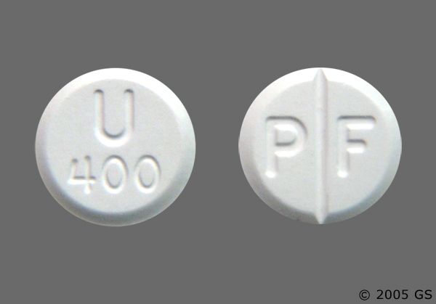

**LABS – click** [here](https://extranet.interiorhealth.ca/IHUBCFaculty/Diagnostics/Forms/AllItems.aspx?RootFolder=%25252FIHUBCFaculty%25252FDiagnostics%25252FLabs&View=%25257bFD97E2FE-FD01-433F-B9CB-D75A4195924E%25257d) **OR fill out below**

**EKGs**

