|  |  |
| --- | --- |
| **Case Title** | Cocaine Toxicity with Chest Pain |
| **Scenario Name** | Cocaine Toxicity |

|  |  |
| --- | --- |
| **Learning Objectives -** [**Use action words**](http://ubccpd.ca/sites/ubccpd.ca/files/Accreditation_Learning%20Objectives_%20Verbs.pdf) | |
| **Knowledge:**   1. Apply basic ACLS protocols 2. Demonstrate management of Cocaine toxicity 3. Demonstrate initial management of chest pain 4. Demonstrate initial management of V. tach | |
| **Skills:**   1. Perform high quality CPR 2. Perform defibrillation 3. Perform intubation 4. Demonstrate EKG interpretation | |
| **Attitude/Behaviours**   1. Demonstrate Team skills 2. Demonstrate Situational awareness 3. Demonstrate Graded Assertiveness | |
| **Scenario Environment** | |
| **Location** | ED |
| **Monitors** | Telemtry/Crash Cart/defibrillator |
| **Props/Equipment** | IV, Meds  Airway equipment  EKG |
| **Make-up/Moulage** | None |
| **Potential Distractors** | None |

|  |
| --- |
| **Case Introduction:** |
| Walk in Arrival. Call to ED acute care bed 4. 35 year old male on 4 day binge using cocaine and crack cocaine, IV, PO, insufflation. |

| **Patient Parameters** | **Effective Management** | **Notes** |
| --- | --- | --- |
| **Phase 1: Unstable Chest Pain, Agitated**  **Condition:** Unstable  Agitated, hallucinating, headache  **Initial Assessment**   * **Heart Rhythm:** Sinus Tachycardia * **HR:** 140 * **BP:** 230/130 * **RR:** 24 * **SP02:** 95% on R/A   ***Will not allow further physical assessment at this time due to agitation*** | 1. **Take a focused history** (see Notes column) 2. **Medical Management**  * History and physical exam. * Oxygen, IV, monitor, vitals. * Lorazepam IV for CP, agitation * Fluids * ASA and Nitro * Treat hypertension with Benzos, Phentolamine (no b-blockers). | 1. **Focused history**  * Arrives to ER with friend. * Has Chest Pain, agitated, hallucinating, headache. * Difficult patient.   **PMHx**   * Smoker * Drug abuse   **Meds**   * Drug abuse   **Allergies**   * NKDA |
| **Phase 2: Respiratory Decompensation**  **Condition:** Unstable  Struggling to breath, Spo2 and GCS start falling (Crack lung- acute lung injury)  **Physical Examination**   * **Heart Rhythm:** Sinus Tachycardia * **HR:** 150 * **BP:** 170/100 * **RR:** 28 * **SPO2**: 85% * **CNS:** GCS 8 | 1. **Patient Reassessment** (see Notes column)-*Recognizes change in condition* 2. **Medical Management:**  * Intubation * Lasix * Positive pressure ventilation   *When Chest pain, Hypertension, and airway addressed – progress to Phase 3 (V. Tach with a pulse)* | 1. **Patient Reassessment**   **Airway**   * Sats and GCS falling, struggling to breath- must intubate   **Breathing**   * Falling sats   **Circulation**   * BP decreasing post meds |
| **Phase 3: Ventricular Tachycardia with pulse**  **Condition:** Highly unstable  Patient unresponsive, eyes closed, intubated  **Physical Examination**   * **Heart Rhythm:** Ventricular Tachycardia * **HR:** 140 * **BP:** 150/90 * **RR:** intubated and bagged * **CNS:** GCS 3 | 1. **Patient Reassessment** (see Notes column)-*Recognizes change in condition- Rhythm* 2. **Medical Management:**  * Appropriate V. tach management:   + Synchronized cardioversion   + Bicarbonate   **Consequences of ineffective management**   * If defibrillation used instead of synchronized cardioversion, progress immediately to Phase 4 (V. Tach Arrest) * Otherwise, allow a couple rounds of cardioversion, and then progress to Phase 4 | 1. **Patient Reassessment**   **Airway**   * Obstructed, must intubate if not already done so   **Breathing**   * Apneic, must bag   **Circulation**   * Pulses present, must use synchronized cardioversion |
| **Phase 4: Ventricular Tachycardia arrest**  **Condition:** Coding  Patient unresponsive, eyes closed, intubated  **Physical Examination**   * **Heart Rhythm:** Ventricular Tachycardia (PEA) * **HR:** 145 * **BP:** -/- * **RR:** intubated and bagged * **CNS:** GCS 3 | 1. **Patient Reassessment** (see Notes column)-*Recognizes change in condition- Rhythm* 2. **Medical Management:**  * Appropriate V. tach cardiac arrest management:   + CPR   + Defibrillation   + More bicarbonate   + Lidocaine/amiodarone etc.   **Consequences of ineffective management**   * If ACLS guidelines followed correctly, progress to phase 5 (ROSC) | 1. **Patient Reassessment**   **Airway**   * Obstructed, must intubate if not already done so   **Breathing**   * Apneic, must bag   **Circulation**   * Pulses absent, must do CPR |
| **Phase 5: ROSC**  **Condition:** Unstable  ROSC, remains sedated and ventilated  **Physical Examination**   * **Heart Rhythm:** Sinus Tachycardia * **HR:** 130 * **BP:** 100/50 * **RR:** 12 on ventilator * **SpO2:** 96% vented on high oxygen | 1. **Patient Reassessment** (see Notes column)-*Recognizes change in condition* 2. **Medical Management:**  * Post Arrest Care | 1. **Patient Reassessment**   **Airway**   * Protected with ETT   **Breathing**   * On ventilator   **Circulation**   * ROSC |

|  |  |
| --- | --- |
| **Expected Patient Management** | **Debriefing Points** |
| 1. **Student** 2. **R1** 3. **Senior IM resident** |  |

**References:**

**X-RAYS**

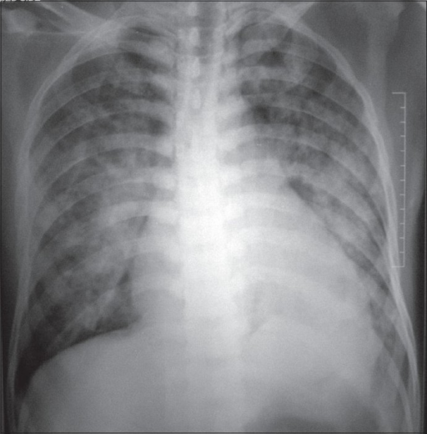

**LABS – click** [here](https://extranet.interiorhealth.ca/IHUBCFaculty/Diagnostics/Forms/AllItems.aspx?RootFolder=%25252FIHUBCFaculty%25252FDiagnostics%25252FLabs&View=%25257bFD97E2FE-FD01-433F-B9CB-D75A4195924E%25257d) **OR fill out below**

CBC Normal, Lytes Normal, Troponin 0.7, BUN/Cr Normal

**EKGs**

