|  |  |
| --- | --- |
| **Case Title** | Respiratory Distress |
| **Scenario Name** | Carl Crump |

|  |  |
| --- | --- |
| **Learning Objectives (3 or more) -** [**Use action words**](http://ubccpd.ca/sites/ubccpd.ca/files/Accreditation_Learning%20Objectives_%20Verbs.pdf) | |
| **Knowledge:**   1. Recognize Respiratory Distress 2. Recognize Shock 3. Identify indications for transfer to CCOT/ higher level of care/Intubation 4. Recognize mottling as a sign of shock 5. Recognize Shock and Respiratory distress as the problem 6. Recognize you need help and call CCOT or Code Blue 7. Generate a short differential diagnosis of post-op respiratory distress    * Aspiration gastric contents    * Sepsis (criteria for severe sepsis)    * Pulmonary embolism    * Volume overload (ie CHF) | |
| **Skills:**   1. Apply Oxygen 2. Intubate 3. Document current vital signs including GCS 4. Initiate generic management (ABCD)    1. Ensure airway    2. Provide oxygen, attach patient non-invasive monitor and O2 sat probe    3. Ensure patent and functioning iv    4. Document GCS, check blood glucose and O2 sat probe 5. Prepare patient for intubation    * Oxygen on/ NP insitu    * Suction ready    * IV started with NS bolus    * Bonus: Drugs for intubation and vasopressor support    * 2nd Bonus: access IH Sepsis protocol 6. Call MRP and communicate patient condition using SBAR | |
| **Attitude/Behaviours**   1. Demonstrate Team skills 2. Demonstrate Situational awareness 3. Demonstrate Graded Assertiveness   Notes and Prompts:   * If students don’t notice that the patient is experiencing respiratory distress and respond, SaO2 will drop to 80’s * If students don’t start IV and administer fluids, BP will continue to drop to 50/30 * If med students don’t call CCOT team or Code Blue team, nursing students can suggest it | |
| **Scenario Environment** | |
| **Location** | Ward |
| **Monitors** | None at the beginning, students must as for them |
| **Props/Equipment** | 1. Tour of the room 2. Handling of the Sim patient 3. Equipment demo 4. Respiratory support equipment 5. Nursing documentation forms 6. Patient’s chart (Case 1 and Case 2) 7. Blank SBAR sheets 8. Observer worksheet 9. Debrief worksheet (questions)   **Students to bring:** Stethoscope |
| **Make-up/Moulage** | None |
| **Potential Distractors** | None |

|  |
| --- |
| **Case Introduction:** |
| 77 Year old male admitted under General Surgeon (Dr. S).hemicolectomy 6/7 ago. Called with c/o SOB. |

| **Patient Parameters** | **Effective Management** | **Notes** |
| --- | --- | --- |
| **Phase 1: Unstable Resp Distress**  **Condition:** Unstable  Restless, disoriented, SOB, c/o needing to have a BM. “I feel awful” ,“am I going to die?”  **Initial Assessment**   * **Heart Rhythm:** Irregular Tachycardia * **HR:** 140s * **BP:** 150/90, BP falls during assessment * **RR:** 40 * **SP02:** 92% on RA, drops if no O2 applied * **T:** 35.0 C * **CNS:** GCS 13/15 (eye open to speech- E3, confused & not oriented to time- V4, obeys- M6)- 2 hours ago * **CVS:** Pale, diaphoretic, legs mottled | 1. **Take a focused history** (see Notes column) 2. **Medical Management** 3. Identify Roles and Delegate Responsibilities – for instance:    1. 2 med students on call for the MRP/service.       1. One providing overall leadership and calling the MRP    2. 1 med student on CCOT providing resuscitation    3. 1 med student on CCOT providing Respiratory/Anesthesia support    4. 1 nursing student on ward supporting assessment and providing care to the patient    5. 1 nursing student on CCOT 4. Complete a systematic patient assessment 5. Communicate salient patient findings clearly and respectfully with each other (SBAR as a guide) 6. Demonstrate listening skills and seek contribution from all team members 7. Acknowledge and provide comfort to patient 8. Formulate a working diagnosis and alternate diagnoses 9. Communicate to MRP patient status using SBAR format | 1. **Focused history**   **RN Assessment:**   * S: Sudden onset Shortness of Breath – RR 36-40; Heart rate fluctuating between 90-150 BPM; “Disorientated and restless” “complaining of urge to have a bowel movement” * - Wait for med student response: If asks questions respond with vague answers or “I don’t know” or “the last RN that assessed him is on break”   **PMHx**   * Day 6 Post-op Hemi-colectomy * HTN * Adeno CA Colon * Smoker   **Meds**  *Hand the MAR to the students:*   * + Oxazepam 15 mg last night   + PCA Morphine   + Ramipril 5 mg this morning   **Allergies**   * None |
| **Phase 2: Worsening Resp Distress**  **Condition:** Unstable  Less Responsive  **Physical Examination**   * **Heart Rhythm:** Irregular Tachycardia * **HR:** 152 * **BP:** 131/72, drops to 50/30 if no IV fluids * **RR:** 44, shallow & irregular * **SPO2:** 88%, drops to 80’s if no O2 applied * **T:** no change * **Chest:** decreased a/e bilat (shallow resps) * **CNS:** GCS 12 (E2, V4, M5) * **CVS:** pale, mottled, diaphoretic | 1. **Patient Reassessment** (see Notes column) 2. **Medical Management**   **Airway/ Breathing**   * O2 on   **Circulation**   * IV, patency checked & re-sited if not patent * IV fluids initiated | 1. **Patient Reassessment**   **Airway**   * Maintaining own   **Breathing**   * Increased effort, shallow, rapid   **Circulation**   * Identifies shock: decreased BP, pale, diaphoretic, decreased GCS. |

|  |  |
| --- | --- |
| **Expected Patient Management** | **Debriefing Points** |
| 1. **Student**    1. Complete ABCD assessment    2. Recognize Respiratory Distress    3. Apply supplemental Oxygen    4. Call R1 with SBAR 2. **R1**    1. Reassess patient ABCD    2. Call CCOT    3. Give epinephrine for shock    4. Formulate Differential Diagnosis    5. Call Senior resident with SBAR    6. Prepare to intubate 3. **Senior IM resident**    1. Safely transfer patient to ICU    2. Call MRP with SBAR    3. Communicate with family | **de-BRIEFING SUGGESTIONS:**   * Ask students:   + What did you do particularly well?   + What would you do differently if you could do it over again?   + How were the team dynamics? * Discuss your observations of what the team did well, and what you think they could have done better. * Discuss whether the team achieved all of the minimal behaviours (above). * What was going on with this patient? Why did it happen? * Write down what you learned during this simulation that you would apply in clinical practice? |

**References:**

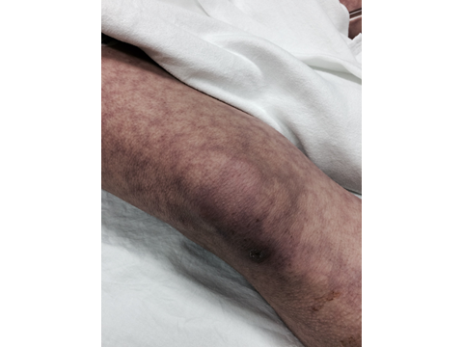

**X-RAYS – Click** [here](https://extranet.interiorhealth.ca/IHUBCFaculty/Diagnostics/Forms/AllItems.aspx?RootFolder=%25252FIHUBCFaculty%25252FDiagnostics%25252FX%25252Drays&View=%25257bFD97E2FE-FD01-433F-B9CB-D75A4195924E%25257d)

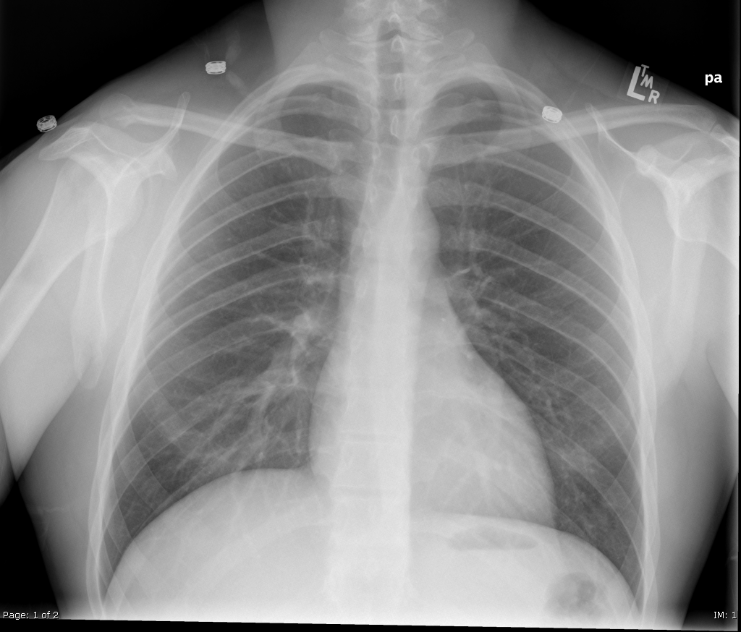

**LABS**

Only if asked: Blood glucose 9.7 by glucometer

|  |  |  |  |
| --- | --- | --- | --- |
| **Test** | **On Admission** | **Postop Day 6** | **Reference** |
| CBC |  |  |  |
| WBC | 5.6 | **16.2 H** | 3.5 – 10.8 10^9/L |
| RBC | 4.5 | **3.7 L** | 4.3 – 5.7 10^12/L |
| Hgb | 135 | **102 L** | 130 – 170 g/L |
| HCT | **0.39 L** | **0.29 L** | 0.37 – 0.47 L/L |
| Platelets | 210 | **90 L** | 150 – 400 10^9/L |
| LYT |  |  |  |
| Glucose - Random | 7.2 | 9.6 | 3.0 – 11.0 mmol/L |
| Na | 142 | **131 L** | 137 – 145 mmol/L |
| K | 3.7 | **5.4 H** | 3.5 – 5.0 mmol/L |
| Cl | 102 | 107 | 98 – 107 mmol/L |
| HCO3 | 24 | **16 L** | 22-26 mmol/L |
| Urea | **7.2 H** | **16 H** | 2.5 – 6.1 mmol/L |
| Creat | 97 | 147 **H** | 62 – 106 umol/L |
| GFR Est | 72 | **25 L** | > 60 ml/min |

|  |  |  |  |
| --- | --- | --- | --- |
| **ABGs** | | | |
| **Arterial** | | | |
| pH | **7.10** | **L** | 7.35- 7.45 |
| pCO2 | **27** | **L** | 35 – 45 mmHg |
| PO2 | 80 |  | 80-100 mmHg |
| BE | **-19.9** | **L** | -2.0 to +2.0 mmol/L |
| HCO3 | **16** | **L** | 22 – 26 mmol/L |
| O2 Sat | **90** | **L** | 95 – 100% |

**EKGs**

