Section 1: Case Summary

Scenario Title: | Medical-Surgical Severe Sepsis
Keywords: | Sepsis, Severe Sepsis, Perforated Bowel, Deterioration
Brief Description of Case: | An inpatient admitted with bowel obstruction becomes severely septic, secondary to a perforated bowel. Unit staff should identify the change in status, call for help early, continuously monitor the patient, and carry out interventions until the MRP arrives and the patient is transferred to a higher level of care.

Goals and Objectives
Educational Goal: | Practice management of a suddenly, severely septic patient
Objectives:  (Medical and CRM) | - Identify and treat sudden patient deterioration  - Continuously monitor patient for changes in status  - Practice ordering and administering STAT medications  - Mobilize resources and call for help early  - Designate leadership, establish role clarity, and distribute the workload appropriately  - Communicate effectively using a succinct and concise SBAR, closed-loop communication, and a sharing a mental model

Learners, Setting and Personnel
Target Learners: | ☒ Junior Learners |  | ☒ Senior Learners |  |  | ☒ Staff
 | ☒ Physicians | ☒ Nurses |  | ☐ RTs | ☒ Inter-professional
 | ☐ Other Learners:
Location: | ☒ Sim Lab |  | ☒ In Situ |  |  | ☐ Other:
Recommended Number of Facilitators: | Instructors: 1
 | Confederates: 1 (play the part of patient’s voice; also physician if none present)
 | Sim Techs: 1

Scenario Development
Date of Development: | 2020.01
Scenario Developer(s): | Adapted from Martin Kuuskne by Christina Choung
Affiliations/Institutions(s): | MK: McGill University; CC: Fraser Health
Contact E-mail: | Martin.kuuskne@mail.mcgill.ca; simulation@fraserhealth.ca
Last Revision Date:
Revised By:
Version Number:

Section 2A: Initial Patient Information

- Patient Chart
Patient Name: Gwen McDonald |  |  |  | Age: 70 | Gender: F | Weight: 75kg
Admitting diagnosis: Bowel Obstruction
Last set of Vital Signs
Temp: 37.2°C | HR: 90 | BP: 178/86 |  | RR: 18 | O₂Sat: 97% | FiO₂: RA
Cap glucose: 6.3 |  |  |  | GCS: 15
History of presenting illness:
Came to the ED this morning complaining of severe abdominal pain and vomiting. Returned from a 14 day cruise a few days ago and has not had any bowel movements during or after. Does not remember exactly when last BM was, as pattern is irregular and frequently experiences constipation. Has tried stool softeners with no results. Imaging done in ED reveals distal small bowel obstruction with gas dilation. Has had NG tube inserted and placed to intermittent suction and 2x enemas in the ED with little result.

Handover:
Neurologically intact. Continues to have abdominal pain but has not received analgesic as NPO and worry of further constipation secondary to narcotics. NG remains to intermittent suction; output ~150mL/h. Abdomen firm, but palpable. Since admission to the unit, has had a mineral oil enema and a high soap suds enema, with minimal result. Dimenhydrinate 25mg IV x1 has been given for nausea. Difficult to auscultated bowel sounds. BP high at 178/86 – unable to take PO meds – but no dizziness or headache present. One peripheral IV with fluids running D5 ½NS at 100mL/h. Other findings normal – warm and well-perfused, peripheral pulses palpable. Breath sounds and resp rate normal. Voiding per bathroom. In and out total so far is approximately (-)300mL.
Surgery should be in to see patient shortly – was seen in the ED, with follow-up planned for some time this shift.

The case begins with you answering Gwen’s call bell.

**Acknowledge during pre-brief that in real life, progression of illness would not happen quite as quickly. The speed of deterioration of the patient are for the purposes of the simulation, but how and why the patient is deteriorating are accurate.**

Allergies: NKDA
Past Medical History:  - Crohn’s disease (currently managed by diet)  - Hypertension  - Hernia repair, 5 years ago |  |  | Current Medications:  - Ramipril 10mg PO daily (on hold)

Section 2B: Extra Patient Information

A. Further History
n/a
B. Physical Exam
At start of case
Cardio: Hot, flushed, febrile at core; cap refill to feet ~4 seconds and slightly mottled | Neuro: Confused to time and place; tired. otherwise normal
Resp: Shallow, rapid, fine crackles to bases | Head & Neck: Normal
Abdo: Rigid | MSK/skin: Hot to touch at core; cool legs and feet with cap refill to feet ~4 seconds
Other:

Section 3: Technical Requirements/Room Vision

A. Patient
☒ Mannequin: Adult
☐ Standardized Patient
☐ Task Trainer
☐ Hybrid
B. Special Equipment Required
- 1 PIV in-situ
- Multiple O2 delivery modalities (NP, FM, NRB, etc.)
- 3x 1L Normal Saline, Ringer’s Lactate, or Plasmalyte
- Patient chart with section to write and process orders
- Sepsis screening tool
- Sepsis PPO

C. Required Medications
- Vancomycin 2g IV
- Piptazo 3.375g IV

D. Moulage
n/a
E. Monitors at Case Onset
☐ Patient on monitor with vitals displayed
☒ Patient not yet on monitor (Big numbers/mimic vital signs machine)
F. Patient Reactions and Exam
Neuro: eyes half open; confused to time and place
Resp: fine crackles bilaterally
CV: cap refill ~4-5 sec
GI: firm abdo

Section 4: Confederates and Standardized Patients

Confederate and Standardized Patient Roles and Scripts
Lab, XRay, ECG | Provide confederate/facilitator phone number for participants to call and request services
Physician, if none present | See Facilitator notes
Patient | See “Patient Status”
Code Blue Team | State that you are the code blue team and want to know what’s been happening to date

Section 5: Scenario Progression

Scenario States, Modifiers and Triggers
Patient State/Vitals | Patient Status | Learner Actions, Modifiers & Triggers to Move to Next State |  | Facilitator Notes
1. Baseline State  Rhythm: STach  HR: 120  BP: 85/55  RR: 22  O₂SAT: 94%  T: 39.5ºC  GCS: 14 | *Rang call bell as abdominal cramping increased and in lots of pain  Neuro: Confused to time and place; tired. otherwise normal  Resp: Shallow, rapid, fine crackles to bases  Cardio: Hot, flushed, febrile at core; cap refill to feet ~4 seconds and slightly mottled  Abdo: Rigid, increased pain | Expected Learner Actions  Ask questions regarding increase in pain; perform targeted assessment  Move to brief head to toe assessment; take vital signs  Note change in patient status  VS  Confusion, crackles, abd rigidity, mottled  Call for help  Roles/tasks are announced and delegated  Closed-loop communication occurs  Call physician/MRP with update; concise SBAR  Repeat physician orders to group  Tasks delegated amongst group and carried out | Modifiers  n/a  Triggers  -Move to next phase after physician orders reported back to group and tasks delegated and IV fluids being infused | -When participant goes to chat with patient, let them know they look flushed  -If no physician participant possible, ask for:  Fluid balance  IV access – ask for 2 large bore IVs total  2L NS IV bolus  Blood cultures  CBC, Lactate, Lytes  Meropenem 500mg IV q6h and Vancomycin 2g IV daily STAT  Abdo XRay STAT  Sepsis PPO (can you read it to me over the phone and do anything extra I might have forgotten?)  Call back if further deterioration occurs; will be calling ICU (or PTN) in case escalation of care required
2. Deterioration  HR to 140 over 20 seconds  BP to 75/40  SpO2 to 89% over 40 seconds | Neuro: feeling more tired  Cardio: feeling dizzy | Expected Learner Actions  Patient re-assessed; VS taken  Supplemental O2 delivery started  Physician re-called with new SBAR  Tasks continue to be carried out | Modifiers  -When supplemental O2 delivered:  --If 3L or less: SpO2 ↑ to 94%  --If 4-6L: ↑ 97%  --If >6L: ↑ 100%  Triggers  - Proceed to next phase after all expected learner action complete | -If no physician participant possible, ask:  What’s been done since last time called  Can we give vasopressors on the unit?  Call a code if LOC changes at all
3. PEA  BP: 0/0  O₂SAT: 0  (Rate and rhythm continue if on telemetry; if on low-tech VS monitor where HR monitored through sat probe, HR also drops to O) | Neuro: eyes closed  Resp: no effort | Expected Learner Actions  Note change in status  Re-assess patient; recognize loss of pulse; start CPR  - 100-120 compressions/min  - 5-6cm deep; full recoil  - 30:2  - Use of oral airway and BVM with chest rise  - Switch compression provider q2min or when compressions ineffective, whichever comes first  Code Blue called  Crash cart brought to bedside  Documentation started  Closed-loop communication used; essential actions stated out loud and communicated to documenter with eye contact  Leader identified; maintains situational awareness  When Code Blue team arrives, concise and accurate handover given | Modifiers  n/a  Triggers  - case ends after handover to Code Blue team | -Code Blue team to arrive 2 min after code called

Appendix A: Laboratory Results

CBC  WBC  Hgb  Plt  Lytes  Na  K  Cl  HCO₃  AG  Urea  Cr  Glucose  Extended Lytes  Ca  Mg  PO₄  Albumin  TSH  VBG  pH  pCO₂  pO₂  HCO₃  Lactate | Cardiac/Coags  Trop  D-dimer  INR  aPTT  Biliary  AST  ALT  GGT  ALP  Bili  Lipase  Tox  EtOH  ASA  Tylenol  Dig level  Osmols  Other  B-HCG

Appendix B: ECGs, X-rays, Ultrasounds and Pictures

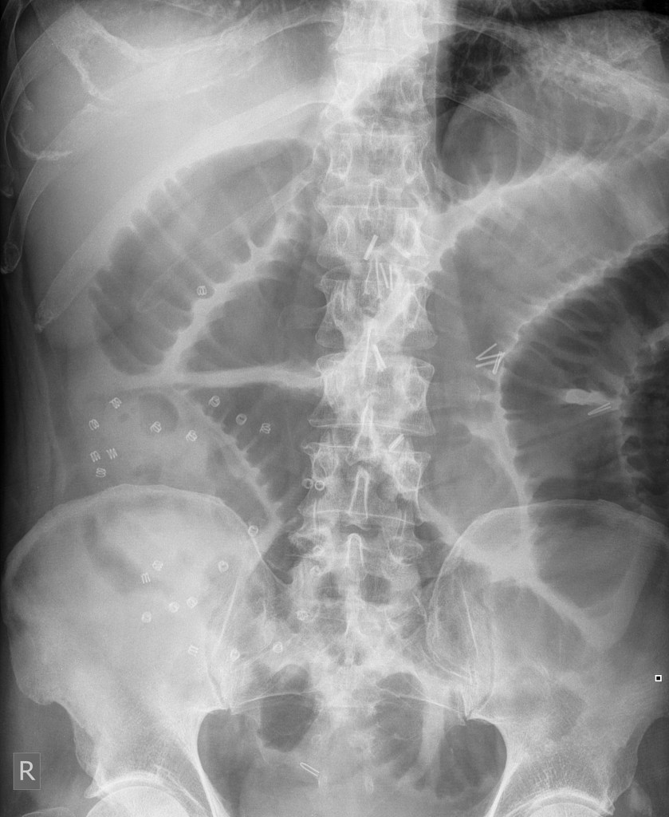

https://radiopaedia.org/cases/small-bowel-obstruction-15?lang=us

Appendix C: Facilitator Cheat Sheet & Debriefing Tips

Include key errors to watch for and common challenges with the case. List issues expected to be part of the debriefing discussion. Supplemental information regarding any relevant pathophysiology, guidelines, or management information that may be reviewed during debriefing should be provided for facilitators to have as a reference.

References

1.
2.
3.

