|  |  |
| --- | --- |
| **Case Title** | Hot and Bothered |
| **Scenario Name** | GHB withdrawal with agitation and seizures |

|  |  |
| --- | --- |
| **Overall Objectives** | |
| **Knowledge:**   1. Chemical/physical restraint of the undifferentiated agitated/violent patient 2. Differential diagnosis and work-up of the hyperthermic/agitated patient 3. Management of seizures in the context of suspected intoxication/withdrawal | |
| **Skills:**   1. Leadership in the initial “Code White” management of a violent/agitated patient 2. Intraosseous placement 3. Intubation | |
| **CRM Behaviours**   1. Demonstrate Team skills 2. Demonstrate Situational awareness 3. Demonstrate Graded Assertiveness | |
| **Scenario Environment** | |
| **Location** | ED trauma bay |
| **Monitors** | All |
| **Props/Equipment** | Physical restraints |
| **Make-up/Moulage** | Nil |
| **Potential Distractors** | Patient agitated, non-compliant, and violent |

|  |
| --- |
| **Royal College EM Residency Competenc by Design (CBD) Objectives** |
| **CBD Objectives for Junior Learners** |
| **Knowledge:**  **C ME 3.1.6** **Recognize indications, contraindications and monitoring requirements for chemical and physical restraints** within the framework of provincial legislation/regulations   * Recognize altered level of consciousness (agitation) and initiate appropriate chemical/physical restraint   **TD ME 2.2.5** Construct a differential diagnosis that recognizes both important uncommon and common diagnoses   * **Provide a differential diagnosis of the hyperthermic/agitated patient** that includes toxicologic, medical, and environmental emergencies   **F ME 2.2.5** **Develop a working diagnosis and differential while simultaneously providing symptom management**   * Initiate management even in the context of an incomplete clinic assessment due to complex clinical presentation |
| **Skills:**  **TD L 1.2.1** **Take appropriate measures to assure safety of the healthcare team and avoid physical injury during the patient encounter**, including but not limited to use of personal protective equipment (PPE)   * Call for security to assist in restraint prior to requesting IM medication administration   **F ME 3.1.1** Describe the indications, contraindications, techniques, risks, and alternatives for a given procedure or therapy   * **Obtain tibial intraosseous access**   **C ME 3.1.3** Describe the indications, contraindications, risks, alternatives, complications, and post-procedure management for a given procedure or therapy   * **Explain the indications for endotracheal intubation** |
| **CRM Behaviours:**  **TD COL 1.2.3** **Communicate the severity of the patient’s condition clearly to a senior clinician and seek supervision in a timely manner**   * Call for help early (more senior clinician and/or poison control)   **F COL 1.2.2** **Prioritize goals of care verbally in the initial resuscitation and assign roles to health care team where appropriate**   * Distribute the workload   **F L 3.1.2** **Demonstrate leadership in the health care team as appropriate**   * Establish clear leadership and inform team members who is in charge |
| **CBD Objectives for Senior Learners** |
| **Knowledge:**  **C ME 2.2.15** **Order appropriate laboratory investigations** while caring for a patient with an overdose, toxic ingestion or exposure   * Initiate CBC, lytes, BUN, Cr, serum osm, VBG, lactate, and ASA, APAP, EtOH levels, U/A, ECG + initiate cooling and appropriate chemical restraint (IM benzodiazepine or IM Ketamine)   **C ME 3.3.4** Triage and set appropriate priorities when dealing with single or multiple critically ill patients   * **Manage seizure with benzodiazepines or propofol** in the context of an undifferentiated hyperthermic patient with toxicological concerns on the ddx   **TD ME 2.2.5** Construct a differential diagnosis that recognizes both important uncommon and common diagnoses   * **Provide a thorough differential diagnosis of the hyperthermic/agitated patient** |
| **Skills:**  **C ME 3.4.5** **Perform the most appropriate approach to definitive airway management**, including endotracheal intubation, and surgical airway techniques, in a skillful and safe manner, adapting to unanticipated findings or changing clinical circumstances   * Prepare for and perform endotracheal intubation including airway assessment, preparation, induction/paralysis, and post-intubation sedation   **C ME 1.6.3 Use sound clinical reasoning and judgment to guide diagnosis and management and arrive at appropriate diagnostic and therapeutic decisions**, even in circumstances where complete clinical or diagnostic information is not immediately available  **TD L 1.2.1** **Take appropriate measures to assure safety of the healthcare team and avoid physical injury during the patient encounter**, including but not limited to use of personal protective equipment (PPE)   * Call for security to assist in restraint prior to requesting IM medication administration |
| **CRM Behaviors:**  **F L 3.1.1** **Organize an interprofessional team in the initial phase of a resuscitation**   * Effectively distribute the workload by involving pharmacy, security, nursing, and RT in the resuscitation and demonstrate closed loop communication   **C COM 2.3.1** **Obtain collateral history from other sources** including but not limited to friends, family members, EMS, law enforcement, social workers, housing workers, and other community liaisons  **F L 3.1.2** **Demonstrate leadership in the health care team as appropriate**   * Establish clear leadership and inform team members who is in charge |

|  |
| --- |
| **Case Introduction:** |
| It’s 0700h. RCMP bring a 40 year old man from a private residence – they were called for agitation/bizarre behaviour. Has become increasingly agitated/aggressive/confused since his apprehension. Police video from the scene is available. Play <https://youtu.be/HfEepVOQrpE> (8:00-9:30 min segment). He is placed supine on a stretcher in T3. He is writhing, agitated, and screaming. No vital signs or capillary blood sugar available due to level of agitation. |

| **Patient Parameters** | **Effective Management** | **Notes** |
| --- | --- | --- |
| **Phase 1: Initial control**  **Condition: uncontrolled/agitated**  **Initial Assessment**  Unable to obtain VS until Phase 2   * **T:** Unknown, but warm to touch * **CNS:** Agitated/confused/tremulous/moving all extremities – GCS ~ 14. Mydriasis. * **Integ:** Flushed, diaphoretic * **Weight:** ~ 80kg | 1. **Take a focused history** (see Notes column) 2. **Medical Management**  * Requires immediate chemical and physical restraint due to ongoing safety risk to staff and self   + Call for additional help (security, staff)   + No chance of IV access initially – initial medications must be given IM   + IM benzodiazepines (midazolam, diazepam, or Lorazepam)   + IM antipsychotics (haloperidol, loxipine, olanzepine)   + IM ketamine (4-5 mg/kg) * Single dose of any agent (except IM ketamine) fails to effect behaviour control. 2+ doses required to achieve an adequate level of control   **Consequences of ineffective management**   * Escalating agitation/aggression – verbal aggression, spitting, hitting, etc… | 1. **Focused history**  * Unsuccessful - patient responds to questions with expletives or nonsense   **PMHx**   * Unknown * No known trauma   **Meds**   * Pharmanet says no   **Allergies**   * Unknown |
| **Phase 2: Workup/management**  **Condition: Remains agitated**  **Physical Examination**   * **Heart Rhythm:** Sinus tachycardia * **HR:** ~165 * **BP:** 185/110 * **RR:** 35 * **SP02:** 100% * **T:** 39.0 * **Glucose:** 5.5 mmol/L * **CNS:** Moderate agitation/confusion. Tremulous. GCS 14. Mydriasis * **Chest:** clear * **CVS:** normal * **GI:** nil acute * **GU:** nil acute * **Integ:** Warm, flushed, diaphoretic | **Medical Management**   * Recognize agitated delirium and consider Ddx * Attempt to obtain IV access (unable)   + Obtain IO access * Escalation of benzodiazepine/antipsychotic dosing for continued agitation * Initiate cooling (cooling blanket, mist/fans, ice packs) * Investigations (ECG, labs, U/A) – still too agitated for CT head * Collateral history - see notes   **Consequences of ineffective management**   * Continued agitation/hyperthermia | **Ddx**   1. Drug intoxication (sympathomimetics, anticholinergics, hallucinogens) 2. Drug withdrawal (EtOH, benzodiazepine, barbiturate, **GHB**) 3. Intracranial infection 4. Thyroid storm 5. SS/NMS/MH 6. Heat Stroke 7. Trauma 8. Salicylate/TCA OD   **Collateral history**   * In computer - 2 previous ED visits with GHB OD * NOK is ex-GF – if called, will volunteer regular GHB user |
| **Phase 3: Seizure management**  **Condition: Generalized tonic-clonic seizure**  **Physical Examination**   * **Heart Rhythm:** sinus tachycardia * **HR:** 180 * **BP:** 190/116 * **RR:** 10 * **SP02:** 88% and dropping * **CNS:** GTC seizure | **Medical Management**   * Aggressive benzodiazepine dosing (ineffective) * No role for phenytoin/fosphenytoin * Requires either barbiturate or Propofol for seizure cessation   **Consequences of ineffective management**   * Persistent GTC seizure activity with worsening of hyperthermia and eventual VF arrest |  |
| **Phase 4: Post seizure management & conclusion**  **Condition: ALOC/hypoxic post seizure**  **Physical Examination**   * **Heart Rhythm:** sinus tachycardia * **HR:** 170 * **BP:** 165/105 * **RR:** 6 * **SP02:** 84% (room air) * **T:** 39.4 * **CNS:** GCS 6 (E1V1M4) | **Medical Management**   * Intubation for airway control   + Sedative (benzodiazepine/Propofol/ketamine all acceptable)   + Short acting paralytic preferred * Continued sedation & cooling   + Propofol infusion preferred (barbiturate or benzodiazepine acceptable)   + Active/aggressive cooling   **Consequences of ineffective management**   * Persistent hypoxia/eventual bradyarrhythmia and asystolic cardiac arrest |  |

**Insert more lines if more phases required.**

|  |  |
| --- | --- |
| **Expected Patient Management** | **Debriefing Points** |
| See CBD Objectives for expected patient management of a junior and senior EM Resident. |  |

**References:**

**X-RAYS**

Normal CXR

[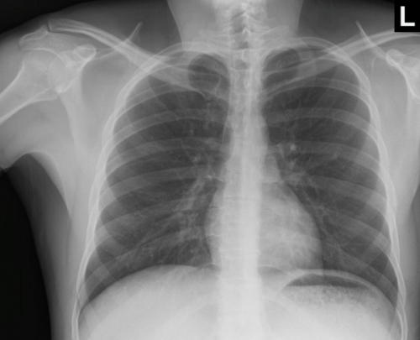](http://www.google.ca/url?sa=i&rct=j&q=&esrc=s&source=images&cd=&cad=rja&uact=8&ved=0ahUKEwiKkZWqvaHWAhXB31QKHaGeDAAQjRwIBw&url=http://www.chestx-ray.com/index.php/education/normal-cxr-module-train-your-eye&psig=AFQjCNFJEu7szZNma_Eu5JQ3Nu-TeCCMCg&ust=1505368297716008)

**LABS – click** [here](https://extranet.interiorhealth.ca/IHUBCFaculty/Diagnostics/Forms/AllItems.aspx?RootFolder=%25252FIHUBCFaculty%25252FDiagnostics%25252FLabs&View=%25257bFD97E2FE-FD01-433F-B9CB-D75A4195924E%25257d) **OR fill out below**

LABORATORY *LIVE* Lab Summary Report

|  |  |  |  |
| --- | --- | --- | --- |
| **Test** | **DATE/TIME here** | **Flag** (H or L) | **Reference** |
| **CBC** | | | |
| WBC | 10.3 |  | 3.5 – 10.8 10^9/L |
| Hgb | 136 |  | 130 – 170 g/L |
| HCT | 0.43 |  | 0.37 – 0.47 L/L |
| Platelets | 388 |  | 150 – 400 10^9/L |
| **Chemistry** | | | |
| Na | 140 |  | 137 – 145 mmol/L |
| K | **5.1** | **H** | 3.5 – 5.0 mmol/L |
| Cl | 106 |  | 98 – 107 mmol/L |
| HCO3 | 22 |  | 22-26 mmol/L |
| Urea | **7.0** | **H** | 2.5 – 6.1 mmol/L |
| Creat | **118** | **H** | 62 – 106 umol/L |
| Glucose - Random | 5.5 |  | 3.0 – 11.0 mmol/L |
| EtOH | 5 |  | 0-10 mmol/L |
| ASA | negative |  | Negative |
| Acetaminophen | negative |  | Negative |
| **Coags** |  |  |  |
| INR | 1.0 |  | 0.9 – 1.2 |
| PTT |  |  | 28 – 38 s |
| **Blood Gases** | | | |
| **Venous** | | | |
| pH | **7.28** | **L** | 7.35- 7.45 |
| pCO2 | **28** | **L** | 35 – 45 mmHg |
| BE |  |  | -2.0 to +2.0 mmol/L |
| HCO3 | 22 |  | 22 – 26 mmol/L |
| O2 Sat | 98 |  | 95 – 100% |
| Lactate | **3.8** | **H** | 0.7-2.1mmol/L |

**EKGs – click** [here](https://extranet.interiorhealth.ca/IHUBCFaculty/Diagnostics/Forms/AllItems.aspx?RootFolder=%25252FIHUBCFaculty%25252FDiagnostics%25252FECGs&View=%25257bFD97E2FE-FD01-433F-B9CB-D75A4195924E%25257d) **or paste**

Sinus tach at 170 bpm

[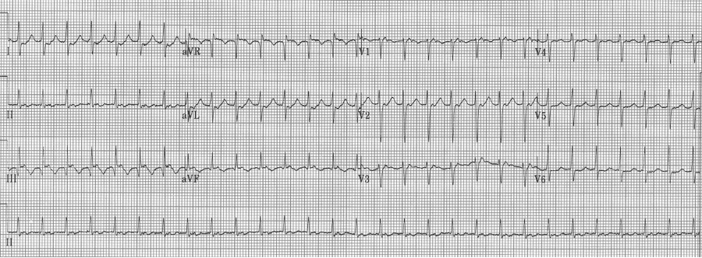](http://www.google.ca/url?sa=i&rct=j&q=&esrc=s&source=images&cd=&cad=rja&uact=8&ved=0ahUKEwiu8MiBuaHWAhWnqFQKHdRTD5oQjRwIBw&url=http://torreyekg.com/index.php/2015/07/27/hyperkalemia-brugada-sign/&psig=AFQjCNFX6Q9_6R_V3L-fRx5gcPAOSZ3UTw&ust=1505367392043461)