|  |  |
| --- | --- |
| **Case Title** | Escil what?? |
| **Scenario Name** | Eslicarbazepine overdose (Aptiom) |

|  |  |
| --- | --- |
| **Learning Objectives -** [**Use action words**](http://ubccpd.ca/sites/ubccpd.ca/files/Accreditation_Learning%20Objectives_%20Verbs.pdf) | |
| **Knowledge:**   1. Of basic overdose principles of management 2. Seizure control 3. Wide complex tachycardia treatment in an overdose patient. 4. Intubation drug of choice in this overdose patient. 5. Decontamination options | |
| **Skills:**   1. Initial assessment of overdose patient. 2. Team direction and leadership. 3. Coordinates with Poison Control and ICU 4. Intubation and airway management | |
| **Attitude/Behaviours:**   1. Demonstrate Team skills 2. Demonstrate Situational awareness 3. Demonstrate Graded Assertiveness | |
| **Scenario Environment** | |
| **Location** | Emergency T3 |
| **Monitors** | ED monitors |
| **Props/Equipment** | Pill Bottle – Eslicarbazepine 800mg – 7 missing |
| **Make-up/Moulage** |  |
| **Potential Distractors** | Poison Control  Friend in room  *** Multiple MDs in room – 5-6 at one time. |

|  |
| --- |
| **Case Introduction:** |
| 18 year old female.  Brought to ED by friend whom she spent the night with.  Past history of ETOH and Drug use.  Sat in WR waiting then Admits to friend in Main WR to taking 7 of friends seizure meds.  7 x 800mg Eslicarpazepine  Became drowsy in WR and en route to hospital  Transferred to T3 – deteriorates – initially drowsy, tachy and rigid with clonus and hyperreflexia |

| **Patient Parameters** | **Effective Management** | **Notes** |
| --- | --- | --- |
| **Phase 1: Drowsy**  **Condition:** Drowsy and Rigid  **Initial Assessment**   * **Heart Rhythm:** Sinus * **HR:** 140 * **BP:** 100/70 * **RR:**  12 * **SP02:**  97 * **T:** 36 * **Glucose:** 5.0 * **CNS:** GCS 13 (M6, E3, V4) * **Chest:** Clear | 1. **Take a focused history** (see Notes column) 2. **Medical Management**  * IV * Oxygen * Monitors * Determine time of OD * Determine pills taken – speak with friend * Assess GCS, Neurologic exam, CVS exam * Consider decontamination options * Contact PCC * Order – EKG, CBC, lytes, renal function, VBG, lactate, hepatic panel, Bhcg, OSM, ETOH, Tylenol and ASA levels | 1. **Focused history**  * As above * OD is 3 hours prior to assessment * Unclear reason why OD * Most history from friend as patient is drowsy   **PMHx**   * ETOH, substance use * Depression   **Meds**   * Paxil * But friend had other meds in house * Carbamazepine, Lamotrigine   **Allergies**   * None |
| **Phase 2: Seizure & PEA Arrest**  **Condition:** Seizure and Arrest  **Physical Examination**   * **Heart Rhythm:** PEA * **HR:** 140 * **BP: -/-** * **RR:** apneic * **SP02:** 50% | 1. **Patient Reassessment** (see Notes column)   Sudden Seizure and hypoxic PEA arrest   1. **Medical Management**  * Stop Seizures – Benzos – Lorazepam or Midazolam * Call Code Blue * Intubate patient – propofol, benzos, paralytic * Basic PEA/ACLS resuscitation * Contacts Poison Control   **Consequences of ineffective management**   * Continued seizures * Death and no ROSC | 1. **Patient Reassessment**   **Airway**   * Intubate as no longer protecting and hypoxic arrest * RSI/Crash airway in arrest   **Breathing**   * Ventilates   **Circulation**   * CPR   ***Ensure discussion with Poison Control*** |
| **Phase 3: Wide Complex VT with pulse**  **Condition:** Converts with 1 cardioversion shock at 200J to SR. Followed by more runs of VT and instability  **Physical Examination**   * **Heart Rhythm:** VT * **HR:** 180 * **BP:** 70/40 * **RR:** 14 (ventilated) * **SP02:** 95% ventilated | Code Blue called at time of arrest  5-6 MDs in Room all giving orders  Need to control room – lead resuscitation and use physician resources as needed.   1. **Patient Reassessment** (see Notes column)   Recognizes VT and runs of VT and manages accordingly   1. **Medical Management**  * Shock patient with 200Joules to convert to SR * Bicarb boluses * Bicarb infusions   ***Repeated runs of Vtach***  **Medical Management cont.**   * Consider intra lipid * CVC and Art line placement can be done as well as other post arrest care. * Foley, OG tube * ? consider Whole bowel irrigation   ***Once stable PCC calls to inform you that drug is dialyzable***  **Disposition is eventual ICU and dialysis once stable.** |  |

**Insert more lines if more phases required.**

|  |  |
| --- | --- |
| **Expected Patient Management** | **Debriefing Points** |
| 1. **Student** 2. **Junior Resident** 3. **Senior Resident** |  |

**References:**

**X-RAYS – Click** [here](https://extranet.interiorhealth.ca/IHUBCFaculty/Diagnostics/Forms/AllItems.aspx?RootFolder=%25252FIHUBCFaculty%25252FDiagnostics%25252FX%25252Drays&View=%25257bFD97E2FE-FD01-433F-B9CB-D75A4195924E%25257d)

**LABS – click** [here](https://extranet.interiorhealth.ca/IHUBCFaculty/Diagnostics/Forms/AllItems.aspx?RootFolder=%25252FIHUBCFaculty%25252FDiagnostics%25252FLabs&View=%25257bFD97E2FE-FD01-433F-B9CB-D75A4195924E%25257d) **OR fill out below**

LABORATORY *LIVE* Lab Summary Report

|  |  |  |  |
| --- | --- | --- | --- |
| **Test** | **DATE/TIME here** | **Flag** (H or L) | **Reference** |
| **CBC** | | | |
| WBC |  |  | 3.5 – 10.8 10^9/L |
| RBC |  |  | 4.3 – 5.7 10^12/L |
| Hgb |  |  | 130 – 170 g/L |
| HCT |  |  | 0.37 – 0.47 L/L |
| Platelets |  |  | 150 – 400 10^9/L |
| D-Dimer |  |  | <250 mcg/L |
| **Chemistry** | | | |
| Na |  |  | 137 – 145 mmol/L |
| K |  |  | 3.5 – 5.0 mmol/L |
| Cl |  |  | 98 – 107 mmol/L |
| HCO3 |  |  | 22-26 mmol/L |
| Urea |  |  | 2.5 – 6.1 mmol/L |
| Creat |  |  | 62 – 106 umol/L |
| GFR Est |  |  | > 60 ml/min |
| Glucose - Random | Post Arrest labs |  | 3.0 – 11.0 mmol/L |
| Lactate | **15** | **H** | 0.9 – 1.8 mmol/L |
| CK |  |  | 5 – 130 U/L |
| Troponin |  |  | <0.03 mcg/L |
| **Coags** |  |  |  |
| INR |  |  | 0.9 – 1.2 |
| PTT |  |  | 28 – 38 s |
| **ABGs** | | | |
| **Arterial** | | | |
| pH | **6.8** | **L** | 7.35- 7.45 |
| pCO2 | **140** | **H** | 35 – 45 mmHg |
| PO2 | **60** | **L** | 80-100 mmHg |
| BE |  |  | -2.0 to +2.0 mmol/L |
| HCO3 | **5** | **L** | 22 – 26 mmol/L |
| O2 Sat |  |  | 95 – 100% |

**EKGs**

[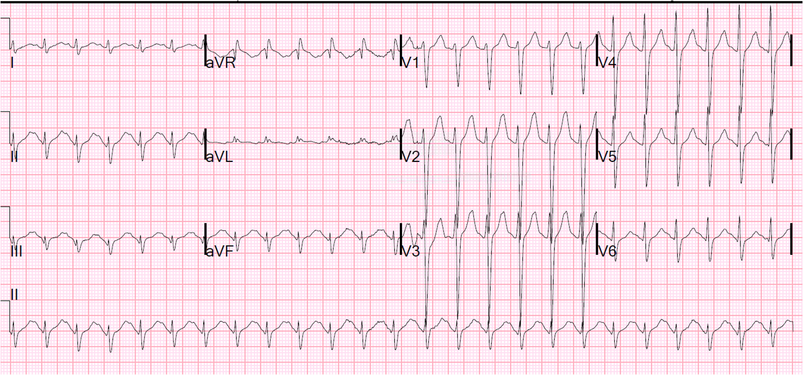](http://2.bp.blogspot.com/-OntdVMJowSk/U2PdingHAKI/AAAAAAAAD24/bnIUPSnm6kM/s1600/First+ECG+QT+360+QTc+540.png)

