|  |  |
| --- | --- |
| **Case Title** | Spontaneous Subarachnoid Hemorrhage (SAH) on Coumadin |
| **Scenario Name** |  |

|  |  |
| --- | --- |
| **Learning Objectives -** [**Use action words**](http://ubccpd.ca/sites/ubccpd.ca/files/Accreditation_Learning%20Objectives_%20Verbs.pdf) | |
| **Knowledge:**   1. Demonstrate intubation including: Approach to difficult airway. Approach in patient with elevated ICP 2. Discuss reversal of Warfarin 3. Demonstrate seizure management | |
| **Skills:**   1. Intubation skills – difficult airway, elevated ICP | |
| **Attitude/Behaviours**   1. Demonstrate Team skills 2. Demonstrate Situational awareness 3. Demonstrate Graded Assertiveness | |
| **Scenario Environment** | |
| **Location** | Emergency |
| **Monitors** | Cardiac |
| **Props/Equipment** | IV  Crash Cart/Defibrillator  Meds  ECG |
| **Make-up/Moulage** | None |
| **Potential Distractors** | None |

|  |
| --- |
| **Case Introduction:** |
| **Pre-hospital notification:** 66 year old male at work with sudden collapse. Decreasing level of consciousness en route to ED.   * Patient given 20mg midazolam by paramedics for intubation. Unsuccessful |

| **Patient Parameters** | **Effective Management** | **Notes** |
| --- | --- | --- |
| **Phase 1: Confusion**  **Condition:** Stable.  **Initial Assessment**   * **Heart Rhythm:** Atrial Fibrillation * **HR:**  50 (irregular) * **BP**: 230/130 * **RR:** 12 * **SP02:** 95% * **CNS:** GCS 13 (E-3, V-4, M-6) | 1. **Take a focused history** (see Notes column) 2. **Medical Management**  * Get ECG | 1. **Focused history**   Patient was in argument at work. Suddenly grabbed his head and collapsed to the ground. Was unresponsive for a minute, then awake and complaining of headache. Slightly increasing confusion en route to ED.  **PMHx**   * Atrial fibrillation   **Meds**   * Coumadin * Diltiazem   **Allergies**   * NKDA |
| **Phase 2: Deterioration**  **Condition:** Unstable.  Patient deteriorates: pupil “blows”, decreasing level of consciousness---Uncal herniation.  **Initial Assessment**   * **Heart Rhythm:** Atrial Fibrillation * **HR:**  50 (irregular) * **SP02:** 88% * **CNS:** GCS 5 (E-1, V-1, M-3) | 1. **Patient Reassessment** -*Recognizes change in condition* 2. **Medical Management:**  * Airway Management:   + Difficult airway set up: back up techniques at bedside. Resident should acknowledge that paramedics could not intubate.   + Intubate: RSI with possible lidocaine, fentanyl, etomidate/propofol and succinylcholine/rocuronium * Call CT scan and neurosurgery. * Pharmacology:   + Call for Octaplex   + Vitamin K 10mg IV * Considerations:   + Consider ICP management - Mannitol infusion, PCO2 of 35 and head of bed up.   + Consider BP control – target 30% drop in BP with nitroprusside or hydralazine (labetolol if HR increased). | 1. **Patient Reassessment**   **Airway**   * No longer maintaining own, needs to intubate   **Breathing**   * Spontaneous resps, falling sats   **Circulation**   * Present |
| **Phase 3: Seizures**  **Condition:** Unstable.  Patient starts to have generalized seizures  **Initial Assessment**   * **Heart Rhythm:** Atrial Fibrillation * **HR:**  110 (irregular) * **SP02:** 80% (drops further if airway not secured) * **CNS:** Seizing,GCS 3 (E-1, V-1, M-1) | 1. **Patient reassessment** -*Recognizes change in condition* 2. **Medical Management:**  * Immediate use of Benzodiazepines * Phenytoin load for further control and prophylaxis | 1. **Patient Reassessment**   **Airway**   * Not maintaining, needs to intubate if not already done so   **Breathing**   * If RSI, no spontaneous resps, needs bagging   **Circulation**   * Present |

|  |  |
| --- | --- |
| **Expected Patient Management** | **Debriefing Points** |
| 1. **Student** 2. **R1** 3. **Senior IM resident** |  |

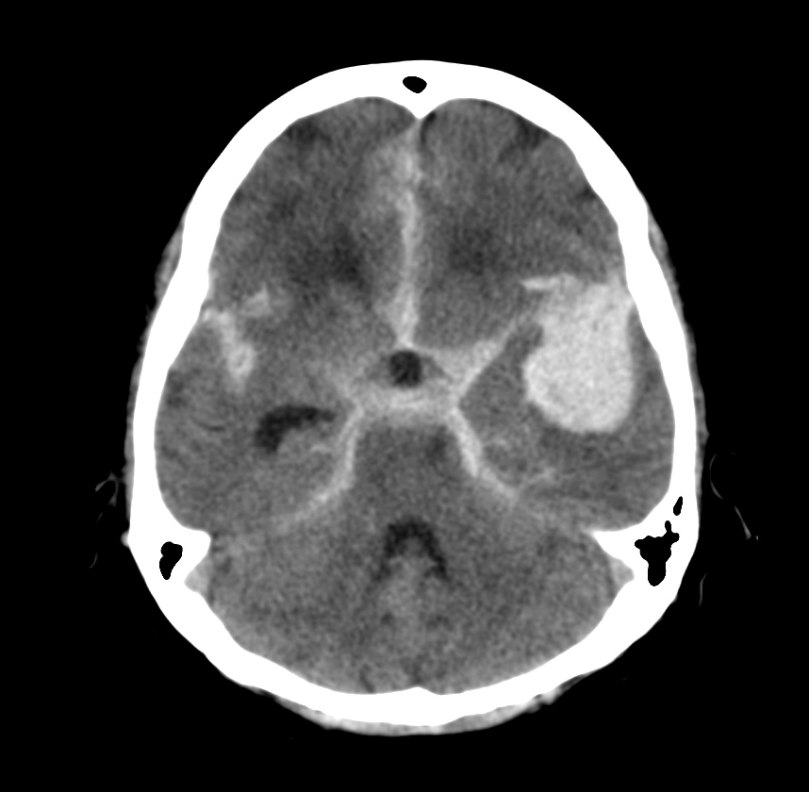

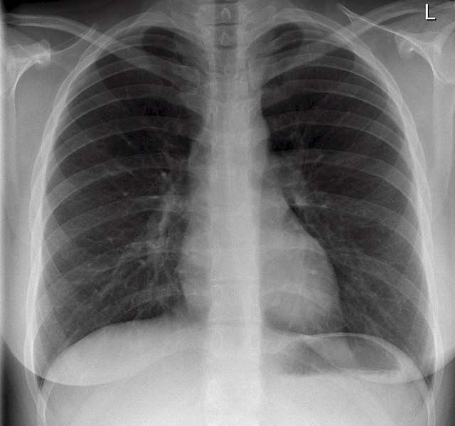

**EKGs – click** [here](https://extranet.interiorhealth.ca/IHUBCFaculty/Diagnostics/Forms/AllItems.aspx?RootFolder=%25252FIHUBCFaculty%25252FDiagnostics%25252FECGs&View=%25257bFD97E2FE-FD01-433F-B9CB-D75A4195924E%25257d) **or paste**

