|  |  |
| --- | --- |
| **Case Title** | Thyroid Storm |
| **Scenario Name** | Thyroid Storm |

|  |  |
| --- | --- |
| **Learning Objectives -** [**Use action words**](http://ubccpd.ca/sites/ubccpd.ca/files/Accreditation_Learning%20Objectives_%20Verbs.pdf) | |
| **Knowledge:**   1. Avoid fixation error/anchoring by maintaining a broad differential diagnosis 2. Use leadership style that encourages team members to offer suggestions for management in a complex patient | |
| **Skills:**   1. Recognize and appropriately manage a patient with congestive heart failure in the context of thyroid storm. 2. Initiate appropriate thyrotoxicosis treatment with assistance from consultants 3. Calmly discuss patient’s status at bedside with husband, including need for intubation | |
| **Attitude/Behaviours:**   1. Demonstrate Team skills 2. Demonstrate Situational awareness 3. Demonstrate Graded Assertiveness | |
| **Scenario Environment** | |
| **Location** | Tertiary Care Centre |
| **Monitors** | NIBP, SP02, ecg |
| **Props/Equipment** | Intubation equipment, IV fluids |
| **Make-up/Moulage** |  |
| **Potential Distractors** | Anxious husband |

|  |
| --- |
| **Case Introduction:** |
| You are working the evening shift at a tertiary care hospital. A 31-year-old female two weeks postpartum is brought in by EMS accompanied by her husband. He is concerned because she is delirious and somewhat difficult to rouse. |

| **Patient Parameters** | **Effective Management** | **Notes** |
| --- | --- | --- |
| **Phase 1: Delirious**  **Condition:** Pt is Delirious, decreased LOC. When roused (sternal rub – eyes half-way open) is confused and disorientated/delirious (will mumble - “I have to feed the cat, I need to wash the car; the plane is about to leave I have to go”).  **Initial Assessment**   * **Heart Rhythm:** Sinus tach * **HR:** 145 * **BP:** 150/80 🡪 drops to 115/70 * **RR:** 32 * **SP02:** 89% on 5L NP 🡪 drops to 93 despite 15L face mask * **T:** 40 * **Glucose:** 6.2 * **CNS:** GCS 12 (E3, V5, M4), confused 🡪 drops to 10 as exam continues * **Chest:** Diffuse crackles bilaterally * **CVS:**  strong pulses * **Abd:** Soft, non distension, no pain on palp * **Integ:** Flushed and moist | 1. **Take a focused history** (see Notes column) 2. **Medical Management**  * Learner Actions * History (including relevant to pregnancy) * Monitors * Px exam (including airway exam) * Replace NP with O2 mask- preoxygenate (desat if not recognized) * IV NS 500mL bolus * Blood work (Including blood cultures, VBG, TSH, LFTs) * Capillary glucose: 6.2 * CXR * ECG * IV Antibiotics * Prepare for intubation * Discuss need to intubate with family members * Push-dose vasopressor at bedside * BiPap or PEEP valve to help pre-oxygenate * Intubate   **Consequences of ineffective management**  Modifiers  - No intubation by 8 min 🡪 drop O2SAT to 85%  - No discussion with husband 🡪 he questions what is happening  - Hypotension if fluids not given | 1. **Focused history**  * Patient is two weeks post-partum. This morning the patient was found to be confused and difficult to rouse confused so the husband called 911. He indicates that she’s been very anxious since delivering her first baby (2 weeks ago). Symptoms include two days of nausea, vomiting and watery-diarrhea associated with generalized abdominal pain. Last emesis 3 hours prior to presentation. Hasn’t been able to breastfeed baby because has been too anxious. No sick contacts. No recent travel or antibiotics. * Nauseated. Last emesis 3 hours before presentation – vomiting 2-3 times for two days. Daily episodes of non-bloody diarrhea.   **PMHx**   * G1P1 2 weeks post-partum * GAD * Social Hx * Pt lives with husband and newborn child at home. Husband’s parents are watching baby.   **Meds**   * Alprazolam   **Allergies**   * Penicillin |
| **Phase 2: A. Fib**  **Condition**: A. Fib, intubated and ventilated  **Physical Examination**   * **Heart Rhythm:** A. Fib * **HR:** 150 * **BP:** 110/70 * **RR:** 16 (vented) * **SP02:** 93% (vented) | 1. **Patient Reassessment** (see Notes column) 2. **Medical Management**  * Propranolol 0.5-1 mg IV slow push test first then q15 min to desired effect (or esmolol) * Recognize cardioversion unlikely to succeed or call cardiology for opinion * Hydrocortisone 300mg IV * Methimazole 20-25 mg PO/NG OR Propylthiouracil 600-1000 mg PO/NG * Initiate cooling * Lasix 40mg iv * Verbalize need for Lugol’s solution (8 drops) or SSKI (5 drops) in 1 hour * Consult Endocrinology & ICU * Insert foley * Insert NG/OG to facilitate giving meds * Initiate post-intubation sedation   **Consequences of ineffective management** | Labs Back – provide results at beginning of state |

|  |  |
| --- | --- |
| **Expected Patient Management** | **Debriefing Points** |
| 1. **Student** 2. **Junior Resident** 3. **Senior Resident** |  |

**References:**

Adapted from French, C. (2015).*Thyroid Storm.* Retrieved from <https://emsimcases.com/?s=thyroid+storm>

**X-RAYS – Click** [here](https://extranet.interiorhealth.ca/IHUBCFaculty/Diagnostics/Forms/AllItems.aspx?RootFolder=%25252FIHUBCFaculty%25252FDiagnostics%25252FX%25252Drays&View=%25257bFD97E2FE-FD01-433F-B9CB-D75A4195924E%25257d)

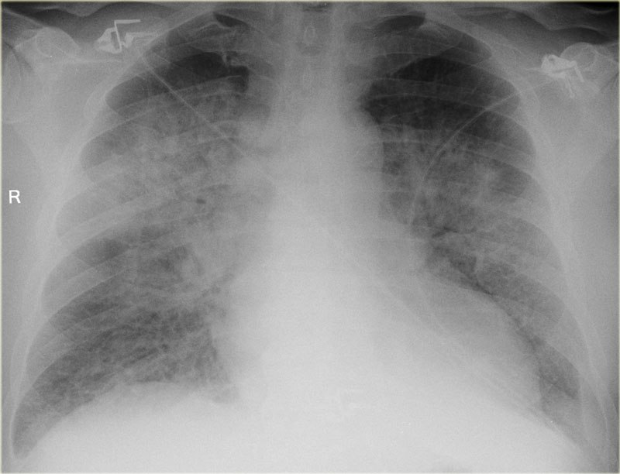**LABS – click** [here](https://extranet.interiorhealth.ca/IHUBCFaculty/Diagnostics/Forms/AllItems.aspx?RootFolder=%25252FIHUBCFaculty%25252FDiagnostics%25252FLabs&View=%25257bFD97E2FE-FD01-433F-B9CB-D75A4195924E%25257d) **OR fill out below**

LABORATORY *LIVE* Lab Summary Report

|  |  |  |  |
| --- | --- | --- | --- |
| **Test** | **DATE/TIME here** | **Flag** (H or L) | **Reference** |
| **CBC** | | | |
| WBC | **14.0** | **H** | 3.5 – 10.8 10^9/L |
| Hgb | **125** | **L** | 130 – 170 g/L |
| Platelets | **450** | **H** | 150 – 400 10^9/L |
| **Chemistry** | | | |
| Na | 144 |  | 137 – 145 mmol/L |
| K | 5.0 |  | 3.5 – 5.0 mmol/L |
| Cl | **109** | **H** | 98 – 107 mmol/L |
| HCO3 | 24 |  | 22-26 mmol/L |
| Urea | **11** | **H** | 2.5 – 6.1 mmol/L |
| Creat | 70 |  | 62 – 106 umol/L |
| Glucose - Random | 6.9 |  | 3.0 – 11.0 mmol/L |
| Calcium | **2.80** | **H** | 2.18-2.58 mmol/L |
| Magnesium | 0.94 |  | 0.75-0.95 mmol/L |
| TSH | **0.1** | **L** | 0.4-5.0 mU/L |
| T3 | Pending |  | 3.5-6.5 pmol/L |
| T4 | Pending |  | 8.5-15.2 pmol/L |
| **Arterial Blood Gas** | | | |
| **Arterial** | | | |
| pH | **7.33** | **L** | 7.35- 7.45 |
| pCO2 | **48** | **H** | 35 – 45 mmHg |
| PO2 | 89 |  | 80-100 mmHg |
| HCO3 | 24 |  | 22 – 26 mmol/L |
| Lactate | **3.2** | **H** | 0.9 – 1.8 mmol/L |

**EKGs – click** [here](https://extranet.interiorhealth.ca/IHUBCFaculty/Diagnostics/Forms/AllItems.aspx?RootFolder=%25252FIHUBCFaculty%25252FDiagnostics%25252FECGs&View=%25257bFD97E2FE-FD01-433F-B9CB-D75A4195924E%25257d) **or paste**

