|  |  |
| --- | --- |
| **Case Title** | CHI – Subdural bleed on DOAC |
| **Scenario Name** |  |

|  |  |
| --- | --- |
| **Learning Objectives -** [**Use action words**](http://ubccpd.ca/sites/ubccpd.ca/files/Accreditation_Learning%20Objectives_%20Verbs.pdf) | |
| **Knowledge:**   1. Management of airway – approach in patient with elevated ICP 2. Reversal of NOAC – Praxibind 3. Seizure management | |
| **Skills:**   1. Intubation skills 2. Praxabind administration | |
| **Attitude/Behaviours:**   1. Demonstrate Team skills 2. Demonstrate Situational awareness 3. Demonstrate Graded Assertiveness | |
| **Scenario Environment** | |
| **Location** | Emergency Department |
| **Monitors** | Bedside cardiac monitor |
| **Props/Equipment** | Vascular access supplies, crash cart, defibrillator, Meds (Praxibind), hard collar |
| **Make-up/Moulage** | Sutures to top of head |
| **Potential Distractors** |  |

|  |
| --- |
| **Case Introduction:** |
| 42 yr old male, presents with wife. C/O Headache, dizziness after workplace injury “day before yesterday.” Hit on top of head. Seen at home hospital, treated for closed head injury and laceration to top of head sutured, sent home with Head Injury information sheet. No imaging done. Triaged to streaming area |

| **Patient Parameters** | **Effective Management** | **Notes** |
| --- | --- | --- |
| **Phase 1: Difficult to rouse & confused**  **Condition:** Stable  **Initial Assessment**   * **Heart Rhythm:** A.Fib * **HR:** 50 * **BP:** 160/85 * **RR:** 12 * **SP02:** 95% RA * **Glucose:** 6.9 * **CNS:**  GCS 13-14 (E3, V4, M6) | * **Take a focused history** (see Notes column) * **Medical Management** * ECG * Move to Trauma bay   + Monitor   + IV   + LAB/RT   + Physician   **Consequences of ineffective management**   * If patient not moved immed from Streaming, then becomes unresponsive in waiting room. | 1. **Focused history**   Ongoing headache since incident yesterday. C/O some dizziness, and visual changes. Steady gait noted. Laceration to top of head, staples insitu.  **PMHx**   * A. Fib – cardioverted x5 in 2 years, awaiting ablation   **Meds**   * Pradaxa * Diltiazem * Metoprolol * Cocaine – recreationally. Last use 30mins PTA   **Allergies**   * NKDA |
| **Phase 2: Deteriorating**  **Condition:** Unstable  **“My head hurts so much – feels like it will explode”**  **Physical Examination**   * **Heart Rhythm:** AFib * **HR:** 50 * **BP:** ?? * **RR:** 8 * **SP02:** 95% * **CNS:** GCS 11 (E3, V4, M4) | 1. **Patient Reassessment** (see Notes column) 2. **Medical Management**  * Call for labs – ensure trauma labs * Call for Head CT Stat * Anticipate tx to Nsx * IV access * Urine Tox Screen * Pharmacology, consider:   + Narcan 0.4mg – if given pt responds agitated/combative   + Praxibind   **Consequences of ineffective management** | 1. **Patient Reassessment**   **Airway**   * Sonorous resps when not stimulated   **Breathing**   * Shallow, sonorous resps * Spontaneous   **Circulation**   * Intact   **Disability**   * Pupils sluggish, L>R, pinpoint |
| **Phase 3: Increased confusion**  **Condition:** Unstable. Responded to Narcan. Increasing agitation  **Physical Examination**   * **Rhythm:** AFib * **HR:** 200 * **BP:** 200/120 * **SP02:** 90 (dropping if no airway management) * **CNS:** GCS 9 (E2, V3, M4) | 1. **Patient Reassessment -** *Recognizes changes in condition* 2. **Medical Management**  * Secure airway for safer patient management and CT   + Airway management:     - Difficult airway set-up: back up techniques at bedside   + Intubate: RSI (lidocaine, fentanyl, etomidate, propofol, succinylcholine, rocuronium)   + Once intubated: ensure tube placement   + Consider post-intubation analgesia and sedation   + OG placement   + CT   ***Consequences of ineffective management:***   * SP02 drops if no airway management | **Airway**   * Not adequately maintaining, need to intubate if not already done so.   **Breathing**  **Circulation** |
| **Phase 4: Seizing –** begins seizing while in CT  **Condition:** Unstable  **Physical Examination:**   * **Generalized tonic-clonic seizure** * **Rhythm:** AFib * **HR:** 120 * **BP: 200/110** * **SP02:** 99% on vent/bagged * **CNS:** L pupil dilated, R normal | 1. **Patient assessment –** recognizes change in condition 2. **Medical Management:**    * Call to PTN for Nsx consult and transfer    * Praxibind 5mg – if not already given    * Meds to stop seizure    * Phenobarb or Dilantin load dose    * Hyperventilate to decreased ETCO2    * Elevate HOB    * Neck midline    * Mannitol    * BP control    * Pain control    * Know where Burr Hole equipment is | **Patient starts seizing while in CT – return patient to ED trauma bay.**  **Airway:**   * Stable with intubation   **Breathing**   * Manual vent during seizure   **Circulation**   * HTN * AFib   **Disability**   * Pupil blown |

**X-RAYS**

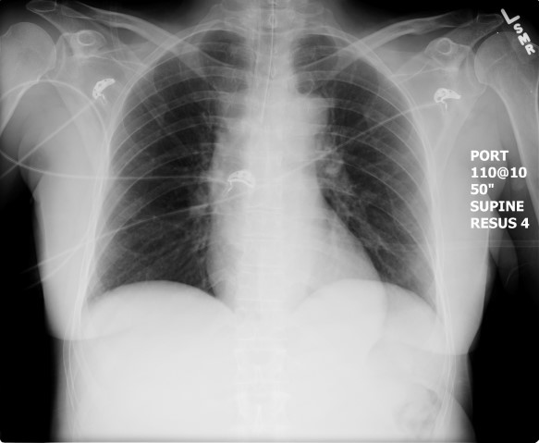

**CT**

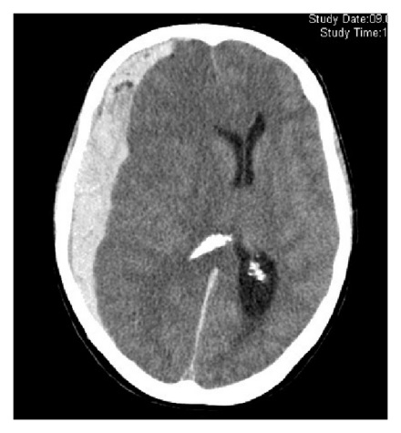

**EKGs**

