|  |  |  |
| --- | --- | --- |
| **Case Title** | Insulin Overdose | Acute Hypotension |
| **Scenario Name** | I gave the wrong medication | Case 3: Year 3/RT/RN students collaborative learning |

|  |  |
| --- | --- |
| **Learning Objectives (3 or more) -** [**Use action words**](http://ubccpd.ca/sites/ubccpd.ca/files/Accreditation_Learning%20Objectives_%20Verbs.pdf) | |
| **Knowledge:**   1. Identify signs and symptoms of hypoglycemia 2. Demonstrate knowledge of pathophysiology of hypoglycemia and the risks 3. Demonstrate knowledge of 30/70 insulin onset, peak and half life 4. Initiate Hypoglycemia Protocol | |
| **Skills:**   1. Complete a systematic patient assessment (ABCDEF) – Include Vital Signs, Blood Glucose and Glasgow Coma Scale 2. Show competency validation with use of Accu-chek®/ protocols in place for high and low Accu-chek® readings. Critical High and Low. 3. Use the SBAR Tool 4. Consider contacting Poison Control 5. Commence appropriate treatment | |
| **Attitude/Behaviours**   1. Demonstrate Team skills - Utilize the whole team to help 2. Demonstrate Situational awareness – Acknowledge and provide comfort to the patient, family, nurse 3. Demonstrate Graded Assertiveness - Inspire confidence in your clinical diagnosis | |
| **Scenario Environment** | |
| **Location** | Surgical Unit |
| **Monitors** | None at the beginning, |
| **Props/Equipment** | Blood Glucose Monitor, Enter lab test, IV, supplies to treat hypoglycemia (dietary, pharmaceuticals), D5NS, D5W, D10W, D50W, Glucagon, Hypoglycemia protocol, patient MAR |
| **Make-up/Moulage** | None |
| **Potential Distractors** | Wife ( An RN) at bedside to visit shortly after the event |

|  |
| --- |
| **Case Introduction:** |
| Mr Ross - 62 year old male 80kg. Post op day 4 Radical Cystectomy with ileal conduit. Vital signs stable. Two JP Drains and dry intact dressing. C/O discomfort after sitting up in chair for 30 minutes. Abdomen distended tender to palpate and passing small amount of gas. LPN called to the ward to assist with workload. She was asked to give the patient medication for discomfort. She reviewed MAR and could administer IM anti-inflammatory medication. Narcotics ordered were IV. ***Do not read this part to students 🡪 *LPN administered 30/70 insulin 100 units IM instead of the Ketorolac 30 mg IM. Patient c/o of nausea post dose.* |

| **Patient Parameters** | **Effective Management** | **Notes** |
| --- | --- | --- |
| **Phase 1: Stable with Nausea & Pain**  **Condition:** Stable  **Initial Assessment**   * **Heart Rhythm:** Sinus Rhythm * **HR:** 92 * **BP:** 122/76 * **RR:** 16 * **SP02:** 97% on RA * **T:** 37.1 C * **Glucose:** 5.3 now * **Chest:** clear * **CNS:** GCS 15 ( E 4, V 5, M 6) * **GI:** Abd distended, tender to palp, few BS * **Weight:** 80 kg | 1. **Take a focused history** (see Notes column) 2. **Medical Management** 3. Monitor – ABCDEF 4. NIBP Monitoring, Oxygen, IV, Stat accucheck and frequent checks. Call for help if needed. 5. Call Medical Student or MRP 6. Consider CCOT if no MRP 7. Take a focused history 8. Identify abnormalities in vital signs and blood sugar level. Initiate management 9. Consider Contacting Poison Control 10. Initiate additional management for investigations Diagnostics : (Labs and ECG) - CBC Lytes, Bun, Creatinine, ionized Ca, Mg PO4, Cardiac Enzyme, Coag levels, Liver functions, ABGs 11. Synthesize information from stat tests/labwork to make a diagnosis. Be able to correctly identify that the patient has hypoglycemia and treat prophylactically | 1. **Focused history**  * Post op day 4 Radical Cystectomy with ileal conduit * Presently c/o discomfort and nausea   **PMHx**   * Arthritis * Bladder CA * CAD * GERD * HTN   **Meds**   |  |  | | --- | --- | | * Lipitor * Monocor * Colace * Famotidine * Heparin sc * Lactulose * Perindopril * Bowel Protocol * Tylenol po/pr prn | * Almagel po prn * Gravol po/ivprn * Hydromorphone IV prn * Ondansetron IV/poprn * Nitroglycerine spray prn * Zopiclone prn * Ketorolac IV/IM PRN |   **Allergies**   * None |
| **Phase 2: Hypoglycemia symptomatic**  **Condition:** Unstable  Dizziness, Lightheaded tired, Nausea, Restless and Anxious  **Physical Examination**   * **Heart Rhythm:** Sinus Tachycardia * **HR:** 118 * **BP:** 134/91 * **RR:** 22 shallow * **SPO2:** 90-902% on RA * **T:** 37.3 C * **Glucose:** 3.8 (*actually was 4.8)* * **CNS:** GCS 8 (E2, V2, M4) | 1. **Patient Reassessment** (see Notes column) 2. **Medical Management** 3. Repeat blood sugars and treat hypoglycemia per protocol 4. Frequency of blood sugar checks q15 min   *Real case scenario orders were as follows:*   * *blood sugar check q30min within normal range but had potential to drop* * *IV D50W,D10W, D5NS, Glucagon*   *Real case scenario ordered D5NS at 125cc/hr*  *Later that night changed to D10W at 75cc/hr*  *Glucagon at bedside*   * *BS < 4.0 prn give ½ amp D50W* * *BS <3 give 1 amp D50W* * *Replace K+ as required* * *Replace electrolytes per ICU electrolyte protocol* | 1. **Patient Reassessment**   **Airway**   * Patent, but falling GCS   **Breathing**   * Sats decreasing   **Circulation**   * Vital Signs   **Disability**   * Check neuro status * Check accucheck   **Environment**   * Check temperature   **Family/ Gather everything else**   * Assess presence, reassure |

|  |  |
| --- | --- |
| **Expected Patient Management** | **Debriefing Points** |
| 1. **Nurse** 2. Identification acuity of the patient - takes vitals, check accucheck, applies O2 prn, takes pertinent history and physical examination. 3. Involvement of help from colleagues/allied health/other health professionals 4. Understands limitations - cannot order investigations/lab work/medications/IV fluids 5. Synthesizes information - follow current protocols/ppos within scope of practice 6. Complete protocol for medication error reporting – MRP and PSLS 7. **PCC/CN or fellow collegue** 8. Acknowledges and clarifies pertinent information with the nurse 9. Proceeds with further management / investigations. 10. Refers for help as the scope of the patient’s management 11. In a useful telephone or in-person handover format SBAR TO Medical Student and or MRP or CCOT 12. **Medical Student** 13. Identifies Differential Diagnosis 14. Clarifies what treatment has been considered and what has been administered 15. Initiates all suggested ideal management and identifies the need for Critical Care consultation 16. Attempts interpretation of investigations (Labs/ECG/CXR/ABG) 17. Demonstrates confidence in team management and patient care | **Instructor Notes for Debriefing**  **Signs and Symptoms of Hypoglycemia (happen quickly)**  Shakiness Nervousness or Anxiety Sweating, Chills and Clamminess Irritability or Impatience Confusion, including Delirium  Rapid/fast heartbeat Lightheadedness or Dizziness Hunger and Nausea Sleepiness Blurred/impaired Vision Tingling or Numbness in the lips or tongue Headaches Weakness or Fatigue Anger, Stubbornness, or Sadness Lack of coordination Nightmares or crying out during sleep Seizures Unconsciousness - See more at: <http://www.diabetes.org/living-with-diabetes/treatment-and-care/blood-glucose-control/hypoglycemia-low-blood.html#sthash.VMinERBo.dpuf>  **Treatment**  **Consume 15-20 grams** of glucose or simple carbohydrates Recheck your blood glucose after 15 minutes If hypoglycemia continues, repeat. Once blood glucose returns to normal, eat a small snack if your next planned meal or snack is more than an hour or two away.  **Acarbose**   * Used (with diet only or diet and other medications) to treat type 2 diabetes (condition in which the body does not use insulin normally and therefore cannot control the amount of sugar in the blood) * Works by slowing the action of certain chemicals that break down food to release glucose (sugar) into your blood. Slowing food digestion helps keep blood glucose from rising very high after meals. * Blocks the breakdown of table sugar and other complex sugars, fruit juice or other products containing these sugars will not help to increase blood sugar.   **Glucagon**  If left untreated, hypoglycemia may lead to a seizure or unconsciousness (passing out, a coma). In this case, someone else must take over. Glucagon is a hormonal chemical produced in one part of the body and released into the blood to trigger or regulate particular functions of the body. For example, insulin is a hormone made in the pancreas that tells other cells when to use glucose for energy. Synthetic hormones, made for use as medicines, can be the same or different from those made in the body that stimulates your liver an organ in the body that changes food into energy, removes alcohol and poisons from the blood, and makes bile, a substance that breaks down fats and helps rid the body of wastes. X to release stored glucose into your bloodstream when your blood glucose levels are too low. **Injectable glucagon kits are used as a medication to treat someone with diabetes that has become unconscious from a severe insulin reaction.**  **Glucagon hormone produced by the alpha cells in the pancreas.**  It raises blood glucose. An injectable form of glucagon, available by prescription, may be used to treat severe hypoglycemia. If glucagon is needed: Inject glucagon into the individual's buttock, arm or thigh, following the manufacturer's instructions.  When the individual regains consciousness (usually in 5-15 minutes), they may experience nausea and vomiting.  See more at: <http://www.diabetes.org/living-with-diabetes/treatment-and-care/blood-glucose-control/hypoglycemia-low-blood.html#sthash.VMinERBo.dpuf>  **Accu-check**   |  |  | | --- | --- | | Normal Range 4 – 11 mmols  Out of Range <4 >2 or  > 11 <30 repeat consider lab and call MRP  Critical Range <2 or > 30 repeat and do lab call MRP | IH Accu-chek® Clinical Practice Standard | |

**References:**

1. Diabetes.ORG
2. Mosby Skills
3. IH Website Regional Pre Printed Orders

**MAR – Pre-Event**



**MAR – Post-Event**



**Hypoglycemia Protocol**



**X-RAYS**

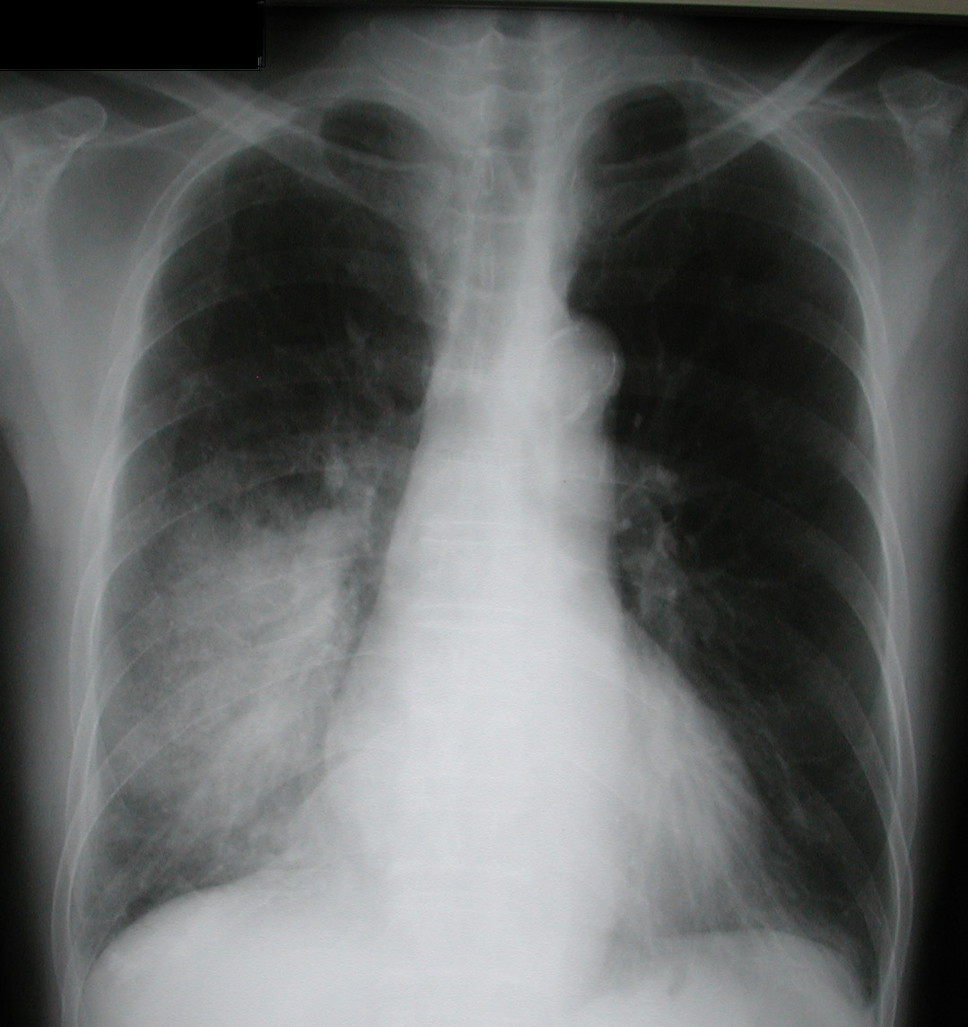

**LABS**

RUN DATE: Today LABORATORY *LIVE* Lab Summary Report

LOCATION

|  |  |  |  |
| --- | --- | --- | --- |
| **Test** | **DATE/TIME here** | **Flag** (H or L) | **Reference** |
| **CBC** | | | |
| WBC | 10.1 |  | 3.5 – 10.8 10^9/L |
| RBC |  |  | 4.3 – 5.7 10^12/L |
| Hgb | 120 | **L** | 130 – 170 g/L |
| HCT | 0.47 |  | 0.37 – 0.47 L/L |
| Platelets | 400 | **H** | 150 – 400 10^9/L |
| D-Dimer |  |  | <250 mcg/L |
| **Chemistry** | | | |
| Na | 146 | **H** | 137 – 145 mmol/L |
| K | 3.3 | **L** | 3.5 – 5.0 mmol/L |
| Cl | 100 |  | 98 – 107 mmol/L |
| HCO3 | 23 | **L** | 22-26 mmol/L |
| Urea | 10 | **H** | 2.5 – 6.1 mmol/L |
| Creat | 62 |  | 62 – 106 umol/L |
| GFR Est |  |  | > 60 ml/min |
| Glucose - Random | 4.2 |  | 3.0 – 11.0 mmol/L |
| Lactate |  |  | 0.9 – 1.8 mmol/L |
| CK |  |  | 5 – 130 U/L |
| Troponin |  |  | <0.03 mcg/L |
| **Coags** |  |  |  |
| INR | 1.3 | **H** | 0.9 – 1.2 |
| PTT | 23 |  | 28 – 38 s |
| **ABGs** | | | |
| **Arterial (Pending)** | | | |
| pH |  |  | 7.35- 7.45 |
| pCO2 |  |  | 35 – 45 mmHg |
| PO2 |  |  | 80-100 mmHg |
| BE |  |  | -2.0 to +2.0 mmol/L |
| HCO3 |  |  | 22 – 26 mmol/L |
| O2 Sat |  |  | 95 – 100% |

Ionized Calcium, Magnesium, Phosphorous : all pending

|  |  |  |  |  |  |  |  |  |
| --- | --- | --- | --- | --- | --- | --- | --- | --- |
| CHEMISTRY | | | | | | | | |
| ADMISSION |  | |  | |  | |  |  |
|  |  | |  | |  | |  |  |
| Glucose-Random | 4.2 |  |  |  |  |  | (3.0-11.0) | mmol/L |
| Na | **146** |  |  | H |  |  | (137-145) | mmol/L |
| K | **3.3** |  |  | L |  |  | (3.5-5.0) | mmol/L |
| Cl | 100 |  |  |  |  |  | (98-107) | mmol/L |
| HCO3 | **23** |  |  | L |  |  | (22-26) | mmol/L |
| Urea | **10** |  |  | H |  |  | (2.5-6.1) | mmol/L |
| Creat | 120 |  |  | **H** |  |  | (62-106) | mmol/L |
| GFR Est | 62 |  |  |  |  |  | (> 60) | ml/min |
| Ionized Calcium | pending |  |  |  |  |  |  |  |
| Magnesium | pending |  |  |  |  |  |  |  |
| Phosphorus | pending |  |  |  |  |  |  |  |
|  |  |  |  |  |  |  |  |  |
| ARTERIAL BLOOD GAS  Pending | | | | | | | | |

**EKGs**

