|  |  |
| --- | --- |
| **Case Title** | Candy party |
| **Scenario Name** | Polypharmacy overdose |

|  |  |
| --- | --- |
| **Learning Objectives -** [**Use action words**](http://ubccpd.ca/sites/ubccpd.ca/files/Accreditation_Learning%20Objectives_%20Verbs.pdf) | |
| **Knowledge:**   1. Recognize a life-threatening overdose without a specific antidote 2. Provide supportive care to a polypharmacy overdose | |
| **Skills:**   1. Intubation 2. Supportive care of polypharmacy overdose | |
| **Attitude/Behaviours:**   1. Demonstrate Team skills 2. Demonstrate Situational awareness 3. Demonstrate Graded Assertiveness | |
| **Scenario Environment** | |
| **Location** | ED |
| **Monitors** | Crash cart |
| **Props/Equipment** | Intubation, 4 empty pill bottles (30 tabs Seroquel 25mg, 30 tabs lamotrigine 100mg, 30 tabs lamotrigine 25mg, 30 tabs lorazepam 1mg), 1 large jar full of random pills |
| **Make-up/Moulage** | Bottle of random pills |
| **Potential Distractors** |  |

|  |
| --- |
| **Case Introduction:** |
| 20F last seen well 2hrs ago. Found by roommate with empty bottle of vodka, multiple empty Rx pill bottles, jar of random pills |

| **Patient Parameters** | **Effective Management** | **Notes** |
| --- | --- | --- |
| **Phase 1: Somnolent**  **Condition: maintaining airway, somnolent**  **Initial Assessment**   * **Heart Rhythm:** sinus, narrow complex * **HR:** 90 * **BP:** 110/60 * **RR:** 18 * **SP02**: 98% NRB * **T:** 36 * **Glucose:** 6 * **CNS:**  E1V2M4 * **Chest:** clear * **CVS:**  normal * **GI:** normal * **Integ**: dry, warm, normal colour * **Weight:** 55kg * **Height:** 165cm | 1. **Take a focused history** (see Notes column) 2. **Medical Management**  * Does primary assessment * Assesses skin, pupils, tone * Attempts to identify toxidrome (specifically serotonin syndrome – not present) * Looks for signs of NaCB on ECG * Considers empiric naloxone (no effect if given) * Prepares to intubate * Calls PCC * Calls ICU   **Consequences of ineffective management**   * Becomes hypoxic and combative | 1. **Focused history**  * Only available from EMS * Found with empty pill bottles filled 3 days ago (brought by EMS): 30 tabs Seroquel 25mg, 30 tabs lamotrigine 100mg, 30 tabs lamotrigine 25mg, 30 tabs lorazepam 1mg, + “candy jar” of random pills + bottle vodka   **PMHx**   * Depression   **Meds**   * As above   **Allergies**   * NKDA |
| **Phase 2: Decreased LOC**  **Condition: HD stable, not protecting airway, GCS 6**  **Physical Examination**   * **Heart Rhythm:** sinus tach * **HR:** 110 * **BP:** 105/65 * **RR:** 18 * **SP02**: 98% NRB * **T:** 36 * **Glucose:** 6 * **CNS:**  E1V1M4 | 1. **Patient Reassessment** (see Notes column) 2. **Medical Management**  * RSI with ketamine, rocuronium * Uses apneic oxygenation, suction ready, vasopressor ready   **Consequences of ineffective management**   * Begins vomiting, likely aspiration | 1. **Patient Reassessment**   **Airway**   * Protected (once intubates)   **Breathing**   * GAEB with BVM   **Circulation**   * No change |

**Insert more lines if more phases required.**

|  |  |
| --- | --- |
| **Expected Patient Management** | **Debriefing Points** |
| 1. **Student** 2. **R1** 3. **Senior IM resident** |  |

**References:**

**X-RAYS – Click** [here](https://extranet.interiorhealth.ca/IHUBCFaculty/Diagnostics/Forms/AllItems.aspx?RootFolder=%25252FIHUBCFaculty%25252FDiagnostics%25252FX%25252Drays&View=%25257bFD97E2FE-FD01-433F-B9CB-D75A4195924E%25257d)

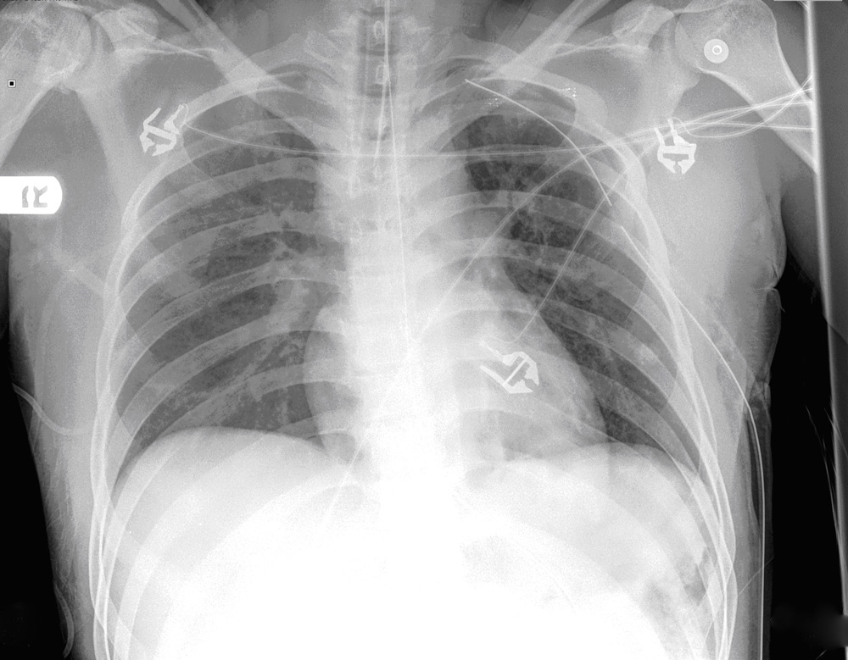

**LABS – click** [here](https://extranet.interiorhealth.ca/IHUBCFaculty/Diagnostics/Forms/AllItems.aspx?RootFolder=%25252FIHUBCFaculty%25252FDiagnostics%25252FLabs&View=%25257bFD97E2FE-FD01-433F-B9CB-D75A4195924E%25257d) **OR fill out below**

LABORATORY *LIVE* Lab Summary Report

|  |  |  |  |
| --- | --- | --- | --- |
| **Test** | **DATE/TIME here** | **Flag** (H or L) | **Reference** |
| **CBC** | | | |
| WBC | 5.3 |  | 3.5 – 10.8 10^9/L |
| RBC |  |  | 4.3 – 5.7 10^12/L |
| Hgb | **120** | **L** | 130 – 170 g/L |
| HCT | **0.35** | **L** | 0.37 – 0.47 L/L |
| Platelets | 236 |  | 150 – 400 10^9/L |
| D-Dimer |  |  | <250 mcg/L |
| **Chemistry** | | | |
| Na | **148** | **H** | 137 – 145 mmol/L |
| K | **3.4** | **L** | 3.5 – 5.0 mmol/L |
| Cl | 109 |  | 98 – 107 mmol/L |
| HCO3 | **21** | **L** | 22-26 mmol/L |
| Urea | **1.6** | **L** | 2.5 – 6.1 mmol/L |
| Creat | **60** | **L** | 62 – 106 umol/L |
| GFR Est | >120 |  | > 60 ml/min |
| Glucose - Random | 5.3 |  | 3.0 – 11.0 mmol/L |
| Lactate |  |  | 0.9 – 1.8 mmol/L |
| βHCG | <6 |  | IU/L |
| Troponin |  |  | <0.03 mcg/L |
| **Coags** |  |  |  |
| INR | 1.0 |  | 0.9 – 1.2 |
| PTT |  |  | 28 – 38 s |
| **Blood gas** | | | |
| VBG | | | |
| pH | **7.32** | **L** | 7.35- 7.45 |
| pCO2 | 40 |  | 35 – 45 mmHg |
| BE | **-5.2** | **L** | -2.0 to +2.0 mmol/L |
| HCO3 | **21** | **L** | 22 – 26 mmol/L |
| O2 Sat | 100 |  | 95 – 100% |
| Lactate | **3.2** | **H** | 0.7-2.1mmol/L |

**EKGs – click** [here](https://extranet.interiorhealth.ca/IHUBCFaculty/Diagnostics/Forms/AllItems.aspx?RootFolder=%25252FIHUBCFaculty%25252FDiagnostics%25252FECGs&View=%25257bFD97E2FE-FD01-433F-B9CB-D75A4195924E%25257d) **or paste**

